**16/07/2024 Java Lab code**

/*this is java*/

/*it is going

to work*/

public class Main

{

public static void main(String[] args)

{

System.out.println("To infinity and beyond");

String name="John";

System.out.println(name);

int myNum = 15;

System.out.println(myNum);

myNum=20;

System.out.println(myNum);

final int Num=15;

System.out.println(Num);

Num=29; /* error thrown while compiling the file */ /* error: cannot assign a value to final variable Num */

}

}

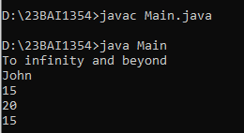

**18/07/2024 Java Lab Codes**

public class Main

{

public static void main(String[] args)

{

int myInt=9;

double myDouble=myInt;

System.out.println(myInt);

System.out.println(myDouble);

int sum1=100+50;

int sum2=sum1+250;

int sum3=sum2+sum2;

System.out.println(sum1);

System.out.println(sum2);

System.out.println(sum3);

}

}

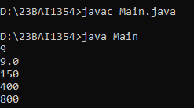

String a="hello";

int sum4=a+sum3;

System.out.println(sum4);

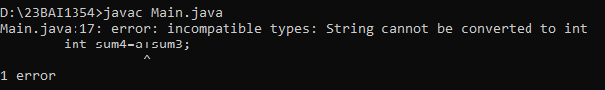

int x,y;

x=20;

y=(x==1)?61:90;

System.out.println("Value of y is: "+ y);

y=(x==20)?61:90;

System.out.println("Value of y is: "+y);

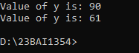

String txt="abcdefghijklmnopqrstuvwxyz";

System.out.println("The length og the txt string is: "+txt.length());



String txt="Hello World";

System.out.println(txt.toUpperCase());

System.out.println(txt.toLowerCase());

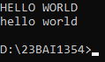

String text="Please locate where 'locate' occurs!";

System.out.println(text.indexOf("locate"));

