Functional Requirements: Smart Quantity Recommendations
This document defines the functional requirements for the Daily Quantity Limit in Cascade Plus. It covers the new Settings page (Smart Quantity Recommendations and its Audit Log) and the warning sign shown in Order Pad. Products, quantities, names and orders shown in the wireframe are sample data only.
1. Purpose
- Warn the pharmacy when the quantity of an item ordered in a day goes above a set limit.
- Let the pharmacy set one general limit for every product, and switch it on or off.
- Let the pharmacy set a different limit for selected products.
- Show the warning in Order Pad without blocking the order.
2. Scope
The scope covers the ‘SETTINGS’ option under MORE, the Settings page (Smart Quantity Recommendations: General Limit and Product Specific Limit, and its Audit Log), and the ‘warning sign’ on Order Basket lines in Order Pad. All other page functions are unchanged.
3. Settings Requirements
a. Access - ‘Settings’ must be available under MORE, directly after Out of Stock. While in the Settings page, MORE and Settings are highlighted.
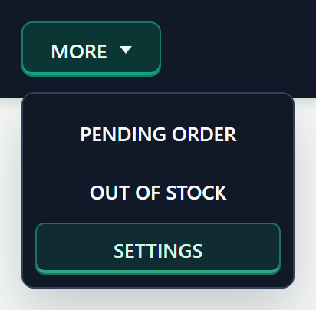
NOTE: When the user hovers over MORE, the dropdown must stay open while the pointer moves from MORE onto the dropdown options, including across the space between them.
b. Layout - The page heading is ‘Settings’. The left ‘OPTIONS’ list shows ‘Smart Quantity Recommendations’ with two sub-items, ‘General Limit’ and ‘Product Specific Limit’, then ‘Audit Log’ with the sub-item ‘Smart Quantity Recommendations’. Settings opens on General Limit with its sub-items shown. Only the group that holds the open item shows its sub-items; the other group is minimised. The selected sub-item has a green bar on the left, and its panel is shown on the right. Clicking an open group again hides or shows its sub-items.
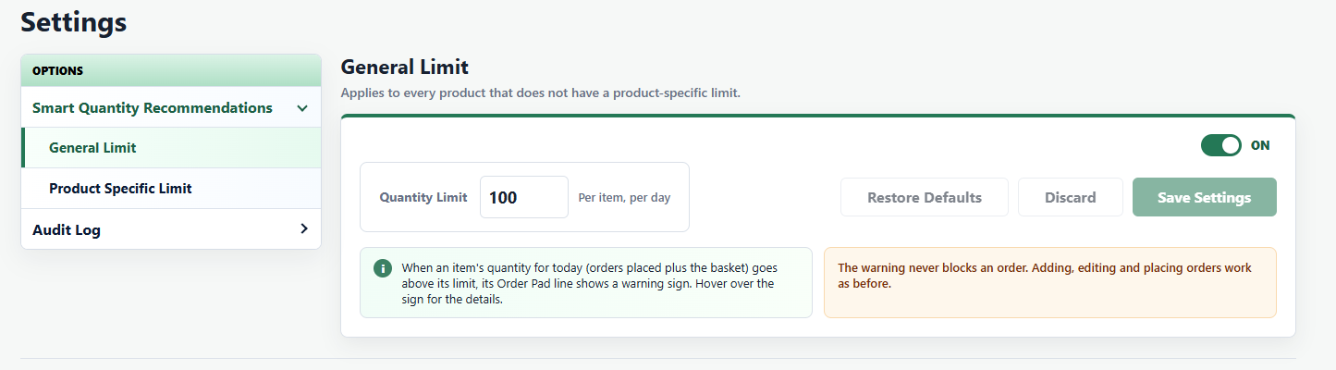
c. Unsaved Changes - Opening another item in the list (or leaving the page and returning with Back) discards unsaved changes. Each item always comes back showing its saved setting.
4. General Limit Requirements
a. Panel - Heading ‘General Limit’ with the sub-heading ‘Applies to every product that does not have a product-specific limit.’ The ‘Quantity Limit’ label, the box with the saved value and ‘Per item, per day’ are on one line. Restore Defaults, Discard and Save Settings are on the same row, to the right of the box.
b. ON/OFF Toggle - The toggle at the top right is ‘ON’ (green) by default. Turning it ‘OFF’ greys out the quantity box (the value is kept) and shows ‘The general limit is off. Only products with a product-specific limit show a warning in the Order Pad.’ Turning it on again uses the kept value. Products with their own limit still show a warning while this toggle is ON or OFF.
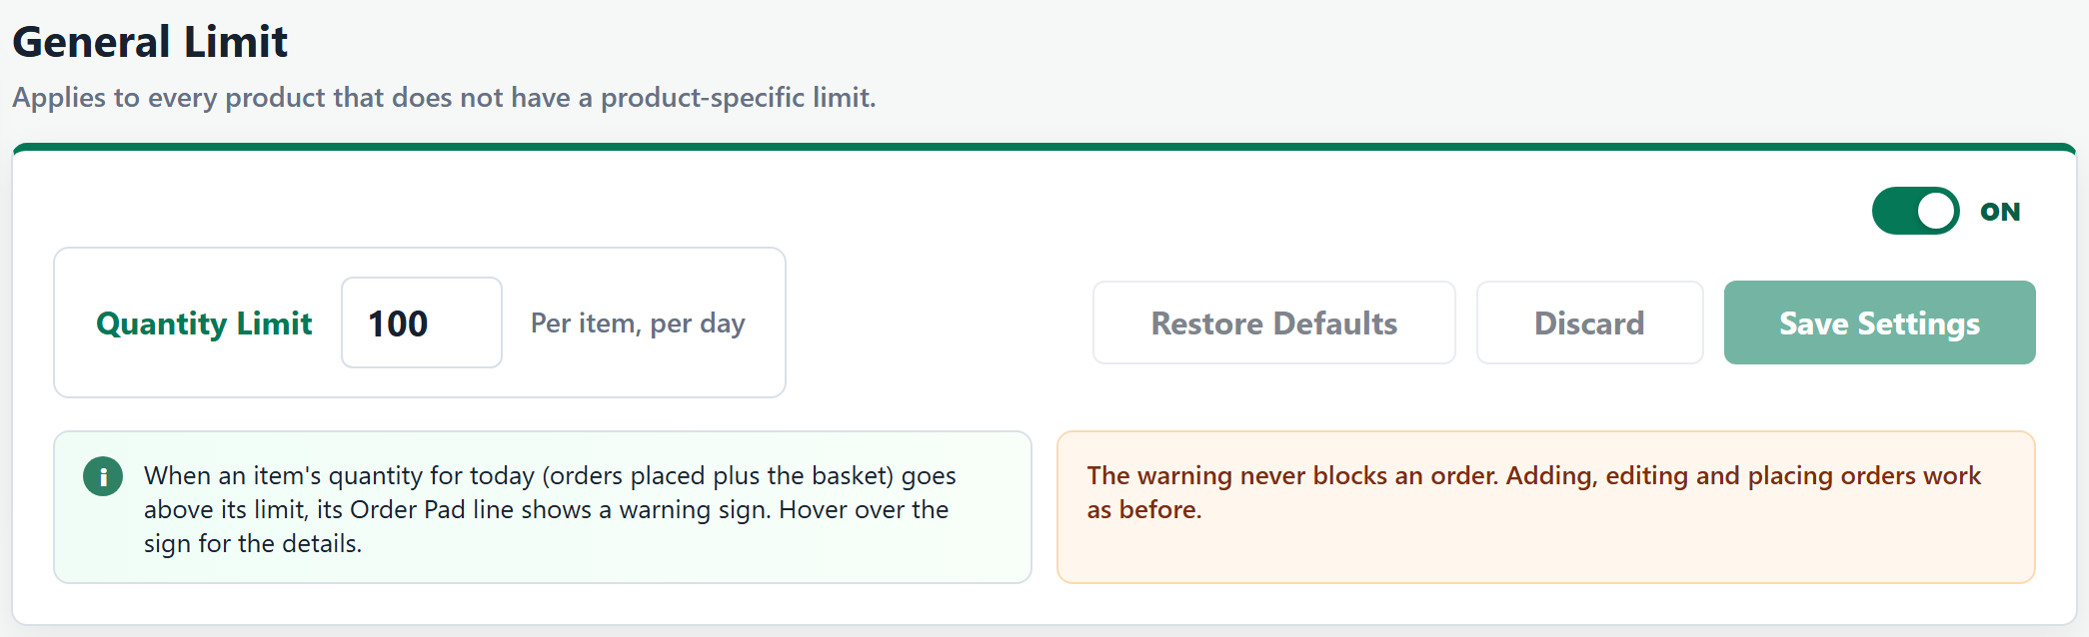
c. Save, Discard and Restore Defaults - Any change to the toggle or the quantity shows the ‘Unsaved Changes’ tag right under Save Settings and enables ‘Discard’ and ‘Save Settings’.
- Save Settings saves the change and shows ‘General limit saved: X per item, per day’, or ‘General limit turned off. Only products with their own limit show a warning’ when saved as Off.
- Discard returns to the saved setting and shows ‘Changes discarded’.
- Restore Defaults sets the toggle to ON and the quantity to 100 (not saved until Save Settings). It is disabled when these values are already shown.
d. Keyboard - Enter in the quantity box saves when there is a change, the same as Save Settings; with no change it does nothing.
e. Invalid Value - An empty, 0, negative or decimal value shows ‘Enter a quantity limit of 1 or more in natural numbers.’ with a red box, and Save Settings stays disabled. The box takes up to 4 digits (maximum 9999).
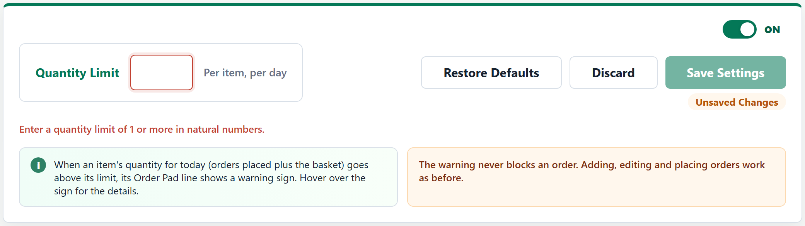
f. Notes - The green info note reads ‘When an item's quantity for today (orders placed plus the basket) goes above its limit, its Order Pad line shows a warning sign. Hover over the sign for the details.’ The orange note reads ‘The warning never blocks an order. Adding, editing and placing orders work as before.’
5. Product Specific Limit Requirements
a. Panel - Heading ‘Product Specific Limit’ with the sub-heading ‘Set a different quantity limit for selected products. It replaces the general limit for those products, and still applies when the general limit is off.’ The product table comes first, with ‘+ Add/Update Product’ below it.
b. Search - Selecting ‘+ Add/Update Product’ opens a new last line in the table with a search box. Typing a product name or PIP code lists up to 12 matching products (Order Pad catalogue and Order History products), each with its PIP code.
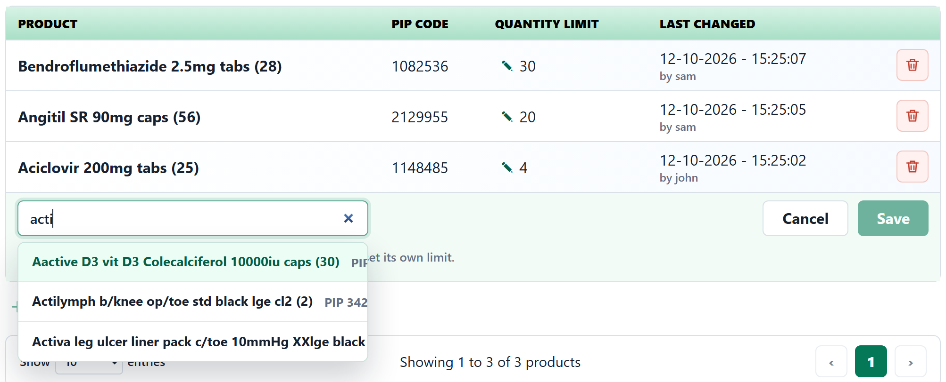
With no match it shows ‘No products found. Try another product name or PIP code.’ Before a product is chosen, the hint under the line reads ‘Type a product name or PIP code, then choose the product to set its own limit.’ Escape or Cancel closes the line.
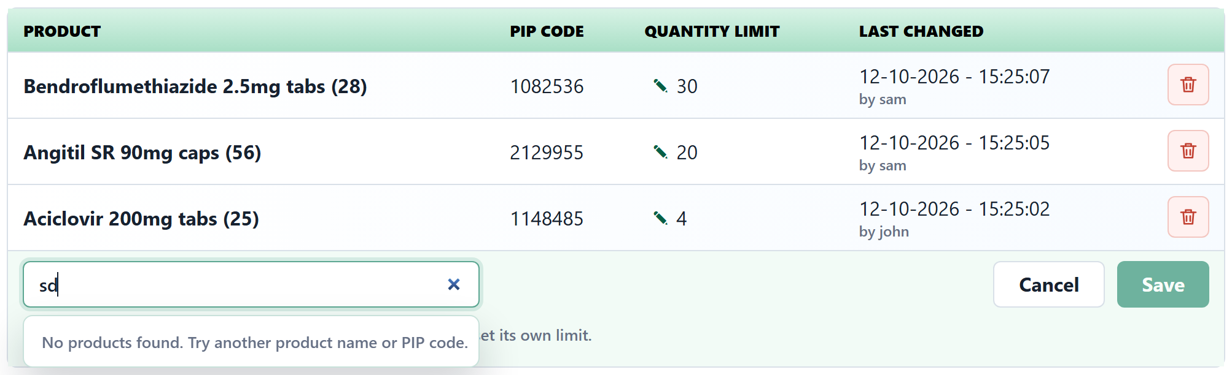
c. Add or Update - Choosing a product fills its PIP Code and shows the Quantity Limit box with Cancel and Save on the same line; the hints show under the line.
- A new product is prefilled with the general value: ‘Prefilled with the general limit (X). If needed, change it, then save it.’ When the general limit is off: ‘Prefilled with X. The general limit is off, so only products listed below show a warning.’
- A product that already has a limit shows its own value, the button reads Update, and the hint reads ‘<Product> already has its own limit. Change it and select Update, or Cancel.’
- Save/Update shows ‘Limit saved for <Product>: X’ or ‘Limit updated for <Product>: X’ and closes the line. Cancel closes the line. Enter saves any change, the same as Save.
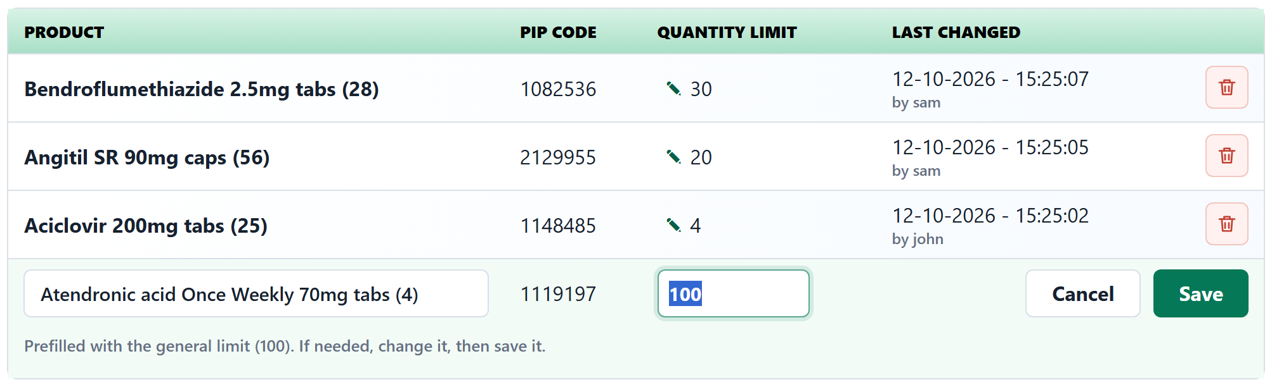
d. List - The table shows Product, PIP Code, Quantity Limit and Last Changed (‘DD-MM-YYYY - HH:MM:SS’ and ‘by <username>’), sorted by the most recently changed product first. It shows Show 10 entries by default (10, 25, 50 or 100), ‘Showing x to y of z products and page buttons. With no products it shows ‘No product-specific limits yet. Every product uses the general limit.’ or ‘No product-specific limits yet. The general limit is off, so no product shows a warning.’
- Pencil edit: a pencil before each Quantity Limit value opens the box with a green tick (save) and a red cross (cancel). Enter saves and Escape cancels. An invalid value shows a red box and the error under the row, and the tick is disabled.
- Saving a new value updates Last Changed, moves the product to the top and shows ‘Limit updated for <Product>: X’. Saving the same value just closes the box, with no history entry.
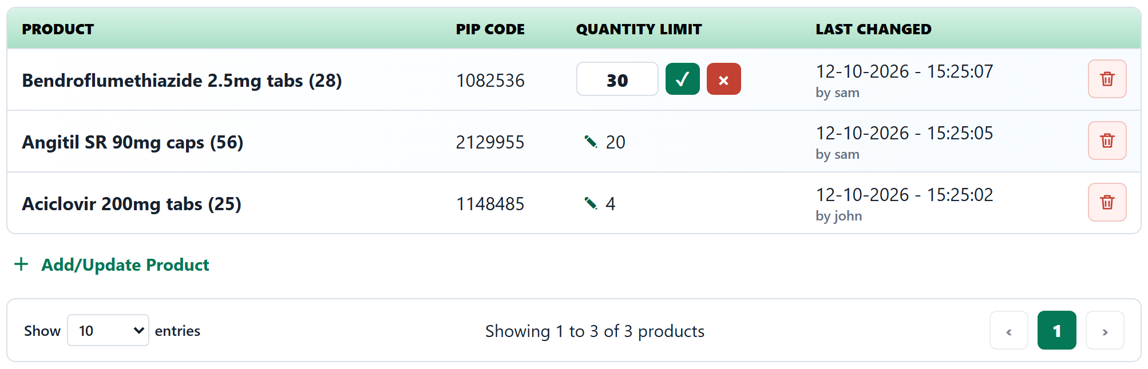
e. Remove - The red delete icon opens ‘Remove limit?’ with ‘<Product> will use the general limit again, if it is on.’ Cancel closes it. Remove deletes the row and shows ‘<Product> now uses the general limit’ (or ‘Limit removed for <Product>’ when the general limit is off).
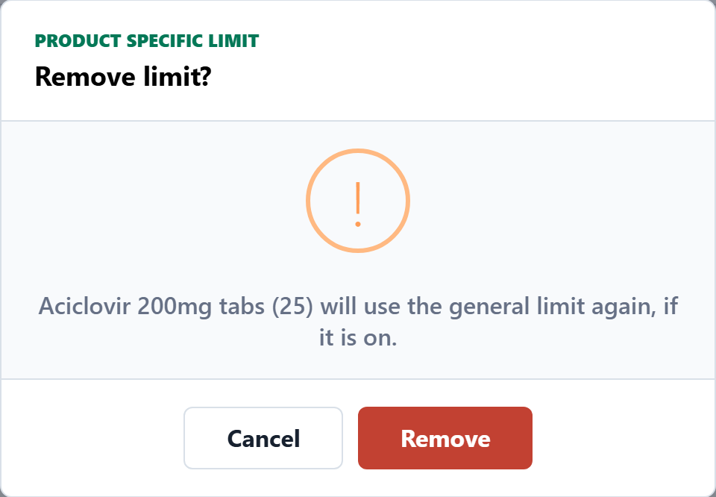
6. Audit Log Requirements
a. Access - Under ‘OPTIONS’, ‘Audit Log’ is shown last, with the sub-item ‘Smart Quantity Recommendations’.
b. Layout - The screen shows the heading and sub-heading at the top, then the filters, then the history table. The heading and sub-heading follow the selected Type:
- General Limit: ‘General Limit History’ with ‘Every time the general limit was switched on or off, or its quantity changed. Newest first.’
- Product Specific Limit: ‘Product Specific Limit History’ with ‘Every product-specific limit that was added, updated or removed. Newest first.’
Below the table, the note reads ‘History entries are added automatically when a limit is saved or removed. They cannot be edited or deleted.’
c. Filters - ‘START’ and ‘END’ dates and ‘TYPE’ (‘General Limit’ or ‘Product Specific Limit’), with Search and Reset buttons.
- Default: the last 7 days (today and the 6 days before) and Type ‘General Limit’. The Audit Log always opens with the defaults, including when the user returns to it from another item.
- Search: Start, End and Type are applied together only when Search is selected. Changing a filter on its own does not change the table or the heading.
- Reset: returns to the defaults and shows ‘Filters reset’.
- Start after End: Search shows ‘The start date must be on or before the end date.’ and the table keeps its last results.
d. General Limit History - Columns: ‘Date & Time’ (‘DD-MM-YYYY - HH:MM:SS’), ‘Changed By’, ‘Action’, ‘Status’ and ‘Quantity Limit’. Action is ‘Switched On’, ‘Switched Off’ or ‘Quantity Changed’; when one saves does both, both are shown (for example ‘Switched On, Quantity Changed’). Status is ‘On’ or ‘Off’ after the change, and Quantity Limit is the quantity saved by that change.
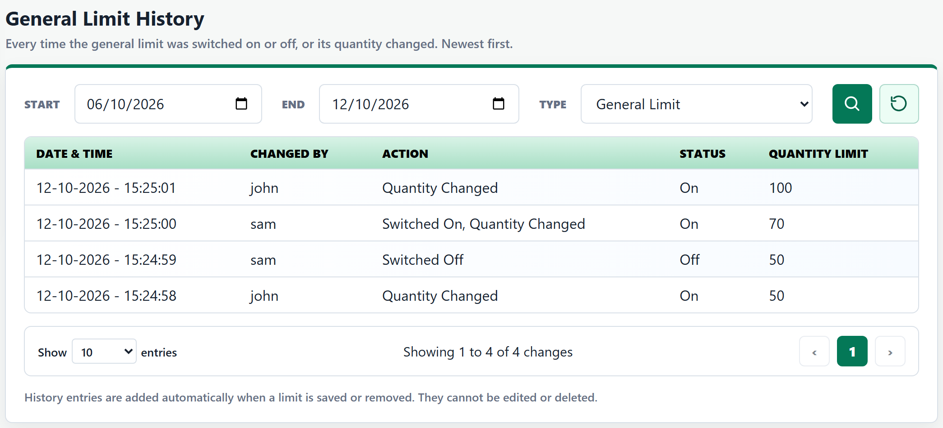
e. Product Specific Limit History - Columns: ‘Date & Time’, ‘Changed By’, ‘Action’, ‘Product’ and ‘Quantity Limit’. Action is ‘Added’, ‘Updated’ or ‘Removed’ (a pencil edit is recorded as ‘Updated’). Quantity Limit is the quantity saved by that change; for ‘Removed’, it is the quantity the product had when it was removed.
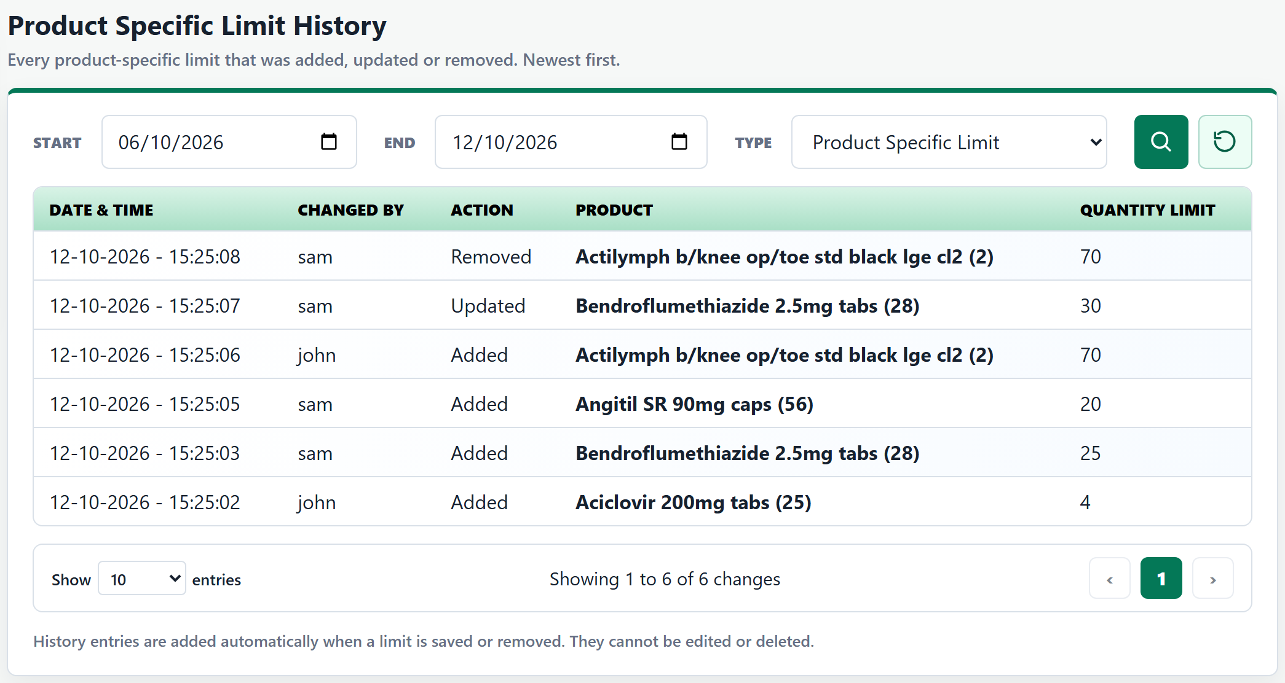
f. Recording - One entry is added each time a limit is saved or removed, with the date and time and the username signed in through Shift sign-in. Saving with nothing changed adds no entry. Entries are listed newest first, with Show 10 entries by default (10, 25, 50 or 100), ‘Showing x to y of z changes’ and page buttons. With no entries for the selected filters it shows ‘No changes found for the selected dates.’
7. Order Pad Requirements
a. Warning Sign - When an item's quantity today is above its limit, a yellow warning sign is shown after the product name and any existing tags (CD, FRIDGE, HIGH VALUE). The sign is always the last tag.
b. Message - Hovering over, tabbing to or clicking the sign shows the message straight away: ‘Quantity:X (Y ordered + Z in basket). General Limit N per day. Warning only, can be edited in Settings.’ For a product-specific limit it reads ‘Quantity:X (Y ordered + Z in basket). Product specific Limit N per day. Warning only, can be edited in Settings.’ The ‘ordered + in basket’ split is shown only when some was ordered earlier today; otherwise, it reads ‘(Z in basket)’. The message closes when the mouse leaves, on Escape, on scroll or on a click elsewhere. Clicking the sign does not open Edit Product.
Example 1 (general limit): Metformin MR 1000mg tabs (56) – 10 ordered earlier today + 95 in basket = 105, above the general limit of 100.
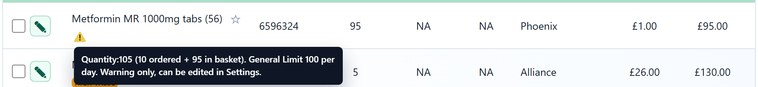
Example 2 (product-specific limit): Angitil SR 90mg caps (56) has its own limit of 20 – 32 in basket. The sign is shown after HIGH VALUE.
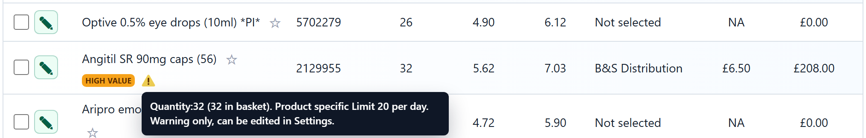
c. Review Before Placing Order - When at least one basket line shows the warning sign, the ‘Review before placing order’ popup lists it under ‘This order contains products requiring attention:’ as the last row. The row shows the warning sign and ‘N Above Daily Quantity Limit’, where N is the number of basket lines showing the sign.
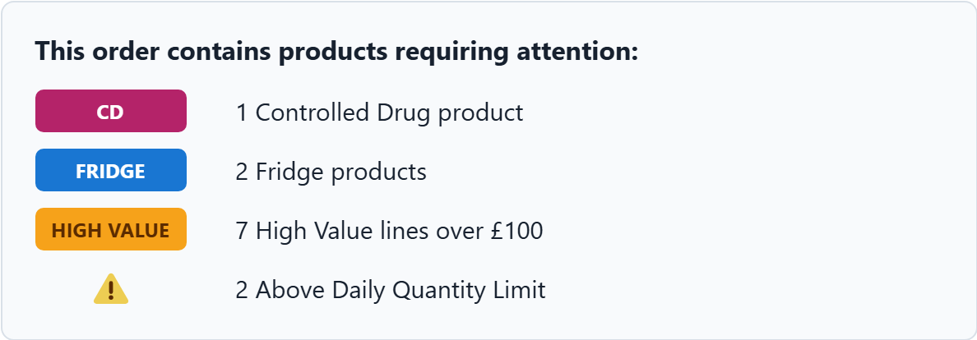
- Hovering over the sign shows ‘Daily quantity limit — quantity (ordered + in basket) is above the daily set limit. Warning only, edit in Settings.’
d. Live Update - The sign updates as soon as a basket quantity changes (quantity edit, product added or line removed) and when a limit is changed in Settings. After an order is placed successfully, its quantities count towards today's totals.
e. No Blocking - The warning never blocks an order. Adding, editing and placing orders work as before.
f. Hover Messages - All hover messages in Order Pad now appear immediately in a dark, round edge message box with white text, replacing the browser's default white rectangular tooltip.
