Functional Requirements: Daily Threshold – Smart Quantity Recommendations
This document defines the functional requirements for the Daily Threshold in Cascade Plus. It covers the new Settings page (Daily Quantity Threshold and Audit Log) and the warning sign shown in Order Pad. Products, quantities, names and orders shown in the wireframe are sample data only.
1. Purpose
- Warn the pharmacy when the quantity of an item ordered in a day goes above a set limit.
- Let the pharmacy set one general limit for every product, and switch it on or off.
- Let the pharmacy set a different limit for selected products.
- Show the warning in Order Pad without blocking the order.
2. Scope
The scope covers the ‘SETTINGS’ option under MORE, the Settings page (Daily Threshold, Audit Log), and the ‘warning sign’ on Order Basket lines in Order Pad. All other page functions are unchanged.
3. Settings Requirements
a. Access – ‘Settings’ must be available under MORE, directly after Out Of Stock. While in the Settings page, MORE and Settings are highlighted.
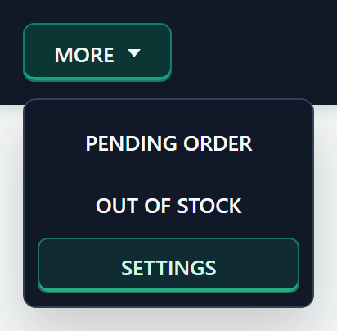
NOTE: Now when the user hovers over MORE, the dropdown must stay open while the pointer moves from MORE onto the dropdown options, including across the space between them.
b. Layout - The page heading is ‘Settings’. The left ‘OPTIONS’ list shows ‘Daily Quantity Threshold’ with two sub-items: ‘General Threshold’ and ‘Product Specific Threshold’ and ‘Audit Log’ with sub-item – ‘Daily Quantity Threshold’. Settings opens on General Threshold with the sub-items shown. The selected sub-item has a green bar on the left, and its panel is shown on the right. Clicking on Daily Quantity Threshold again hides or shows the sub-items.
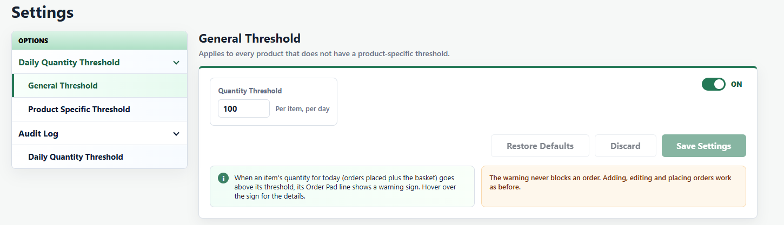
c. Unsaved Changes - Opening another item in the list (or leaving the page and returning with Back) discards unsaved changes. Each item always comes back showing its saved setting.
4. General Threshold Requirements
a. Panel - Heading ‘General Threshold’ with the sub-heading ‘Applies to every product that does not have a product-specific threshold.’ The ‘Quantity Threshold’ box shows the saved value, with ‘Per item, per day’ to its right.
b. ON/OFF Toggle - The toggle at the top right is ‘ON’ (green) by default. Turning it ‘OFF’ greys out the quantity box (the value is kept) and shows ‘The general threshold is off. Only products with a product-specific threshold show a warning in the Order Pad.’ Turning it on again uses the kept value. Products with their own threshold still show a warning while this toggle is ON/OFF.
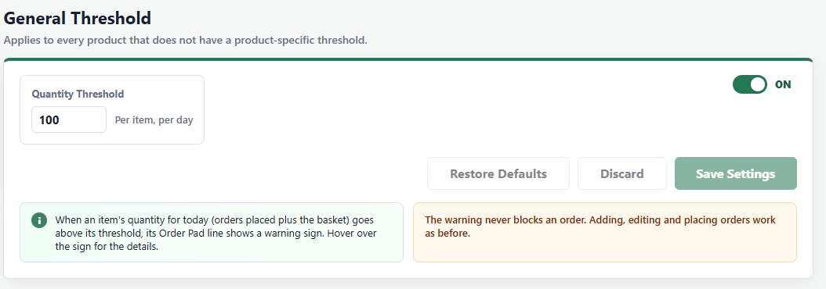
c. Save, Discard and Restore Defaults - Any changes to the toggle or the quantity show ‘Unsaved Changes’ tag and enables ‘Discard’ and ‘Save Settings’.
- Save Settings saves the change and shows ‘General threshold saved: X per item, per day’, or ‘General threshold turned off. Only products with their own threshold show a warning’ when saved as Off.
- Discard returns to the saved setting and shows ‘Changes discarded’.
- Restore Defaults sets the toggle to ON and the quantity to 100 (not saved until Save Settings). It is disabled when these values are already shown.
d. Keyboard - Enter in the quantity box saves when there is a change, the same as Save Settings; with no change it does nothing.
e. Invalid Value - An empty, 0, negative or decimal value shows ‘Enter a quantity threshold of 1 or more in natural numbers.’ with a red box, and Save Settings stays disabled.
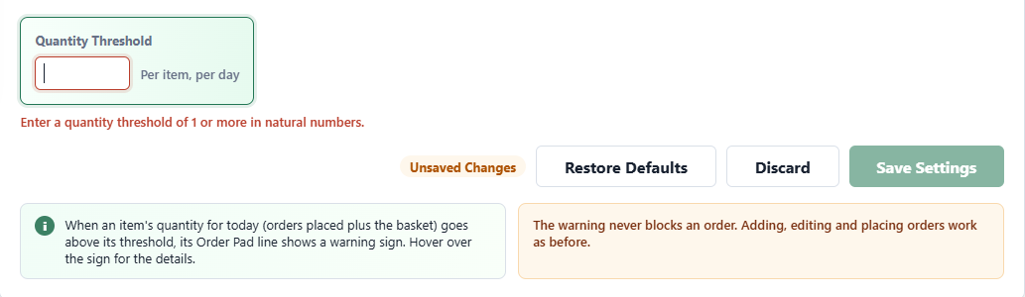
f. Notes - The green info note reads ‘When an item's quantity for today (orders placed plus the basket) goes above its threshold, its Order Pad line shows a warning sign. Hover over the sign for the details.’ The orange note reads ‘The warning never blocks an order. Adding, editing and placing orders work as before.’
5. Product Specific Threshold Requirements
a. Panel - Heading ‘Product Specific Threshold’ with the sub-heading ‘Set a different quantity threshold for selected products. It replaces the general threshold for those products, and still applies when the general threshold is off.’
b. Search - Typing a product name or PIP code in ‘Product’ search box lists up to 12 matching products (Order Pad catalogue and Order History products), each with its PIP code
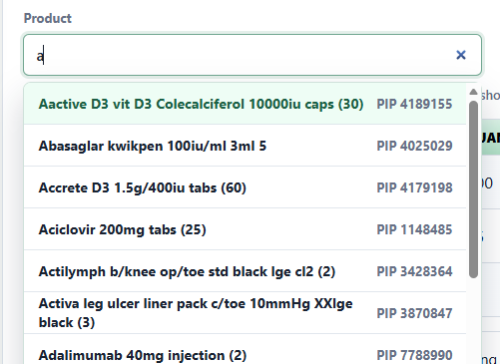
With no match it shows ‘No products found. Try another product name or PIP code.’ Before a product is chosen, the hint reads ‘Type a product name or PIP code, then choose the product to set its own threshold.’
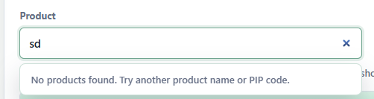
c. Add or Update - Choosing a product shows the ‘Quantity Threshold’ box with Cancel and Save.
- A new product is prefilled with the general value: ‘Prefilled with the general threshold (X). If needed, change it, then save it.’ When the general threshold is off: ‘Prefilled with ‘X’. The general threshold is off, so only products listed below show a warning.’
- A product that already has a threshold shows its own value, the button reads Update, and the hint reads ‘<Product> already has its own threshold. Change it and select Update, or Cancel.’
- Save/Update shows ‘Threshold saved for <Product>: X’ or ‘Threshold updated for <Product>: X’. Cancel clears the selection. Enter key saves any change, works the same as Save.
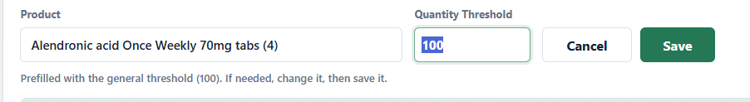
d. List - The table shows Product, PIP Code, Quantity Threshold and Last Changed (‘DD-MM-YYYY - HH:MM:SS’ and ‘by <username>’), with Edit and Remove buttons, sorted by newly added product first. It shows Show 10 entries by default (10, 25, 50 or 100), ‘Showing x to y of z products’ and page buttons; Edit opens the product in the box above. With no products it shows ‘No product-specific thresholds yet. Every product uses the general threshold.’ or ‘No product-specific thresholds yet. The general threshold is off, so no product shows a warning’.
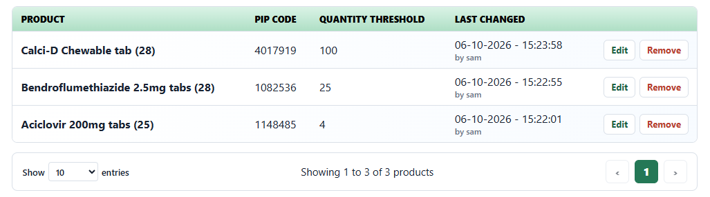
e. Remove - Remove opens ‘Remove threshold?’ with ‘<Product> will use the general threshold again, if it is on.’ Cancel closes it. Remove deletes the row and shows ‘<Product> now uses the general threshold’ (or ‘Threshold removed for <Product>’ when the general threshold is off).
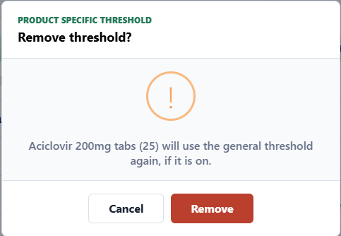
6. Audit Log Requirements
a. Access - Under ‘OPTIONS’, ‘Audit Log’ is shown below Daily Quantity Threshold with one sub-item, ‘Daily Quantity Threshold’.
b. Layout - The screen shows the heading and sub-heading at the top, then the filters, then the history table. The heading and sub-heading follow the selected Type:
- General Threshold: ‘Daily Quantity General Threshold History’ with ‘Every time the general threshold was switched on or off, or its quantity changed. Newest first.’
- Product Specific Threshold: ‘Daily Quantity Product Specific Threshold History’ with ‘Every product-specific threshold that was added, updated or removed. Newest first.’
Below the table, the note reads ‘History entries are added automatically when a threshold is saved or removed. They cannot be edited or deleted.’
c. Filters - ‘START’ and ‘END’ dates and ‘TYPE’ (‘General Threshold’ or ‘Product Specific Threshold’), with Search and Reset buttons.
- Default: the last 7 days (today and the 6 days before) and Type ‘General Threshold’. The Audit Log always opens with the defaults, including when the user returns to it from another item.
- Search: Start, End and Type are applied together only when Search is selected. Changing a filter on its own does not change the table or the heading.
- Reset: returns to the defaults and shows ‘Filters reset’.
- Start after End: Search shows ‘The start date must be on or before the end date.’ and the table keeps its last results.
d. General Threshold History - Columns: ‘Date & Time’ (‘DD-MM-YYYY - HH:MM:SS’), ‘Changed By’, ‘Action’, ‘Status’ and ‘Quantity Threshold’. Action is ‘Switched On’, ‘Switched Off’ or ‘Quantity Changed’; when one saves does both, both are shown (for example ‘Switched On, Quantity Changed’). Status is ‘On’ or ‘Off’ after the change, and Quantity Threshold is the quantity saved by that change.
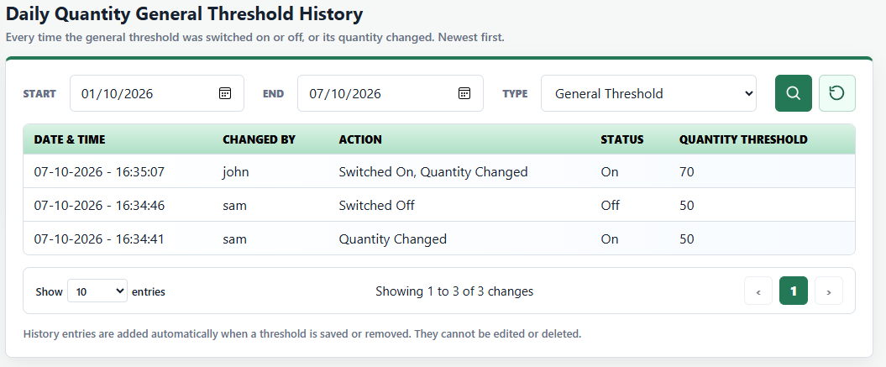
e. Product Specific Threshold History - Columns: ‘Date & Time’, ‘Changed By’, ‘Action’, ‘Product’ and ‘Quantity Threshold’. Action is ‘Added’, ‘Updated’ or ‘Removed’. Quantity Threshold is the quantity saved by that change; for ‘Removed’, it is the quantity the product had when it was removed.
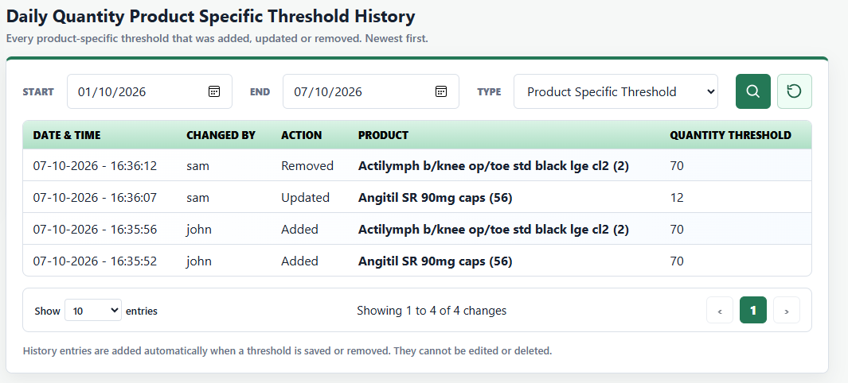
f. Recording - One entry is added each time a threshold is saved or removed, with the date and time and the username signed in through Shift sign-in. Saving with nothing changed adds no entry. Entries are listed newest first, with Show 10 entries by default (10, 25, 50 or 100), ‘Showing x to y of z changes’ and page buttons. With no entries for the selected filters it shows ‘No changes found for the selected dates.’
7. Validation Requirements
Area | Validation
Default | General threshold On at 100 per item, per day, with no product-specific thresholds. In the wireframe, a new session or a page refresh returns to the default.
Quantity | A natural number of 1 or more. Empty, 0, negative or decimal values show ‘Enter a quantity threshold of 1 or more, in natural numbers.’ and Save stays disabled. The general box is not checked while the switch is Off.
Threshold used | A product's own threshold always comes first, whether the general threshold is on or off. Otherwise, the general threshold is used while it's on. If neither is set, no warning is shown.
Quantity today | Quantity received today from Order History orders (out-of-stock quantities do not count) + the quantity of that product in the basket (all lines with the same PIP code).
Warning shown | Only when the quantity today is above the threshold. A quantity equal to the threshold (for example 100 of 100) shows no warning.
Last Changed | ‘by’ shows the username signed in through Shift sign-in.
Audit Log | Start and End are inclusive, and Start must be on or before End. Entries are added only for saved changes and cannot be edited or deleted. In the wireframe, the history lasts for the session; a page refresh clears it along with the thresholds.
8. Order Pad Requirements
a. Warning Sign - When an item's quantity today is above its threshold, a yellow warning sign is shown after the product name and any existing tags (CD, FRIDGE, HIGH VALUE). The sign is always the last tag.
b. Message - Hovering over, tabbing to or clicking the sign shows the message straight away: ‘Quantity today: X (Y ordered + Z in basket). Above the daily quantity threshold of N (Edit in Settings).’ The ‘ordered + in basket’ split is shown only when some was ordered earlier today; otherwise, it reads ‘(in basket)’. For a product-specific threshold it reads ‘Quantity today: X (Y ordered + Z in basket). Above this product's daily quantity threshold of N (Edit in Settings)’. The message closes when the mouse leaves, on Escape, on scroll or on a click elsewhere. Clicking the sign does not open Edit Product.
Example 1 (general threshold): Metformin MR 1000mg tabs (56) – 10 ordered earlier today + 95 in basket = 105, above the general threshold of 100.
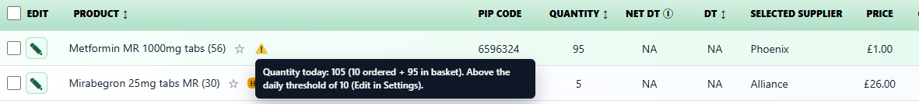
Example 2 (product-specific threshold): Angitil SR 90mg caps (56) has its own threshold of 20 – 32 in basket. The sign is shown after HIGH VALUE.
c. Review Before Placing Order - When at least one basket line shows the warning sign, ‘Review before placing order’ popup lists it under ‘This order contains products requiring attention:’ as the last row. The row shows the warning sign and ‘N Above Daily Quantity Threshold’, where N is the number of basket lines showing the sign.
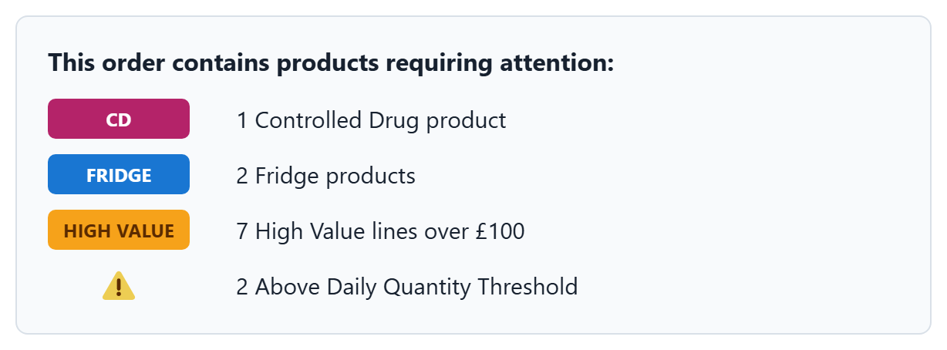
- Hovering over the sign shows ‘Daily quantity threshold — today's quantity (ordered + in basket) is above the threshold, edit in Settings.’
- If the warning is the only thing needing attention, the popup still opens as ‘Review before placing order’ with Review Basket and Place Order.
- If no line shows the warning sign, the row is not shown.
d. Live Update - The sign updates as soon as a basket quantity changes (quantity edit, product added or line removed) and when the threshold is changed in Settings. After an order is placed successfully, its quantities count towards today's totals.
e. No Blocking - The warning never blocks an order. Adding, editing and placing orders work as before.
f. Hover Messages - All hover messages in Order Pad now appear immediately in a dark, round edge message box with white text, replacing the browser's default white rectangular tooltip.
