Functional Requirements: Out of Stock Place Order
This document defines the functional requirements for placing orders from the ‘Out of Stock’ page and how those orders are shown in Order History, Order Report and Order Exceptions Report. Products, prices, names and orders shown in the wireframe are sample data only.
1.Background – Why This Change
Before this change, ‘Add To Order’ on the Out of Stock page did not place an order:
- Selected lines were moved to the Pending Orders page and stayed there until a user opened that page and clicked ‘Submit Orders’. Until then, the lines were not ordered.
- Each ‘Add To Order’ added the lines to the order basket again, creating duplicate entries for the same product.
2. Purpose
- Let users reorder out-of-stock lines directly from the Out of Stock page with ‘PLACE ORDER’.
- Show only one Out of Stock entry per product, always with the latest order information.
- Return lines that are still unavailable to the Out of Stock page under the new order ID.
- Show every placed order the same way in Out of Stock, Order History, Order Report and Order Exceptions Report.
3. Scope
The scope covers the Out of Stock page, the order details in Order History, the Order Report and the Order Exceptions Report. Orders placed from the Order Pad follow the same Out of Stock rules. All other page functions are unchanged.
4. Out of Stock Page Requirements
a. Place Order Button – The ‘Add To Order’ button is renamed ‘PLACE ORDER’. It keeps its position, colour and size next to ‘CLEAR ALL’ in the bottom bar, and ‘Selected Lines Count’ still shows how many lines are selected.
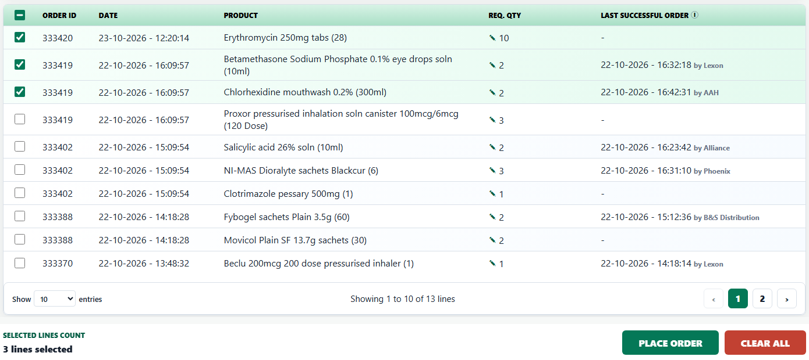
b. Checks Before Placing – Place Order shows a message and does not place the order when:
- No line is selected – ‘Select at least one line to place an order’.
- A Req. Qty edit is still open – ‘Save or cancel the quantity edit first’.
- A selected line has a Req. Qty below 1 – ‘Set a Req. Qty of 1 or more for <product>’.
c. Placing the Order – All selected lines are placed as one new order, each with its saved Req. Qty. While the order is processed the button shows ‘Placing…’ and cannot be clicked.
d. Confirmation – When processing finishes the table refreshes and the message ‘Order placed, check order history’ is shown. The selection is cleared and the table returns to page 1.
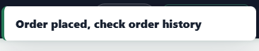
e. Order Outcome – The order is completed by backend processing. Each line is either fulfilled by a supplier or comes back out of stock, and the order status is Completed in both cases.
- Fulfilled lines are removed from the Out of Stock page.
- Lines that come back out of stock are shown as a new entry with the new Order ID, the date and time of the new order and the quantity that was ordered. Last Successful Order shows ‘-’ until a successful order is placed after that time.
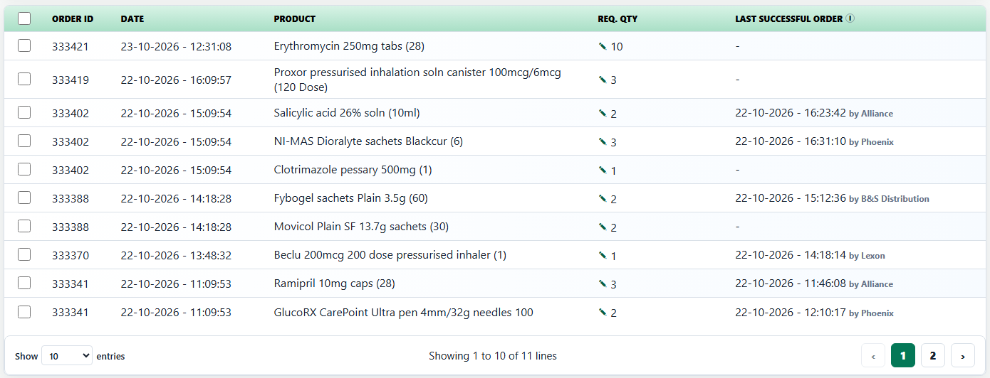
f. One Entry per Product – The page shows only one entry for each product, taken from the latest order that included it, whether that order was placed from the Out of Stock page or the Order Pad.
- If the latest order did not get the product, the entry shows that order’s Order ID, Date and Req. Qty. Older entries for the same product are not shown.
- If the latest order got the product, the product is no longer shown.
- All PIP and supplier-response records of the latest order are still shown as one row.
Time | Action | Result | Out of Stock shows
12:20:14 | Erythromycin 250mg tabs (28) × 10 placed from the Order Pad (order 333420) | Out of stock | One row: 333420, 23-10-2026 - 12:20:14, Req. Qty 10
12:31:08 | Erythromycin placed again from the Out of Stock page (order 333421) | Out of stock | One row: 333421, 23-10-2026 - 12:31:08. The 333420 row is no longer shown.
Later | Erythromycin placed again and fulfilled | Fulfilled | No row for Erythromycin

e. Clear All – Clear All empties the page as before. Lines from orders placed after Clear All are shown as normal. Cleared orders stay in Order History and both reports.
f. Default Dates – Start defaults to 01/10/2026 (sample) and End defaults to today, so lines that come back out of stock today are shown without changing the filter.
5. Order History Requirements
a. New Order – An order placed from the Out of Stock page appears straight away as the newest order at the top of the list, with the next Order ID, the date and time it was placed.
b. Order Details – Order Placed By shows the user signed in through Shift sign-in.
c. Re-ordered from Out of Stock – For orders placed from the Out of Stock page, a small tag, ‘Re-ordered from OOS’, is shown next to the item count under Total Products. The tag stays on the same line as the count, so the summary layout and height do not change;

Hovering over the tag, or moving to it with the Tab key, shows ‘Product is re-ordered from out of stock’ when the order has one product, or ‘Products are re-ordered from out of stock’ when it has more than one. No tag is added to the order list and the original order IDs are not shown.
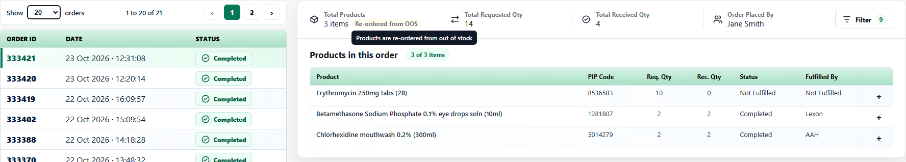
d. Supplier Outcomes – Expanding a line shows each supplier response. A line that came back out of stock lists each supplier tried with Rec. Qty 0, Status ‘Out of stock’ and Comment ‘Out Of Stock’. Price shows ‘-’ where it is not known.
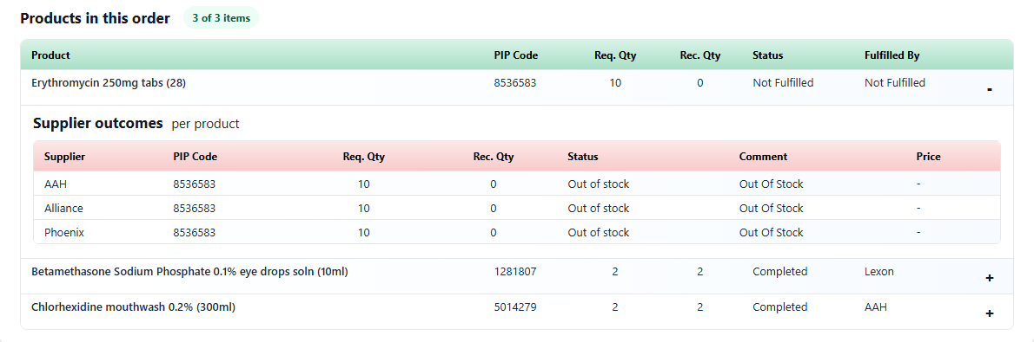
e. Order Pad Orders – An order placed from the Order Pad is shown in the same way, without the ‘Re-ordered from OOS’ tag.
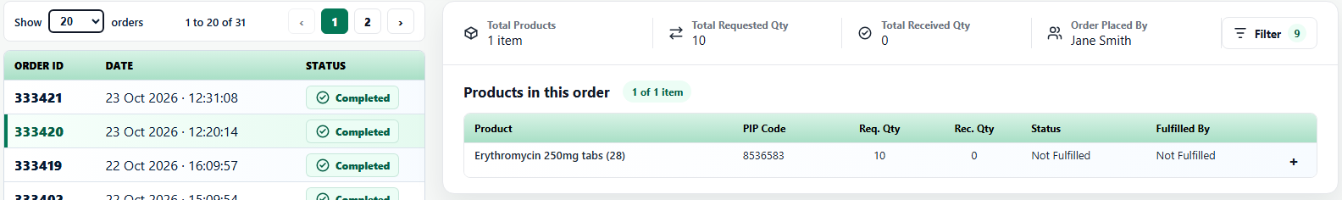
f. Existing Behaviour – Search, filters, status, pagination and export are unchanged.
6. Order Report Requirements
a. Data – The report lists one row per supplier response for every order, newest first, from the same orders as Order History. New orders appear at the top straight away.
b. Columns – Order ID, Date, PIP Code, Product, Supplier Name, Rec. Qty, Req. Qty, Supplier Comment and Order Placed By are unchanged. Order Placed By shows the same user as Order History for that order.
c. Totals and Pagination – Total Requested Qty, Total Received Qty and ‘Showing x to y of z entries’ are calculated from the filtered rows. Page buttons show up to five pages around the current page.
d. Filters and Download – From defaults to 01/10/2026 and To defaults to today. Product matches the product name or PIP code and Supplier matches the supplier name. Reset returns to the defaults. Download exports every filtered row, not just the current page.
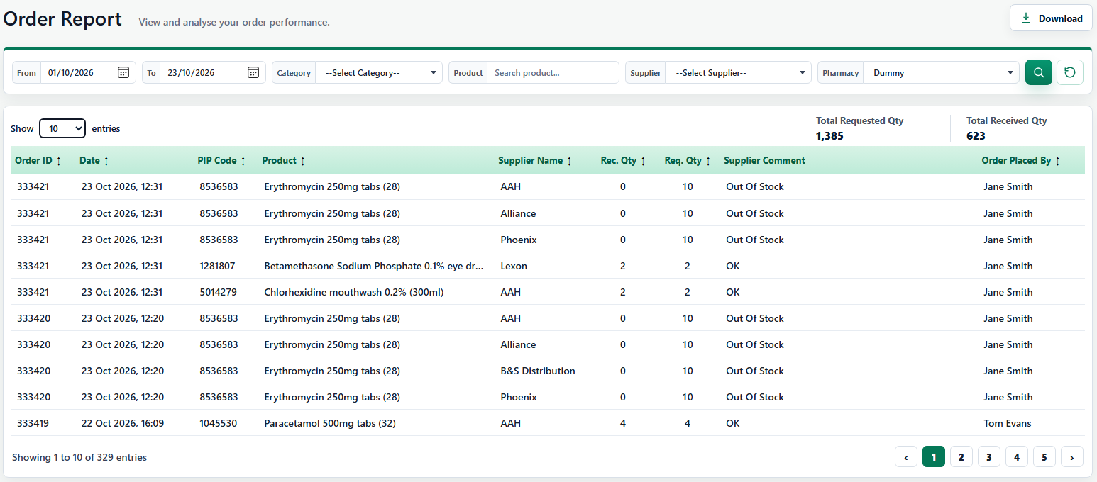

7. Data Consistency Requirements
Area | Rule
Shared orders | Out of Stock, Order History, Order Report and Order Exceptions Report always show the same orders, including orders placed from the Out of Stock page or the Order Pad.
Order ID | A new order takes the next number after the highest existing Order ID (sample: 333420, then 333421).
Date and time | Set when the order is placed. Shown as DD-MM-YYYY - HH:MM:SS on Out of Stock, DD Mon YYYY · HH:MM:SS in Order History and DD Mon YYYY, HH:MM in both reports.
Order status | Completed once processing finishes, whether the lines were fulfilled or came back out of stock.
Order Placed By | The Shift sign-in user when the order was placed; the same value in Order History and Order Report.
Sample data | Sample orders are dated in October 2026 and are all before today. In the wireframe, moving between pages keeps placed orders, and a page refresh returns to the sample data.

