Functional Requirements: Out of Stock and Order Exceptions Enhancements
This document defines the functional requirements for the updated Out of Stock Screen and Order Exceptions report (previously out of stock report) in Cascade Plus.
1. Purpose
- Reduce duplicate Out of Stock rows caused by multiple PIP or supplier-responses for the same order and product.
- A new product filter to search across the complete ‘Out of Stock’ result set and edit Req. Qty without leaving the table.
- Show last successful order activity so the user has an informed reason to retry an out of stock product.
- Renaming the out-of-stock report to Order Exceptions Report and supplier comment column renamed to Reason and changes in filters and grouping reasons.
2. Scope
The scope of this requirement covers the Out-of-Stock page, Reports landing page and Order Exceptions Report page.
3. Out of Stock Page Layout Requirements
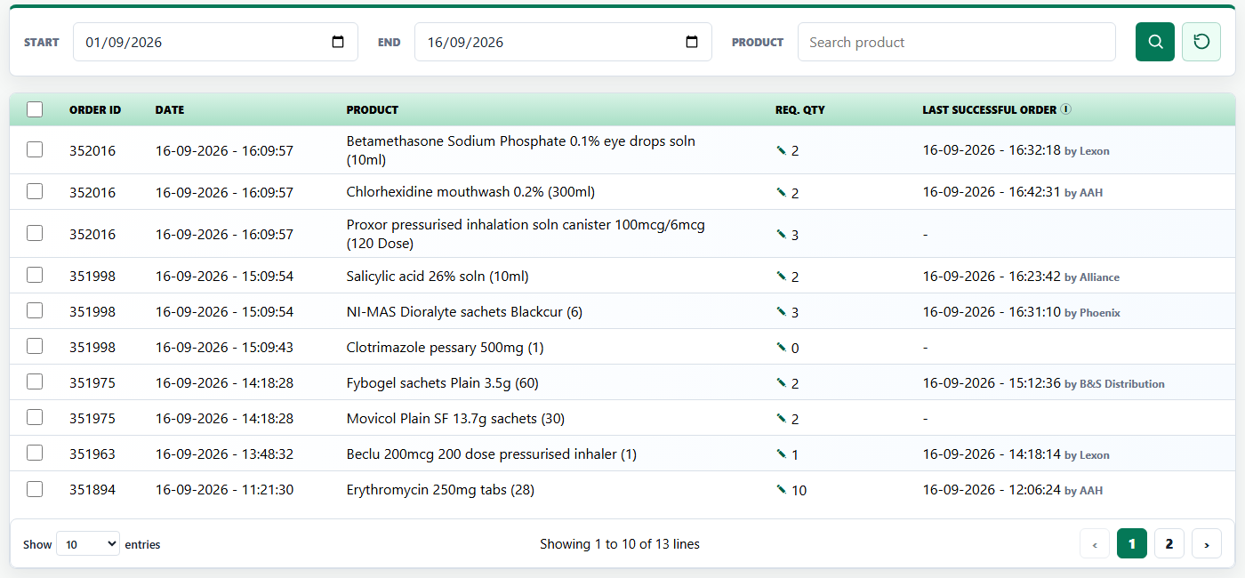
a. Page Access - The existing Out of Stock page must remain available from the current navigation and retain its established theme, fonts, spacing and responsive table container.
b. Visible Columns - The table must display the selection checkbox, Order ID, Date, Product, Req. Qty and Last Successful Order in that order.
c. Removed Columns - The Action heading, PIP Code, Rec. Qty and Status columns must not be displayed anymore.
d. Status Scope - The page must return only out-of-stock items and not Blocked as price above drug tariff. Call supplier.
4. One Logical Row per Order and Product
The Out-of-Stock grid must represent an ordered product line, not each PIP or supplier-response record returned for that line.
a. Logical Key - The system must display one row for each distinct combination of Order ID and product.
b. Example - If Order ID 332613 contains two records for Candesartan 8mg tabs (28) with different PIP codes, the page must show one Candesartan row for Order ID 332613.
Order ID | Product | PIP/Response Records | Visible Rows
332613 | Candesartan 8mg tabs (28) | 2 records with different PIP codes | 1
332613 | Rosuvastatin 15mg tabs f/c (28) | 1 record | 1

5. Product Search Requirements
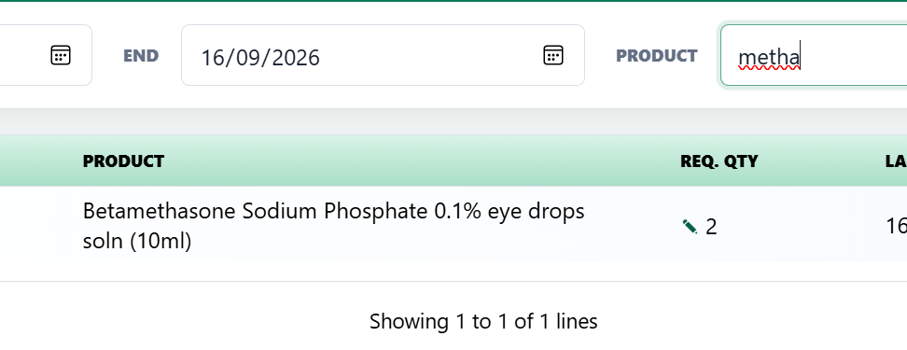
a. Filter Replacement - Product search must occupy the former Status-filter position and must use the existing styling.
b. Contains Matching - Product matching must be case-insensitive and must return a product when the entered characters occur anywhere in the product name. The product result set should update as the user types.
c. Across Pagination - Matching must be performed against the complete filtered Out of Stock dataset before pagination. A match on a later page must be returned even when the user starts on page 1.
6. Inline Req. Qty Editing
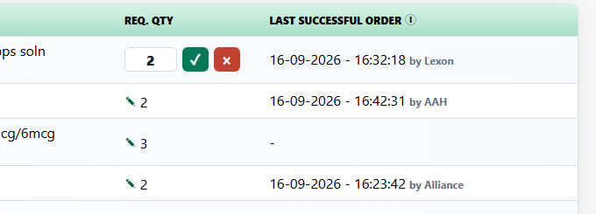
a. Edit Quantity - The pencil icon appears just before the Req. Qty number. Clicking it opens a small quantity edit box in the same row, with a green tick to save and a red X to cancel.
b. Enter Quantity - Users can enter a Real number of 1 or more. The box must be wide enough to clearly show at least three digits without truncation.
c. Save or Cancel - The green tick saves the new quantity. The red X cancels the edit and keeps the previous quantity.
d. Keep the Layout Stable - Editing must not move the quantity, other columns, or the table layout. The tick and X appear to the right of the number box.
e. One Edit at a Time - Only one row can be edited at once. The saved quantity must be used when the line is added to the order.
7. Last Successful Order Requirements
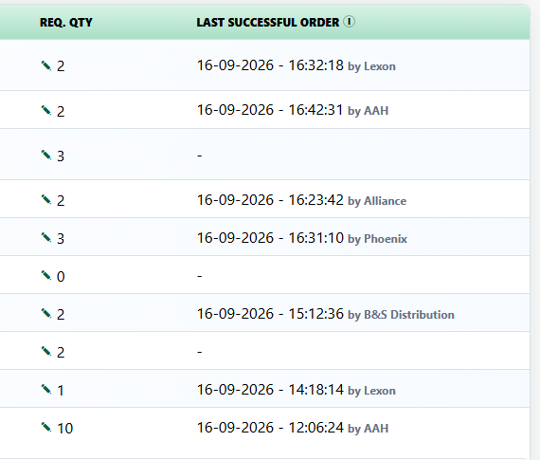
Last Successful Order - shows that a pharmacy recently ordered the same product successfully on cascade plus. It is only a helpful indication that stock may be available; it does not guarantee stock or automatically select a supplier.
Last Successful Order Selection Rule
- Match the same product as the Out of Stock row.
- show date and time information only if orders recorded as successful.
- The successful-order time must be later than the exception order time and not later than the current time.

a. Column Placement - Last Successful Order must appear immediately after Req. Qty and must contain the timestamp and supplier, who fulfilled the latest qualifying successful order.
b. Dynamic Refresh - The value must be retrieved from live order history of all customers whenever the page is loaded or refreshed.
c. Cross-User Evidence - A qualifying successful order may have been placed by any Cascade Plus user. The successful order does not have to belong to the current user.
d. Supplier Scope - The displayed supplier may be any supplier, who fulfilled successful order and does not have to be configured for the current user.
e. Display Format - A populated value must show the date and time followed on the same line by by and the supplier name, format - dd-mm-yyyy – hh:mm:ss by supplier. For example 16-09-2026 - 16:32:18 by Lexon.
f. No Qualifying Order - If no qualifying successful order exists, the cell must display a single hyphen (-).
g. Information Icon - An uppercase I information icon must appear directly after the Last Successful Order heading. Mouse hover and keyboard focus on the information icon must display: ‘Recently ordered elsewhere from this supplier. Stock availability not guaranteed’.
8. Reports Landing Page Requirements
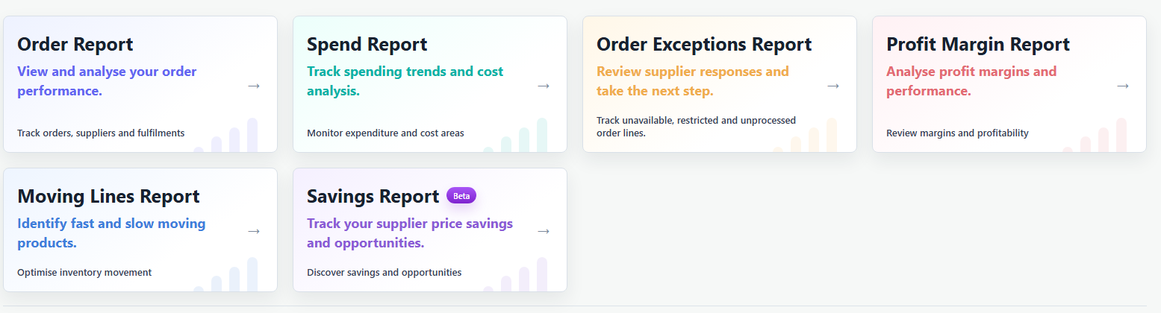
a. Out of stock report renamed - Selecting the Order Exceptions Report card must open the existing ‘out of stock report’ page now presented as ‘Order Exceptions Report’.
b. Report Card Titles - The new report-card titles must be Spend Report, Order Exceptions Report, Profit Margin Report and Moving Lines Report. Existing Order Report and Savings Report titles remain unchanged.
c. Order Exceptions Card Subheading - The Order Exceptions Report card must display: ‘Review supplier responses and take the next step.’
d. Order Exceptions Supporting Text - The Order Exceptions Report card must display: ‘Track unavailable, restricted and unprocessed order lines.’

9. Order Exceptions Report Page Layout
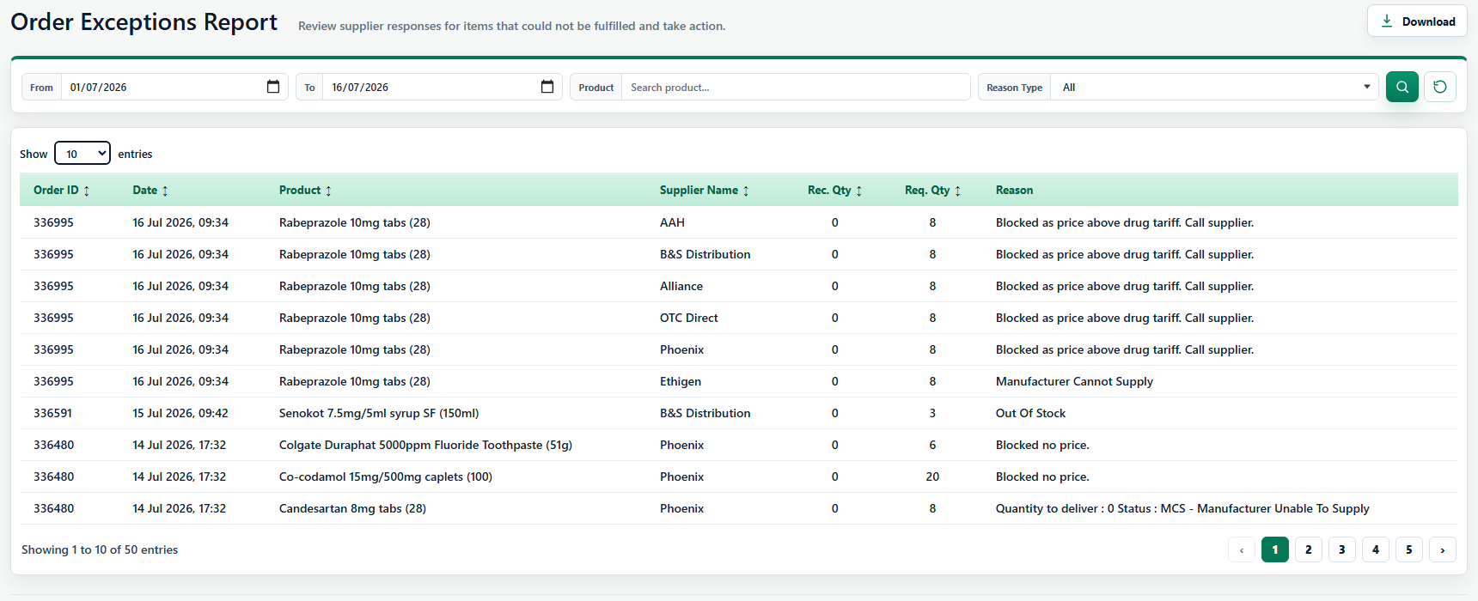
a. Page Heading - The page heading must be Order Exceptions Report.
b. Page Subheading - The page subheading must be: ‘Review supplier responses for items that could not be fulfilled and take action.’
c. Category Filter Removed - The Category filter is removed. Product filter must move into the position previously occupied by Category without losing its existing search behaviour.
e. New Reason Type Placement - Reason Type must occupy the position to the right of Product filter and use the existing dropdown styling, font, dimensions and arrow behaviour.
f. Reason Column - The Supplier Comment column heading must be renamed Reason. The underlying response text in each row must remain unchanged.

Reason Type Option | Records Included | Business Rule
All | Every reason | Default option. Equivalent to no Reason Type restriction.
Blocked By System | Blocked as price above drug tariff. Call supplier.; Blocked no price. | Include either of the two named system-blocked reason groups.
Manufacturer Cannot Supply | Every record included by All except records in Blocked By System | Defined as default excluding Blocked By System; it is not limited to text that literally says Manufacturer Cannot Supply.

10. Reason Type Filter Requirements
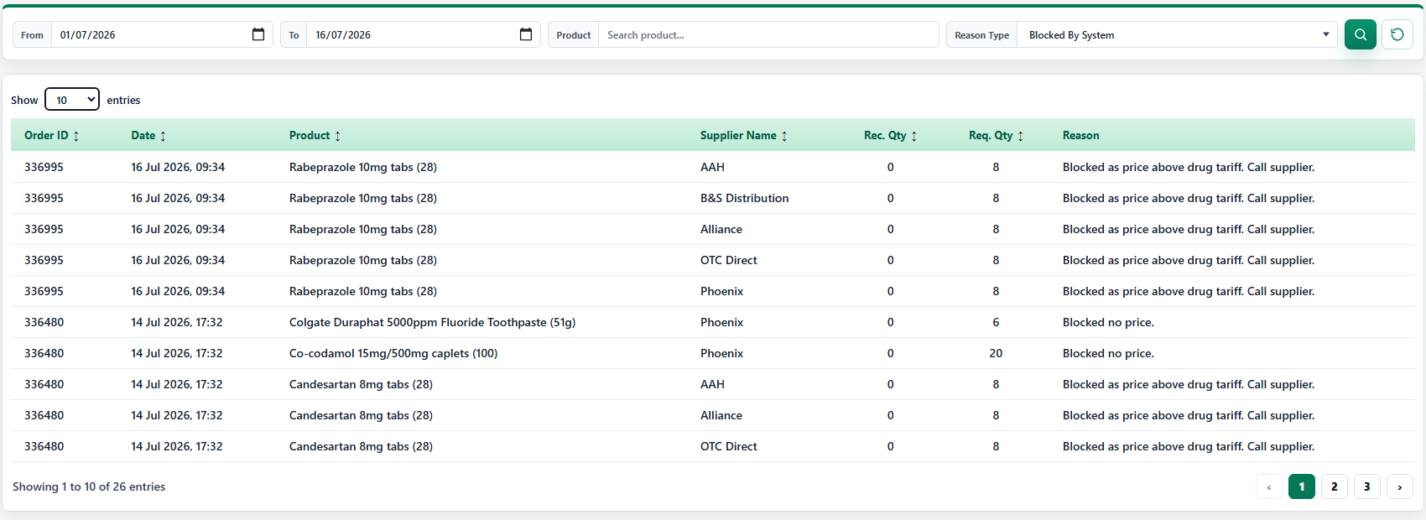

a. Default - Reason Type must default to All when the page opens.
b. Blocked Classification - Blocked by System must include both ‘Blocked as price above drug tariff. Call supplier’ and ‘Blocked no price’ across the complete filtered result set.
c. Manufacturer Classification - Manufacturer Cannot Supply must include all non-blocked reasons, including unavailable, out-of-stock and other supplier responses.
11. Download Requirements
a. Excel file Header - The existing out-of-stock-report Excel file download must rename the Supplier Comment column header to Reason.

