Functional Requirements: Drug Tariff Price Override
This document defines the functional requirements for Drug Tariff (DT) Price Override requirements. It covers the ‘Override Drug Tariff’ option on the Settings page (with its Audit Log entry), Order Pad and Order History. Products, prices, names and orders shown in the wireframe are sample data only.
1. Purpose
- Let the pharmacy allow supplier prices up to a set percentage above Drug Tariff.
- Apply one override limit to every product in Order Pad.
- Clearly show which prices are allowed only because of the override.
- Record every change to the limit, with when and who changed it.
2. Scope
The scope covers the Override Drug Tariff option and its Audit Log entry on the Settings page, supplier selection and tags, indicators in Order Pad (Order Basket, Edit Product and Review before placing order), and the override tag in Order History. All other page functions are unchanged. Icon tags on basket lines, the Order Basket legend, their hover messages and the icons in Review before placing order.
3. Settings Requirements
a. Access – ‘Override Drug Tariff’ is part of the Settings page under MORE, it opens from the Settings OPTIONS list, or from the ‘DT OVERRIDE’ chip in the Order Basket (section 6e).
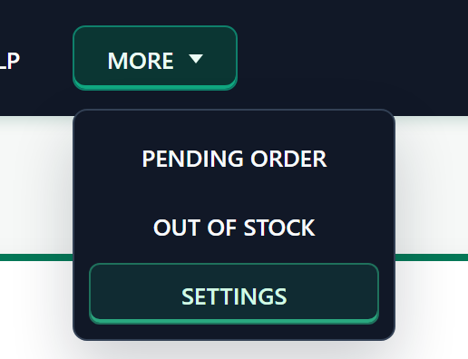
b. Layout - In the left OPTIONS list, ‘Override Drug Tariff’ sits between Smart Quantity Recommendations and Audit Log (Smart Quantity Recommendations, Override Drug Tariff). It has no sub-items; opening it minimises all other groups, and it shows the green bar on the left while selected.
c. Override Drug Tariff - The heading ‘Drug Tariff Price Override’ and sub-heading ‘Allow supplier prices up to a set percentage above Drug Tariff.’ sit above the green-topped panel. Under ‘Override Limit Above Drug Tariff’ the user chooses one of six tiles: Off (default), +5%, +10%, +15%, +20% or Other (user defined). The selected tile is outlined in green and the saved tile shows ‘CURRENT’. No status chip is shown.
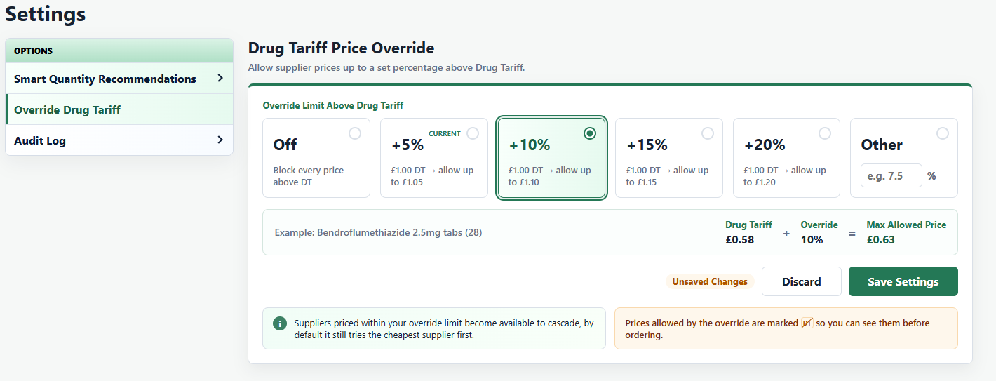
d. Example - The example strip shows Drug Tariff + Override = Max Allowed Price for Bendroflumethiazide 2.5mg tabs (28), DT £0.58 (for example, +10% = £0.63). It updates as the selection changes and shows ‘–’ while the Other value is invalid.
e. Discard and Save - Any change from the saved value shows the ‘Unsaved Changes’ tag and enables Discard and Save Settings. Discard returns to the saved value and shows ‘Changes discarded’ and disables Discard and Save Settings. Save Settings stays disabled while the Other value is invalid.
f. Keyboard - When Override Drug Tariff opens, the cursor is on the current selection (Off by default). ‘←’ moves to the previous tile and ‘→’ to the next, wrapping between Off and Other; moving onto Other puts the cursor in its box. Enter should works the same as Save Settings; with no change it does nothing.
g. Save Confirmation - Save Settings opens ‘Save override setting?’. For a value above 0 it shows a warning icon, ‘Suppliers priced up to X% above Drug Tariff will be allowed for every product.’ and the required tick box ‘I understand orders may be placed at prices above Drug Tariff, up to this limit.’ For Off it shows ‘Every supplier priced above Drug Tariff will be blocked again.’ with no tick box.
- Confirm is selected by default (green outline). ← selects Cancel, → selects Confirm and Enter acts on the selected button. Space ticks or unticks the box.
- Until the box is ticked, Confirm is greyed out and does nothing and only Cancel works. For Off, Enter on Confirm saves straight away.
- On Confirm the value is saved, an Audit Log entry is added, ‘CURRENT’ moves to the new tile and ‘Override saved: +X% above Drug Tariff’ or ‘Override turned off’ is shown. After Confirm or Cancel the cursor returns to the selected tile.
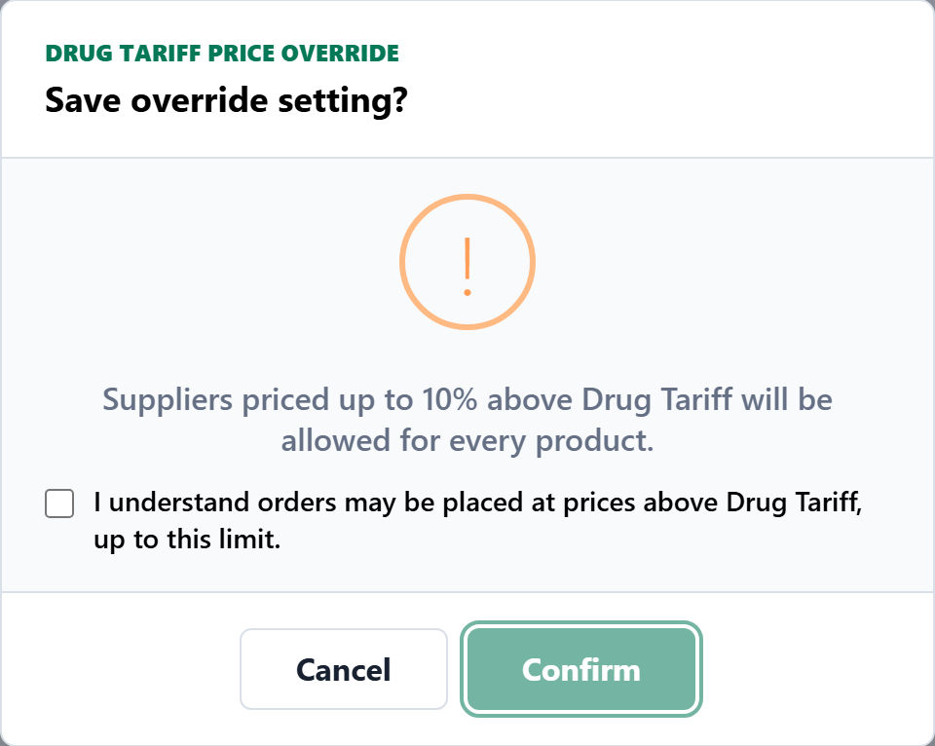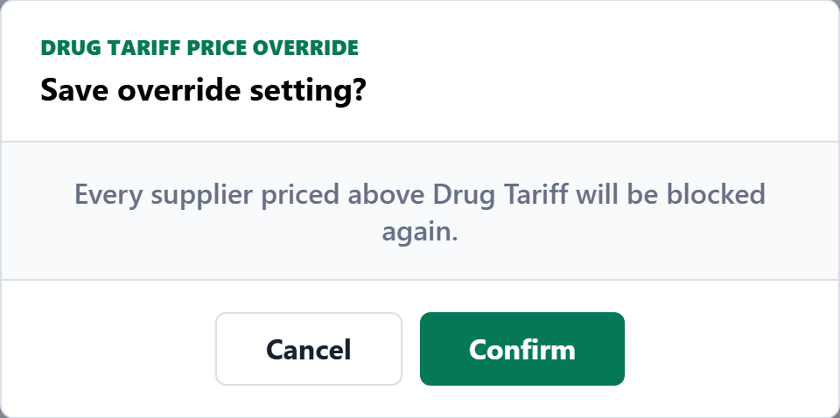
h. Unsaved Changes - Opening another option, or leaving the page and returning with Back, discards unsaved changes. Override Drug Tariff always comes back showing the saved setting.
i. Notes - The green info note reads ‘Suppliers priced within your override limit become available to cascade, by default it still tries the cheapest supplier first.’ The orange note reads ‘Prices allowed by the override are marked  so you can see them before ordering.’
4. Audit Log Requirements
a. Access - Under Audit Log, Override Drug Tariff is the second sub-item, after Smart Quantity Recommendations.
b. Display - The heading ‘Override Change History’ and sub-heading ‘Every change to the Drug Tariff price override, newest first.’ sit above the green-topped panel. The table lists every saved change, newest first, with ‘Date & Time’ (DD-MM-YYYY - HH:MM:SS), ‘Changed By’ (signed-in username) and ‘Override DT Limit’ (+X% or Off, as plain text in the same font and colour as the other columns). With no changes it shows ‘No changes yet.’
c. Pagination - Show 10 entries by default (10, 25, 50 or 100), ‘Showing x to y of z changes’ and page buttons. Saving a new change returns to page 1.
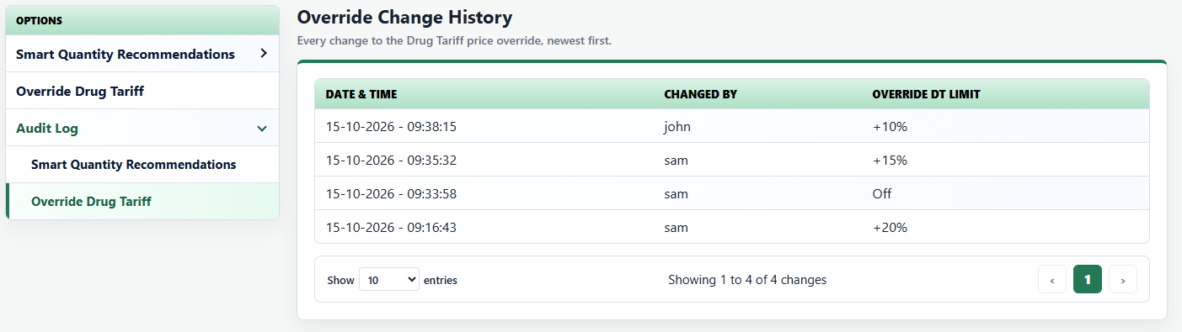
5. Validation Requirements
Area | Validation
Default | The override is Off (0%) until a user saves another value. In the wireframe, a new session or a page refresh returns to Off.
Max allowed price | Drug Tariff + override %, rounded down to the penny. Example: £0.65 + 10% = £0.715, so the max allowed price is £0.71. With Off, the max allowed price is the Drug Tariff.
Other % | 1 to 50, in steps of 0.5 (for example 7.5). Values such as 0.3, 60 or 7.3 show ‘Enter a percentage from 1 to 50, in steps of 0.5 (for example 7.5).’ and Save Settings stays disabled. An empty box disables Save with no message. Typing in or clicking the box selects Other. The mouse wheel must not change the value. The arrow keys in the box move between tiles.
Supplier price | At or below DT: normal and selectable. Above DT but within the max allowed price: selectable and marked OVERRIDE. Above the max allowed price: blocked (cannot be selected, red price, no hover message). Products with no Drug Tariff are unchanged.
DT OVERRIDE hover | Every DT OVERRIDE tag (Order Basket, Edit Product, Review before placing order, Order History) shows the same message, ‘Override — Above Drug Tariff rate, allowed by price override’, only when hovering over the tag itself, with no percentage.
Audit user | Changed By is the username signed in through Shift sign-in.
6. Order Pad Requirements
a. Override Off (Default) - Every supplier priced above Drug Tariff is blocked in Edit Product: greyed out, cannot be selected, red price, with no hover message. If all suppliers are blocked, it works as before. No OVERRIDE tags or PRICE OVERRIDE chip are shown, but the price legend is always shown.
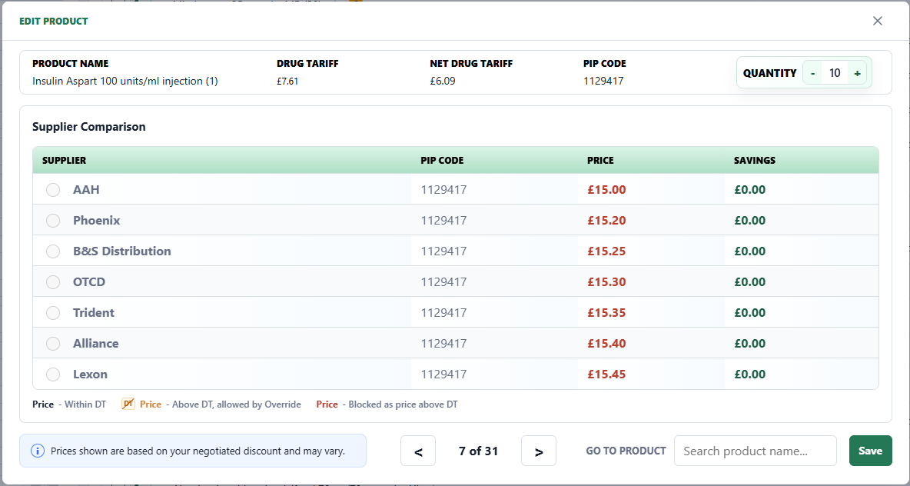
b. Override Set - Suppliers up to the max allowed price become selectable and are included in Best Price and cascade; the cheapest selectable supplier is still chosen first by default. Suppliers above the max allowed price stay blocked, with no hover message.

c. Edit Product Indicators - When an override is set, Edit Product shows the chip ‘PRICE OVERRIDE +X% | Max allowed £x’, an ‘DT OVERRIDE’ tag and orange price for suppliers allowed by the override, and red prices for blocked suppliers. The legend always reads ‘Price - Within DT’, ‘OVERRIDE Price - Above DT, allowed by Override’ and ‘Price - Blocked as price above DT’. Hovering over the OVERRIDE tag on current row shows ‘Override — Above Drug Tariff rate, allowed by price override’. Savings are calculated from the highest allowed price (logic is same as before), and blocked rows show £0.00.
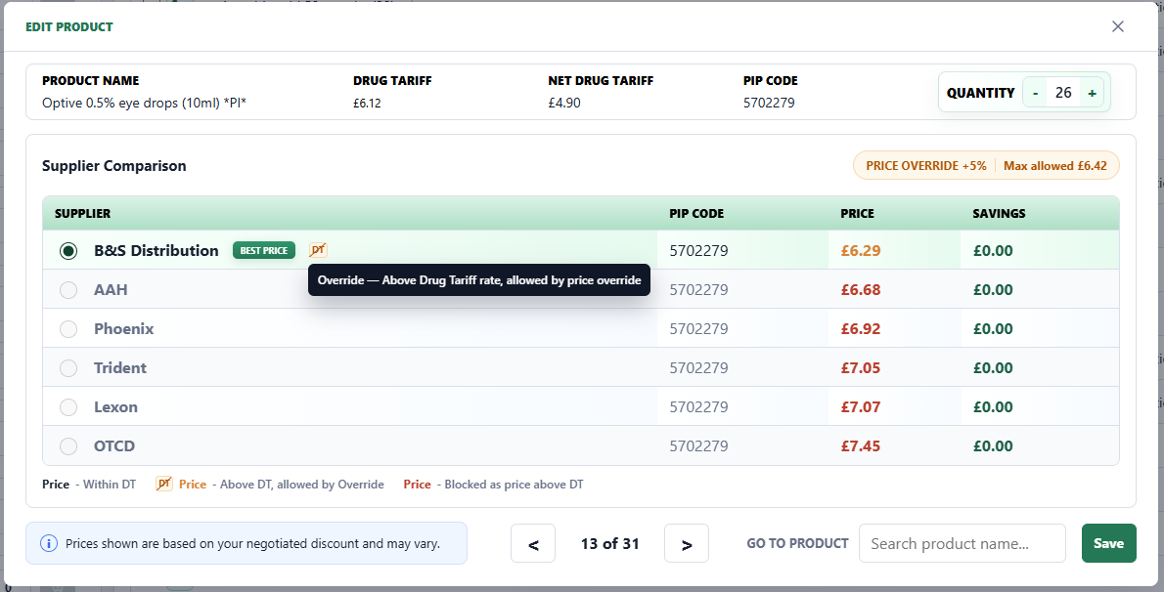
d. Popup Position - The Edit Product popup keeps a fixed bottom edge (where a popup with 7 suppliers is centred), so the ‘info note’, ‘<’, ‘>’, ‘Go to product’ and ‘Save’ stay in place. Only the top edge moves as the number of suppliers changes. On small screens the popup fills the screen as before. Enter saves the supplier and any quantity changes, the same as the Save button.
e. Order Basket - A ‘DT OVERRIDE’ chip is always shown next to ORDER BASKET: ‘DT OVERRIDE OFF’ (grey) by default, or ‘DT OVERRIDE +X% (amber)’. A settings (gear) icon sits before the text, in the same colour as the text, so users can see the chip leads to Settings. Selecting it opens Settings on Override Drug Tariff.
f. Basket Layout - Selected Supplier is left-aligned like Product. Product uses the spare width and the other columns are evenly spaced. B&S is shown as ‘B&S Distribution’, and long Best Price values wrap instead of being cut off.
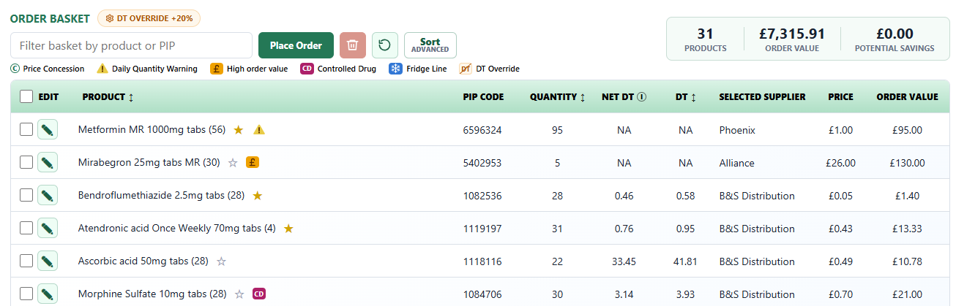

When a line's selected supplier is allowed only by the override, an DT OVERRIDE tag icon is shown after any existing tags (for example HIGH VALUE then OVERRIDE) and before the daily quantity limit warning sign, which is always last. Hovering over the tag shows ‘Override — Above Drug Tariff rate, allowed by price override’ straight away in the dark, round-edged message box.

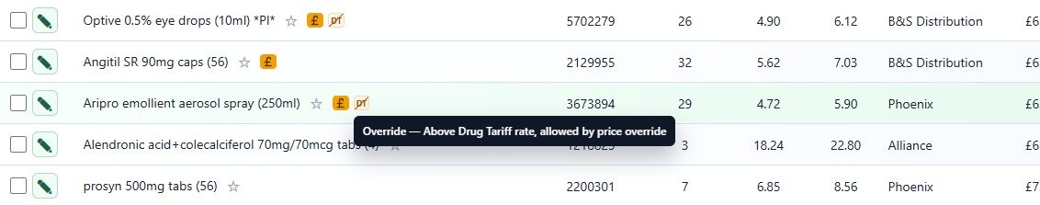
h. Review Before Placing Order - When at least one basket line shows the DT OVERRIDE tag, the popup lists an OVERRIDE row under ‘This order contains products requiring attention:’ as the second-last row (before the daily quantity limit warning sign).
- The row reads ‘N Above Drug Tariff, allowed by override’, where N is the number of basket lines showing the tag.
- The tag has the same size and font as the Order Basket OVERRIDE tag. Hovering over it shows ‘Override — Above Drug Tariff rate, allowed by price override’.
- If OVERRIDE is the only thing needing attention, the popup still opens as ‘Review before placing order’ with Review Basket and Place Order. With no OVERRIDE lines (or the override Off), the row is not shown.

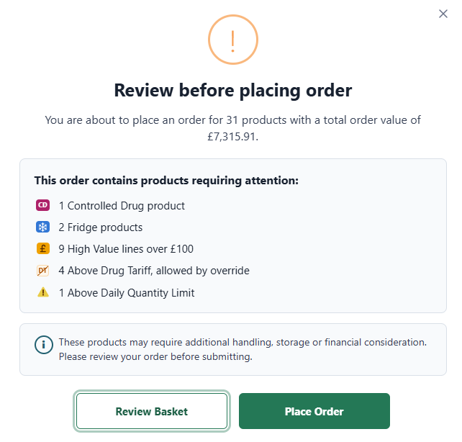
7. Order History Requirements
a. Override Tag - When an order line was fulfilled by a supplier allowed only by the override, ‘Fulfilled By’ shows the supplier with an ‘DT OVERRIDE’ tag icon, and the same tag icon is shown in that line's Supplier outcomes. The tag is shown only while an override is set and line order is successful. Hovering over it shows ‘Override — Above Drug Tariff rate, allowed by price override’ (black background box with white text with rounded edges; same as in order pad)
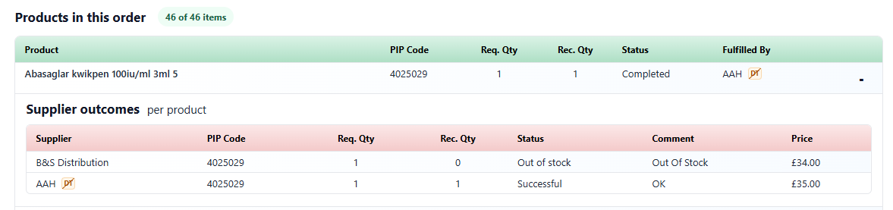
b. Existing Behaviour - Search, filters, status, Order Placed By, pagination and export are unchanged.
8. Changes – Icons, Legend and Hover Messages
a. Icon Tags on Basket Lines - The text tags on basket lines are replaced by small icons, so each line needs less width in the Product column. Each icon is a round edged box (the warning sign has no box around it), the Daily Quantity Warning sign, which is always last.
- CD – ‘CD’ in white on a magenta box(#b42369) (was the ‘CD’ text tag).
- Fridge – a white snowflake on a blue box (#1976d2) (was ‘FRIDGE’).
- High Value – ‘£’ on an orange box (#f6a21a) (was ‘HIGH VALUE’).
- DT Override – ‘DT’ with a thin diagonal line from corner to corner, in amber on a light-amber box (#b45309). Edit Product and Order History use the same DT icon.
- Daily Quantity Warning – a yellow warning triangle with a dark ‘!’ and no box (unchanged).
b. Order Basket Legend - A legend under the basket filter shows every icon followed by its name: Price Concession (C), Daily Quantity Warning, High order value, Controlled Drug, Fridge Line and DT Override. The legend is always shown and wraps onto a second line when there is not enough width. All the legend icons, font and style and size should be similar.
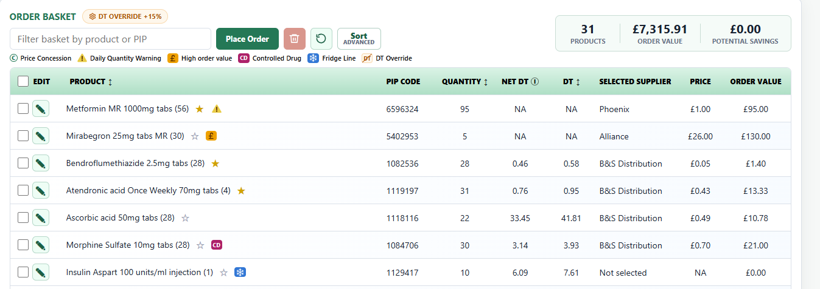
c. Legend Hover Messages - Hovering over the icon or the name (or moving keyboard focus to it) shows its message straight away in the dark, round-edged message box:
- Price Concession – ‘C — Price Concession active for this month’
- Daily Quantity Warning – ‘Daily Quantity Warning — As per daily quantity limit set in Smart Quantity Recommendations in Settings’
- High order value – ‘High Value line — quantity multiplied by the selected unit price exceeds £100.’
- Controlled Drug – ‘Controlled Drug — additional handling and compliance controls may apply.’
- Fridge Line – ‘Fridge line — temperature-controlled storage and transport may apply.’
- DT Override – ‘Override — Above Drug Tariff rate, allowed by price override in Settings’
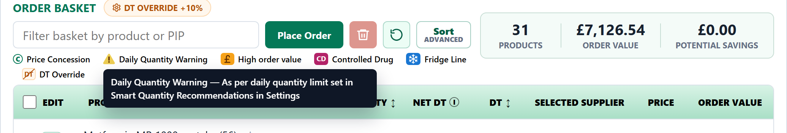
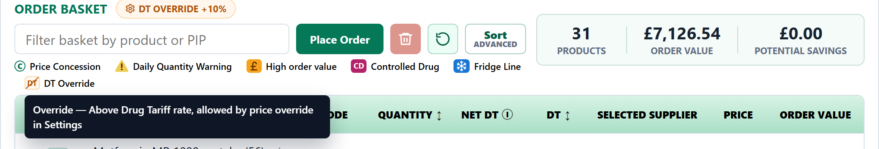
d. Basket Line Hover Messages - Hovering over an icon on a basket line shows the same message as its legend entry, with two exceptions:
- DT Override shows ‘Override — Above Drug Tariff rate, allowed by price override’ .
- The Daily Quantity Warning sign shows that line's own quantities, for example ‘Quantity:105 (10 ordered + 95 in basket). General Limit 100 per day. Warning only, can be edited in Settings.’ It reads ‘Product specific Limit’ when a product limit is set.
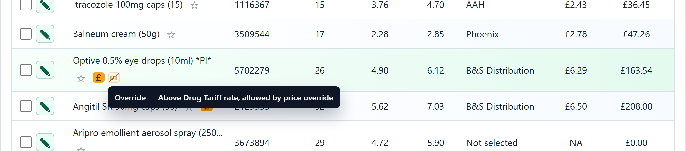
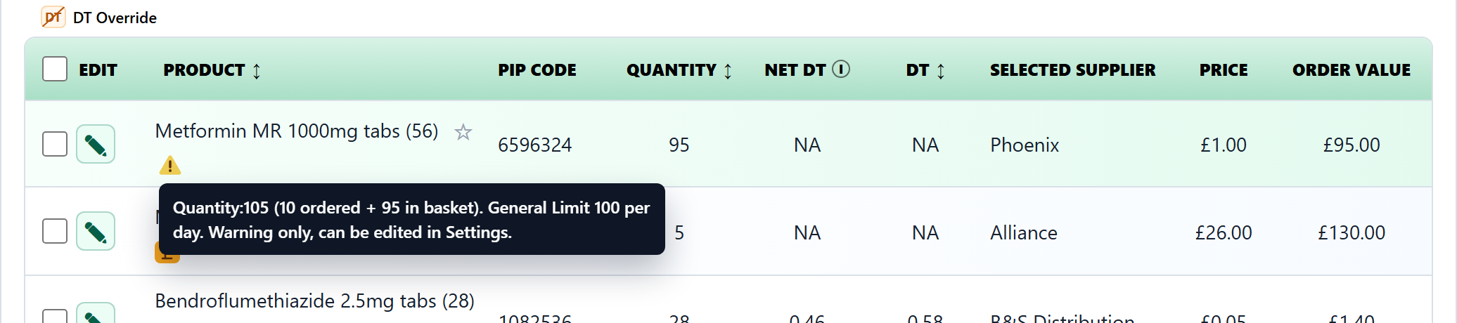
e. Review Before Placing Order - The rows under ‘This order contains products requiring attention:’ now show the same icons as the basket lines and the legend, at the same size. The row text and row order are unchanged for CD, Fridge, High Value, DT Override, and except the Daily Quantity Warning last.
- Rows read ‘N Controlled Drug product(s)’, ‘N Fridge product(s)’, ‘N High Value line(s) over £100’, ‘N Above Drug Tariff, allowed by override’ and ‘N Above Daily Quantity Limit’.
- The hover messages are unchanged. CD, Fridge and High Value show the same messages as on the basket lines, and DT Override shows ‘Override — Above Drug Tariff rate, allowed by price override’. The warning sign shows ‘Daily quantity limit — quantity (ordered + in basket) is above the daily set limit. Warning only, edit in Settings.’
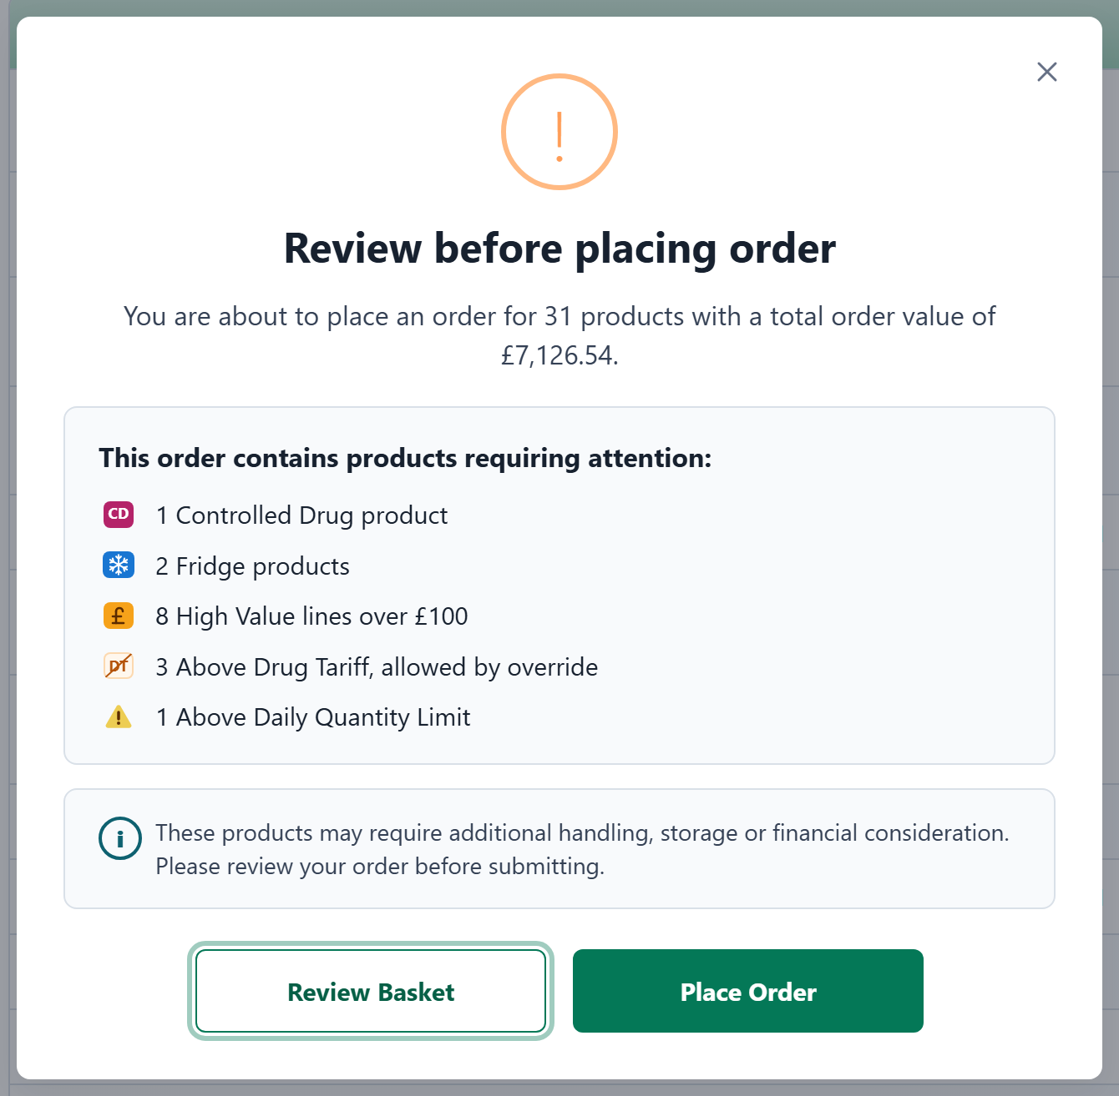

f. Favourite Star Position - On a basket line, the add to favourites star (☆) always sits directly after the product name, before the icons. It stays next to the product name whatever the columns or layout, for example when the Best Price column is shown or a long product name wraps.

