Functional Requirements: Supplier Lock
This document defines the functional requirements for Supplier Lock. Products, prices, names and orders shown in the wireframe are sample data only.
1. Purpose
- Let the pharmacy user lock a supplier so the Order Pad never selects or cascades to it.
- Let a lock apply from when it is saved, between two dates and times, or on chosen days every week.
- Clearly show locked suppliers in the Order Pad, Order History and Reports.
- Show the customer’s locks in the admin portal, let admin unlock them, and record every change with when and who changed it.
2. Scope
The scope covers the Supplier Lock option and its Audit Log entry on the Settings page, the Supplier Lock chip and cascade in Order Pad, locked suppliers in Edit Product, supplier outcomes in Order History, the Order Exceptions Report and Order Report, the Suppliers tab of Customers in the admin portal, and the Settings icon in the top navigation bar. All other page functions are unchanged.
3. Settings Requirements
a. Access – ‘Supplier Lock’ is part of the Settings page. It opens from the Settings OPTIONS list, or from the Order Basket chip. In OPTIONS it sits after Override Drug Tariff and before Audit Log, has no sub-items and shows the green bar on the left while selected.

b. Layout – The heading ‘Supplier Lock’ and sub-heading ‘Lock a supplier so the Order Pad never cascades to it. Switch a lock on, then optionally schedule when it applies. Changes apply once saved.’ sit above the green-topped panel. The table lists every supplier configured for the pharmacy with the columns Supplier, Status, Lock and Schedule. With no suppliers it shows ‘No suppliers are configured for this pharmacy.’
c. Status – Shows the saved lock, i.e. what the Order Pad applies now: ‘Locked’ while a lock is in force, ‘Scheduled’ when a lock starts later, and ‘Available’ when there is no lock or it has ended. The status is checked again every 30 seconds while the page is open.
d. Lock and Schedule – The Lock switch is Off by default and the Schedule column reads ‘Not locked’. Switching it on shows the Schedule button and the schedule summary; with no schedule the lock reads ‘Until switched off’ and starts when saved. Schedule opens a panel under the row with two options:
- Set time range – lock from a start date and time to an end date and time. Times are in 15-minute steps (24-hour clock).
- Recurring – start date, start time, end time, the ‘Repeat on’ day circles (M T W T F S S) and ‘Until’. It opens on today’s weekday, 09:00 to 17:00, until six months later; the end date can be removed (bin icon) or added again (‘Add end date’).
- Selecting the chosen option again clears it, back to ‘Until switched off’. A sentence under the panel describes the lock, for example ‘Phoenix is locked every Mon, Thu, Sat from 09:00 to 17:00, starting 22/10/2026, until 28/11/2026.’ Done closes the panel, and the summary next to Schedule reads ‘Mon, Thu, Sat, 09:00 to 17:00, until 28/11/2026’.
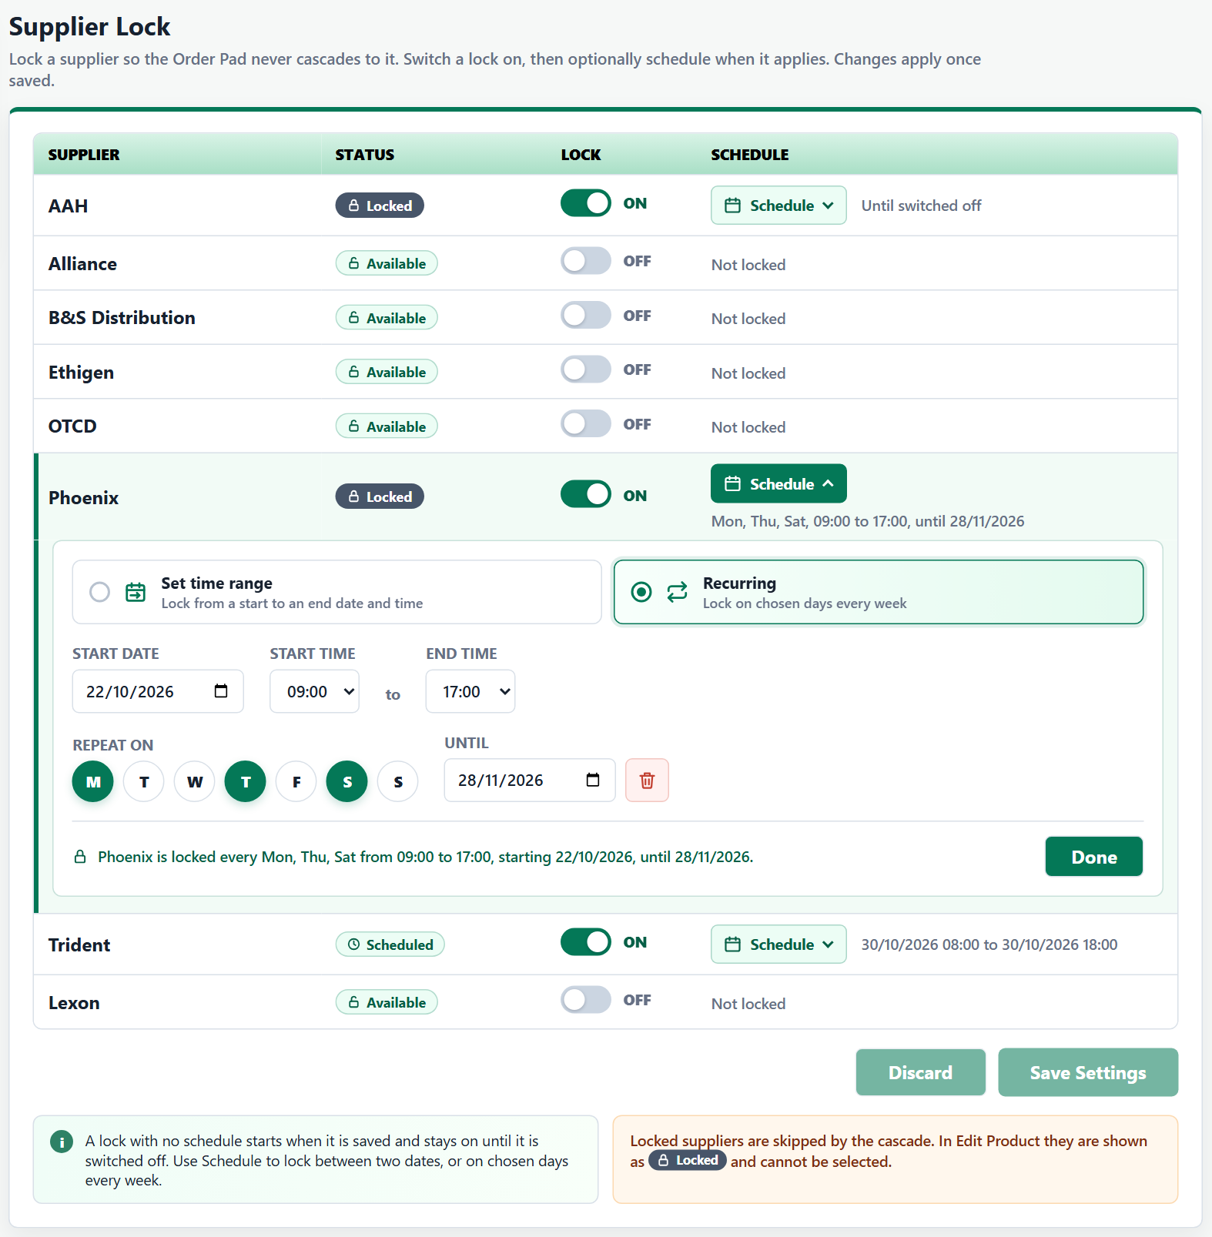
e. Discard and Save – Any change shows ‘Unsaved’ on that supplier’s row and ‘Unsaved Changes’ next to the buttons, and enables Discard and Save Settings. Discard returns to the saved locks and shows ‘Changes discarded’. While a changed schedule is invalid, its Schedule button and summary turn red (‘Check the schedule’) and the message is shown in the panel (section 5).
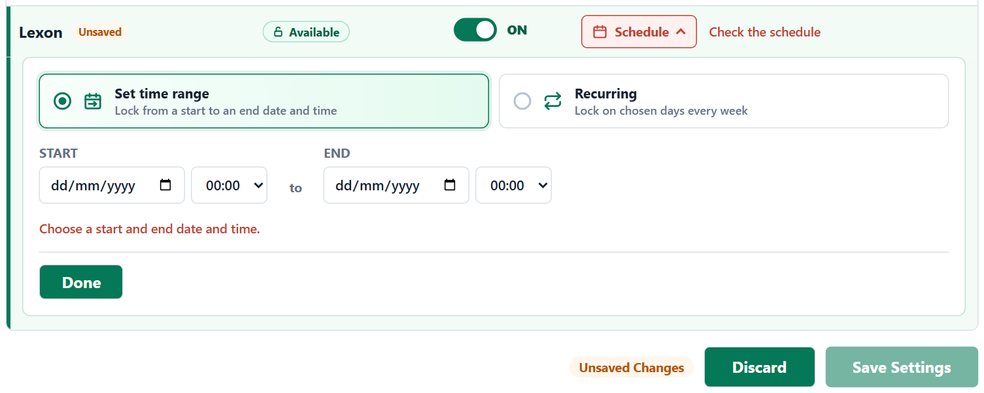
f. Save Confirmation – Save Settings opens ‘Save supplier locks?’, listing each changed supplier with a LOCK, UNLOCK or CHANGE tag and its schedule (or ‘Available for cascade again’), under ‘This change applies straight away.’ or ‘These N changes apply straight away.’ If every supplier would be locked right now, the warning ‘Every supplier will be locked. Products cannot be ordered until a lock ends or is switched off.’ is shown.
- Confirm saves all suppliers together, adds one Audit Log entry for each changed supplier and shows, for example, ‘AAH locked’ or ‘Supplier locks saved: 1 locked, 1 unlocked’. Cancel closes it with nothing saved.
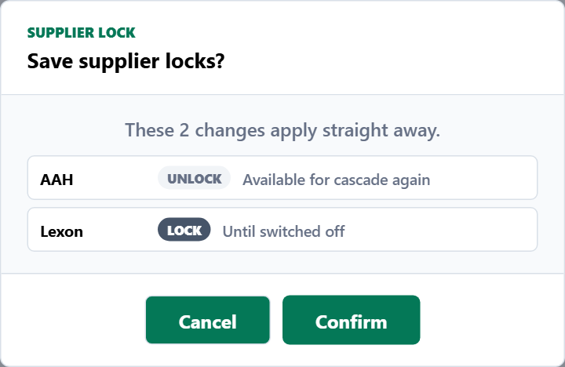
g. Notes – The green info note reads ‘A lock with no schedule starts when it is saved and stays on until it is switched off. Use Schedule to lock between two dates, or on chosen days every week.’ The orange note reads ‘Locked suppliers are skipped by the cascade. In Edit Product they are shown as Locked and cannot be selected.’
h. Unlocked by Admin – When admin unlocks a supplier (section 10c) while Settings is open, its switch turns off straight away and ‘<Supplier> unlocked by Admin’ is shown. Unsaved changes to other suppliers are kept.
4. Audit Log Requirements
a. Access – Under Audit Log, Supplier Lock is the third sub-item, after Smart Quantity Recommendations and Override Drug Tariff.
b. Display – The heading ‘Supplier Lock History’ and sub-heading ‘Who locked or unlocked each supplier, and the period it was locked for. Newest first.’ sit above the panel. The columns are ‘Date & Time’ (DD-MM-YYYY - HH:MM:SS), ‘Changed By’ (username signed in through Shift sign-in, or ‘Admin’ for an unlock made in the admin portal), ‘Supplier’, ‘Action’ (Locked, Unlocked or Schedule Changed), ‘Locked From’, ‘Locked Until’ (an end date and time, ‘Until switched off’ or ‘No end date’) and ‘Repeat’ (‘Does not repeat’, or the days and times). Unlocked rows show ‘–’.
c. Filters – Start and End (the last 7 days by default) and Supplier (‘All suppliers’ or one supplier), applied with Search; Reset returns to the defaults. With no entries it shows ‘No supplier lock changes found for the selected dates.’
d. Pagination – Show 10 entries by default (10, 25, 50 or 100), ‘Showing x to y of z changes’ and page buttons. Entries cannot be edited or deleted.
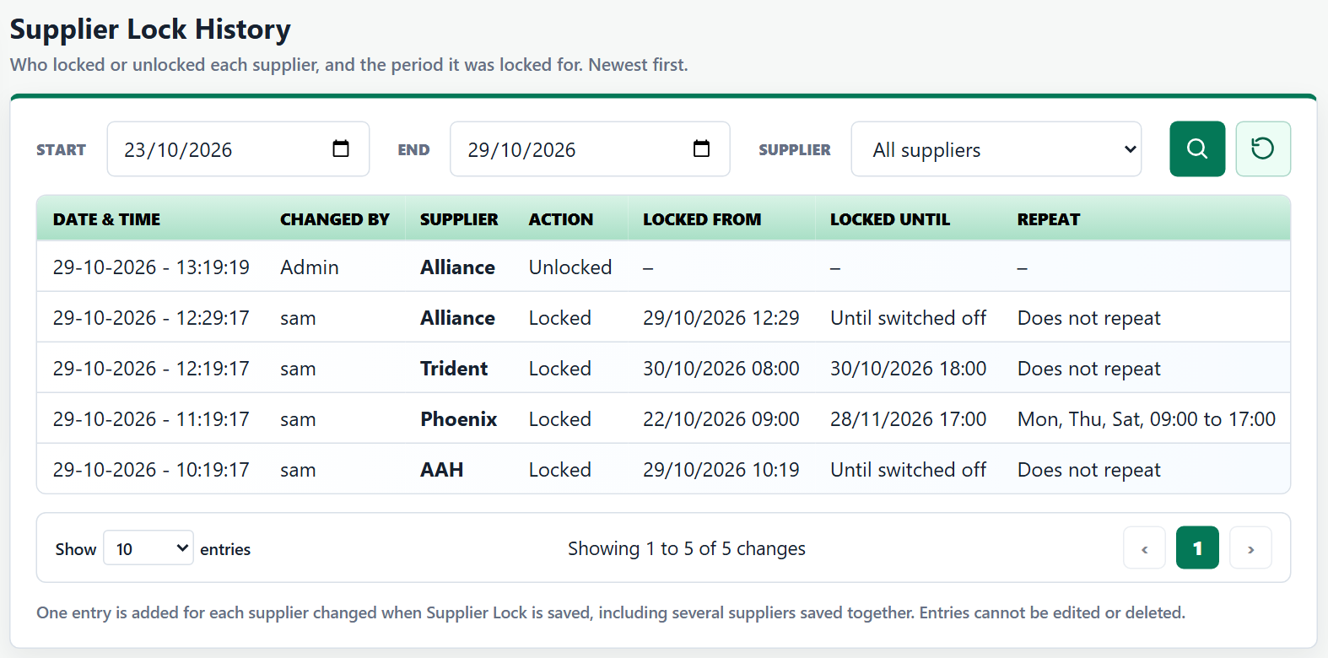
5. Validation Requirements
Area | Validation
Default | By default, there are no locks present for any supplier configured for the pharmacy.
Set time range | Both dates and times are required: ‘Choose a start and end date and time.’ The end must be after the start: ‘The end must be after the start.’ The end cannot be in the past: ‘The end is in the past. Choose a later end date or time.’ A new start cannot be in the past: ‘The start is in the past. Choose a start from now on.’ Past dates and times cannot be picked (the start from the next quarter hour, the end after the start); a lock already running keeps its saved start.
Recurring | ‘Choose a start date, start time and end time.’ ‘The end time must be different from the start time.’ ‘Choose at least one day.’ Until must be valid (‘Choose a valid end date, or remove it.’), on or after the start date (‘The end date must be on or after the start date.’) and not in the past (‘The end date is in the past. Choose a later date, or remove it.’). An end time at or before the start time ends the next day (e.g. 22:00 to 06:00).
Saving | Save Settings stays disabled while any changed schedule is invalid.
6. Order Pad Requirements
a. Order Basket Chip – A Supplier Lock chip is always shown next to the DT OVERRIDE chip: ‘SUPPLIER LOCK OFF’ when no supplier is locked, or ‘N SUPPLIER(S) LOCKED’ while one or more locks are in force. The settings (gear) icon sits before the text, in the same colour as the text. Hovering over it lists each locked supplier and until when, for example ‘AAH – locked until switched off’, then ‘Not cascaded to. Change in Settings.’ Selecting it opens Settings on Supplier Lock.
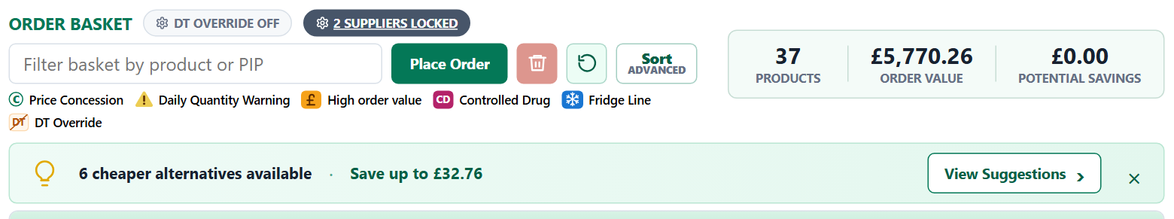
b. Cascade – Locked suppliers are never selected and are left out of Best Price and the cascade; the cheapest selectable supplier is still chosen first. If every supplier with a price for a product is locked, the line shows ‘Not selected’.
- When a lock starts, lines on that supplier move to the next best supplier and ‘N line(s) moved from a locked supplier to the next best supplier’ is shown. An unsaved Edit Product choice of that supplier is dropped.
- When a lock ends, or admin unlocks it (‘<Supplier> unlocked by Admin – available for cascade again’), the supplier can be selected again. Lines already in the basket are not moved back.
c. Review Before Placing Order – No row is added for locked suppliers.
7. Edit Product Requirements
a. Locked Rows – A locked supplier is still listed so its price can be seen, but the row is greyed out with a striped background, cannot be selected (radio disabled), shows its price struck through in grey and Savings as ‘–’, and has a ‘LOCKED’ tag after the supplier’s name. It is never Best Price.
b. Hover – Only the LOCKED tag has a hover message: ‘Supplier locked in Settings until DD/MM/YYYY HH:MM. It cannot be selected or cascaded to.’, or ‘Supplier locked in Settings until switched off. It cannot be selected or cascaded to.’
c. Legend – The legend always shows ‘LOCKED - Supplier locked in Settings’ after the price entries.
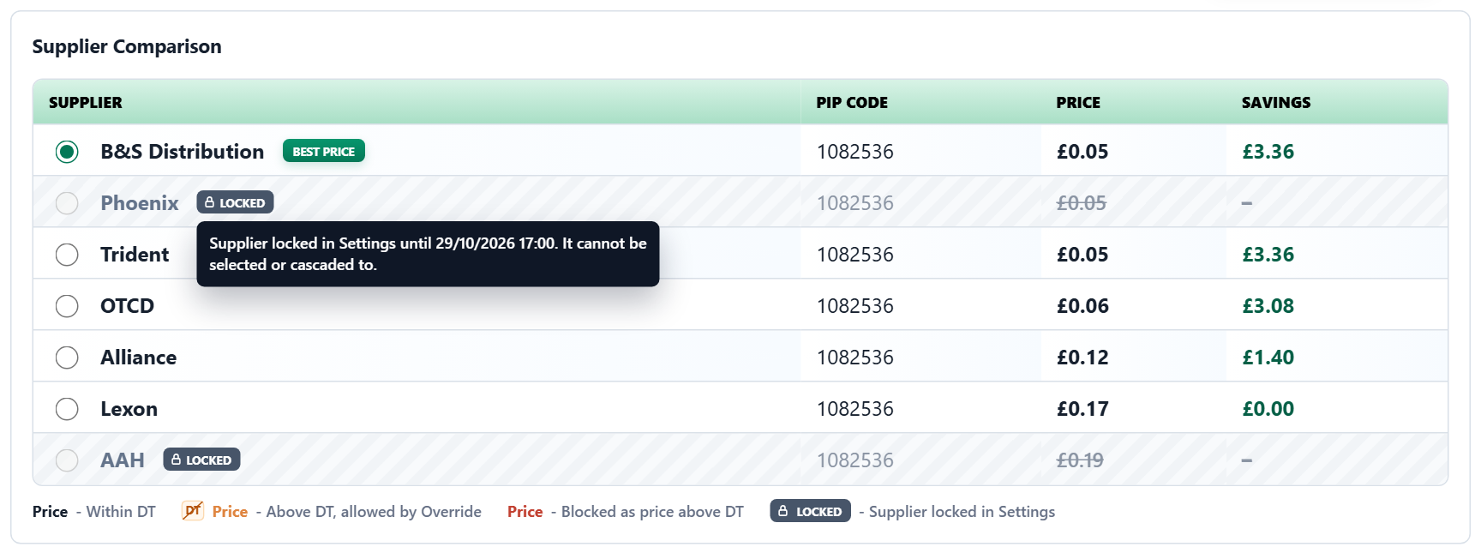
8. Order History Requirements
a. Supplier Outcomes – When an order is placed, each locked supplier that had a price for the line is listed in that line’s Supplier outcomes with Rec. Qty 0, Status ‘Not Fulfilled’ and Comment ‘Blocked as Supplier Locked. Check in Settings.’, above the supplier that fulfilled it. Fulfilled By shows the supplier the line was sent to.
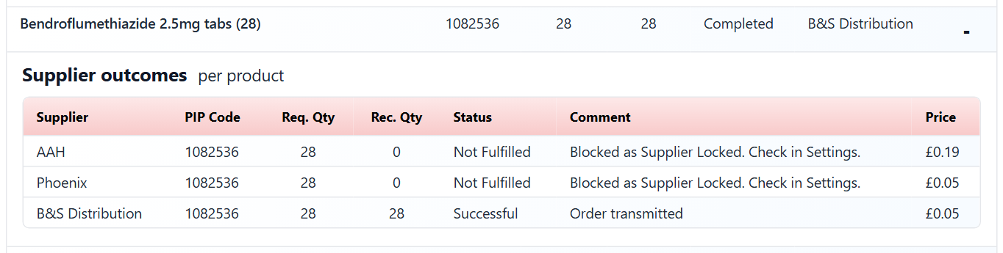
9. Reports Requirements
a. Order Exceptions Report – Supplier outcomes for locked suppliers from placed orders are listed with the Reason ‘Blocked as Supplier Locked. Check in Settings.’ Reason Type ‘Blocked By System’ includes it, with ‘Blocked as price above drug tariff. Call supplier.’ and ‘Blocked no price.’; ‘Manufacturer Cannot Supply’ does not.
b. Order Report – Rows for a locked supplier show the same comment as 9a.
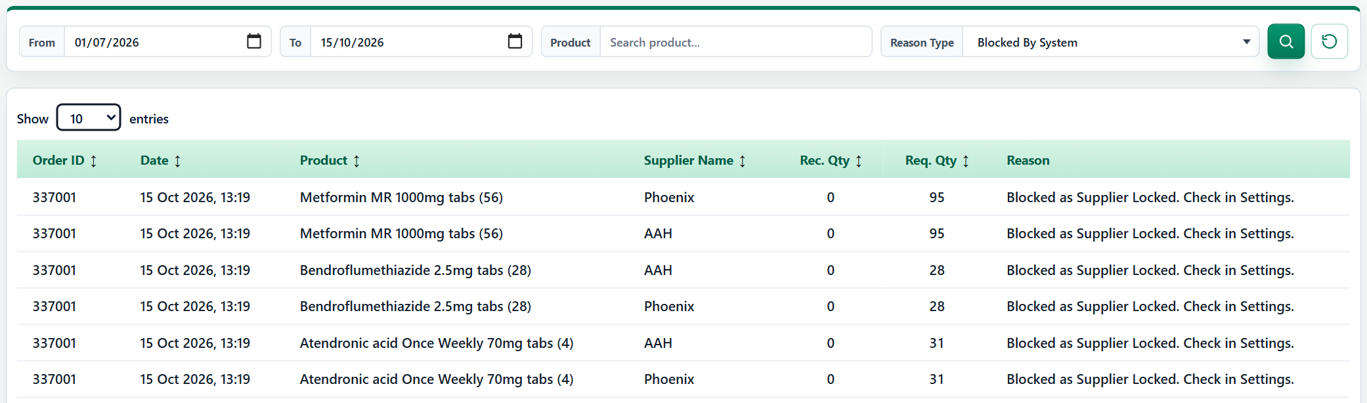
10. Admin Portal Requirements (Customers – Suppliers)
a. Locked Column – A padlock is shown for each supplier the customer has locked while the lock is in force. Hovering over it shows the lock, for example ‘Locked by customer until switched off.’
b. Lock Note – Selecting a supplier the customer has locked shows a purple note above the buttons:
- No schedule: ‘Locked by customer until switched off in Cascade Plus Settings. Orders will not cascade to this supplier.’ Time range: ‘Locked by customer until DD/MM/YYYY HH:MM in Cascade Plus Settings. …’
- Recurring: ‘Locked by customer. Repeats every Monday, Thursday and Saturday, 09:00 to 17:00, until 28/11/2026. Orders will not cascade to this supplier.’ Days read ‘every day’, ‘every weekday (Monday to Friday)’ or ‘every weekend (Saturday and Sunday)’ where they match; an overnight lock reads ‘to 06:00 the next day’ and one with no end date ‘with no end date’.
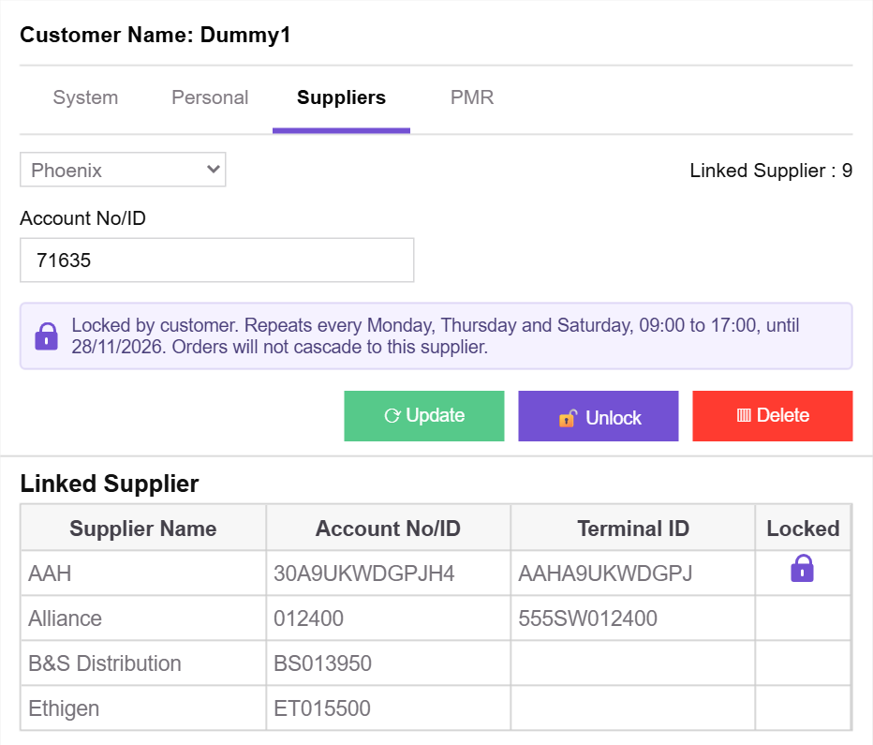
c. Unlock – While a customer lock is in force, the Lock button reads ‘Unlock’. It opens ‘Unlock "<Supplier>"?’ with ‘<Supplier> is locked by customer … Unlocking turns the customer’s lock off, including any schedule, so orders can cascade to <Supplier> again.’ and the required ‘Reason for change’ (section 5). Unlock turns the customer’s lock off on the customer site straight away and shows ‘<Supplier> supplier unlocked for the customer’.
- A supplier with a Lock Scheduled lock shows Lock, so a lock that has not started cannot be unlocked.
- The admin’s own Lock button is unchanged and is not shown on the customer site.
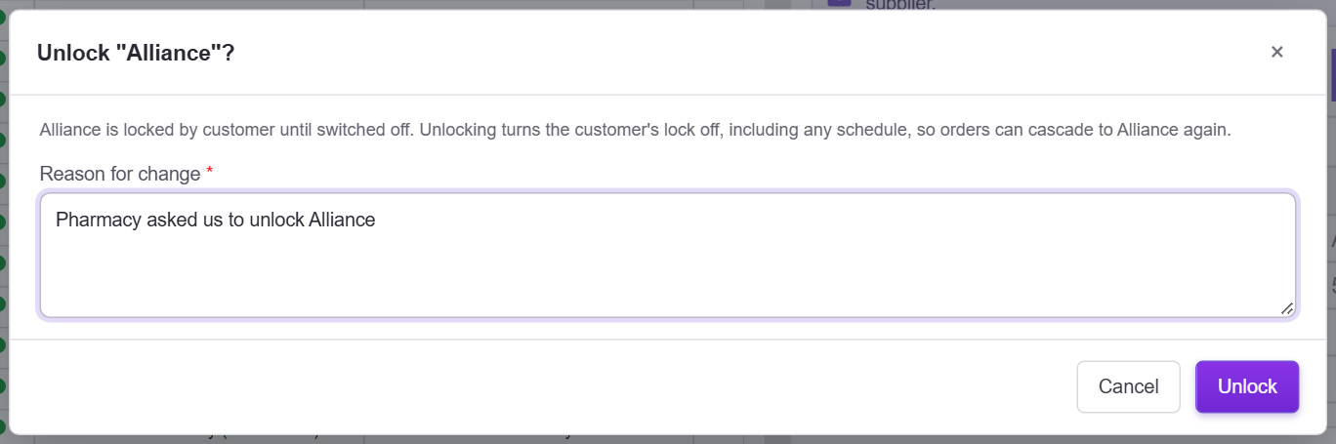
d. Change Log – Customer lock changes are listed with admin changes, newest first. The Action column is wide enough for every badge.
- Locked with no schedule – ‘Locked’, Changed By ‘Customer’, Reason ‘Supplier locked by customer’.
- Scheduled – ‘Lock Scheduled’ (amber) until the schedule is in force, then ‘Locked’; Changed By ‘Customer’, Reason ‘Supplier lock scheduled by customer’ in both cases.
- Unlocked by the customer – ‘Unlocked’, ‘Customer’, ‘Supplier unlocked by customer’. Unlocked by admin – ‘Unlocked’, the admin user and the reason entered.
- Changes to a schedule are not listed.
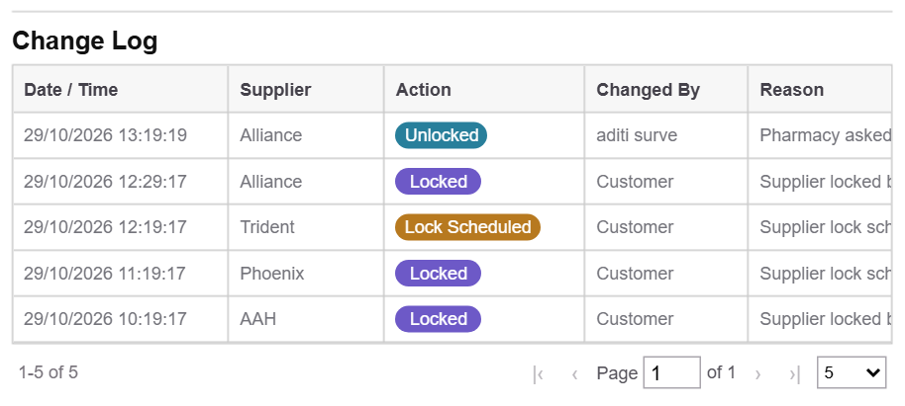
11. Changes – Settings Icon in Top Navigation
a. Settings Icon – A round settings (gear) icon sits to the left of the operator (shift user) chip on every page, in the same white colour, border, height and green hover as the chip. Hovering over it shows ‘Settings’ and selecting it opens the Settings page. On the Settings page it stays highlighted.


