Functional Requirements: Supplier Spend Targets and Report
This document defines the functional requirements for Supplier Spend Targets in Cascade Plus. It covers the Supplier Spend Targets option and its Audit Log in Settings, the new Supplier Target Report and the Dashboard card. Suppliers, amounts, dates and names shown in the wireframe are sample data only.
1. Purpose
- Let the pharmacy set a maximum spend (cap) for each supplier, repeating weekly, monthly or quarterly, or between specific dates.
- Show how much of each cap is used and where spend is heading.
- Keep a history of who set, changed or removed each target.
- A spend target only informs. It never blocks an order or changes the cascade.
2. Scope
Settings (Supplier Spend Targets and its Audit Log), the Supplier Target Report and the Dashboard
3. Supplier Spend Targets (Settings)
a. Access and Layout – ‘Supplier Spend Targets’ is shown in the Settings ‘OPTIONS’ list after Supplier Lock. The heading is ‘Supplier Spend Targets’ with ‘Set the most you want to spend with each supplier.’ The table lists every supplier with ‘Supplier’, ‘Spend Target’, ‘Maximum Cap’ and ‘Schedule’, followed by Discard, Save Settings and two notes: ‘Choose how often the cap starts again: weekly, monthly or quarterly, or on specific dates.’ and ‘A spend target never blocks an order or changes the cascade. Progress shows in the Supplier Target Report and on the Dashboard.’ Opening another option discards unsaved changes.
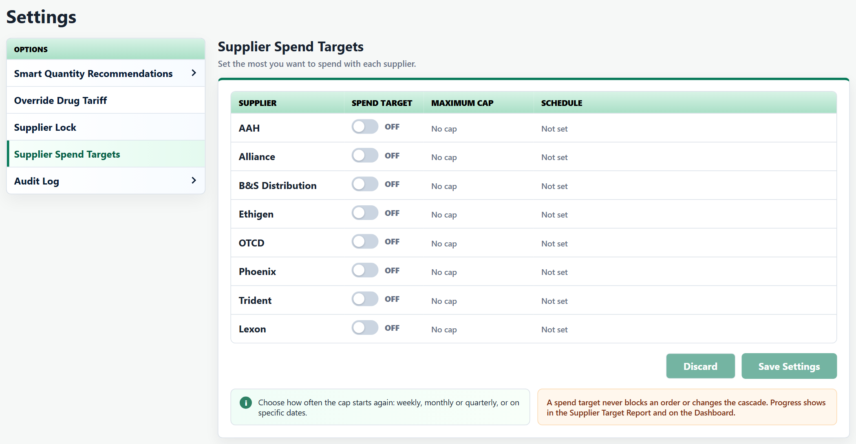
b. Spend Target Switch - Off by default, showing ‘No cap’ and ‘Not set’. Turning it On shows the ‘£’ cap box and the ‘Schedule’ button, and for a new target opens the scheduler straight away. A new target starts ‘Monthly’ from the first of the current month, until six months later. Turning a saved target Off removes it when saved.
c. Maximum Cap - Entered in pounds, for example 5000 or 5000.50. Pressing Enter in the box opens the save confirmation when there is a valid change.
d. Schedule - ‘Schedule’ opens or closes the scheduler under the supplier. A summary next to the button shows the schedule, for example ‘Monthly from 01/10/2026 to 31/03/2027’, on the same line as the button.
- ‘Weekly’, ‘Monthly’ and ‘Quarterly’ start again every 7 days, month or 3 months from the ‘Start date’. ‘Until’ is the last day a new period can start; it can be removed (no end date) or added back with ‘+ Add end date’.
- ‘Specific dates’ runs once from ‘Start date’ to ‘End date’ (the end date defaults to the end of the start month).
- A sentence describes the target, for example ‘AAH is capped at £5,000 every month from 01/10/2026, until 31/03/2027. Current period: 01/10/2026 – 31/10/2026.’ ‘Done’ closes the scheduler.
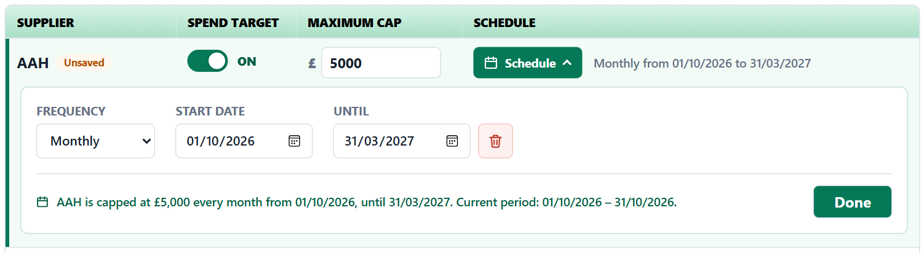
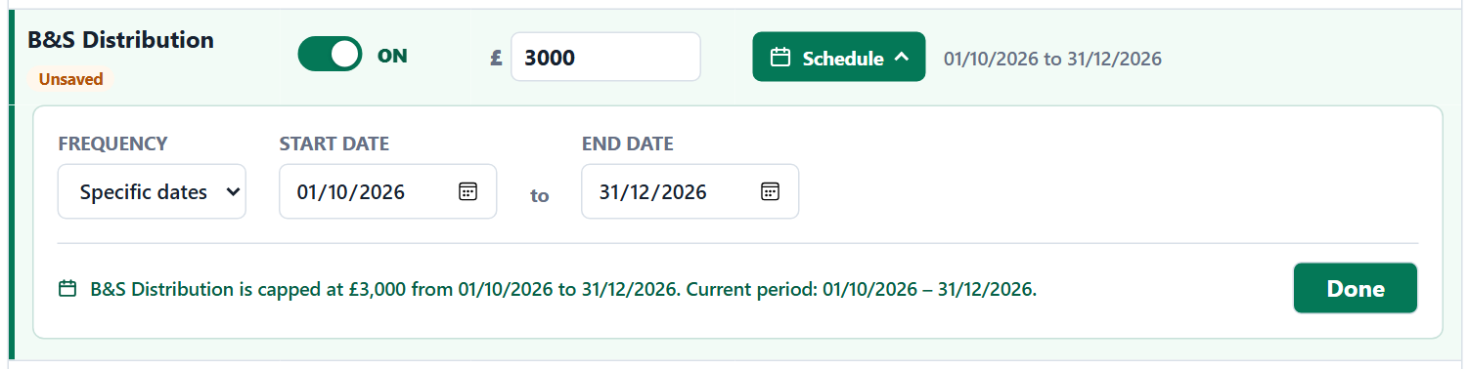
e. Errors - Cap errors show under the cap box. Schedule errors show in the scheduler, the Schedule button turns red and the summary reads ‘Check the schedule’. Save Settings is disabled while any error is shown (messages in section 5).
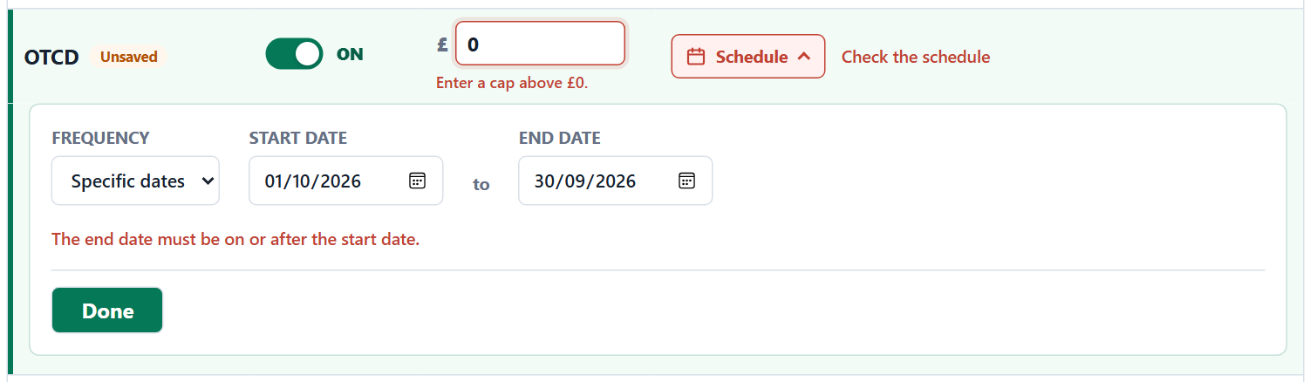
f. Save and Discard - Changes show an ‘Unsaved’ tag on the supplier and ‘Unsaved changes’ by the buttons. Discard restores the saved settings (‘Changes discarded’). Save Settings opens ‘Save spend targets?’ listing each changed supplier with a ‘Set’, ‘Change’ or ‘Remove’ tag and its new cap and schedule. Confirm saves all suppliers together and shows, for example, ‘AAH spend target set’ or ‘Spend targets saved: X changes’. The report and Dashboard update straight away.
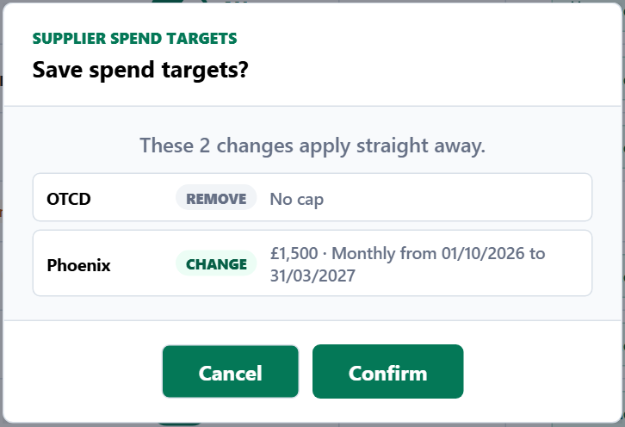
4. Audit Log
a. Layout - ‘Audit Log’ in Settings has the sub-item ‘Supplier Spend Targets’. Heading ‘Supplier Spend Target History’ with ‘Who set, changed or removed each supplier's spend target. Newest first.’
b. Filters - ‘START’, ‘END’ and ‘SUPPLIER’ (All suppliers by default) are applied with Search. The default is the last 7 days and the Audit Log always opens on it. Reset returns to the defaults (‘Filters reset’).
c. History - Columns: ‘Date & Time’, ‘Changed By’, ‘Supplier’, ‘Action’ (Target Set, Target Changed or Target Removed), ‘Maximum Cap’ and ‘Schedule’. A removed target shows ‘–’. One entry is added for each supplier changed in a save, and entries cannot be edited or deleted. All columns must be visible without scrolling sideways.
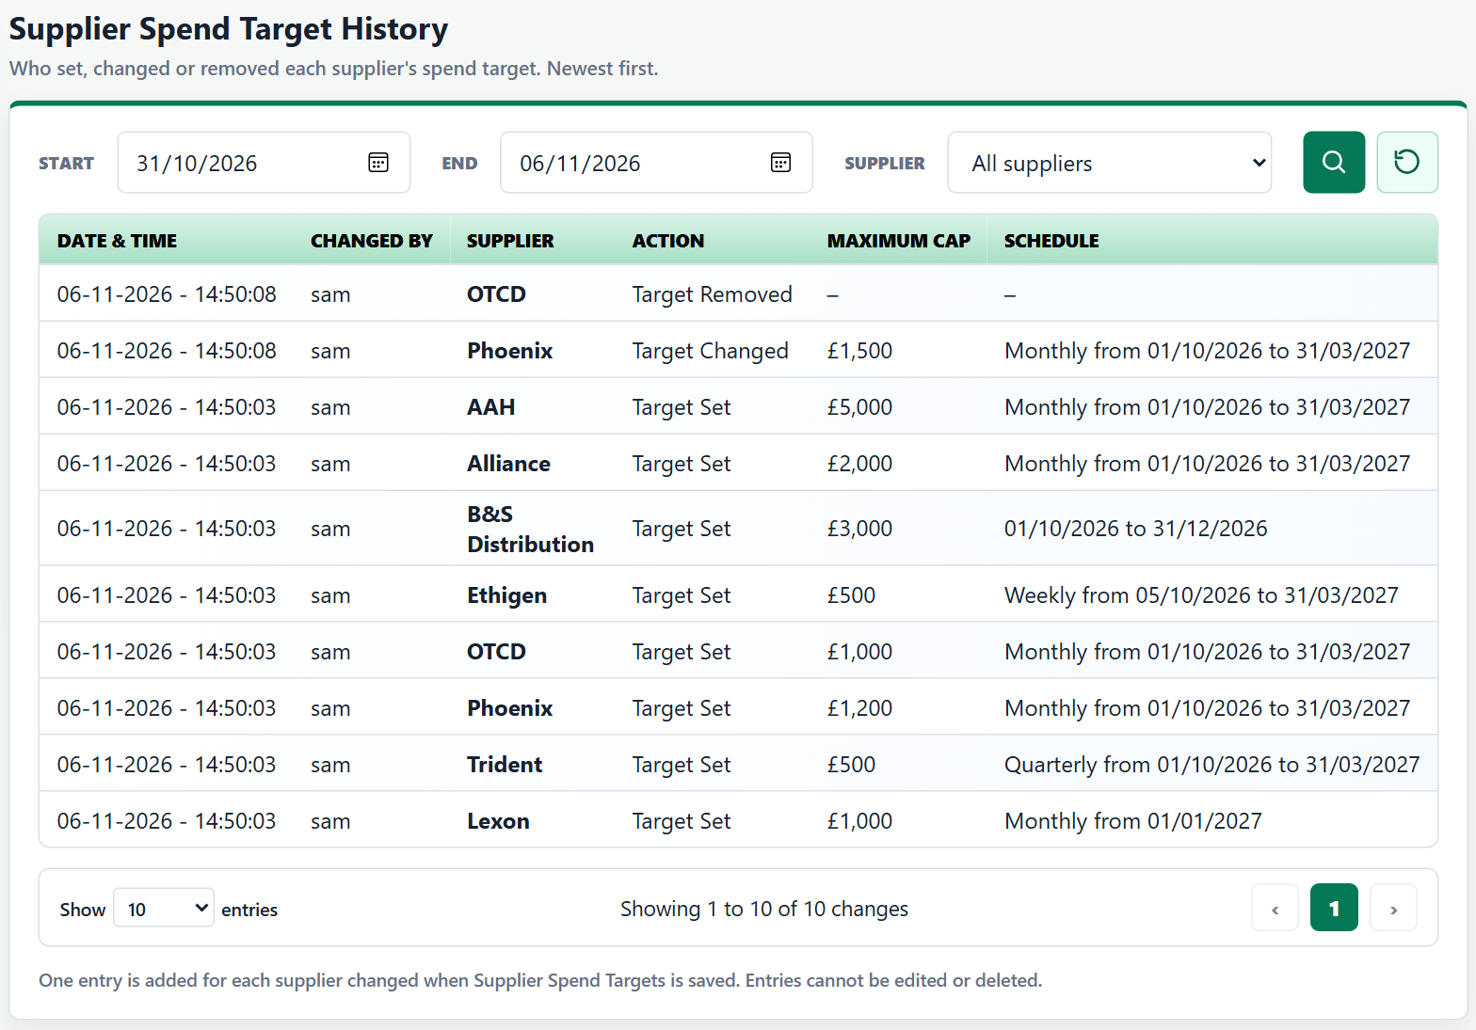
5. Validation Requirements
Area | Validation
Default | No targets set; every supplier Off. In the wireframe, today is fixed at 15/10/2026 and a new session or page refresh returns to no targets.
Maximum Cap | Empty: ‘Enter a maximum cap.’ Not a valid amount: ‘Enter an amount in pounds, for example 5000 or 5000.50.’ £0: ‘Enter a cap above £0.’ Above £10,000,000: ‘Enter £10,000,000 or less.’
Dates | Missing: ‘Choose a start date and an end date.’ / ‘Choose a start date.’ End or until before start: ‘The end date must be on or after the start date.’ In the past: ‘The end date is in the past. Choose a later date.’ (recurring: ‘…, or remove it.’)
Save Settings | Disabled with no changes or any error. Only changed suppliers are checked.
Audit Log | Start after End: ‘The start date must be on or before the end date.’

6. Spend and Status Rules
- Spend is the received quantity × price of each supplier line in Order History in the current period. Out-of-stock lines add nothing (same rule as the Daily Threshold).
- Projected is spend so far ÷ days gone × days in the period.
- Only targets running today are shown on the report and Dashboard.
Status | Rule and colour
On track | Spend and Projected are within the cap. Green.
Will exceed | Spend is within the cap but Projected is above it. Amber.
Cap reached | Spend is equal to or above the cap. Orange.

7. Supplier Target Report
a. Access - From the Reports page card ‘Supplier Target Report’ (‘Track spend against each supplier's cap.’), Dashboard Quick Access and the Dashboard card.
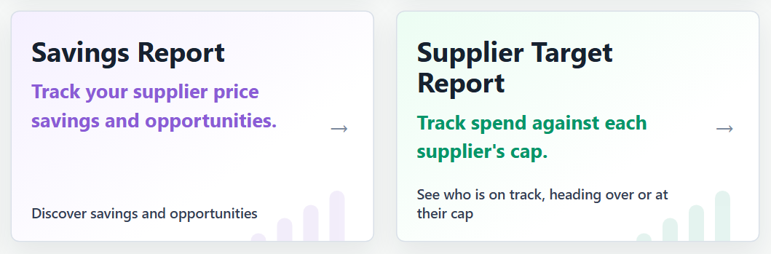
b. Filters - ‘Supplier’ (only suppliers with a saved target), ‘Status’ and ‘Pharmacy’ (fixed), with Search and Reset.
c. Summary Cards - ‘On Track’, ‘Will Exceed’ and ‘Cap Reached’ counts and ‘Spend Against Caps’ total for the rows shown, in the same card style as the Savings Report.
d. Spend Against Cap Table - Supplier, Frequency, Current Period, Cap (£), Spend (£), Used of Cap (bar and %), Left (£), Days Left, Projected (£) and Status. Columns sort by clicking the heading (default: Cap reached first). Paging shows 10, 25, 50 or 100 entries. Notes below list targets not running today (for example ‘Lexon (starts 01/01/2027)’).
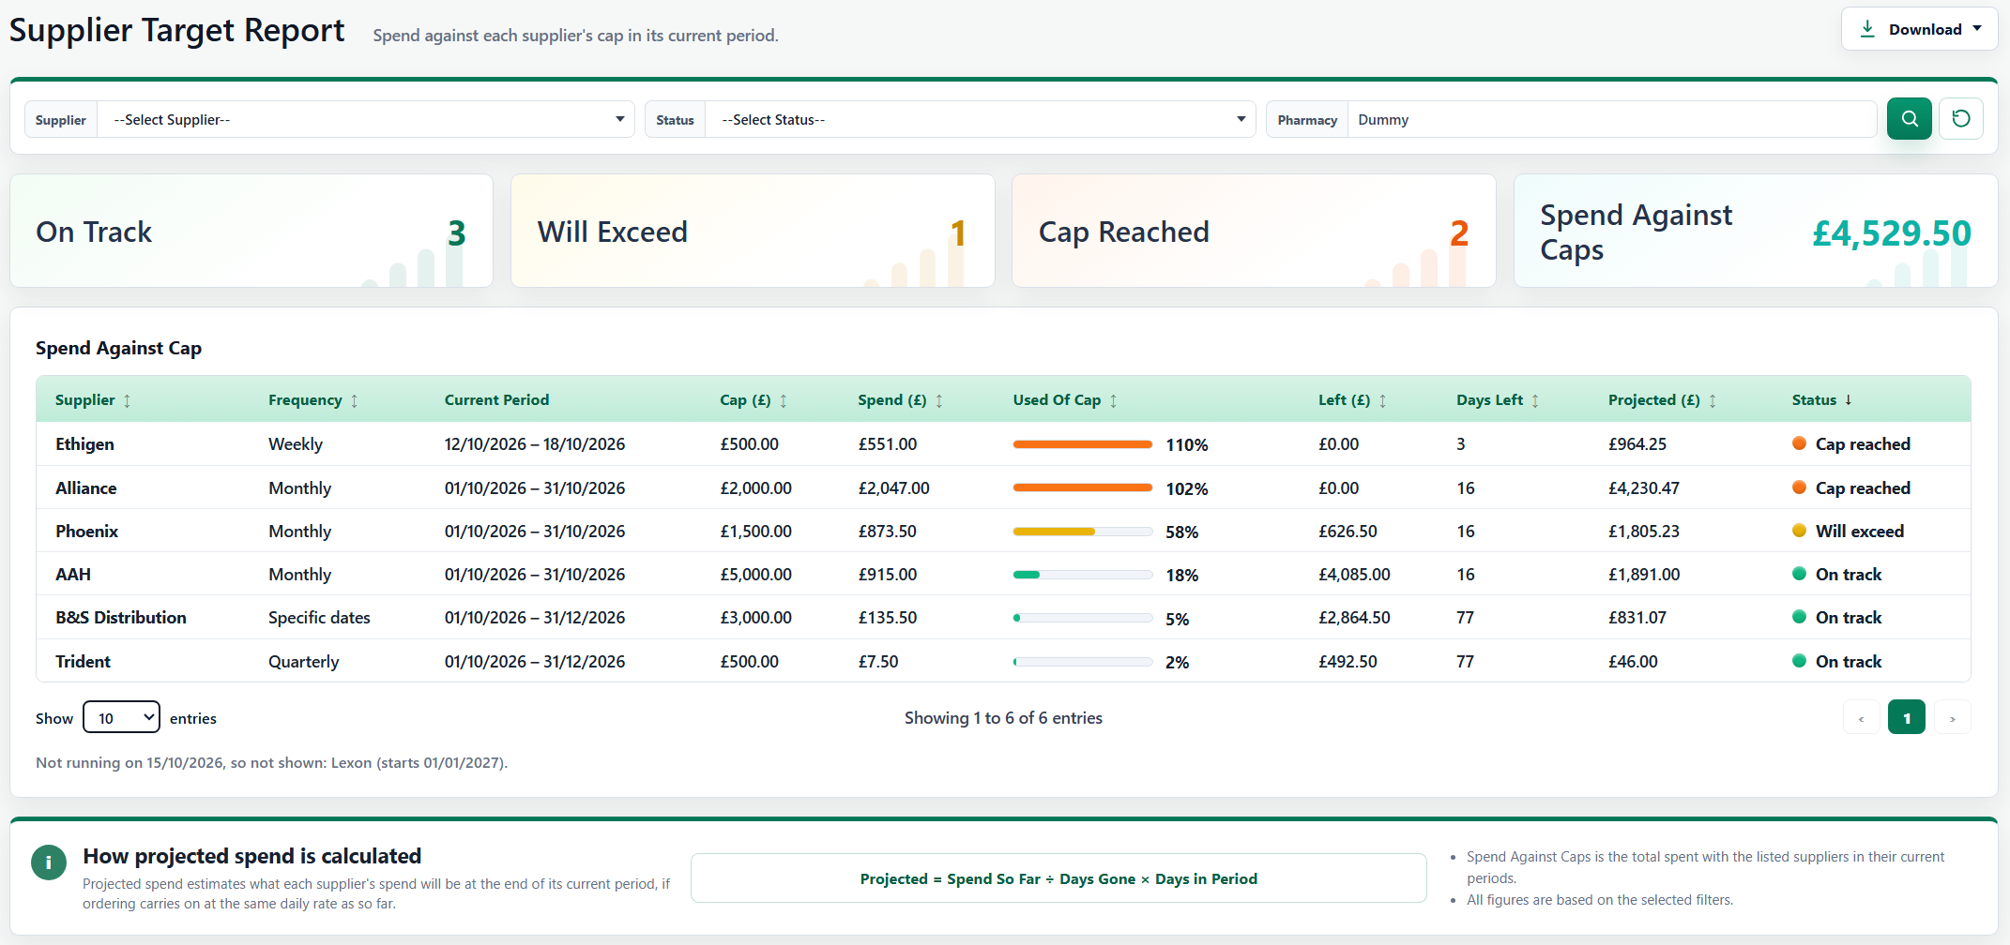
e. How Projected Spend Is Calculated - Below the table, a box in the same style as the Savings Report’s ‘How savings are calculated’ box. It shows the heading ‘How projected spend is calculated’, a sentence explaining that Projected estimates each supplier’s spend at the end of its current period if ordering carries on at the same daily rate, the Projected formula (section 6) and two notes: ‘Spend Against Caps is the total spent with the listed suppliers in their current periods.’ and ‘All figures are based on the selected filters.’
f. One Supplier - Opened from a Dashboard row, the report shows only that supplier with its row marked by a green bar.
g. Empty Report - ‘No spend targets are set. Set a maximum cap for a supplier in Settings, under Supplier Spend Targets.’ (with a link to Settings), ‘No spend targets are running in their current period.’ or ‘No suppliers match the selected filters.’
h. Download - ‘Download CSV’ (rows shown, in the current sort) and ‘Print / PDF’.
8. Dashboard
a. Quick Access - ‘Supplier Target Report’ is added to ‘Quick Access to Reports’.
b. Supplier Spend Targets Card - One row per running target with the supplier, a bar in the status colour and the % used. Four rows are shown and more scroll. A row opens the report for that supplier, and ‘More details →’ opens the full report. With no targets it reads ‘No spend targets set. Set a maximum cap for a supplier in Settings.’
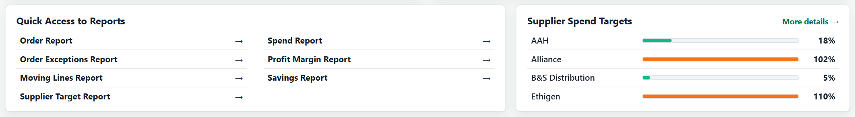
9. Other Changes
- The ‘Beta’ tag has been removed from the Savings Report on the Reports page and in Dashboard Quick Access.

