Deployment path

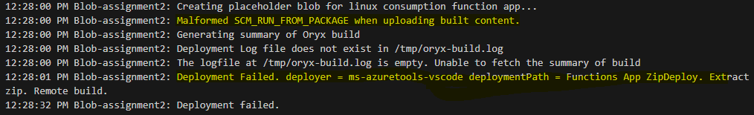

Local deployment

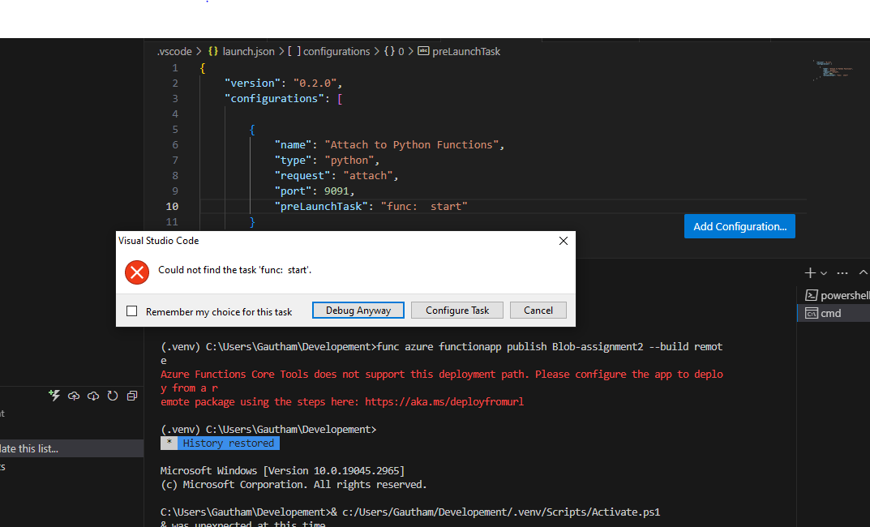

Local settings

