**Script: test_iner.py**

Instructions for Use:

To use the script, follow these steps:

**Source**: Provide the absolute path of the source image, including the file extension.

**Target**: Provide the absolute path where the labeled image will be saved, including a new image name with the file extension.

**Class**: Enter an integer (1, 2, or 3) to specify the label class:

1: Blue

2: Green

3: Red

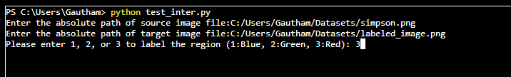

* The image may pop up or open in a separate window. If not visible, please check the taskbar.
* To select a region, click and drag from the top-left to the bottom-right. The region will be highlighted in the selected color when the mouse is released.
* Press the "Escape" button to finish.

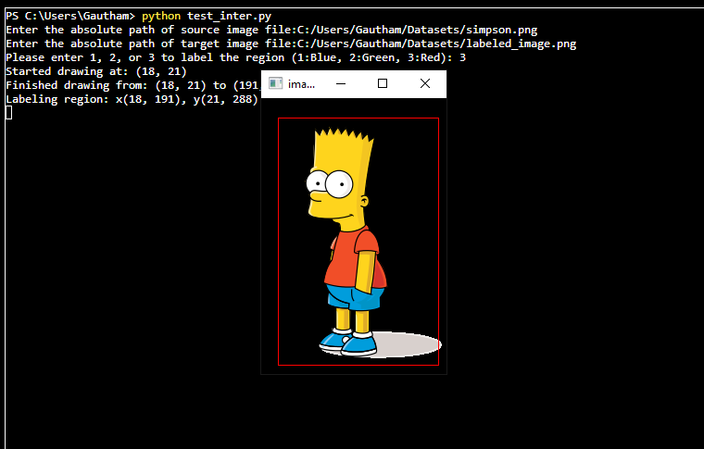

Labeled image will be visible in below format

Press “escape” button

Image will be stored in target path

