**Step1:** Loading Transaction data and adjusting support to 0.03, confidence to 0.20 and Min.length to 1.Item frequency plot shows that Magazine is present majority of the transaction.

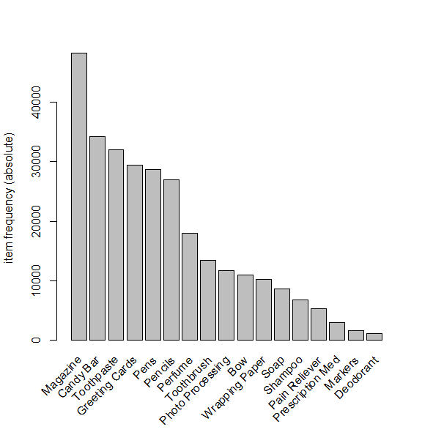

**Step 2:** After sorting by lift, the top 10 rules are represented below

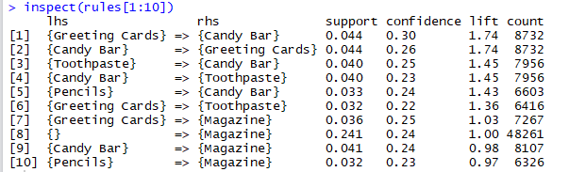

**Step 3:** Two rules have been removed because of redundancy and the results are represented below

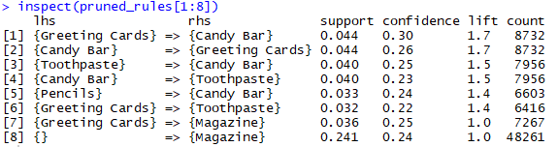

**Step** **4:**

1. Two rules have the highest lift value of 1.7. Rules are:

{Greeting Cards} => {Candy Bar}

{Candy Bar} => {Greeting Cards}



Lift ratio = Confidence / Benchmark confidence

Benchmark confidence $=\frac{no. transactions with consequent itemset}{no. transactions in database}$

1. Rule {Greeting Cards} => {Candy Bar}

Confidence of the rule is 0.30

No. of transactions with consequent { Candy Bar} item are 34,201

No. of transactions in the database are 200,000

Benchmark confidence = 34,201/200,000= 0.171

Lift Ratio = 0.30/0.171 = 1.7

ii) Rule {Candy Bar} => {Greeting Cards}

Confidence of the rule is 0.26

No. of transactions with consequent {Greeting Cards} item are 29,377

No. of transactions in the database are 200,000

Benchmark confidence = 29,377/200,000= 0.146

Lift Ratio = 0.26/0.171 = 1.7



Rule 1: {Greeting Cards} => {Candy Bar}

Rule 2: {Candy Bar} => {Greeting cards}

Relatively many people buy Candy Bar along with sliced Greeting card and vice versa

Rule 3: {Toothpaste} => {Candy Bar}

If someone buys Candy Bar, they are likely to have bought Toothpaste as well

Rule 4: {Candy Bar} => {Toothpaste}

If someone buys Toothpaste, they are likely to have bought Candy Bar as well

Rule 5: {Pencils} => {Candy Bar}

People who buy Pencils also bought Candy bar

1. There are two rules which have been removed because of redundancy and both the rules have lift less than 1.

Results after removing redundancy are mentioned in Step 3.

As a decision maker, I would suggest placing the items in the same set (mentioned below) together or to be promoted together. This exercise can help in improving sales.

Magazine is present across most the transactions, which means most of the customers in the area where store is located has affinity towards reading magazines. Place the magazines in high visibility places (near checkout counters), which will help in either maintaining or improving the sales of Magazines.

Set 1: {Greeting Cards and Candy Bar}

Set 2: {Toothpaste and Candy Bar}

Set 3: {Pencils and Candy Bar}

Ste 4: {Greeting Cards and Tooth paste}

Set 5: {Greeting Cards and Magazine}