Created simple project which implements simple React, Redux, Saga then added iframe component. Where I loaded external url.

Below are my observation

<https://github.com/svenanders/react-iframe>

License -> ISC License equivalent to MIT License

<https://github.com/svenanders/react-iframe/blob/master/LICENSE>

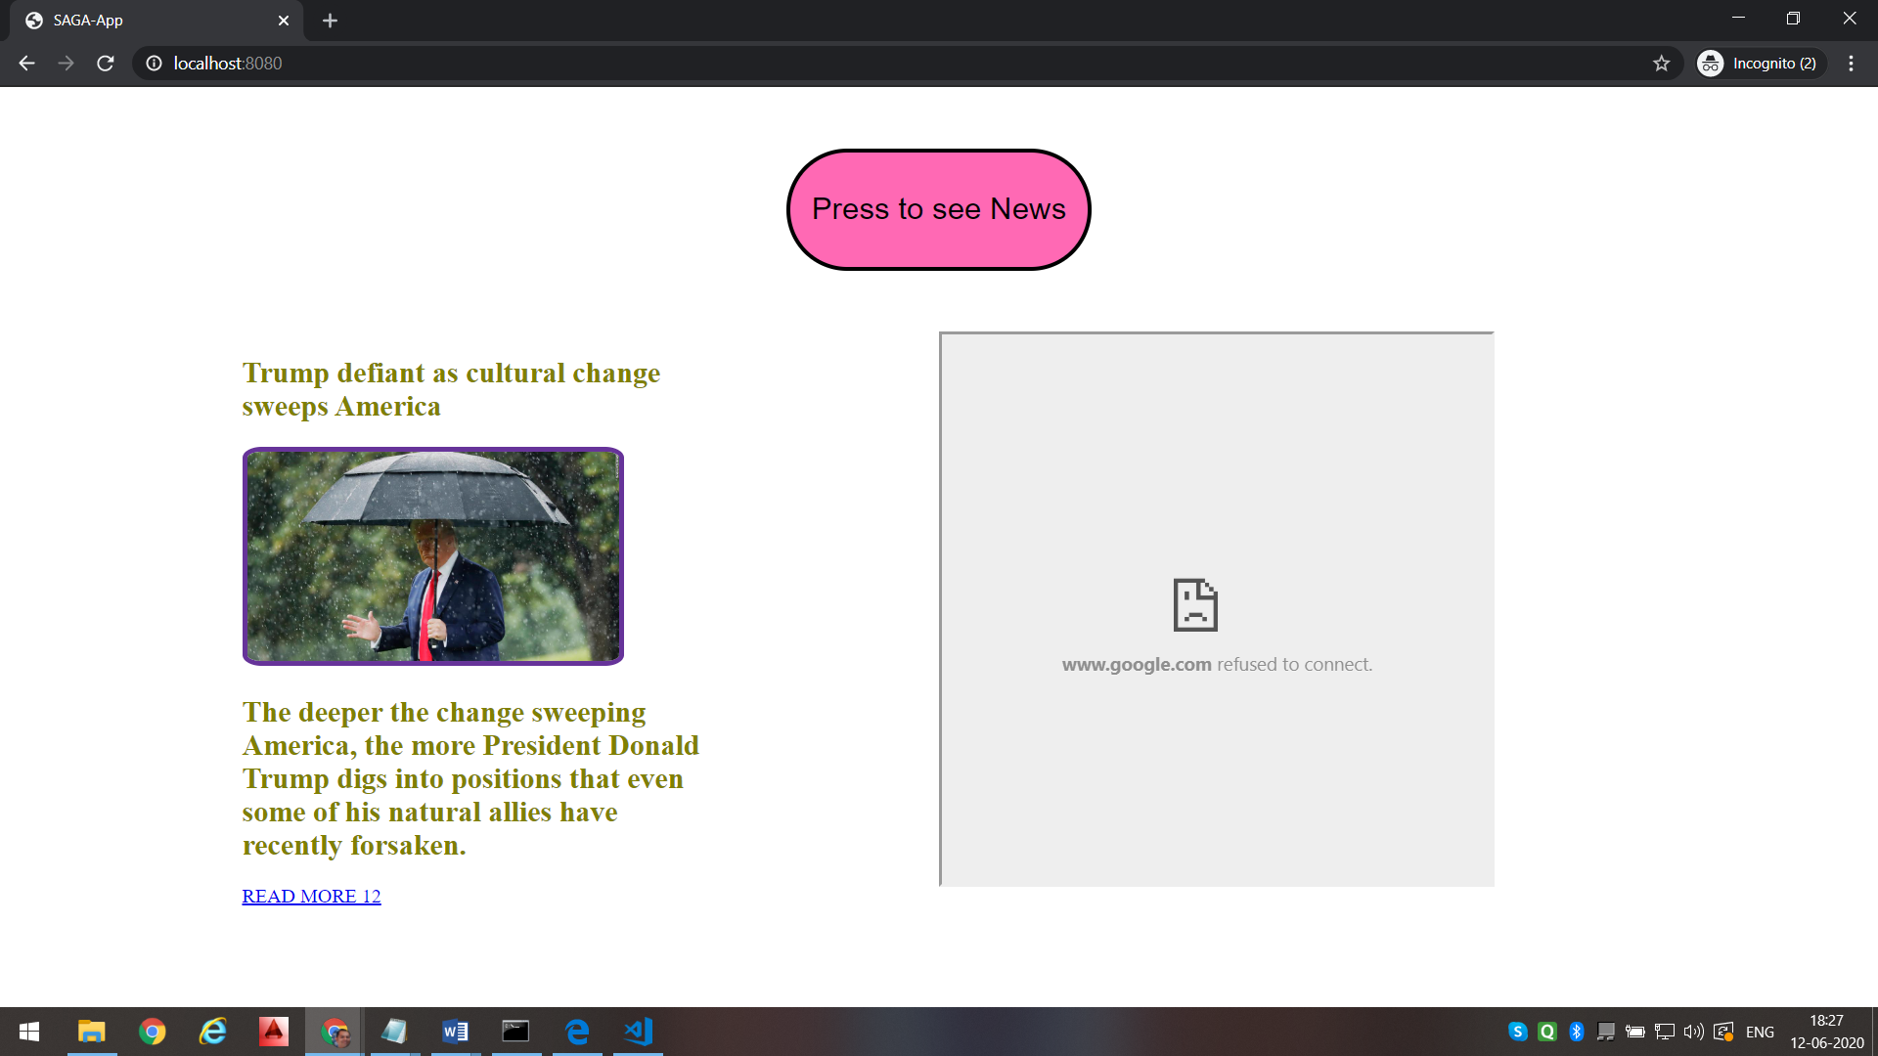

Reason: <https://www.quora.com/How-do-I-show-Google-com-in-IFrame>

You cannot as Google does not support Iframe You can see Clearly By Inspect Element In Browser Or Reading Google Source Code :

X-Frame-Options is set to False

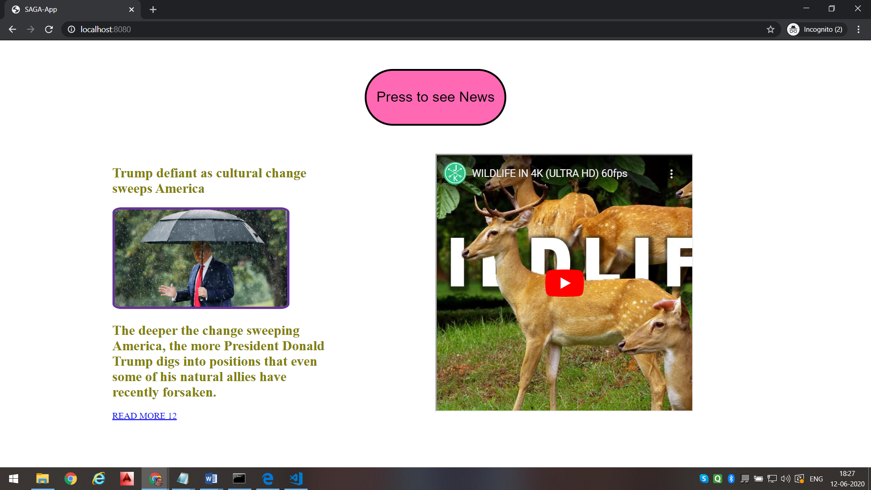

Reference: <http://www.kvcodes.com/2015/01/how-to-align-two-divs-horizontally-in-html-by-using-css/>

<https://www.quora.com/How-do-I-show-Google-com-in-IFrame>

<https://github.com/Lavitr/React-Redux-SAGA-tutorial-APP>