**CHAPTER 1**

**INTRODUCTION**

# 1.1 GENERAL

A **water tank** is a container for storing water. Water tanks are used to provide storage of water for use in many applications, [water,](https://en.m.wikipedia.org/wiki/Drinking_water) [irrigation,](https://en.m.wikipedia.org/wiki/Irrigation) agriculture,  [fire](https://en.m.wikipedia.org/wiki/Fire) suppression, [agricultural](https://en.m.wikipedia.org/wiki/Agricultural) farming, both for plants and livestock [chemical](https://en.m.wikipedia.org/wiki/Chemical) manufacturing, [food preparation](https://en.m.wikipedia.org/wiki/Food_preparation) as well as many other uses. [Water](https://en.m.wikipedia.org/wiki/Water) tank parameters include the general design of the tank, and choice of construction materials, linings. Various materials are used for making a water tank  [plastics](https://en.m.wikipedia.org/wiki/Plastics) [(polyethylene,](https://en.m.wikipedia.org/wiki/Polyethylene) [polypropylene)](https://en.m.wikipedia.org/wiki/Polypropylene), [fiberglass,](https://en.m.wikipedia.org/wiki/Fiberglass) [concrete,](https://en.m.wikipedia.org/wiki/Concrete) [stone,](https://en.m.wikipedia.org/wiki/Rock_(geology)) [steel(](https://en.m.wikipedia.org/wiki/Steel)welded or bolted, carbon, or stainless). Earthen pots also function as water storages. Water tanks are an efficient way to help developing countries to store clean water. Throughout history, [wood,](https://en.m.wikipedia.org/wiki/Wood) [ceramic](https://en.m.wikipedia.org/wiki/Ceramic) and [stone](https://en.m.wikipedia.org/wiki/Rock_(geology)) tanks have been used as water tanks. These containers were all naturally occurring and some manmade and a few of these tanks are still in service. The [Indus Valley Civilization](https://en.m.wikipedia.org/wiki/Indus_Valley_Civilization) (3000–1500 BC) made use of [granaries](https://en.m.wikipedia.org/wiki/Granary) and water tanks. [Medieval](https://en.m.wikipedia.org/wiki/The_Middle_Ages) [castles](https://en.m.wikipedia.org/wiki/Castle) needed water tanks for the defenders to withstand a siege. A wooden water tank found at the [Nuevo State Reserve](https://en.m.wikipedia.org/wiki/A%C3%B1o_Nuevo_State_Reserve) [(California)](https://en.m.wikipedia.org/wiki/California) was restored to functionality after being found completely overgrown with [ivy.](https://en.m.wikipedia.org/wiki/Ivy) It had been built in 1884.

## 1.2 TYEPS OF TANKS

**Chemical contact tank** of FDA and NSF polyethylene construction, allows for retention time for chemical treatment chemicals to "contact" (chemically treat) with product water.

**Ground water tank**, made of lined carbon steel, may receive water from a water well or from surface water, allowing a large volume of water to be placed in inventory and used during peak demand cycles.

**Elevated water tank**, also known as a [water tower,](https://en.m.wikipedia.org/wiki/Water_tower) will create a pressure at the ground-level outlet of 1 kPa per 10.2 cm or 1 psi per 2.31 feet of elevation. Thus a tank elevated to 20 metres creates about 200 kPa and a tank elevated to 70 feet creates about 30 psi of discharge pressure, sufficient for most domestic and industrial requirements.

Vertical cylindrical dome top tanks may hold from 200 litres or fifty gallons to several million gallons. Horizontal cylindrical tanks are typically used for transport because their low-profile creates a low centre of gravity helping to maintain equilibrium for the transport vehicle, trailer or truck.

A Hydro-pneumatic tank is typically a horizontal pressurized storage tank. Pressurizing this reservoir of water creates a surge free delivery of stored water into the distribution system. By design, a water tank or container should do no harm to the water. Water is susceptible to a number of ambient negative influences, including [bacteria,](https://en.m.wikipedia.org/wiki/Bacteria) [viruses,](https://en.m.wikipedia.org/wiki/Viruses) [algae,](https://en.m.wikipedia.org/wiki/Algae) changes in [pH,](https://en.m.wikipedia.org/wiki/PH) and accumulation of [minerals](https://en.m.wikipedia.org/wiki/Minerals) accumulated [gas.](https://en.m.wikipedia.org/wiki/Gas) The contamination can come from a variety of origins including piping, tank construction materials, animal and bird faeces, mineral and gas intrusion. A correctly designed water tank works to address and mitigate these negative effects. It is imperative that water tanks be cleaned annually to preclude delivery of algae, bacteria and viruses to people or animals.

# 1.3 TRADITIONAL METHOD OF CLEANING

The traditional or ordinary method of cleaning the water tank is still an old process.

## 1.3.1 LIFTING A BOY INSIDE A TANK

In this process, to clean the water tank, a small boy is lifted and placed into the tank. After cleaning the tank, the boy is lifted out. This is a method which is followed on the rural areas. This is not a hygienic method of cleaning the water tank, since the germs and infectant may affect the life of the boy.

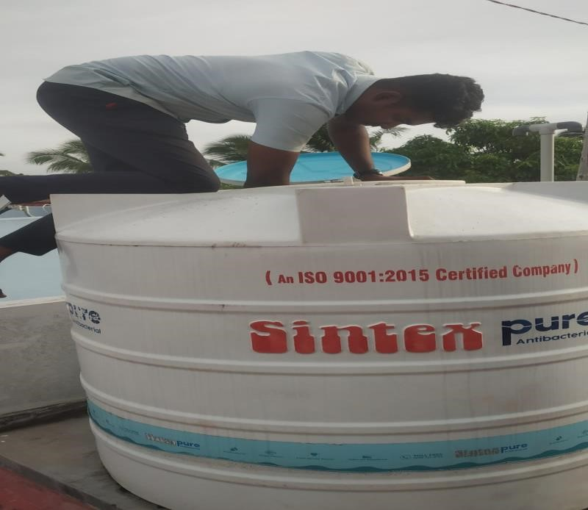

Fig 1.1 a boy placed on the tank to clean it

## 1.3.2 BY USING A MOP

In this type of cleaning a water tank, a mop is used to clean the tank and it is the widely used method in the urban areas. But still this is not an effective method of cleaning a water tank. Here the human power is very much needed. By using a mop, we cannot assure that the waste will be removed thoroughly.

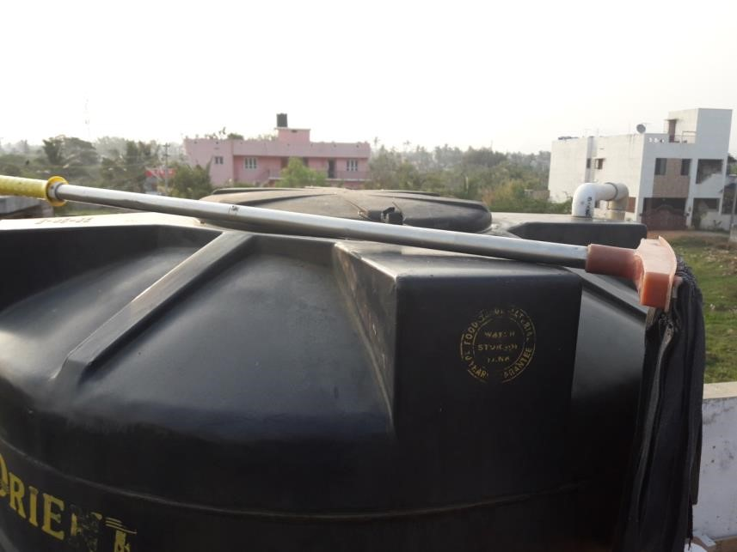

Fig 1.2 cleaning a tank by a MOP

# 1.4 IMPURITIES IN WATER TANK

Pure water is colorless, tasteless, and odourless and is chemically composed of just two elements, hydrogen and oxygen. Because water is such a good solvent, it dissolves almost everything that comes into contact with it. Water is known as a ‘universal solvent’. That is why water is not pure from water that is available to us from rain, well, streams, rivers, etc., due to the lack of availability of clean safe drinking water in India. The usual contaminants and types of impurities in water are of the following three main categories.

## 1.4.1 DIRT OR SUSPENDED SOLIDS

These are the solids which are insoluble like dust, fine sand, clay, rust, etc. They remain suspended in the water and cause muddy water or cloudiness in water. ‘Total Suspended Solids’ or ‘TSS’ is the technical term used to measure how much of dirt there is in the muddy water and a unit of measurement of cloudy water is based on the transmission of light through the muddy or cloudy water.

A simple filter usually called a sediment filter, with pore size of 20 microns or lower can remove almost all of the suspended matter in muddy water. Also the use of flocculants like Alum is widely used to settle and clear muddy water. Muddy water after passing through a simple filter may be good for drinking, as long as there is no contamination with germs and dissolved chemicals.

## 1.4.2 GERMS IN WATER

Biological contamination water is caused by the presence of living organisms like algae, bacteria, protozoa, pathogens, microbes, viruses, parasites and their eggs, etc. commonly known as microorganism and commonly called germs. The health effect of drinking water contaminated with germs may be severe, but easily curable with modern day medicine. These minute living organisms in water are the causes of diseases from dirty water like typhoid fever, dysentery, cholera, gastroenteritis, etc. Water tanks can sometimes be a breeding ground for microbes in water. In the usual test for microorganisms, only one group of bacteria known as coliform or ecoli is tested for, this is because it is the most common species, and the first organism to infect water.

## 1.4.3 CHEMICALS FOUND IN WATER

The problem with chemicals in water is that they dissolve in water and cannot be removed by simple filtration. ‘Total Dissolved Solids’ or ‘TDS’ is the technical term used to give a measure of the amount of dissolved matter in the water and is usually expressed as ‘ppm’ which stands for ‘parts per million’ or ‘milligrams per liter’ (mg/l).

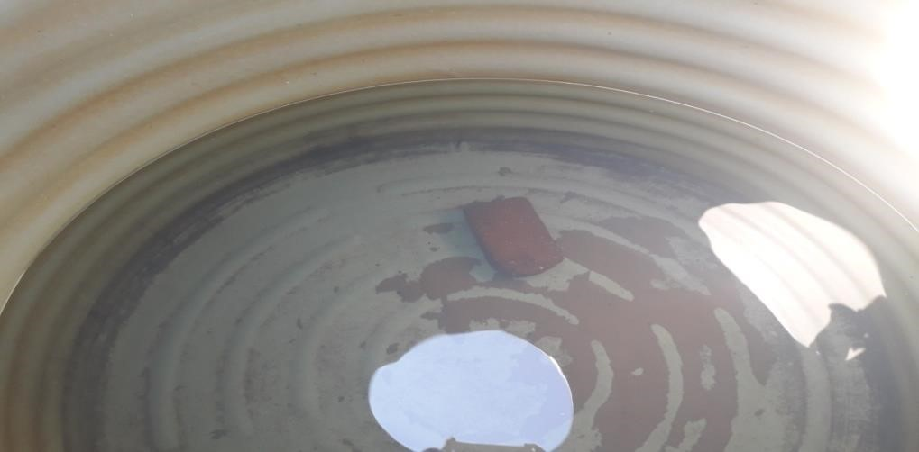

Fig 1.3 sediments found in the tank

# 1.5 PURPOSE

In today’s era automation plays a very important role in all industrial applications for the proper disposal of sewage from industries and household is still a challenging task. Water tank cleaning the adequate disposal of waste and unfortunately sometimes there may be a threat to human life during the cleaning of water tank or it can cause serious health issues because of pertaining problems like malaria, dengue, etc. In order to overcome this problem as well as to save the human life we implement a design **“House Tank Cleaning Equipment”**.

# 1.6 OBJECTIVE

We designed our project in order to use it in an efficient way to clean the water tank. And we use the brush attached with motor for the cleaning purpose and we use the pump to remove the waste water from the tank.

**CHAPTER 2**

**LITERATURE SURVEY**

# 2.1 INTRODUCTION

The modern world is running with automatic and updated techniques. But the cleaning process of homely water is still done by traditional method, where the Engineers had invented robots and hi-tech machines for cleaning the large storage tank such as petrol, diesel, cooking oil, chemical oil etc.

The Engineers focus on cleaning homely water tank is very less. Since the homely water tank is clean by house wife .so it is necessary to invent a water tank cleaning machine.

# 2.2 REVIEW

A man from kottayam named prasad invented a design for water tank, where he got a PATENT RIGHTS approval from chennai.

# LIFE OF PRASAD

Prasad is 45 years old man from kottayam, who had passed S.S.L.C in kottayam government school in kerala state. He had been working as a plumber for the past six years,where he had gained good knowledge in plumbing works.

Usually prasad has undergo,on cleaning the watertank of his house .where he find difficulty and lack of energy during the process. Finally he had come into the conclusion to invent a water tank cleaning machine by his own knowledge

# RISE OF CREATIVITY

He used to visualise the water tank daily to get idea for his inventions. From his deep investigation, he had design a machine which is capable of removing the impurites without letting the water out. He plan to collect the sand sediment which may found in bottom of water tank.

# 2.3 DESIGN OF THE MACHINE

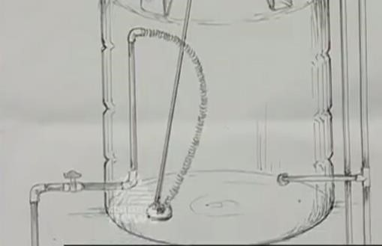

Fig 2.1 design of the machine

The machine is designed to clean the water tank only at the full load of water condition. Where it doesn’t work in the empty tank .In empty tank there is lack of water pressure. The machine is complety works on the pressure of the water. It consists of PVC pipe, floating hoses, rectangular brush and tiny wheel to rotate the brush etc.

# 2.4 WORKING

Initially set the water at the three fourth level. A PVC pipe is made to contact with bottom outlet and placed perpendicular to level of water. A disk which is attached with the fixed rectangular brush at its top and bottom. And also it consists of tiny rotating wheel at its left and right end. In addtion to such things, the disk also has a hole of 30mm diameter hole at the centre to suck the impurites. Where in the upper surface there is a small extended piece to hold the disk to required direction by the help of PVC pipe.

The diameter of the disk is 10cm.where one end of the floating hoses is connected in the center hole of the disk and the other end is connected to the perpendicular PVC pipe. When the disk is exhibited towards the bottom surface, the impurites gets inside the center hole of the disk with water.This happens due to the pressure in the water.

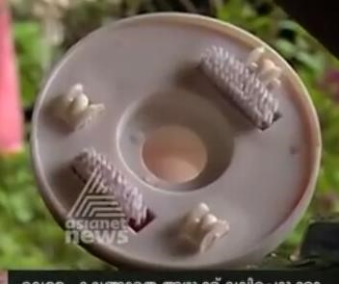

Fig 2.2 bottom view of the machine

# RUBBING DISK

Thus the impure water comes outside via perpendicular PVC pipe towards the outlet of the tank. Here the water will not undergo any kind of disturbance during the process. Since the sediments are settle down in bottom of the water tank

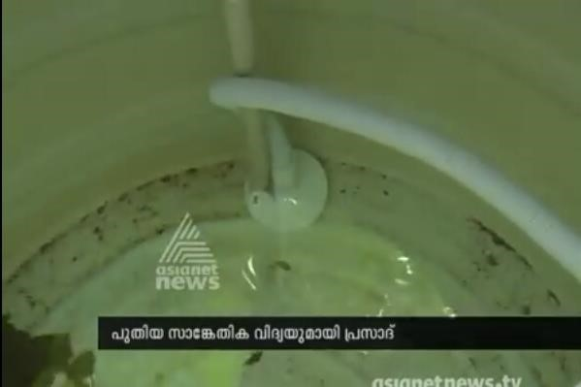

Fig 2.3 working process of the machine

# 2.3 PATENT RIGHTS APPROVAL

Prasad had submitted all the written documents to WTO office (world trade organization) at Chennai for the approval Trade mark and Patent rights.

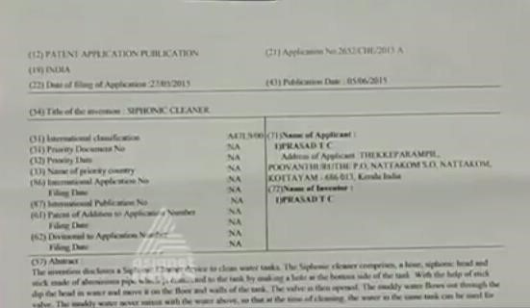

Fig 2.4 patent approval form

Prasad had hold a patent rights and trade mark in the year of 2015 and now he is the production work of is water tank cleaning project towards the market.

**CHAPTER 3**

**METHODOLOGY AND DESCRIPTION**

# 3.1 COMPONENTS USED

The major components of this project are,

* Motor
* Adaptor
* Pump
* Regulator IC
* Brush
* Indicator switch

## 3.1.1 MOTOR

A motor is a mechanical device which is powered by electricity or any other external source that supplies the motive power to the brush of 6cm diameter. Here the DC motor is capable of running in both 12 volt and 24 volt with 1.2A of current .The motor cannot be run manually without electricity, since it is a stepper motor.

The motor runs at 2800 rpm at no load condition and runs at 2200 rpm at load condition, where it is connected to the brush. The outer diameter of the axle is

2.5mm.The gear attached to the shaft is removable.

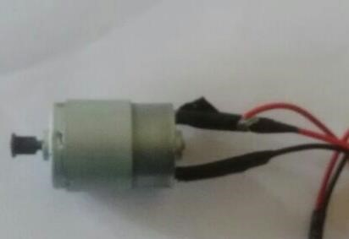

Fig 3.1 motor

## 3.1.2 ADAPTOR

Here the adaptor acts as a rectifier which converts the AC current into DC current. It is necessary to convert the AC into DC current, since the motor is in contact with the water in the tank. For the better safety purpose, it is good to have DC current. The capability of the adaptor is 24volt, which converts the 230 AC voltage into 24

DC voltage. Again the 24 volt is step down into 12 volt by a regulator IC (L7812CV). Where the pump runs at 12 volt to suck the impure water from the water

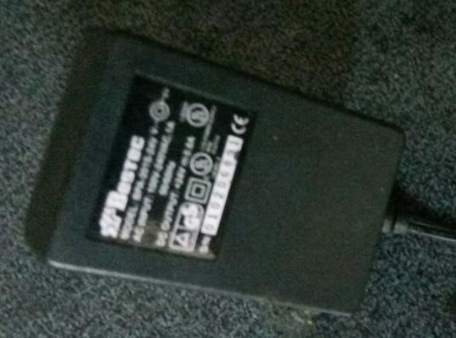

Fig 3.2 adaptor

## 3.1.3 PUMP

A pump is a machine or a device used to force a liquid or gas to flow in a required direction with a constant velocity. The limited voltage of the pump is 12 volt. The size of the pump is 40*90*35(length*width*height). The working voltage of the pump is DC 6-12 volt. The working current of the pump is 0.5-0.7 ampere, where the outlet diameter of the pump is 6mm.

It is free from noise and its sound level is under 30 decibel. The pump can handle pumping heated liquids up to a temperature of 80 degree Celsius. And it has a suction limit of up to 2m where it can pump water vertically for up to 3 meter. The pump has a filter inside as well as a suction cup which helps in proper functioning.

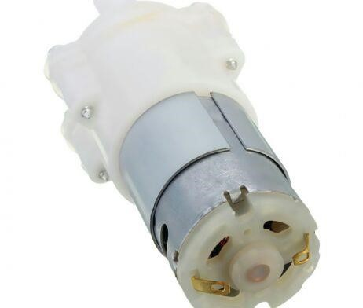

Fig 3.3 pump

## 3.1.4 REGULATOR IC

A voltage regulator IC maintains the output voltage at a constant value.The regulator IC employed here is (L7812CV), where the series 78 represent the fixed liner voltage and the series 12 represent the output voltage of the regulator IC. It avoids the voltage fluctuation, here the adaptor receives 24 volt, where regulator IC step down the 24 volt into 12 volt. Absence of regulator IC cause damage to pump due to the over load of voltage, since the limited voltage of the pump is 12 volt.

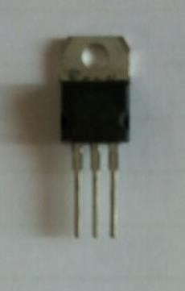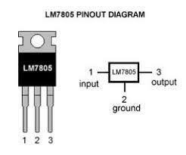

Fig 3.4(a) regulator IC Fig 3.4(b) regulator IC pinout diagram

## 3.1.5 CIRCULAR BRUSH

A circular brush is used to remove the impurities which get adhere on the internal surface of the water tank. The diameter of the brush is 6.5cm, which has a plastic hair of 5cm length.

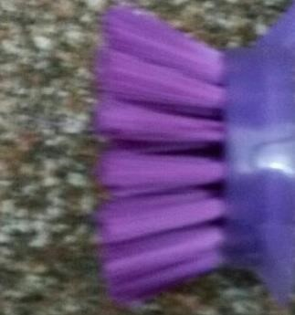

Fig 3.5 brush

## 3.1.6 INDICATOR SWITCH

A switch is an electrical component that can make or break an electrical circuit. The purpose of indicator switch is to control two devices by using a single switch. Here the indicator switch is used to control both the pump and motor. It also has a neutral position where the pump and motor remains unchanged.

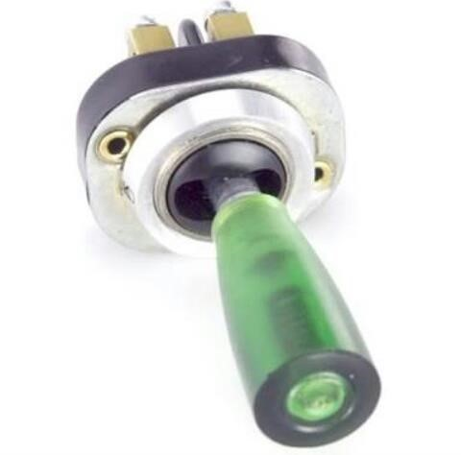

Fig 3.6 indicator switch

# 3.2 DESIGN CALCULATION

## 3.2.1 DESIGN OF MOTOR

Descriptions details of the motor

* Voltage(V) = 24V
* Current(I) = 1.1A
* Speed (N) = 1800rpm
* Torque(Ʈ) = .094 Nm

The efficiency of the motor is given by

E = (mechanical output power) ÷ (electrical input power)

E = P out /P in

Power input = voltage × current

P input = V× I

P in = 24 × 1.1

P in = 26.4 watts

Power output = torque × angular velocity

P out = Ʈ × ω

Angular velocity (ω) = 2 Л N / 60

ω = 2 × Л × 1800 /60 ω = 188.49 rad/s

P out = 0.094 × 188.49

P out = 17.71 watts

Efficiency (E) = (17.71 / 26.4) × 100

E = 67.08%

Therefore the efficiency of the motor = 67.08%

## 3.2.2 DESIGN OF PUMP

Descriptions details of the pump

* Voltage(V) = 12V
* Current(I) = 0.8A
* Speed (N) = 1100rpm
* Torque(Ʈ) = .051 Nm

The efficiency of the Pump is given by

E = (mechanical output power) ÷ (electrical input power)

E = P out /P in

Power input = voltage × current

P input = V× I

P in = 12 × 0.8

P in = 9.6 watts

Power output = torque × angular velocity

P out = Ʈ × ω

Angular velocity (ω) = 2 Л N / 60

ω = 2 × Л × 1100 /60 ω = 115.19 rad/s

P out = 0.051× 115.19

P out = 5.874 watts

Efficiency (E) = (5.874 / 9.6) × 100

E = 61.19%

Therefore the efficiency of the pump = 61.19%

# 3.3 DESIGN MODELLING

## 3.3.1 TWO DIMENSIONAL VIEW

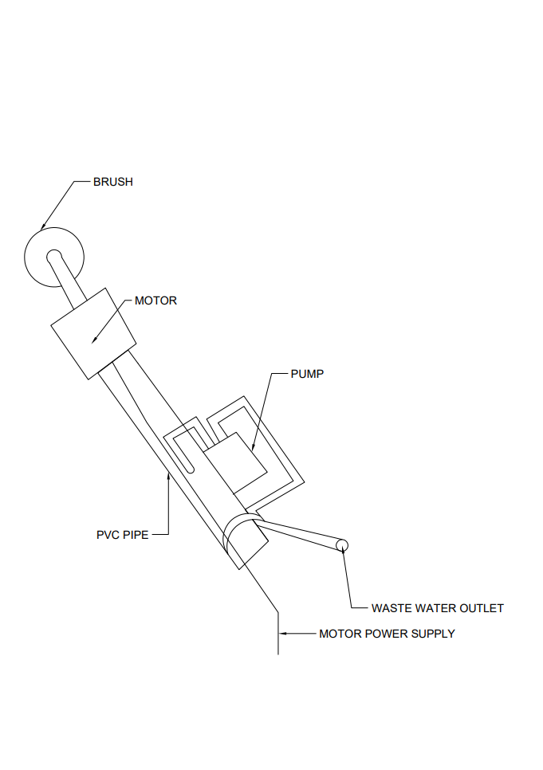

Fig 3.7 2D view of the instrument

## 3.3.2 THREE DIMENSIONAL VIEW

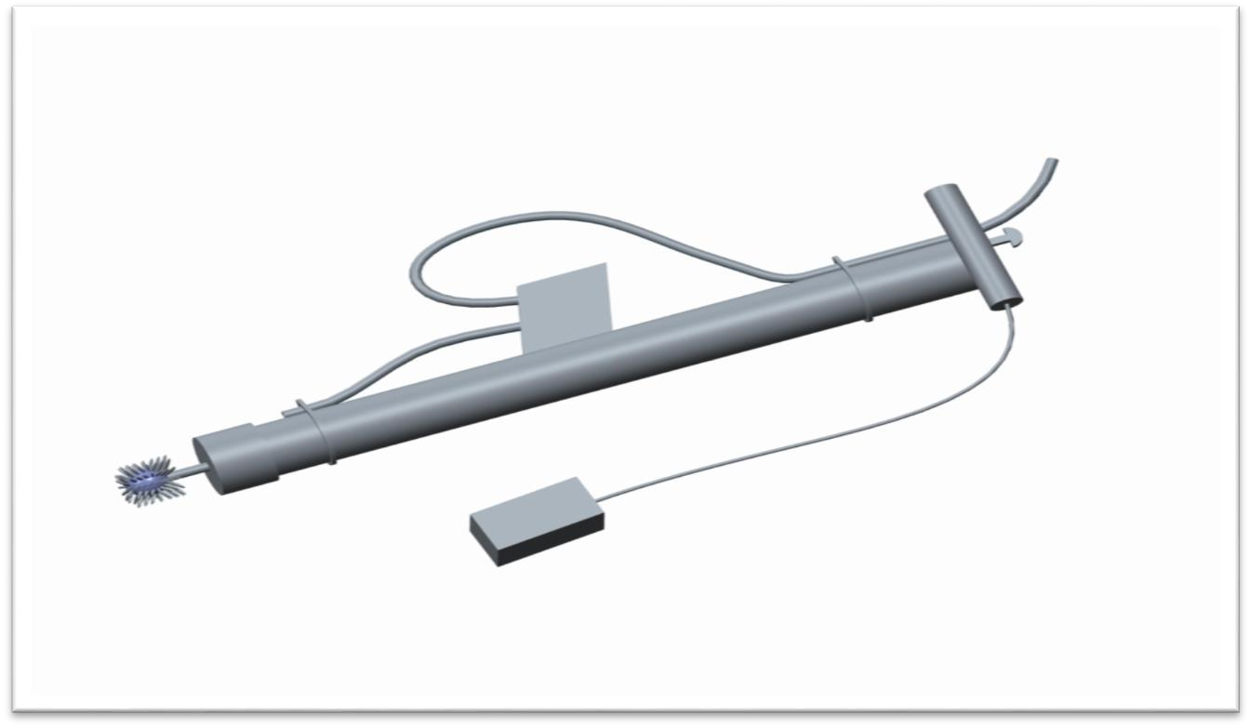

Fig 3.8(a) horizontal view of instrument

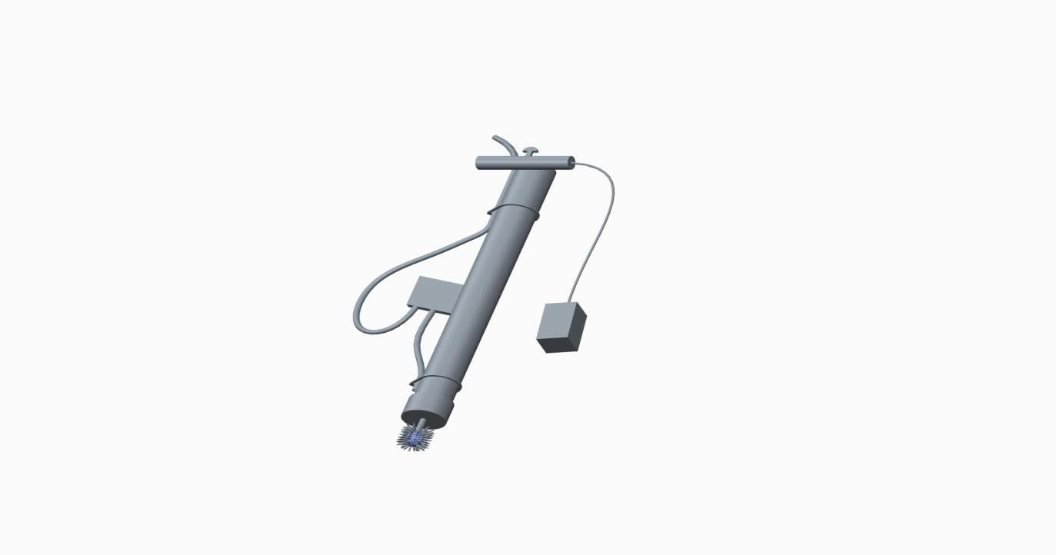

Fig 3.8 (b) vertical view of instrument

**CHAPTER 4**

# WORKING OF MACHINE

Initially a PVC pipe of length 3.5 feet is taken where its bottom end is fixed by a motor of 24 volt. The motor is placed into the PVC pipe by expanding its diameter. Where the outer surface of the motor is coated with araldite afterwards it is inserted into the bottom end of the PVC pipe. A circular brush of 7cm diameter is taken, where it is drilled at its centre point of 4mm diameter. The internal surface of the brush hole is coated with the araldite. Afterwards it fixed into the shaft of the motor, where wire connection is given to both positive and negative terminal. A pump of 12 volt is fixed above the top of the PVC pipe which has one outlet and inlet. The diameter of both inlet and outlet are same. The suction tube of length 0.5 meter is inserted into the inlet of the pump, where the suction tube of length 2 meter is inserted into the outlet of the pump. Finally the suction tubes are tagged along with PVC pipe. Similarly the wire connection is given to the both positive and negative terminal. The top end of the PVC pipe is closed with the T-section PVC pipe, where an indicator switch is placed above to it. Here the indicator switch is used to operate both pump and motor. Finally the power supply is given to the indicator switch by means of an adaptor, where the adaptor acts as a rectifier. Here the adaptor converts 230 AC voltage into 24 DC voltage, thus 24 volt reaches the indicator switch, where it supplies directly to the motor. While in the case of pump the voltage is step down into 12 volt by using a regulator IC. The both end of the T-section is closed by an end cup, where the wire connection is taken out by drilling the left side end cup of the T-section. Initially the indicator switch is in neutral position, by lifting switch to right side, the motor get rotated simultaneously the brush also get rotated and it is projected towards the internal surface of the water tank. Thus the impurities get mixed to the water which can be sucked by using the pump. Finally, the water tank is free from impurities by using this machine.

# 4.1 BLOCK DIAGRAM

2

way switch

Adaptor

(24V)

M

otor

(24

V, 2200rpm

)

Pump

(12

V, 1200rpm

)

Brush

(7

cm dia

)

Tube

m length

)

(3

Removing of dirt

particles

Sucking out the

dirt water

Fig4.1 block diagram

**CHAPTER 5**

**ADVANTAGES & APPLICATIONS**

# 5.1 ADVANTAGES

* Cost of production is low.
* It is an eco-friendly process.
* Handling the machine is very easy.
* The machine is very simple and less in weight.
* Machine is portable.
* Highly adjustable.
* Pump is attached so that dirt water is easily sucked out.
* Power consumption is very less.
* No need of separate power input for motor and pump.
* It can clean any kind of tank.

**5.2 APPPLICATION**

* Any kind of water tanks can be cleaned.
* It is applicable to clean any kind of dirt places.
* It can be used to clean aquarium fish tank.
* Since, there is a rotating motor it can be used to clean the wall.

**CHAPTER** **6**

**COST ESTIMATION**

# 6.1 RAW MATERIAL COST

|  |  |  |  |
| --- | --- | --- | --- |
| **COMPONENT** | **COST** | **NUMBER** | **TOTAL** |
| Adaptor | 400 | 1 | 400 |
| Motor | 350 | 1 | 550 |
| Pump | 600 | 1 | 600 |
| Tube | 10/mt | 3mt | 30 |
| Brush | 30 | 1 | 30 |
| Indicator switch | 55 | 1 | 55 |
| Regulator IC | 55 | 1 | 55 |
| Nuts & Bolts | 5 | 5 | 25 |
| PVC pipe | 15/ft | 3.5ft | 52 |
| Wire | 8/mt | 6mt | 48 |
| Araldite | 50 | 1 | 50 |
| Plastic tag | 2 | 10 | 20 |
| End cup | 10 | 2 | 20 |
| Insulation tape | 10 | 1 | 10 |
| **TOTAL** |  |  | **1945** |

**Tab 6.1 Raw Material Cost**

# 6.1 MACHINING COST

|  |  |
| --- | --- |
| **PROCESS** | **COST** |
| Drilling & soldering | 80 |
| Cutting | 25 |
| **TOTAL** | 105 |

**Tab 6.2 Machining Cost**

**Raw Material Cost = 1945**

**Machining Cost = 105**

**TOTAL COST = 2050**

**CHAPTER 7**

# CONCLUSION

In the treatment of water in water tank, it is controlled by motor, adaptor, and pump. Waste water in water tank is treated through our project to avoid water borne diseases. In this world many kind of diseases are increasing and most of them are caused by stagnated water. To remove that unclean water and to clean the water tank our project **House Tank Cleaning Equipment** can be used. By this system human risk of cleaning tank can be reduced and the clean and hygienic life can be maintained.

**CHAPTER 8**

# REFERENCES

1. M. Mohamed Idhris, M.Elamparthi, C. Manoj Kumar, Dr.N.Nithyavathy, Mr. K. Suganeswaran, Mr. S. Arunkumar, “Design and fabrication of remote controlled sewage cleaning Machine”, IJETT – Volume-45 Number 2 -March 2017
2. Mr.Abhijeet.M.Ballade, Mr.Vishal.S.Garde, Mr.Akash.S. Lahane and Mr.Pranav.V.Boob, “Design & fabrication of river cleaning system”, IJMTER Volume 04, Issue 2, [February– 2017] ISSN (Online):2349–9745.
3. Mr. P. M. Sirsat, Dr. I. A. Khan, Mr. P. V. Jadhav, Mr. P. T. Date, “Design and fabrication of River Waste Cleaning Machine”, IJCMES 2017 Special Issue-1 ISSN: 2455-5304
4. Pankaj Singh Sirohi, Rahul Dev, Shubham Gautam, Vinay Kumar Singh, Saroj Kumar, “Review on Advance River Cleaner”, IJIR Vol-3, Issue-4, 2017 ISSN: 2454-1362.
5. Ndubuisi.c. Daniels, “Drainage System Cleaner A Solution to Environmental Hazards”, IRJES) ISSN (Online) 2319-183X, Volume3, Issue 3(March 2014)
6. Osiany Nurlansa, Dewi Anisa Istiqomah, and Mahendra Astu Sanggha Pawitra, “AGATOR (Automatic Garbage Collector) as Automatic Garbage Collector Robot Model” International Journal of Future Computer and Communication, Vol. 3, No. 5, October 2014.
7. Basant Rai, “Pollution and Conservation of Ganga river in modern India”, International Journal of Scientific and Research Publications, Volume 3, Issue 4, April 2013 1 ISSN 2250-315
8. Huang Cheng, Zhang Zhi*,“Identification of the Most Efficient Methods For Improving Water Quality in Rapid Urbanized Area Using the MIKE 11 Modelling System”, 2015 Seventh International Conference on Measuring Technology and Mechatronics Automation.
9. Emaad Mohamed H. Zahugi, Mohamed M. Shanta and T. V. Prasad, “Design Of Multi-Robot System For Cleaning Up Marine Oil Spill”, IJAIT Vol. 2, No.4, August 2012.

Prof.S N.G. Jogi, Akash Dambhare, Kundan Golekar, Shubham Take, “Efficient Lake Garbage Collector By Using Pedal Operated Boat”, IJRTER Volume 02, Issue 04; April 2016 ISSN: 2455-1457.

1. Ankita B.Padwal, Monica S. Tambe, Pooja S. Chavare, Reshma K. Manahawar, Mitali S. Mhatre, “Review Paper on Fabrication Of Manually Controlled Drainage Cleaning System”, IJSER, Volume 8, Issue 3, March-2017 ISSN 2229-5518.
2. Kalpakjian, Serope; Steven R. Schmid (2001). “Manufacturing Engineering and Prentice Hall”. ISBN 0-201-36131-0.

**CHAPTER 9**

# PHOTOGRPHIC VIEW

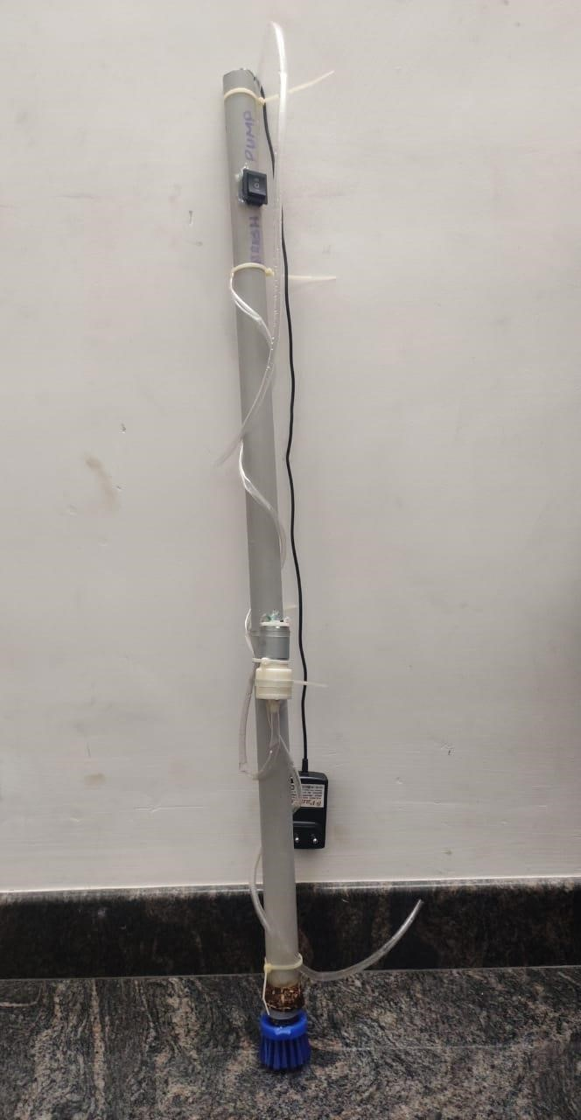

Fig 9.1 water tank cleaning instrument

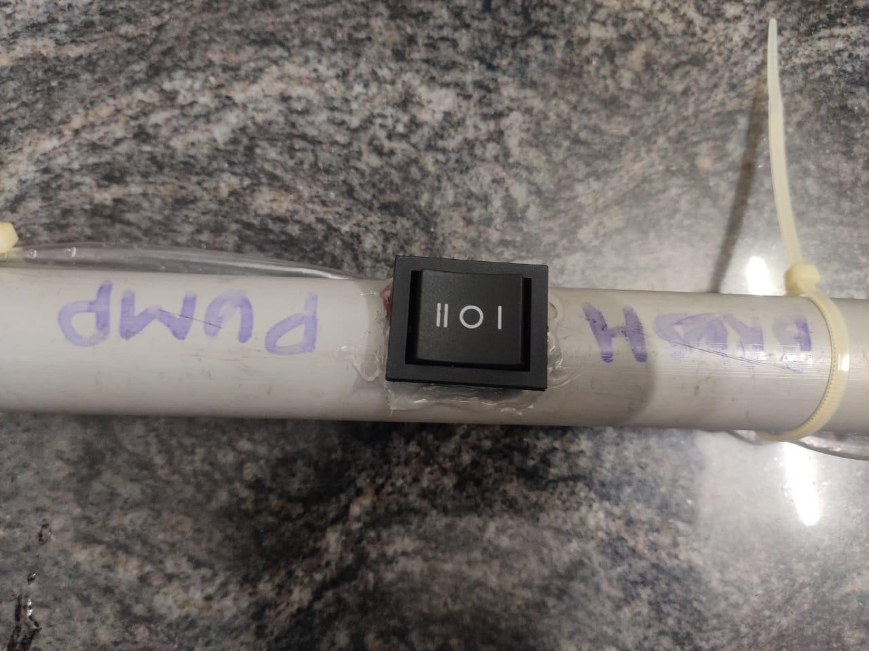

Fig 9.2 top view showing indicator switch