

# Preparation 2/05: How to make your own design out of any material

Mohammad Amir

# Intro

Having our components function just like we want but we can’t place it on the RC-car. Then we wondered if we could make a holder for every component, like a table to glue everything on. In this preparation we are going to use a laser cutter to make our shapes fit on the RC car.

# Materials and Methods

On our campus we have a laser cutter Thunderlaser in the Z-block. Over there we used some Plexiglas to cut our shapes from. On the computer we used the software RDworks to make our design of the shape we were going to cut.

# Results

Since it was our first time using a laser cutter the result did not match our desires at first time. We chose the wrong starting point which resulted in cutting off the edges. Secondly, the cutter was moving too fast so our shapes were not cut off the sample Plexiglas. And another problem was the size for the shape of the SR04 sensor did not match. 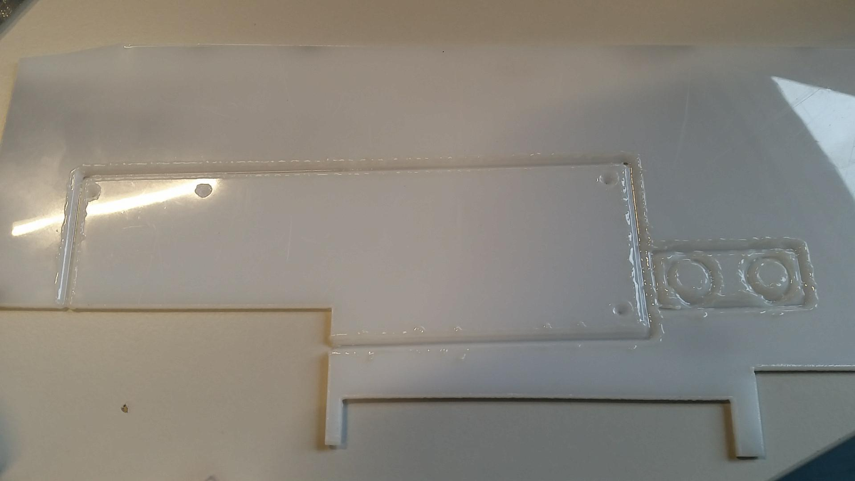

So eventually we remeasured the dimensions and placed the laser in a better starting point. We also let the laser mover slower so it would cut through the plexi.

# Information & conclusion

#### In the RDworks software you have to make a file in .rd extension , the laser cutter can only read these files. You can choose if you want to cut through the material or just engrave it into the material. That can be done by selecting different colours for different layers. Distance between 2 figures can be adjusted in the work bar above. In the left toolbar you can select different figures. When selecting a figure you can adjust the height or width of the figure. When you finished your shapes, you can simulate how the laser will print it by pressing the preview button.Afbeeldingsresultaat voor laser cutter software

Always make sure you take extra space so your screws will fit in the holes of the Plexiglas. Also make sure you take enough space between different shapes.

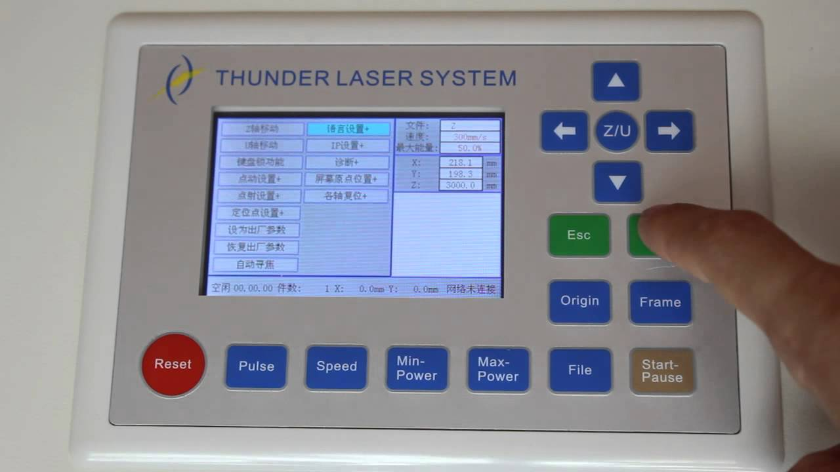

When you made your file you can use an USB-stick to transfer the file to the laser cutter. On the laser cutter screen navigate to file -> read from USB, select the file you want to insert into memory and write it into memory. Then go back to file and select it, the preview will be shown on the screen. Insert your material frame and adjust the position of the laser. That can be done by moving the laser with the arrow keys and pressing the origin button for changing its starting point. You can always check where the laser cutter will cut by pressing the frame button. That shows the outter lines of the preview screen. With the pulse button you can check how strong the laser will be and at which spot it is on your material. Adjust the right height of the laser(Z-axis movement). if everything is set correctly you can start by pressing the start button. Make sure that the cooling system is activated and the ventilation is on or else there will be smoke coming out of the laser and a bad smell will fill the room.

When the shapes have been cut the only thing that we have to do is screw it on the RC car. 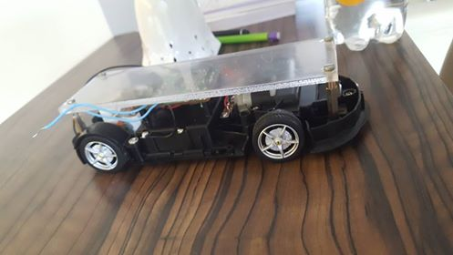

# Reference List