

# Title: programming of the code into the NodeMCU

# Amir, Mohammad Ali

# Intro

We are going to code our NodeMCU with ESP8266 in this report. This will be done in the Arduino IDE by selecting the correct board in the boards tab.

# Information And Conclusion

Now, since we are using wifi to communicate with the car, we need to declare a name and password to connect to the wifi-network in the code. Most codes use a webserver to connect to the car by their ip address. To know this ip address, we will have to run the program with a serial monitor and implement a serial output display in the code. The code will be used to let the 2 cars interact which each other so whenever the first car breaks, the other would do as well. The coding language is mainly C/C++ style written.

In the code we configure the pins which will be used by a function on the nodemcu with ESP8266, so if a certain pin has the functionality of driving a motor, then we will have to connect that pin to the correct pin on the motor driver. Note: we are using the rc car’s own motor driver, we are not adding an extra board on the car.

The main code that will be running should have a loop, so it will keep on waiting until it gets a command from the client. After programming, you should not forget to program it into the nodemcu.

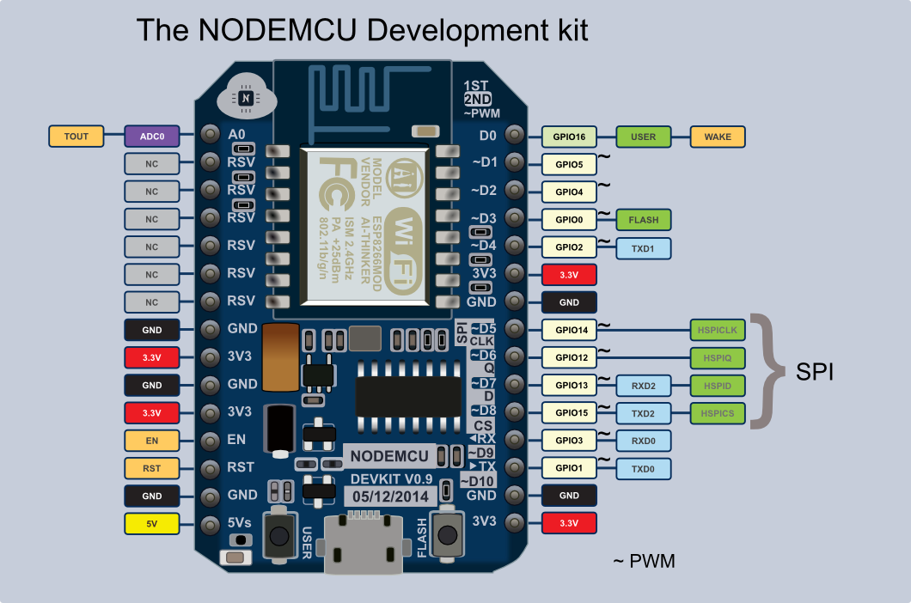

# Referentielijst

<https://www.geeker.co.nz/accessories/esp8266-nodemcu-development-board.html>

# Bijlagen

Het verslag bevat enkel de belangrijkste resultaten. In de bijlagen kunnen extra figuren, tabellen of documenten opgenomen die verklarend kunnen zijn maar niet essentieel zijn voor het betoog van het verslag. Verwijs er ook naar in je tekst..