

# Title: UDP packets to nodeMCU

Mohammad, Amir

# Table of contents:

Enkel nodig bij lange verslagen waarin bijvoorbeeld verschillende deel-opdrachten zijn opgenomen

# Intro

How can we make a connection between 2 computers? What kind of connections are they and what are their benefits? But more importantly in this case, how can we make a connection between our Ubuntu server and the nodeMCU?

In this report we will find an answer for these questions.

In de inleiding plaats je een algemene verduidelijking.

Vermeld het onderwerp van de opdracht, de context waarin het kadert en de doelstellingen van de uitgevoerde opdracht.

Het tweede deel van de inleiding licht de opbouw van het werk en de samenhang van de delen nader toe, met de nadruk op de logische volgorde van wat de lezer zal te lezen krijgen.

De inleiding geeft de lezer een inzicht in gestelde probleem en het gepresteerde werk, waardoor hij wordt aangezet tot verdere lectuur..

Tip: schrijf de inleiding pas nadat de hoofdtekst volledig is uitgeschreven, dan heb je een duidelijker zicht op de problematiek en de logische opbouw van het werk.

# Materials and Methods

We will use our laptop and some software to run our Ubuntu server on. This software will be VMware or Virtualbox to run our virtual machine on. Next we need the Ubuntu server installed or the correct virtual image to install the Ubuntu server. Ubuntu server is a Linux OS, which means the server makes use of the bash shell to execute commands. We only need some bash shell commands, so we can use the datasheets for those commands (like netcat or echo). There also exist third party software which will send packages for you to a specific ip address. In this case, we use the Package Sender.

Beschrijft alle materialen (software, apparatuur,…) en methoden die gebruikt werden in detail.

Beschrijf de methodes voor het verzamelen en verwerken van de resultaten die je gebruikte..

Neem alle informatie op die nodig is om het werk te herhalen.

Resultaten of conclusies mogen in dit deel niet voorkomen.

# Results

Connections between 2 computers can be done wireless (Antenna with receiver and transmitter) or wired with a cable (UTP most often used). The ip address of both pc’s should be in the same subnet to have a local connection.

Making connections can be done in different ways. CO (Connection Oriented) is a good way to make sure the package will be delivered. However, this takes more time to make the connection and to end the connection. The connection has to be set up by sending starting frames and displaying eachothers buffers to check either you can send your packages or receive more packages from the other side. In case of master-slave connection ofcourse you will only receive or send packages depending on your rights to do so. TCP is a typical example of CO connection in Layer 4. In CL (Connection Less) you don’t have these handshaking frames, no buffers, just straight it sends its frame and hopefully it will reach its destination. The advantage of this kind of connection is that you will send or receive the frames very quickly but you are not guaranteed that your package will reach its destination, there might occur some faults. This type of connection is highly recommended in connections that have small chance of faults occurring or data that is permissible to have some errors. We are choosing the UDP CL connection, because of its fast speed and we are most likely to have no faults in the connection.

Commonly when using any linux OS there is use of the bash shell. Bash shell is a command processor using a text window to execute commands typed by the user. Sending UDP packets from the ubuntu server should be possible by the following command:

Echo “My data” >/dev/[ip-adres]/[port]

Another way of sending udp packages via ubuntu can be done by using netcat.



For instance, you can use it like this: nc -l -p [LocalPort] -e [FileWithCommandsToBeExecuted]

Check the datasheet below for more information on how to use this command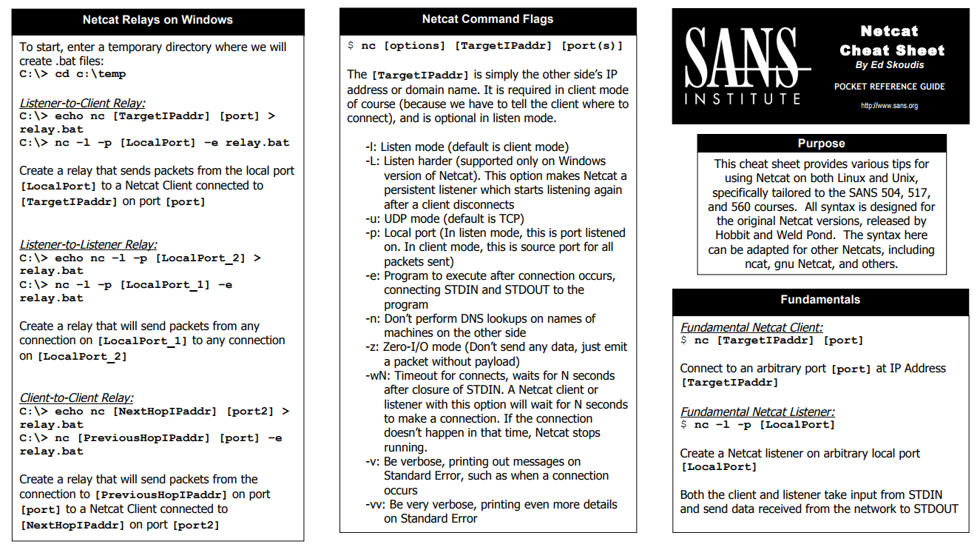

Link datasheet Netcat: <https://www.sans.org/security-resources/sec560/netcat_cheat_sheet_v1.pdf>

We can also use the following application to send packages, the package sender:

<https://github.com/esp8266/Arduino/blob/master/doc/esp8266wifi/udp-examples.rst>

# Information & conclusion

See Results

# Referencelist

Link datasheet Netcat: <https://www.sans.org/security-resources/sec560/netcat_cheat_sheet_v1.pdf>

<https://github.com/esp8266/Arduino/blob/master/doc/esp8266wifi/udp-examples.rst>