 | 
 | Scientific project - Cart-to-car communication
report of the 4th meeting

Date: 21 March 2018, 13u45-17u45

Place: CGB- US213

Present:
President:
Ali Amir
Rapporteur:
Asif Wasefi

Present group members:
Gauthier de Borrekens
Daniel Smetankin
Satish Singh
Absent group members:
None

Agenda
- Follow-up and approval of report of 14 March 2018
- Progress of the project (according to planning document)
- Setting the planning/assignments
- Agreements for the next session

      - Follow-up and approval of report of 14 March 2018
I researched on how to make a WI-FI hotspot on Ubuntu server for the nodeMCU clients to connect to which succeeded without any issues. Ali researched on the other side part of the connection i.e. how to send a UDP packet from the server to our nodeMCU chipsets. Gauthier ensured in his research on how to program a nodeMCU chipset to connect to a Wi-Fi network.
      - Progress of the project
        - Gauthier de Borrekens and Daniel Smetankin
They tried to program the nodeMCU in Arduino IDE (Integrated Development Environment) to connect the chipsets to the hotspot that I made during the session. Daniel worked on programming a DC motor to manipulate the forward/backward rotation of the motor.
        - Ali Amir and Satish Singh
They opened up the RC car and tried to power the RC board. They found out which pins were needed to use in order to make the car move forward/backward. They used a Hameg HM-7042 5 device to power the correct pins with suitable voltage.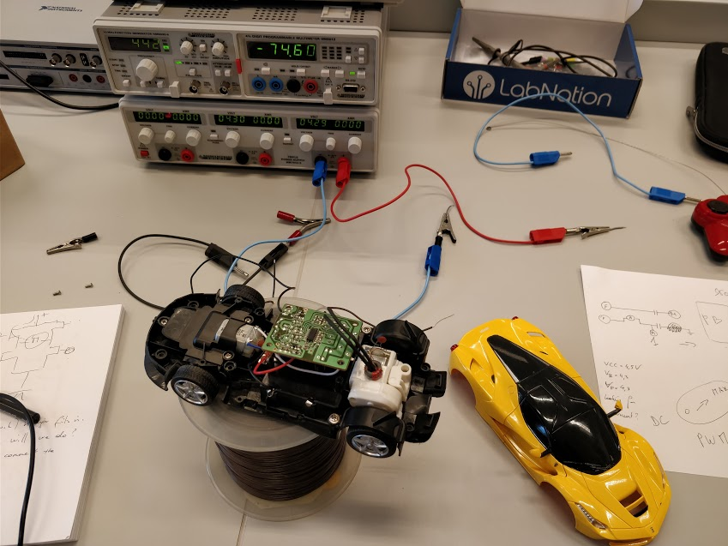
        - Asif Wasefi
I made sure the hotspot is set well and that the nodeMCU can connect to it. A connection was established between the nodeMCU and Ubuntu server with the following IP addresses in blue with the first being the server:
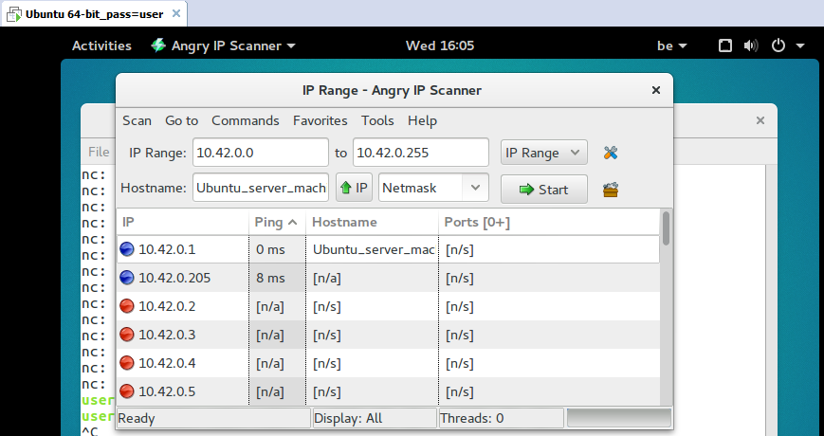

Actual UDP packet transfer via a chosen UDP port (2000 port number in our example):
The “ack” on the third line in the below image shows that the packet is sent and received by the client successfully.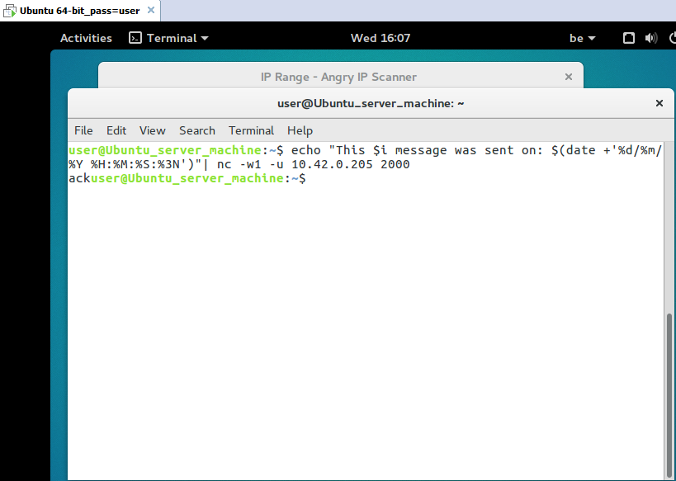
      - Setting the planning/assignments
I will try to get more information on how to establish a UDP connection between the Ubuntu server and the nodeMCU more precisely with the least possible data loss.
Satish has yet to research on how to make a safe voltage stabilizer for our electrical chips and devices to ensure that these things do not get overpowered.
Daniel will try to integrate an H-bridge into the DC motor.
Gauthier will try to research on how to set the Ultrasonic sensor HC-SR04 to determine the mutual distance between the moving RC cars.
Ali will make an overview of a number of measurements in a statistical form. These measurements are the voltage and current applied to the RC car.
      - Agreements for the next session
Date next meeting session: 28/03/2018
President: Daniel Smetankin
Rapporteur: Ali Amir

The president concluded the session and invited all the members to the following meeting.

