## **Group 1-5 Weekly Report - #2**

## List of members

**Group Leader:** [Krupaben Kothadia](mailto:kkothadi@asu.edu)

**Group Deputy Leader:** [Gautham Vijayaraj](mailto:gvijaya6@asu.edu)

**Group Members:** [Krupaben Kothadia](mailto:kkothadi@asu.edu)

* [Avani Mundra](mailto:amudra@asu.edu)
* [Justin Young](mailto:jtyoun15@asu.edu)
* [Anuranjan Dubey](mailto:adubey37@asu.edu)
* [Rahul Nayak](mailto:rrnayak@asu.edu)
* [Sangeeth Santhosh](mailto:ssantho9@asu.edu)
* [Yeshwanth Reddy Chennur](mailto:ychennur@asu.edu)
* [Gautham Vijayaraj](mailto:gvijaya6@asu.edu)

## Submission Details

**Name of member that prepared the report:** [Rahul Nayak](mailto:rrnayak@asu.edu)[Justin Young](mailto:jtyoun15@asu.edu)

**Name of member that submitted this report:** [Gautham Vijayaraj](mailto:gvijaya6@asu.edu)  
**Report is approved by:** [Krupaben Kothadia](mailto:kkothadi@asu.edu)[Gautham Vijayaraj](mailto:gvijaya6@asu.edu)

## 

## Meeting Notes

**09/05/23 - 6:00 p.m. (Mode: Online)**

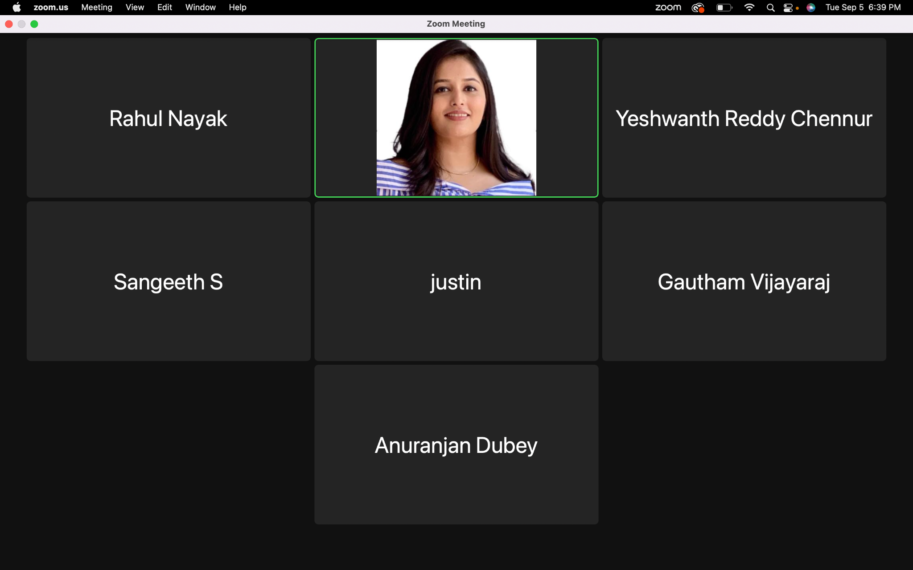

* **Meeting Objective:** Discuss the overall progress of the project,Addressing questions related to adding additional reference papers, discussing an approach to continue the in-depth progress reports, addressing questions and providing information to team members,discussing formatting related questions, task discussion and distribution for project plan.
* **Members present:** [Krupaben Kothadia](mailto:kkothadi@asu.edu)[Justin Young](mailto:jtyoun15@asu.edu)[Rahul Nayak](mailto:rrnayak@asu.edu)[Sangeeth Santhosh](mailto:ssantho9@asu.edu)  
   [Yeshwanth Reddy Chennur](mailto:ychennur@asu.edu) [Gautham Vijayaraj](mailto:gvijaya6@asu.edu)[Anuranjan Dubey](mailto:adubey37@asu.edu)
* **Members absent:** [Avani Mundra](mailto:amudra@asu.edu)
* **Reason for absence:** Traveling
* **Discussion:**
  + Evaluated the project's overall advancement, considering the key milestones and objectives achieved thus far.
  + Addressed queries pertaining to the inclusion of supplementary reference materials, discussing their relevance and potential impact on project outcomes.
  + Outlined a systematic approach for formatting in-depth progress reports, defining the structure and content requirements.
  + Efficiently distributed tasks and responsibilities within the project plan.
  + Effectively resolved inquiries related to individual reports, weekly progress updates, and references, ensuring clarity and accuracy in project documentation.
* **To Do List:**
  + Each team member will be responsible for preparing their individual in-depth report (if any) for a reference paper they have collected.
  + Each team member will be responsible for preparing their individual progress report.
  + Each member will be responsible for evaluating another member’s individual progress reports.
  + Team leader and deputy leader will be responsible for approving 4 individual progress reports.
  + Team leader will organize the Google Drive and keep track of member’s progress and completion of tasks.
  + Team members on this week’s rotation will prepare the Gantt chart and weekly reports.
* **Next Meeting Scheduled on***:* **09/12/23 - 6:00 p.m.**

## Individual Progress Reports and In-Depth Reports

| **Member Name** | **Weekly Member Progress Link** | **Individual In-Depth Reports Link** | **Self Acknowledgement** | **Evaluator Acknowledgement** |
| --- | --- | --- | --- | --- |
| [Krupaben Kothadia](mailto:kkothadi@asu.edu) | [Individual progress report](https://docs.google.com/document/d/1ES6y61ts6NrFwOJhTX3Qu_7Awhpu2OwF/edit) |  | [Krupaben Kothadia](mailto:kkothadi@asu.edu) | [Gautham Vijayaraj](mailto:gvijaya6@asu.edu) |
| [Gautham Vijayaraj](mailto:gvijaya6@asu.edu) | [Individual Progress Report](https://docs.google.com/document/d/1EIIUwriHDWQVeCMFHppKH4AUTEYcw2chQSoHZzIGLtE/edit) | [Individual In-Depth Report](https://docs.google.com/document/d/1Kntk1wZENQjdTkGypBMYCTaT3hQYSbiYDZNCdxDpCyc/edit) | [Gautham Vijayaraj](mailto:gvijaya6@asu.edu) | [Krupaben Kothadia](mailto:kkothadi@asu.edu) |
| [Avani Mundra](mailto:amudra@asu.edu) | [Individual Progress report](https://docs.google.com/document/d/1XUJjpLXi8pWo-RSizxx3XwQaPfIe22kl/edit) |  | [Avani Mundra](mailto:amudra@asu.edu) | [Rahul Nayak](mailto:rrnayak@asu.edu) [Krupaben Kothadia](mailto:kkothadi@asu.edu) |
| [Justin Young](mailto:jtyoun15@asu.edu) | [Individual Progress report](https://docs.google.com/document/d/1a41OxN9o3rHKHoXGryx3KSuCAY6Ci6RW/edit) | [Individual In-Depth Report](https://docs.google.com/document/d/12gjLQIFTVQhlbpW4wLfmzPYmFYMdt6jH/edit) | [Justin Young](mailto:jtyoun15@asu.edu) | [Yeshwanth Reddy Chennur](mailto:ychennur@asu.edu) [Krupaben Kothadia](mailto:kkothadi@asu.edu) |
| [Anuranjan Dubey](mailto:adubey37@asu.edu) | [Individual Progress report](https://docs.google.com/document/d/1qW3deMsUdFkdSbl8cXLVOQyo0YJaiGx40ABbbGg6C-U/edit) | [Individual In-Depth Report](https://docs.google.com/document/d/1ZmY3NUKcXkcmkWu-1AncXaRacKjpBIbfnSPo0TnGBso/edit) | [Anuranjan Dubey](mailto:adubey37@asu.edu) | [Sangeeth Santhosh](mailto:ssantho9@asu.edu) [Krupaben Kothadia](mailto:kkothadi@asu.edu) |
| [Rahul Nayak](mailto:rrnayak@asu.edu) | [Individual Progress report](https://docs.google.com/document/d/1hJPdcsqCJeYmry3lKXqgmbHwCECWVaaE/edit#heading=h.ex4ljgcoifmx) | [Individual In-Depth report](https://docs.google.com/document/d/1QGkYKtKZymmKfcjz_5n3PdStGJ55IFFY/edit#heading=h.lgxj1hfjwj4z) | [Rahul Nayak](mailto:rrnayak@asu.edu) | [Anuranjan Dubey](mailto:adubey37@asu.edu) [Gautham Vijayaraj](mailto:gvijaya6@asu.edu) |
| [Sangeeth Santhosh](mailto:ssantho9@asu.edu) | [Individual Progress report](https://docs.google.com/document/d/1Uld5nqTn8FBifmCflsjxT7SA5HFWMfbz/edit) | [Individual In-Depth Report](https://docs.google.com/document/d/1B1hxOr_ErJt8EaPqAnqt_V5yt71pVEVB/edit) | [Sangeeth Santhosh](mailto:ssantho9@asu.edu) | [Justin Young](mailto:jtyoun15@asu.edu) [Gautham Vijayaraj](mailto:gvijaya6@asu.edu) |
| [Yeshwanth Reddy Chennur](mailto:ychennur@asu.edu) | [Individual Progress report](https://docs.google.com/document/d/1dxsCWQV6VuC8RWBMOwEZWqIizbNiuKFi/edit) |  | [Yeshwanth Reddy Chennur](mailto:ychennur@asu.edu) | [Avani Mundra](mailto:amudra@asu.edu) [Gautham Vijayaraj](mailto:gvijaya6@asu.edu) |

## 

## Tasks Summary

| **Task Number** | **Task Goal** | **Description of Task** | **Assignee** | **Task Status** | **Evaluator** |
| --- | --- | --- | --- | --- | --- |
| #3.1 | Individual progress report, Evaluation and approval of reports, Gantt chart evaluation and approval, weekly report evaluation and approval, team meetings, organize Google Drive | Preparing individual progress report,evaluating Gautham’s individual progress report and in-depth report,evaluating Weekly Report,Gantt chart, Approving 4 members in-depth reports, organizing group meetings, assigning tasks, organizing google drive. | [Krupaben Kothadia](mailto:kkothadi@asu.edu) | Completed | [Gautham Vijayaraj](mailto:gvijaya6@asu.edu) |
| #3.2 | In-depth report, individual progress report, prepare Gantt chart, weekly report evaluation and approval, Evaluation and approval of reports, taking meeting notes, organize Google Drive | Preparing In depth report,Preparing individual progress report,evaluating [Krupaben Kothadia](mailto:kkothadi@asu.edu)’s individual progress report and in-depth report,evaluating Weekly Report,Preparing Gantt chart, Taking meeting notes, organizing google drive, Approving 4 members in-depth reports. | [Gautham Vijayaraj](mailto:gvijaya6@asu.edu) | Completed | [Krupaben Kothadia](mailto:kkothadi@asu.edu) |
| #3.3 | In-depth report, individual progress report, evaluation of reports | Preparing In depth report,Preparing individual progress report ,Evaluating [Yeshwanth Reddy Chennur](mailto:ychennur@asu.edu)’s In depth and progress reports. | [Avani Mundra](mailto:amudra@asu.edu) | Completed | [Krupaben Kothadia](mailto:kkothadi@asu.edu) |
| #3.4 | In-depth report, individual progress report, evaluation of reports, prepare weekly report | Preparing In depth report,Preparing individual progress report,Preparing weekly Report, Evaluating [Sangeeth Santhosh](mailto:ssantho9@asu.edu)’s In depth and progress reports. | [Justin Young](mailto:jtyoun15@asu.edu) | Completed | [Krupaben Kothadia](mailto:kkothadi@asu.edu) |
| #3.5 | In-depth report, individual progress report, evaluation of reports | Preparing In depth report,Preparing individual progress report,Evaluating [Rahul Nayak](mailto:rrnayak@asu.edu)’s  In depth and progress reports. | [Anuranjan Dubey](mailto:adubey37@asu.edu) | Completed | [Krupaben Kothadia](mailto:kkothadi@asu.edu) |
| #3.6 | In-depth report, individual progress report, evaluation of reports, prepare weekly report | Preparing In depth report,Preparing individual progress report, Preparing Weekly report, Evaluating [Avani Mundra](mailto:amudra@asu.edu)’s  In depth and progress reports. | [Rahul Nayak](mailto:rrnayak@asu.edu) | Completed | [Gautham Vijayaraj](mailto:gvijaya6@asu.edu) |
| #3.7 | In-depth report, individual progress report, evaluation of reports | Preparing In depth report,Preparing individual progress report, Evaluating [Anuranjan Dubey](mailto:adubey37@asu.edu)’s In depth and progress reports. | [Sangeeth Santhosh](mailto:ssantho9@asu.edu) | Completed | [Gautham Vijayaraj](mailto:gvijaya6@asu.edu) |
| #3.8 | In-depth report, individual progress report, evaluation of reports | Preparing In depth report,Preparing individual progress report,Evaluating [Justin Young](mailto:jtyoun15@asu.edu)’s  In depth and progress reports. | [Yeshwanth Reddy Chennur](mailto:ychennur@asu.edu) | Completed | [Gautham Vijayaraj](mailto:gvijaya6@asu.edu) |

## Gantt chart

**Link to the gantt chart:** [Gantt Chart](https://docs.google.com/spreadsheets/d/1JlRRnvylGhJam--DJADF3giub7SQOi1B/edit?usp=drive_link&ouid=116067103181768245745&rtpof=true&sd=true)

**Gantt chart updated by**: [Gautham Vijayaraj](mailto:gvijaya6@asu.edu)

**Gantt chart approved by**: [Krupaben Kothadia](mailto:kkothadi@asu.edu)

## Comments

* All group members have been cooperative, showed enthusiasm to work on a project, and have put in an effort to complete their assigned tasks successfully this week.