## **Group 1-5 Weekly Report - #3**

## List of members

**Group Leader:** [Krupaben Kothadia](mailto:kkothadi@asu.edu)

**Group Deputy Leader:** [Gautham Vijayaraj](mailto:gvijaya6@asu.edu)

**Group Members:** [Krupaben Kothadia](mailto:kkothadi@asu.edu)

* [Avani Mundra](mailto:amudra@asu.edu)
* [Justin Young](mailto:jtyoun15@asu.edu)
* [Anuranjan Dubey](mailto:adubey37@asu.edu)
* [Rahul Nayak](mailto:rrnayak@asu.edu)
* [Sangeeth Santhosh](mailto:ssantho9@asu.edu)
* [Yeshwanth Reddy Chennur](mailto:ychennur@asu.edu)
* [Gautham Vijayaraj](mailto:gvijaya6@asu.edu)

## Submission Details

**Name of member that prepared the report:** [Gautham Vijayaraj](mailto:gvijaya6@asu.edu)[Yeshwanth Reddy Chennur](mailto:ychennur@asu.edu)

**Name of member that submitted this report:** [Krupaben Kothadia](mailto:kkothadi@asu.edu)  
**Report is approved by:** [Krupaben Kothadia](mailto:kkothadi@asu.edu)[Gautham Vijayaraj](mailto:gvijaya6@asu.edu)

## 

## Meeting Notes

**09/22/23 - 6:30 p.m. (Mode: Online)**

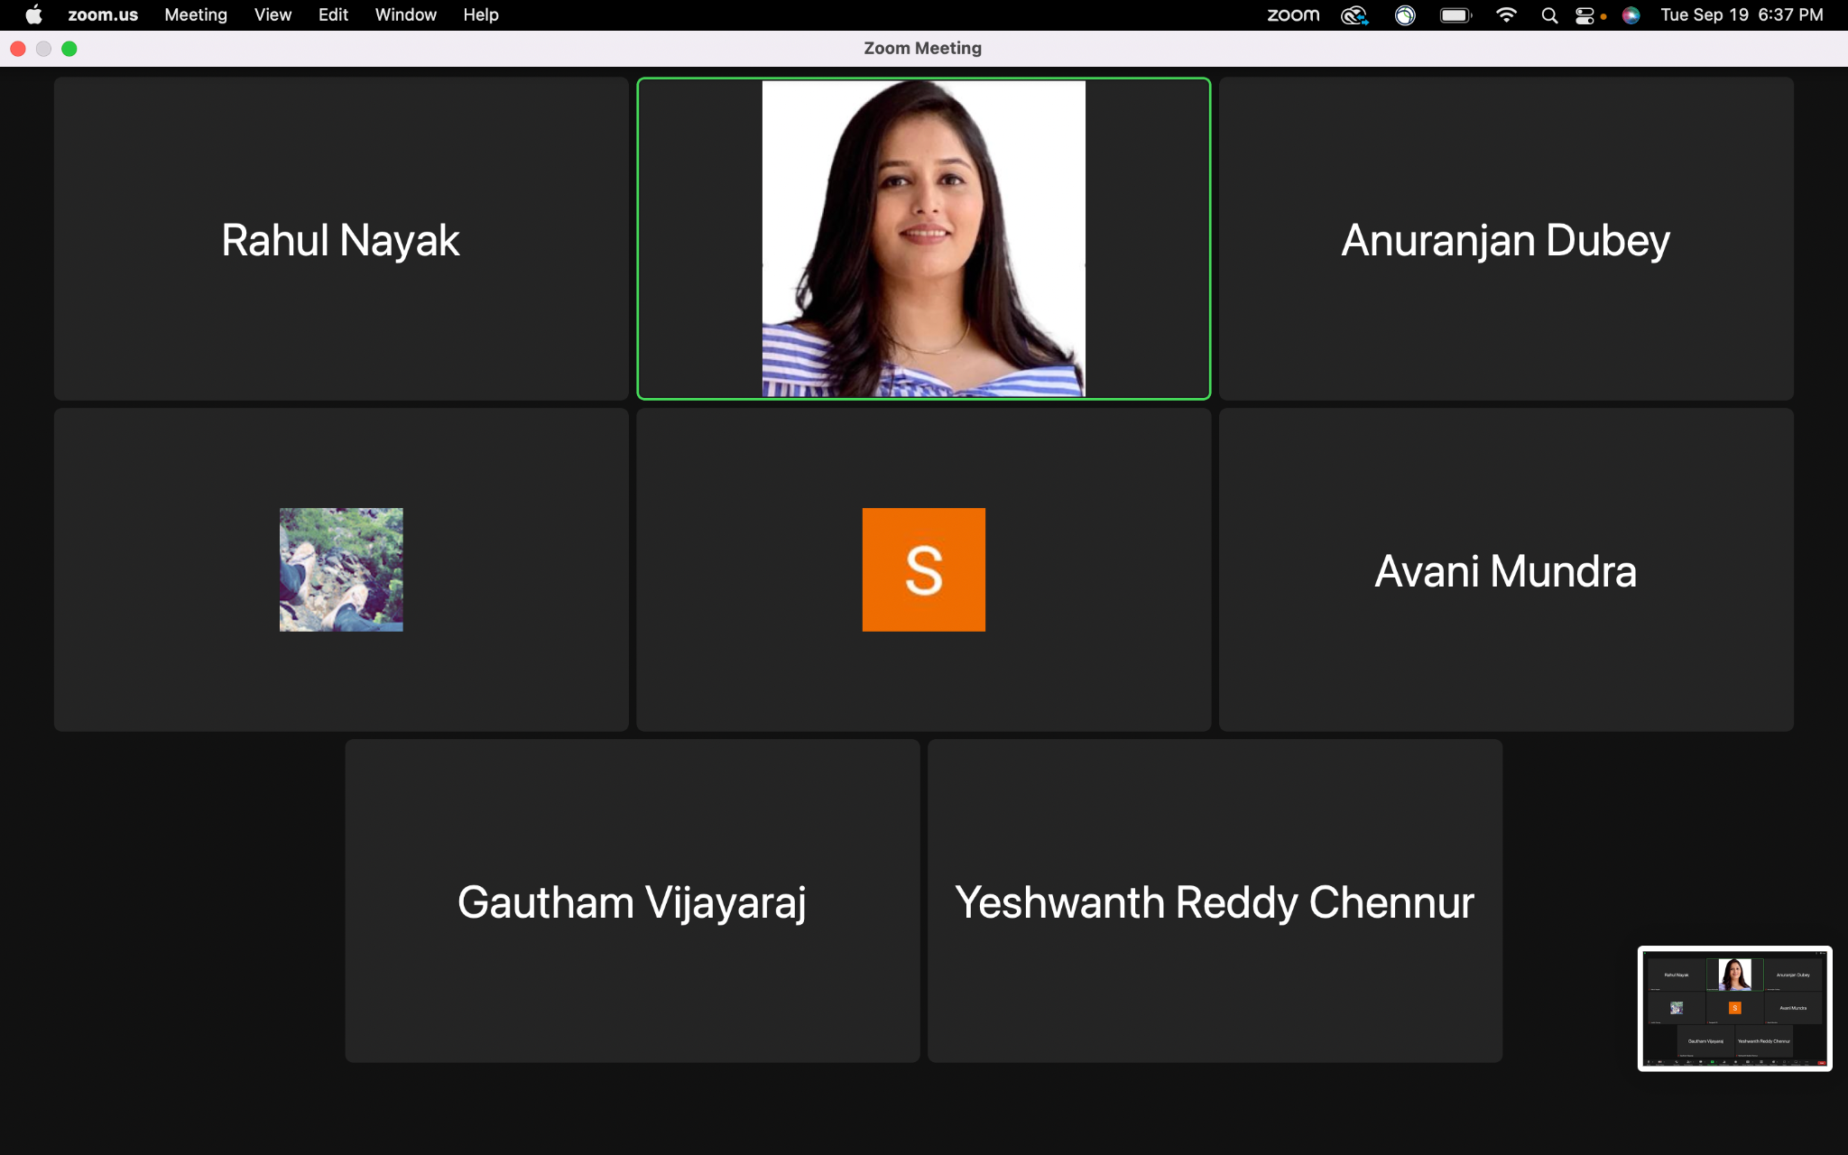

* **Meeting Objective:** Discuss the overall progress of the project, addressing questions related to adding additional not so important reference papers, discussion on to make a visit every week by one member from the group to writing center, discussing an approach to continue the in-depth progress reports, addressing questions and providing information to team members, discussing formatting related questions, task discussion and distribution for project plan.
* **Members present:** [Krupaben Kothadia](mailto:kkothadi@asu.edu)[Avani Mundra](mailto:amudra@asu.edu) [Anuranjan Dubey](mailto:adubey37@asu.edu) [Gautham Vijayaraj](mailto:gvijaya6@asu.edu) [Rahul Nayak](mailto:rrnayak@asu.edu) [Yeshwanth Reddy Chennur](mailto:ychennur@asu.edu) [Sangeeth Santhosh](mailto:ssantho9@asu.edu)[Justin Young](mailto:jtyoun15@asu.edu)
* **Members absent:** N/A
* **Reason for absence:** N/A
* **Discussion:**
  + Evaluated the project's overall advancement, considering the key milestones and objectives achieved thus far.
  + Addressed queries pertaining to the inclusion of supplementary reference materials, discussing their relevance and potential impact on project outcomes.
  + Outlined a systematic approach for formatting in-depth progress reports, defining the structure and content requirements.
  + Efficiently distributed tasks and responsibilities within the project plan.
  + Effectively resolved inquiries related to individual reports, weekly progress updates, and references, ensuring clarity and accuracy in project documentation.
* **To Do List:**
  + Each team member will be responsible for preparing their individual in-depth report (if any) for a reference paper they have collected.
  + Each team member will be responsible for preparing their individual progress report.
  + Each member will be responsible for evaluating another member’s individual progress reports.
  + Group leader and deputy leader will be responsible for approving 4 individual progress reports.
  + Group leader will organize the Google Drive and keep track of member’s progress and completion of tasks.
  + Team members on this week’s rotation will prepare the Gantt chart and weekly reports.
  + During our meeting, we deliberated on the task of classifying references and decided to categorize them into two distinct groups (Important and Not so Important).
  + We agreed, one member at a time should visit the writing center to have their report verified. Krupaben Kothadia visited the writing center last week and got her reports evaluated.
* **Next Meeting Scheduled on***:* **09/19/23 - 6:00 p.m.**

## Classification of Important and Generic Reference Papers

Link to the Reference Documents Classification List: [References_List](https://docs.google.com/document/d/15T-F8te1yxn_htvAxAdAmRKHNw10Ci9SCHduxrQxA4c/edit)

## Approval from the Writing Center

Team Member who visited: [Gautham Vijayaraj](mailto:gvijaya6@asu.edu)  
  
Appointment Confirmation: [Krupa_Writing_Center_Confirmation.png](https://drive.google.com/file/d/1b404bzPCxFhRBDqZExhIAYY3tdt5ZhrY/view?usp=drive_link)

## Individual Progress Reports and In-Depth Reports

| **Member Name** | **Weekly Member Progress Link** | **Individual In-Depth Reports Link** | **Self Acknowledgement** | **Evaluator Acknowledgement** |
| --- | --- | --- | --- | --- |
| [Krupaben Kothadia](mailto:kkothadi@asu.edu) | [Individual progress report](https://docs.google.com/document/d/1MvjY-j77q_SKH28UhaRMgXhRW0UBhdh6/edit?usp=drive_link&ouid=116067103181768245745&rtpof=true&sd=true) | [Individual In-Depth Report](https://docs.google.com/document/d/1PsIaYpLgsXiAWfzaVHTFckO0JiOgwIPs/edit?usp=drive_link&ouid=116067103181768245745&rtpof=true&sd=true) | [Krupaben Kothadia](mailto:kkothadi@asu.edu) | [Gautham Vijayaraj](mailto:gvijaya6@asu.edu) |
| [Gautham Vijayaraj](mailto:gvijaya6@asu.edu) | [Individual Progress Report](https://docs.google.com/document/d/1U8HpfuEO-D15eKaPNMX2Sk_hfabVypJp_xE8V31qoyo/edit?usp=drive_link) | [Individual In-Depth Report](https://docs.google.com/document/d/1fG4LzSGURuVtwNBOD_D3LfmGkpmiGffUHLq4mGQ0P58/edit?usp=drive_link) | [Gautham Vijayaraj](mailto:gvijaya6@asu.edu) | [Krupaben Kothadia](mailto:kkothadi@asu.edu) |
| [Avani Mundra](mailto:amudra@asu.edu) | [Individual Progress Report](https://docs.google.com/document/d/1F7GVY-gLneeLOQWVELbbeAXqXhUQ4EOB/edit?usp=drive_link&ouid=112867995748295868322&rtpof=true&sd=true) | [Individual In-Depth Report](https://docs.google.com/document/d/1C3yYKzLyBr2hDLX69AEa7T-Pg2kC0LYn/edit) | [Avani Mundra](mailto:amudra@asu.edu) | [Gautham Vijayaraj](mailto:gvijaya6@asu.edu) [Krupaben Kothadia](mailto:kkothadi@asu.edu) |
| [Justin Young](mailto:jtyoun15@asu.edu) | [Individual Progress report](https://docs.google.com/document/d/1S1dC4lbApRAUGSJ57dLDH0JpsRkCe1iP/edit?usp=drive_link&ouid=116067103181768245745&rtpof=true&sd=true) | [Individual In-Depth Report](https://docs.google.com/document/d/1ngfCZIp47B_1vlbMLniVQSB9svgv5RA7/edit?usp=drive_link&ouid=116067103181768245745&rtpof=true&sd=true) | [Justin Young](mailto:jtyoun15@asu.edu) | [Yeshwanth Reddy Chennur](mailto:ychennur@asu.edu) [Krupaben Kothadia](mailto:kkothadi@asu.edu) |
| [Anuranjan Dubey](mailto:adubey37@asu.edu) | [Individual Progress report](https://docs.google.com/document/d/1nKk06CJGXPmRFrDTEpHcKEj_uNQ1Gwpj/edit?usp=drive_link&ouid=116067103181768245745&rtpof=true&sd=true) | [Individual In-Depth Report](https://docs.google.com/document/d/1l3P5Ti-SS2k1O8JsMPobUNxNJhU897y9/edit?usp=drive_link&ouid=116067103181768245745&rtpof=true&sd=true) | [Anuranjan Dubey](mailto:adubey37@asu.edu) | [Anuranjan Dubey](mailto:adubey37@asu.edu) [Krupaben Kothadia](mailto:kkothadi@asu.edu) |
| [Rahul Nayak](mailto:rrnayak@asu.edu) | [Individual Progress report](https://docs.google.com/document/d/1sh4xs6wa3JC6MQudNHu1CL3DuyLi4i-F/edit?usp=drive_link&ouid=116067103181768245745&rtpof=true&sd=true) | [Individual In-Depth report](https://docs.google.com/document/d/1ZA5s9wc2Tp7KwbqorLPad3fPBkbkKb8M/edit?usp=drive_link&ouid=116067103181768245745&rtpof=true&sd=true) | [Rahul Nayak](mailto:rrnayak@asu.edu) | [Anuranjan Dubey](mailto:adubey37@asu.edu) [Gautham Vijayaraj](mailto:gvijaya6@asu.edu) |
| [Sangeeth Santhosh](mailto:ssantho9@asu.edu) | [Individual Progress report](https://docs.google.com/document/d/1FOREg5kyL8Yzmhgep8Ea0CIf5leqsNa2/edit?usp=drive_link&ouid=116067103181768245745&rtpof=true&sd=true) | [Individual In-Depth Report](https://docs.google.com/document/d/1iS3-fIrzOwuBhX32X8MVXcnS3Jkq8wkv/edit?usp=drive_link&ouid=116067103181768245745&rtpof=true&sd=true) | [Sangeeth Santhosh](mailto:ssantho9@asu.edu) | [Justin Young](mailto:jtyoun15@asu.edu) [Gautham Vijayaraj](mailto:gvijaya6@asu.edu) |
| [Yeshwanth Reddy Chennur](mailto:ychennur@asu.edu) | [Individual Progress report](https://docs.google.com/document/d/1CnJS3xcXqx7p3pFjIXJjpyeFXwGEMvpn/edit?usp=drive_link&ouid=116067103181768245745&rtpof=true&sd=true) | [Individual In-Depth Report](https://docs.google.com/document/d/11vKsKw3MoRBUCHBcrFRM8hQpJ7R7Yqek/edit?usp=drive_link&ouid=116067103181768245745&rtpof=true&sd=true) | [Yeshwanth Reddy Chennur](mailto:ychennur@asu.edu) | [Avani Mundra](mailto:amudra@asu.edu) [Gautham Vijayaraj](mailto:gvijaya6@asu.edu) |

## Tasks Summary

| **Task Number** | **Task Goal** | **Description of Task** | **Assignee** | **Task Status** | **Evaluator** |
| --- | --- | --- | --- | --- | --- |
| #4.1 | Visiting Writing Center, Preparing References_List document, Preparing Work_Distribution_Draft, Individual progress report, Evaluation and approval of reports, Gantt chart evaluation and approval, weekly report evaluation and approval, team meetings, organize Google Drive | Visiting Writing Center, Preparing References_List document, Preparing Work_Distribution_Draft, Preparing individual in-depth report, Preparing individual progress report, Evaluating Gautham’s individual progress report and in-depth report, Evaluating and approving GANTT Chart, Evaluating and approving Weekly Report, Evaluating and approving 4 team members’ individual progress reports, Assigning the task distribution, Providing a summary of content for the weekly report and GANTT Chart, Organizing group meetings, Organizing google drive. | [Krupaben Kothadia](mailto:kkothadi@asu.edu) | Completed | [Gautham Vijayaraj](mailto:gvijaya6@asu.edu) |
| #4.2 | In-depth report, individual progress report, prepare Gantt chart, preparing weekly report and approval, Evaluation and approval of reports, taking meeting notes, organize Google Drive | Preparing References_List doc, Preparing individual in-depth report, Preparing individual progress report, Evaluating Krupaben Kothadia’s individual progress report and in-depth report, Evaluating and approving GANTT Chart, Preparing Weekly Report (Add References_List doc link), Evaluating and approving 4 team members’ individual progress reports, Taking meeting notes. | [Gautham Vijayaraj](mailto:gvijaya6@asu.edu) | Completed | [Krupaben Kothadia](mailto:kkothadi@asu.edu) |
| #4.3 | In-depth report, individual progress report, evaluation of reports | Preparing individual progress report, Preparing individual in-depth report, Evaluating Yeshwanth Reddy Chennur’s In depth and progress reports | [Avani Mundra](mailto:amudra@asu.edu) | Completed | [Krupaben Kothadia](mailto:kkothadi@asu.edu) |
| #4.4 | In-depth report, individual progress report, evaluation of reports | Preparing individual progress report, Preparing individual in-depth report, Evaluating Sangeeth Santhosh’s In depth and progress reports | [Justin Young](mailto:jtyoun15@asu.edu) | Completed | [Krupaben Kothadia](mailto:kkothadi@asu.edu) |
| #4.5 | In-depth report, individual progress report, evaluation of reports, Preparing GANTT Chart | Preparing individual progress report, Preparing individual in-depth report, Evaluating in-depth report of Rahul Rajaram Nayak, Evaluating Rahul Rajaram Nayak's individual progress reports, Preparing GANTT Chart | [Anuranjan Dubey](mailto:adubey37@asu.edu) | Completed | [Krupaben Kothadia](mailto:kkothadi@asu.edu) |
| #4.6 | In-depth report, individual progress report, evaluation of reports | Preparing individual progress report, Preparing individual in-depth report, Evaluating Avani Mundra's in-depth report, Evaluating Avni Mundra's individual progress reports | [Rahul Nayak](mailto:rrnayak@asu.edu) | Completed | [Gautham Vijayaraj](mailto:gvijaya6@asu.edu) |
| #4.7 | In-depth report, individual progress report, evaluation of reports | Preparing individual progress report, Preparing individual in-depth report, Evaluating Anuranjan Dubey's in-depth report, Evaluating Anuranjan Dubey's individual progress reports | [Sangeeth Santhosh](mailto:ssantho9@asu.edu) | Completed | [Gautham Vijayaraj](mailto:gvijaya6@asu.edu) |
| #4.8 | In-depth report, individual progress report, evaluation of reports, Preparing Weekly Report | Preparing individual progress report, Preparing individual in-depth report, Evaluating in-depth report of Justin Young , Evaluating Justin Young's individual progress reports, Preparing Weekly Report (Add References_List doc link) | [Yeshwanth Reddy Chennur](mailto:ychennur@asu.edu) | Completed | [Gautham Vijayaraj](mailto:gvijaya6@asu.edu) |

## Gantt chart

**Link to the gantt chart:** [Gantt Chart](https://docs.google.com/spreadsheets/d/1NIskjUBbhy5d08YOiqovhmlFkJIcYy3a/edit?usp=drive_link&ouid=116067103181768245745&rtpof=true&sd=true)

**Gantt chart updated by**: [Anuranjan Dubey](mailto:adubey37@asu.edu)

**Gantt chart approved by**: [Krupaben Kothadia](mailto:kkothadi@asu.edu) [Gautham Vijayaraj](mailto:gvijaya6@asu.edu)

## Comments

* All group members have been cooperative, showed enthusiasm to work on a project, and have put in an effort to complete their assigned tasks successfully this week.