[Krupaben Kothadia](mailto:kkothadi@asu.edu)

Preparing Midterm report

Preparing Work_Distribution_Draft

Preparing GANTT Chart

Preparing individual midterm review report

Preparing individual in-depth report

Preparing individual progress report

Evaluating and approving 4 team members’ individual progress and in-depth reports

Evaluating and approving Midterm Report

Evaluating and approving Weekly Report

Assigning the task distribution

Providing a rough draft of content for midterm report, weekly report and GANTT Chart

Organizing group meetings

Organizing google drive

[Gautham Vijayaraj](mailto:gvijaya6@asu.edu)

Preparing Midterm report

Visiting Writing Center

Preparing individual midterm review report

Preparing individual in-depth report

Preparing individual progress report

Evaluating and approving 4 team members’ individual progress and in-depth reports

Evaluating and approving Midterm Report

Evaluating and approving GANTT Chart

Evaluating and approving Weekly Report

Format for Mid term report

Taking meeting notes

[Avani Mundra](mailto:amudra@asu.edu)

Preparing Midterm report

Preparing weekly report

Preparing individual midterm review report

Preparing individual progress report

Preparing individual in-depth report

Evaluating 1 team member’s individual progress and in-depth reports

[Justin Young](mailto:jtyoun15@asu.edu)

Preparing Midterm report

Preparing weekly report

Preparing individual midterm review report

Preparing individual progress report

Preparing individual in-depth report

Evaluating 1 team member’s individual progress and in-depth reports

[Anuranjan Dubey](mailto:adubey37@asu.edu)

Preparing Midterm report

Preparing individual midterm review report

Preparing individual progress report

Preparing individual in-depth report

Evaluating 1 team member’s individual progress and in-depth reports

[Rahul Nayak](mailto:rrnayak@asu.edu)

Preparing Midterm report

Preparing individual midterm review report

Preparing individual progress report

Preparing individual in-depth report

Evaluating 1 team member’s individual progress and in-depth reports

[Sangeeth Santhosh](mailto:ssantho9@asu.edu)

Preparing Midterm report

Preparing individual midterm review report

Preparing individual progress report

Preparing individual in-depth report

Evaluating 1 team member’s individual progress and in-depth reports

[Yeshwanth Reddy Chennur](mailto:ychennur@asu.edu)

Preparing Midterm report

Preparing individual midterm review report

Preparing individual progress report

Preparing individual in-depth report

Evaluating 1 team member’s individual progress and in-depth reports

**Below is the screenshot of our group meeting with the time stamp on it 09/19/2023 6-7 pm, please attach this in the weekly report.**

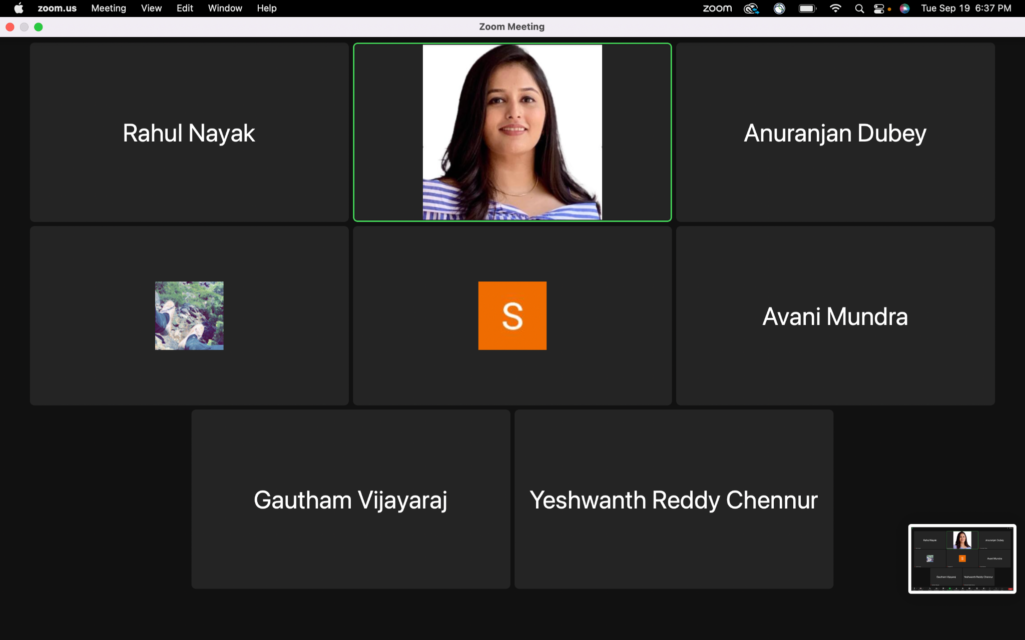

**Below is the screenshot of the group leader and deputy leader’s meeting for discussing the content of the Midterm Report with the time stamp on it 09/22/2023 6:30-7 pm, please attach this in the weekly report.**

