## **Weekly_Report_#6_CSE 543_Group_1-5**

## List of members

**Group Leader:** [Krupaben Kothadia](mailto:kkothadi@asu.edu)

**Group Deputy Leader:** [Gautham Vijayaraj](mailto:gvijaya6@asu.edu)

**Group Members:** [Krupaben Kothadia](mailto:kkothadi@asu.edu)

* [Gautham Vijayaraj](mailto:gvijaya6@asu.edu)
* [Avani Mundra](mailto:amudra@asu.edu)
* [Justin Young](mailto:jtyoun15@asu.edu)
* [Anuranjan Dubey](mailto:adubey37@asu.edu)
* [Yeshwanth Reddy Chennur](mailto:ychennur@asu.edu)
* [Sangeeth Santhosh](mailto:ssantho9@asu.edu)
* [Yeshwanth Reddy Chennur](mailto:ychennur@asu.edu)

## Submission Details

**Name of member that prepared the report:** [Krupaben Kothadia](mailto:kkothadi@asu.edu)[Gautham Vijayaraj](mailto:gvijaya6@asu.edu)

**Name of member that submitted this report:** [Gautham Vijayaraj](mailto:gvijaya6@asu.edu)  
  
**Report is approved by:** [Krupaben Kothadia](mailto:kkothadi@asu.edu)[Gautham Vijayaraj](mailto:gvijaya6@asu.edu)

## 

## Meeting Notes

**10/03/23 - 6:30-7:30 p.m. (Mode: Online)**

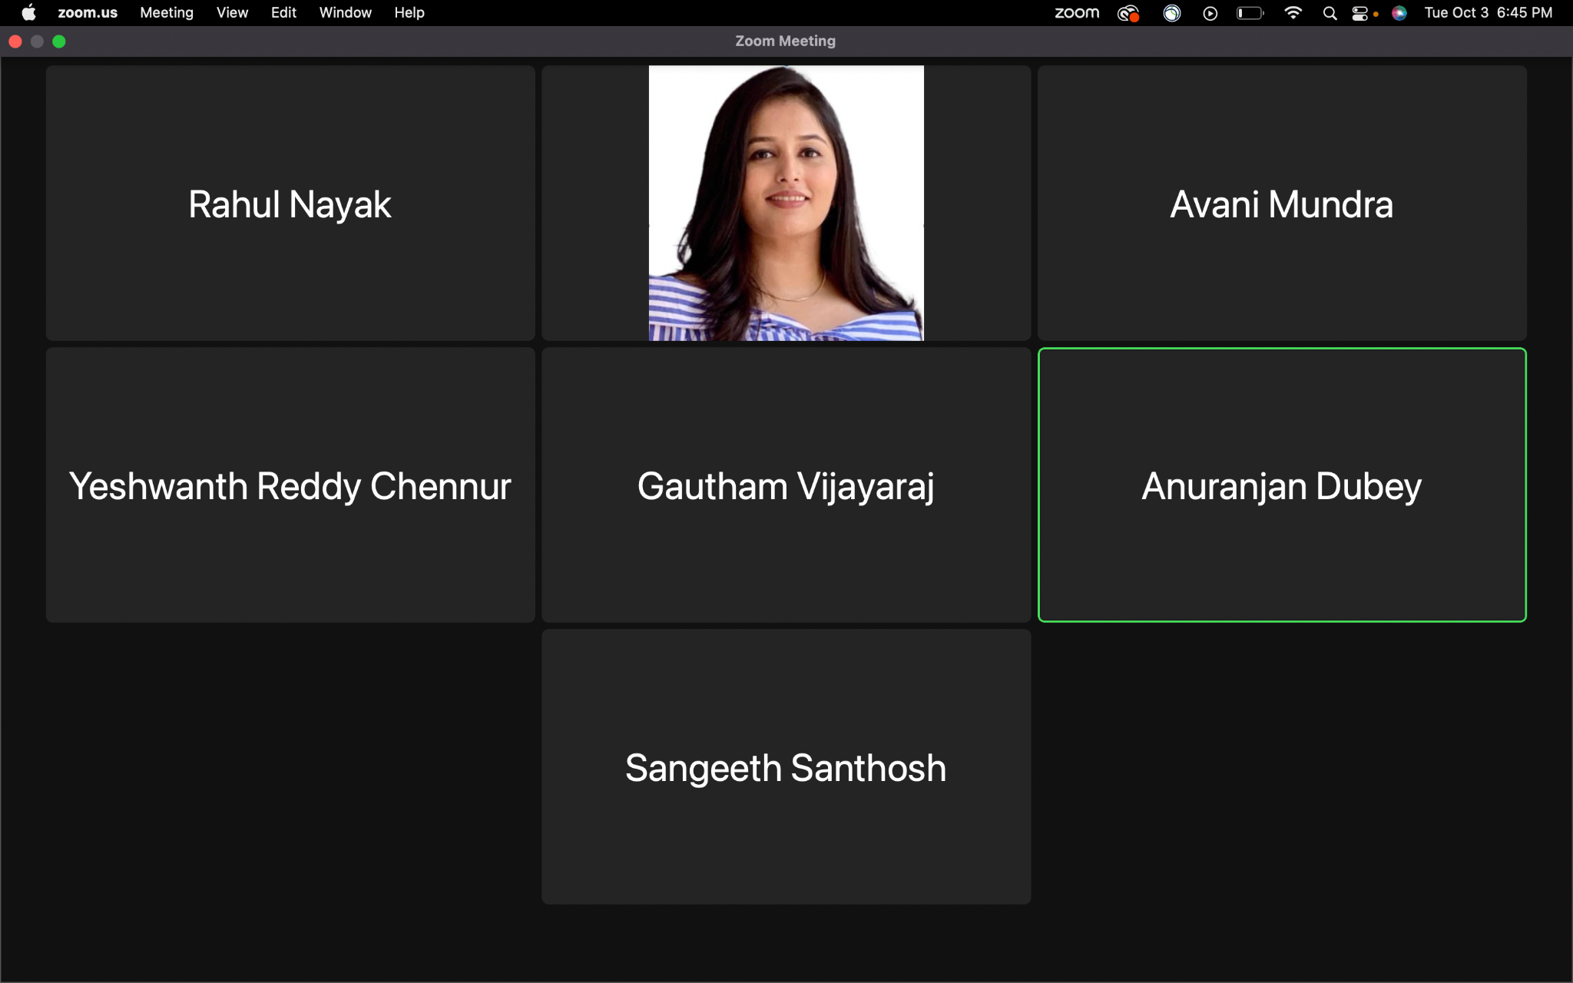

* **Meeting Objective:** Review the project's overall advancement, consider having a group member visit the writing center weekly, discussion on reading not-so-important papers, explore a strategy to maintain detailed progress reports, handle inquiries, share information with team members, and discuss and allocate tasks for the project plan.
* **Members present:**[Krupaben Kothadia](mailto:kkothadi@asu.edu)[Gautham Vijayaraj](mailto:gvijaya6@asu.edu)[Avani Mundra](mailto:amudra@asu.edu)[Anuranjan Dubey](mailto:adubey37@asu.edu)[Rahul Nayak](mailto:rrnayak@asu.edu)[Sangeeth Santhosh](mailto:ssantho9@asu.edu)[Yeshwanth Reddy Chennur](mailto:ychennur@asu.edu)
* **Members absent:** [Justin Young](mailto:jtyoun15@asu.edu)
* **Reason for absence:** N/A
* **Discussion:**
  + Conducted an assessment of the project's overall advancement, taking into account the attainment of key milestones and objectives up to this point.
  + Discussed the relevance and potential impact of incorporating additional reference materials into the project, addressing related queries and considerations.
  + Developed a systematic approach for formatting comprehensive in-depth progress reports, clearly defining the structure and content requirements to ensure consistency and completeness.
  + Efficiently allocated tasks and responsibilities within the project plan, ensuring that team members are aligned with their respective roles and duties.
  + Successfully resolved inquiries related to individual reports, weekly progress updates, and references, with a focus on maintaining clarity and accuracy in all project documentation.
* **To Do List:**
  + Each team member will create their individual in-depth report based on a reference paper they've gathered.
  + Every team member will also craft an individual progress report. Members will assess their peers' progress reports.
  + Group leaders will approve individual progress reports and manage Google Drive organization.
  + Rotating team members will prepare Gantt charts and weekly reports.
  + During our meeting, we agreed that members who finished their in-depth reports should start reviewing not-so-important papers.
  + We also established estimated completion timelines for each member regarding their assigned reference papers.
  + [Sangeeth Santhosh](mailto:ssantho9@asu.edu) and [Anuranjan Dubey](mailto:adubey37@asu.edu) visited the writing center to evaluate our group reports this week.
* **Next Meeting Scheduled on***:* **10/10/23 - 6:30 p.m**

## Classification of Important and Generic Reference Papers

Link to the Reference Documents Classification List: [References_List](https://docs.google.com/document/d/15T-F8te1yxn_htvAxAdAmRKHNw10Ci9SCHduxrQxA4c/edit)

## Approval from the Writing Center

Writing Center visit confirmation emails’ screenshots from Sangeeth Santhosh and Anuranjan Dubey:

[Sangeeth_Santhosh_Writing_Center_Confirmation.png](https://drive.google.com/file/d/1L5mWZofi74Ge3zb0Cb36V-h6oJ2kfUst/view?usp=drive_link)

[Anuranjan_Dubey_Writing_Center_Confirmation.png](https://drive.google.com/file/d/19e2a6tombKuSg_wdIrY5604jQ5tSWKFv/view?usp=drive_link)

## Project Tasks in Progress

| **Tasks in Progress** | **Timeline**  **(No.of Weeks)** | **No.of Important Papers to Study** | **Name of Assignee** |
| --- | --- | --- | --- |
| **Secure Data Collection Techniques** | 1 | Completed 6 research papers | [Gautham Vijayaraj](mailto:gvijaya6@asu.edu) |
| **Data Preprocessing and Feature Engineering** | 1 | Completed all 5 research papers | [Krupaben Kothadia](mailto:kkothadi@asu.edu) |
| **Data Mining Techniques to Handle Multimodal Data** | 1 | Completed 4 research papers | [Avani Mundra](mailto:amudra@asu.edu) |
| **Model Security Assurance** | 1 | Completed all 5 research papers | [Justin Young](mailto:jtyoun15@asu.edu) |
| **Model Evaluation** |  | Completed 5 research papers | [Sangeeth Santhosh](mailto:ssantho9@asu.edu) |
| **Leveraging Machine Learning Models** | 1 | Completed all 5 research papers | [Anuranjan Dubey](mailto:adubey37@asu.edu) |
| **Data Exploration** | 1 | Completed 4 research papers | [Rahul Nayak](mailto:rrnayak@asu.edu) |
| **Machine Learning Model Security Assurance** | 1 | Completed all 5 research papers | [Yeshwanth Reddy Chennur](mailto:ychennur@asu.edu) |

## 

## Member Contribution (Individual Reports) :

| **Member Name** | **Weekly Member Progress Link** | **Individual In-Depth Reports Link** | **Self Acknowledgement** | **Evaluator Acknowledgement** |
| --- | --- | --- | --- | --- |
| [Krupaben Kothadia](mailto:kkothadi@asu.edu) | [Individual progress report](https://docs.google.com/document/d/1zSlKu-DOkv8JGKUZeAne-WQznvWcLedi/edit?usp=drive_link&ouid=116067103181768245745&rtpof=true&sd=true) | [Individual In-Depth Report](https://docs.google.com/document/d/1DRgAGnE0YMupv8OuPnByahiPTpGRZ_gi/edit?usp=drive_link&ouid=116067103181768245745&rtpof=true&sd=true) | [Krupaben Kothadia](mailto:kkothadi@asu.edu) | [Gautham Vijayaraj](mailto:gvijaya6@asu.edu) |
| [Gautham Vijayaraj](mailto:gvijaya6@asu.edu) | [Individual progress report](https://docs.google.com/document/d/1KhGUOoTfJyqX9b4Y8uy_Kqo4LygwpMdr/edit?usp=drive_link&ouid=116067103181768245745&rtpof=true&sd=true) | [Individual In-Depth Report](https://docs.google.com/document/d/1me4r5OXA20Ac4tYYI8JqvB5Rp71-C4FivWYtbC0ZeuA/edit?usp=drive_link) | [Gautham Vijayaraj](mailto:gvijaya6@asu.edu) | [Krupaben Kothadia](mailto:kkothadi@asu.edu) |
| [Avani Mundra](mailto:amudra@asu.edu) | [Individual progress report](https://docs.google.com/document/d/1lB6YbJirskjuaErohV3_y_vHCTBWRSJp/edit?usp=drive_link&ouid=116067103181768245745&rtpof=true&sd=true) | [Individual In-Depth Report](https://docs.google.com/document/d/1jjPYEhAiZq8VQdQZqSVfh5aLYWTNvd-r/edit?usp=drive_link&ouid=116067103181768245745&rtpof=true&sd=true) | [Avani Mundra](mailto:amudra@asu.edu) | [Rahul Nayak](mailto:rrnayak@asu.edu) [Krupaben Kothadia](mailto:kkothadi@asu.edu) |
| [Justin Young](mailto:jtyoun15@asu.edu) | [Individual progress report](https://docs.google.com/document/d/1V2YC7eIbij8a6WQCmfIXmPBsfB_WPo3g/edit?usp=drive_link&ouid=116067103181768245745&rtpof=true&sd=true) |  | [Justin Young](mailto:jtyoun15@asu.edu) | [Yeshwanth Reddy Chennur](mailto:ychennur@asu.edu) [Krupaben Kothadia](mailto:kkothadi@asu.edu) |
| [Anuranjan Dubey](mailto:adubey37@asu.edu) | [Individual progress report](https://docs.google.com/document/d/1H4UbPNeaImagXc7TiUJgCh_5ZgYkchIb/edit?usp=drive_link&ouid=116067103181768245745&rtpof=true&sd=true) |  | [Anuranjan Dubey](mailto:adubey37@asu.edu) | [Sangeeth Santhosh](mailto:ssantho9@asu.edu) [Krupaben Kothadia](mailto:kkothadi@asu.edu) |
| [Rahul Nayak](mailto:rrnayak@asu.edu) | [Individual progress report](https://docs.google.com/document/d/1KsrWQJsiuPK5SRRh9RTgZjNavjdnD8er/edit?usp=drive_link&ouid=116067103181768245745&rtpof=true&sd=true) |  | [Rahul Nayak](mailto:rrnayak@asu.edu) | [Anuranjan Dubey](mailto:adubey37@asu.edu) [Gautham Vijayaraj](mailto:gvijaya6@asu.edu) |
| [Sangeeth Santhosh](mailto:ssantho9@asu.edu) | [Individual progress report](https://docs.google.com/document/d/1HDfJPZ5xFc0dFaRudrSTJ2hit08kR5a1/edit?usp=drive_link&ouid=116067103181768245745&rtpof=true&sd=true) |  | [Sangeeth Santhosh](mailto:ssantho9@asu.edu) | [Justin Young](mailto:jtyoun15@asu.edu) [Gautham Vijayaraj](mailto:gvijaya6@asu.edu) |
| [Yeshwanth Reddy Chennur](mailto:ychennur@asu.edu) | [Individual progress report](https://docs.google.com/document/d/1M9EES0mvdKeMFJsdZUfX58TCZg8sTqhF/edit?usp=drive_link&ouid=116067103181768245745&rtpof=true&sd=true) | [Individual In-Depth Report](https://docs.google.com/document/d/1AD0E5ucIjEBth3ZbmpTVWjmzPuK5ZlXo/edit?usp=drive_link&ouid=116067103181768245745&rtpof=true&sd=true) | [Yeshwanth Reddy Chennur](mailto:ychennur@asu.edu) | [Avani Mundra](mailto:amudra@asu.edu) [Gautham Vijayaraj](mailto:gvijaya6@asu.edu) |

## 

## Tasks Summary

| **Task Number** | **Task Goal** | **Description of Task** | **Assignee** | **Task Status** | **Evaluator** |
| --- | --- | --- | --- | --- | --- |
| #7.1 | Preparing Weekly report, Work_Distribution_Draft, Individual in-depth and progress report, Evaluation and approval of reports, GANTT Chart and Weekly report evaluation and approval, team meetings, organize Google Drive | Preparing Weekly Report and Work_Distribution_Draft, Preparing individual in-depth report, Preparing individual progress report, Evaluating and approving Weekly report and GANTT Chart, Evaluating and approving team members’ individual progress and in-depth reports, Assigning the task distribution, Organizing group meetings, Organizing google drive. | [Krupaben Kothadia](mailto:kkothadi@asu.edu) | Completed | [Gautham Vijayaraj](mailto:gvijaya6@asu.edu) |
| #7.2 | Preparing Weekly report, Individual progress report, Evaluation and approval of reports, Weekly report and GANTT Chart evaluation and approval, team meetings, Taking meeting notes | Preparing Weekly Report, individual progress report, Evaluating and approving GANTT Chart and Weekly report, Evaluating and approving team members’ individual progress and in-depth reports, Taking meeting notes | [Gautham Vijayaraj](mailto:gvijaya6@asu.edu) | Completed | [Krupaben Kothadia](mailto:kkothadi@asu.edu) |
| #7.3 | In-depth report, individual progress report, evaluation of reports | Preparing individual progress report, Preparing individual in-depth report, evaluation of Yeshwanth’s reports | [Avani Mundra](mailto:amudra@asu.edu) | Completed | [Krupaben Kothadia](mailto:kkothadi@asu.edu) |
| #7.4 | Preparing individual progress report, evaluation of report, studying not-so-important papers | Preparing individual progress report, Evaluating Sangeeth Santosh’s individual progress report, studying not-so-important papers | [Justin Young](mailto:jtyoun15@asu.edu) | Completed | [Krupaben Kothadia](mailto:kkothadi@asu.edu) |
| #7.5 | Visiting Writing Center, studying not-so-important papers, individual progress report, evaluation of reports | Visiting Writing Center, studying not-so-important papers, Preparing individual progress report, Evaluating Rahul’s individual progress report. | [Anuranjan Dubey](mailto:adubey37@asu.edu) | Completed | [Krupaben Kothadia](mailto:kkothadi@asu.edu) |
| #7.6 | Individual progress report, evaluation of reports | Preparing individual progress report, Evaluating Avani’s individual progress and in-depth reports. | [Rahul Nayak](mailto:rrnayak@asu.edu) | Completed | [Gautham Vijayaraj](mailto:gvijaya6@asu.edu) |
| #7.7 | Visiting Writing Center, individual progress report, evaluation of reports | Visiting Writing Center, Preparing individual progress report, Evaluating Anuranjan’s individual progress report. | [Sangeeth Santhosh](mailto:ssantho9@asu.edu) | Completed | [Gautham Vijayaraj](mailto:gvijaya6@asu.edu) |
| #7.8 | Preparing GANTT chart, Preparing In-depth report, individual progress report, evaluation of reports | preparing GANTT chart, Preparing individual progress reports, Preparing an individual in-depth report, Evaluating Justin’s individual progress report. | [Yeshwanth Reddy Chennur](mailto:ychennur@asu.edu) | Completed | [Gautham Vijayaraj](mailto:gvijaya6@asu.edu) |

## 

## Gantt chart

**Link to the gantt chart:** [Gantt Chart](https://docs.google.com/spreadsheets/d/1AZhFG14sHTXiL6crmWMlqNu-Z9PF4H-W/edit#gid=1653990051)

**Gantt chart updated by**: [Yeshwanth Reddy Chennur](mailto:ychennur@asu.edu)

**Gantt chart approved by**: [Krupaben Kothadia](mailto:kkothadi@asu.edu) [Gautham Vijayaraj](mailto:gvijaya6@asu.edu)

## 

## Comments

* All group members have been cooperative, showed enthusiasm to work on a project, and have put in an effort to complete their assigned tasks successfully this week.