**Individual Report**

**Member name:**[Avani Mundra](mailto:amudra@asu.edu)

**Evaluated by:** [Rahul Nayak](mailto:rrnayak@asu.edu)

**Date: 10/16/2023**

**Tasks Assigned:**

* Reviewed a not so important research paper ‘A Multiple Feature Category Data Mining and Machine Learning Approach to Characterize and Detect Health Misinformation on Social Media,’.
* Evaluated [Yeshwanth Reddy Chennur](mailto:ychennur@asu.edu)’s individual progress report for the present week.
* Prepared the Gantt Chart for the present week
* Visited the writing center for evaluation of reports.

**Summary:**

* The research paper ‘A Multiple Feature Category Data Mining and Machine Learning Approach to Characterize and Detect Health Misinformation on Social Media’ focuses on characterizing health misinformation on social media, with a specific focus on the Zika discussion on Twitter in 2016.
* The authors use network metrics and a nonhomogeneous Poisson process
* It identifies misinformation tweets and matches them with real information tweets.
* The authors use network metrics and a nonhomogeneous Poisson process (NHPP) to model information dissemination through retweets.
* Content-based features are extracted using linguistic inquiry and word count (LIWC) and document-to-vector (Doc2Vec) techniques.
* User features are also considered.
* Support vector machine and random forest classifiers are trained to detect health misinformation.
* Prepared the Gantt chart for this week that included all the activities executed by the members for the present week
* Visited the Graduate Writing Center to get the reports reviewed and evaluated by a professional writing tutor.

**Outcome:**

* The random forest classifier achieves over 83% accuracy and over 90% AUC in detecting misinformation.
* The study emphasizes the need for a holistic approach to tackle health misinformation on social media.

**References:**

[4] L. Safarnejad, Q. Xu, Y. Ge and S. Chen, "A Multiple Feature Category Data Mining and Machine Learning Approach to Characterize and Detect Health Misinformation on Social Media," in IEEE Internet Computing, vol. 25, no. 5, pp. 43-51, 1 Sept.-Oct. 2021, doi: 10.1109/MIC.2021.3063257.

**Writing Centre Confirmation:**

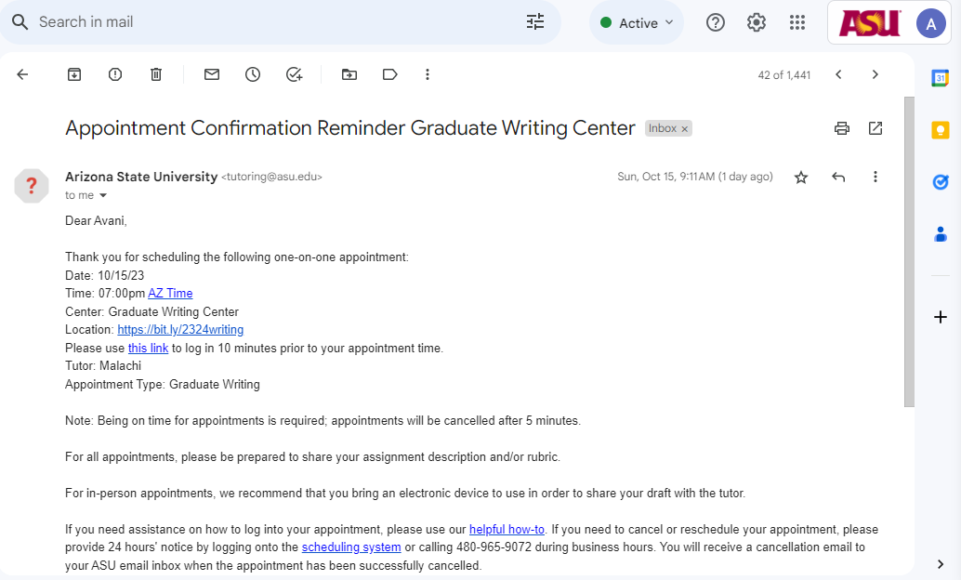

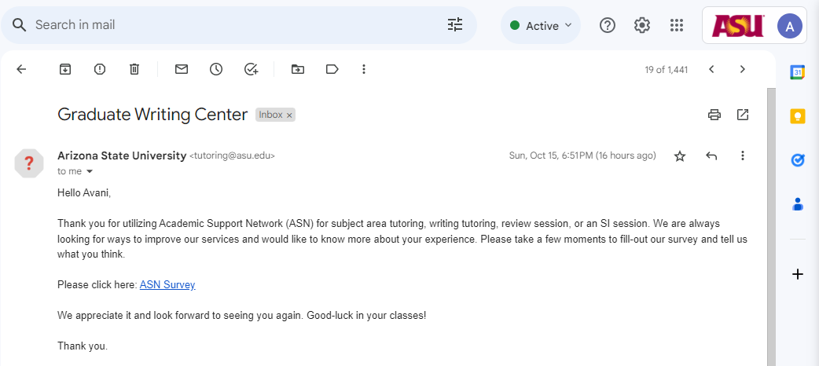

**Evaluation of Report  
  
Evaluation by:** [Rahul Nayak](mailto:rrnayak@asu.edu) **Date: 10/16/2023**

**Is the weekly member report complete with all the major result(s) of the paper(s)? If not, provide as many examples of the major result(s) missing in the written report as possible. (in bullet form). [within 100 words]**

Yes, this report covers all major results of the tasks for this week

**Is each section of the guidelines sufficiently completed? If not, point out what is missing. [Normally within 40 words].**

yes each section has been completed according to the expectations

**Is the quality of this version of the written report satisfactory? If not, then why not? [Normally within 40 words]**

Yes the quality of the written report is satisfactory.

**Approved by:** [Krupaben Kothadia](mailto:kkothadi@asu.edu)

**Date: 10/16/2023**