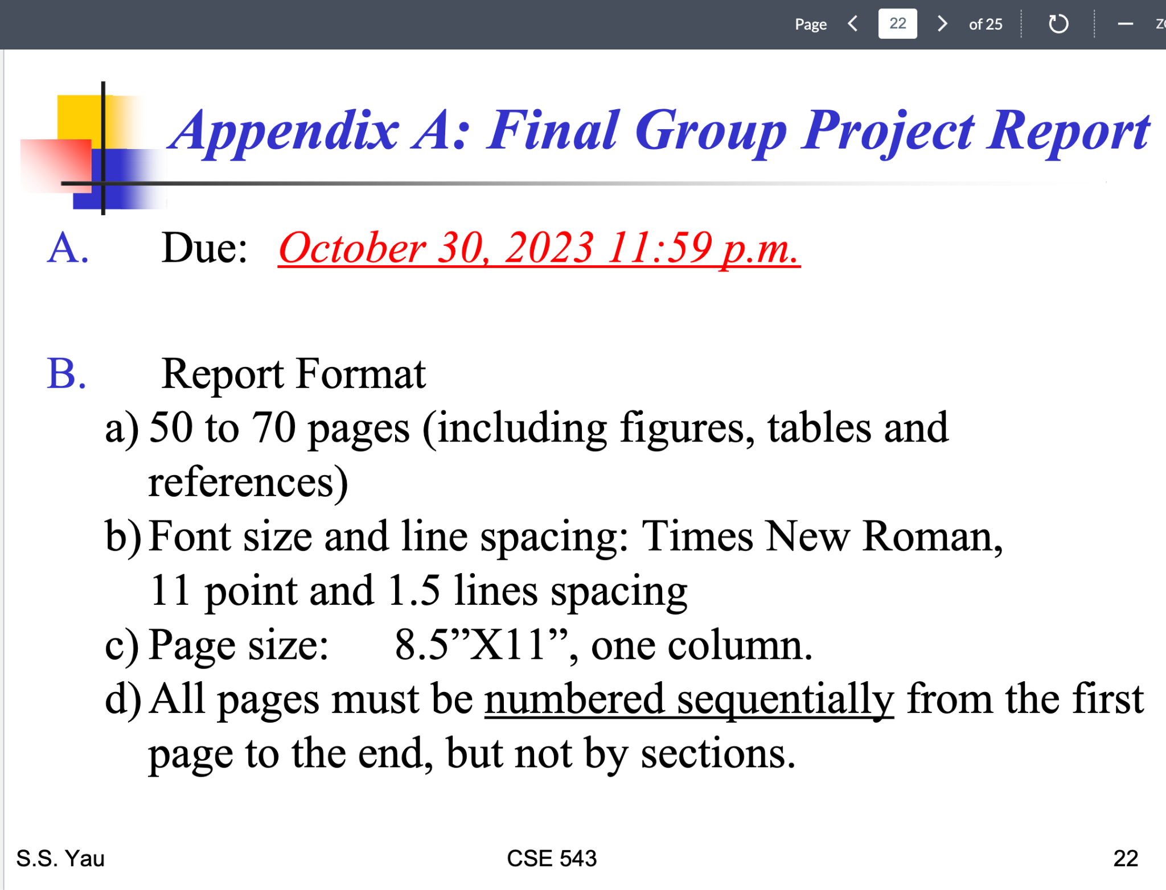

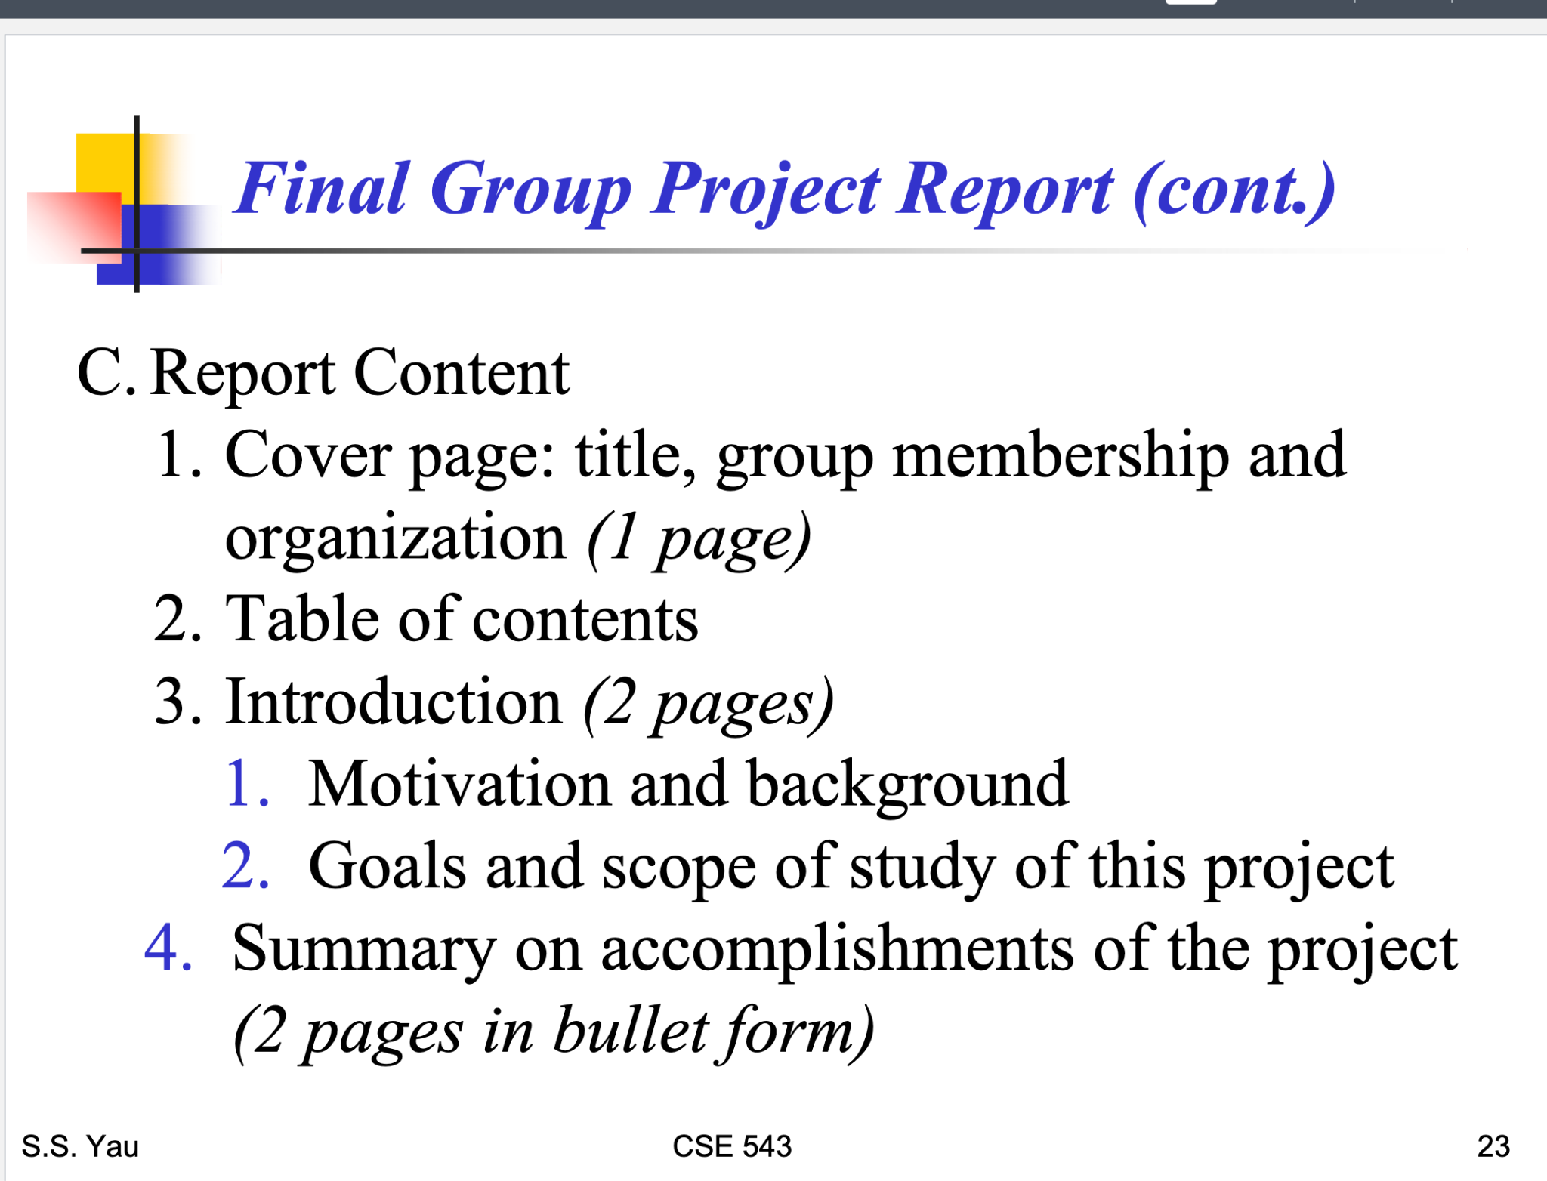

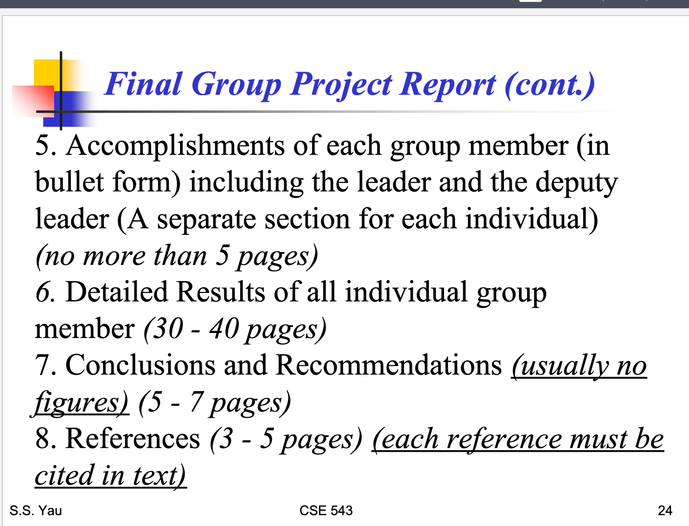

Final Group Project Report Template: [Krupaben Kothadia](mailto:kkothadi@asu.edu) [Gautham Vijayaraj](mailto:gvijaya6@asu.edu)

Sections:

1. [Krupaben Kothadia](mailto:kkothadi@asu.edu)[Gautham Vijayaraj](mailto:gvijaya6@asu.edu)
2. [Krupaben Kothadia](mailto:kkothadi@asu.edu)[Gautham Vijayaraj](mailto:gvijaya6@asu.edu)
3. Introduction (2 Pages)
   1. Motivation and Background: [Anuranjan Dubey](mailto:adubey37@asu.edu) and [Justin Young](mailto:jtyoun15@asu.edu)
   2. Goals and Scope: [Rahul Nayak](mailto:rrnayak@asu.edu) and [Sangeeth Santhosh](mailto:ssantho9@asu.edu)
4. Summary on accomplishments of the project (2 Pages): [Avani Mundra](mailto:amudra@asu.edu) and [Yeshwanth Reddy Chennur](mailto:ychennur@asu.edu) (Go through “Outcomes” of each in-depth report for each team member and generate a 115 words summary for each in-depth report.)
5. 285 words strictly per head (Everyone has to add their respective sections)
6. 5 pages per head not more than that (Everyone has to add their respective sections)
7. 402 words per head (Everyone has to add their respective sections)
8. [Krupaben Kothadia](mailto:kkothadi@asu.edu)[Gautham Vijayaraj](mailto:gvijaya6@asu.edu)

**NOTES:**

**Accomplishments Definition (4th and 5th Section):**

How many Outcomes accomplished based on our project plan, and based on the research each one identified what he/she gained from that.

If you add any figures or tables directly from reference paper then please make sure that you are adding content for that and also citing it is crucial.

The text should be “Justify” aligned.

Individual progress report: Everyone

Gantt Chart: [Yeshwanth Reddy Chennur](mailto:ychennur@asu.edu)

Weekly Report: [Anuranjan Dubey](mailto:adubey37@asu.edu), [Sangeeth Santhosh](mailto:ssantho9@asu.edu)

