Stereo Visual Odometry with Local bundle adjustment

Stereo Odometry uses stereo camera system with two cameras fixed at constant distance known as base line. The cameras see same scene. There are many state-of-the art stereo odometry algorithms available based on different approaches such as Direct approach, Indirect approach and Hybrid approach. Direct Odometry methods are very efficient and accurate in featureless environment. While Indirect or feature based approaches perform well in feature rich environment like outdoors.

Here in this task evaluation KITTI dataset is used as input of which sequences 00 and 05 is taken in outdoor environment with stereo camera fixed on the top of a car. There exists many open source algorithms for Visual Odometry /SLAM. Considering the constraints given in tasks few algorithms exists which can work in real-time environment by achieving high accuracy. ORB-SLAM2 is a versatile Visual SLAM method based on indirect approach which shows accuracy compared to its state-of-the-art. From comparison of the algorithms on KITTI dataset on website (http://www.cvlibs.net/datasets/kitti/eval_odometry.php) SOFT-SLAM shows higher accuracy than others. Furthermore, ORB-SLAM2 has its own Local and Global BA implementation using g2O framework. Therefore, for further evaluation and Local bundle adjustment SOFT-SLAM is selected.

The source code is imported from - https://github.com/ZhenghaoFei/visual_odom
It uses SOFT-SLAM algorithm as reference. It does not apply a full SLAM framework rather only odometry estimation is implemented. Furthermore, a local bundle adjustment is implemented using Ceres-solver as described in task.

Implementation code is available at - https://github.com/gauti1311/stereo-odomery-with-Local-BA

Installation guide : For detailed installation and demo test kindly check the Readme of the given repository. (https://github.com/gauti1311/stereo-odomery-with-Local-BA/blob/main/README.md)

Local BA : Bundle adjustment is implemented in optimizer.cpp and optimizer.h As many as 7 number of local image frames are used for pose optimization and they can also be changed. But testing with 7 frames gives satisfactory result while it slows the test. The implementation is not tested on GPU due to non-availability but it can surely increase the efficiency of the algorithm.
The result without Local BA and with it is shown in below figure 1 and 2 respectively. The red line shows pose estimation using algorithm and yellow line shows ground truth pose. It can be seen that there is still some drift during sharp rotations which has still some scope of improvement.

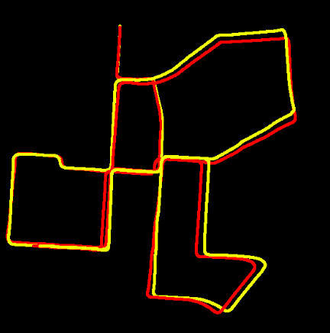
Figure 1 :KITTI dataset sequence 00 without Local BA

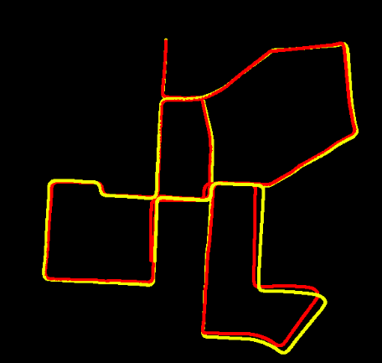

Figure 2 : KITTI dataset sequence 00 with Local BA

