|  |
| --- |
| CS590BD Big Data Analytics and Applications |
| Lab 5 Assignment |
| Goutham Marikanti  Rama Krishna |

TASK 1

# Build an on-line motion-based game app using the Data Processing and Motion Recognition apps

We have chosen 2048 game as our motion app. We have four motions in this game, namely:

* Top-Down
* Left-Right
* Right-Left
* Bottom-Up

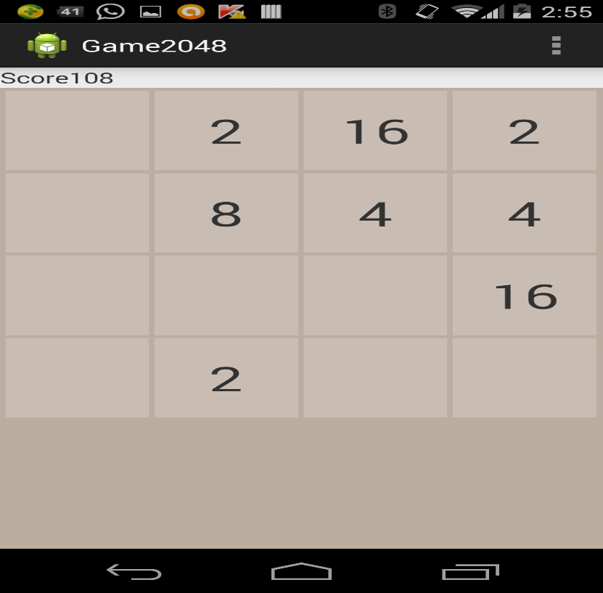

Currently, this game works only using touch, our aim is to accommodate the game with motions to be recognized from the sensor and respond accordingly.These are the four sequence files that we generated as we did in Lab4.

* LefttoRight.seq
* RighttoLeft.seq
* ToptoBottom.seq
* BottomtoTop.seq

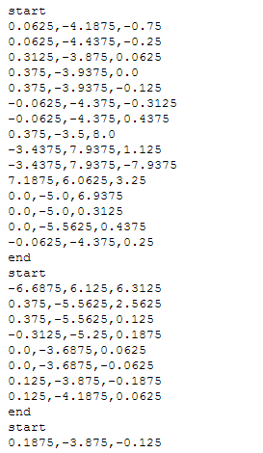

This is the screenshot for Training.

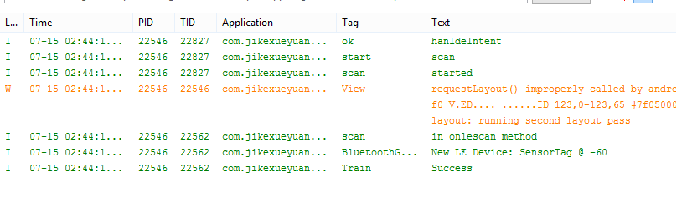

Screenshot for Right to Left motion

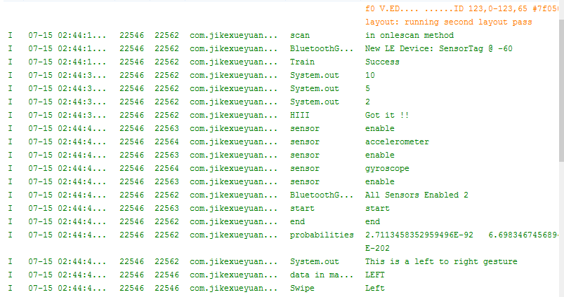

Screenshot for Left to Right motion

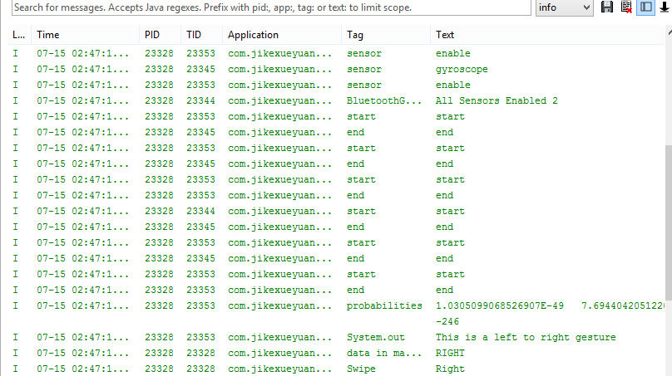

Screenshot for Bottom to Top motion

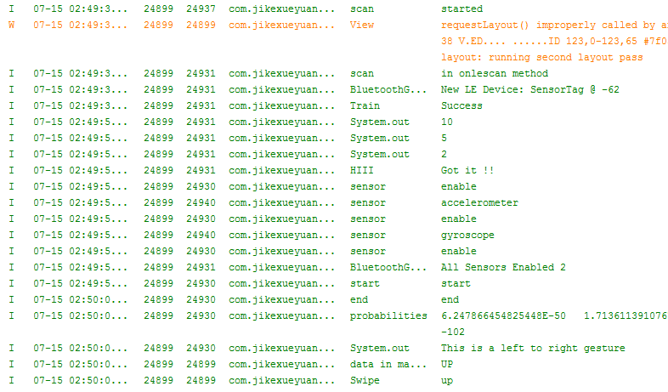

Screenshot for Top to Bottom motion

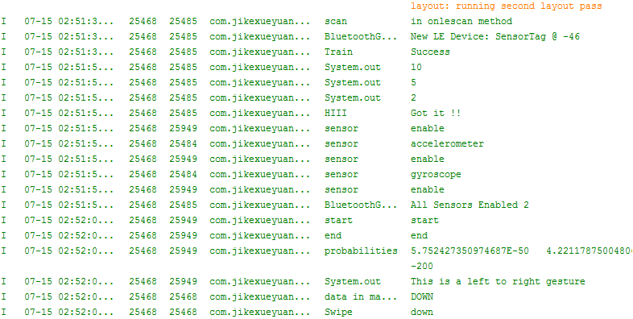

From the Flappy cow game, we made changes by adding the below methods:

