Cyber AI Platform (CAIP)
Architecture Proposal: Dedicated AWS Account for Cyber Defense AI Workloads
Owner: Cyber Defense Architecture | Status: Draft for Architecture Review | Date: April 2026

1. Overview
CAIP is an AWS account dedicated to Cyber Defense for running LLM analysis against vulnerability scans, pentest output, malware samples, and our internally deployed AI services. The work is defensive in purpose. It uses offensive techniques because that is what defensive testing requires.
AI Dome (AI Platform) stays the default route for all general-purpose LLM traffic in the company. CAIP only handles the specific Cyber Defense workloads listed in Section 5, where AI Dome’s payload limits, content filters, or shared rate budgets get in the way.

2. Platform Capabilities
The platform provides:
- Bedrock inference, called directly in-account over IAM. No API keys on this path, and no internet egress.
- A controlled route to non-Bedrock providers (OpenAI, Anthropic API direct, Gemini, others) where API keys are needed. Keys live in AWS Secrets Manager. Outbound traffic is allowlisted at AWS Network Firewall.
- A Cyber Defense-owned screening layer on both paths. Bedrock calls go through a Guardrails profile tuned for security operations. Non-Bedrock calls use a matching pre/post-processing library invoked by the calling tool.
- S3-based batch inference for scan outputs that are too large for synchronous calls on either path.
- Cross-account IAM patterns so the Cyber Defense tools we already run (scanners, pentest platforms, AI red-team frameworks) can reach the platform without being moved.
- Full observability: prompt-and-response capture, network flow logs, secrets retrieval logs, and cost attribution into the same FinOps and SIEM pipelines we use elsewhere.

3. Rationale
AI Dome is the right default for application traffic. It is not the right path for the workloads above. Four reasons:
Payload. APIGEE Edge enforces a 10 MB request body by default and 30 MB at the hybrid maximum. The Portkey gateway behind AI Dome relies on buffered policies for routing, key handling, and PII screening, which means streaming around the limit isn’t a safe global option. Our scan outputs routinely cross 30 MB before the prompt envelope is added: Nessus exports of mid-sized scopes, network scans with banner data, aggregated SAST runs. Bedrock supports requests up to 32 MB at the Anthropic provider tier, and OpenAI’s standard endpoints support comparable sizes. The model can take it. AI Dome cannot, with policies engaged.
Cost. Reasoning models with extended thinking burn far more tokens per call than the previous generation. Routing high-volume security batches through AI Dome stacks gateway processing cost on top of inference cost, and forces our jobs to share a rate budget with application traffic. A direct in-account path is cheaper at scale and removes the contention.
Data sensitivity. What we send names vulnerable hosts, exposed credentials, and exploit paths. We don’t want that data in the same logs and cost views as application traffic. There is also a content-filter problem: AI Dome’s filters are tuned for customer-facing applications and refuse a lot of what we ask. The work this team does needs a different filter profile than the work the rest of the company does.
Business case. IBM’s Cost of a Data Breach Report 2025 puts the global average breach at $4.44M and the US average at $10.22M. Organizations using AI extensively in security operations save $1.9M per breach on average and shorten the breach lifecycle by 80 days. Breaches contained in under 200 days averaged $3.61M; over 200 days, $5.49M (a $1.88M gap per incident). The same report finds that 97% of AI-related breaches involved systems without proper access controls. CAIP is how we close both of those gaps in our environment.

4. Solution Architecture
CAIP is an AWS account in the Security OU, vended through Control Tower. SCPs deny public S3, IAM users (federated only), and uncontrolled internet gateway creation. There are two inference paths inside the account, and they share the same governance and logging plane.
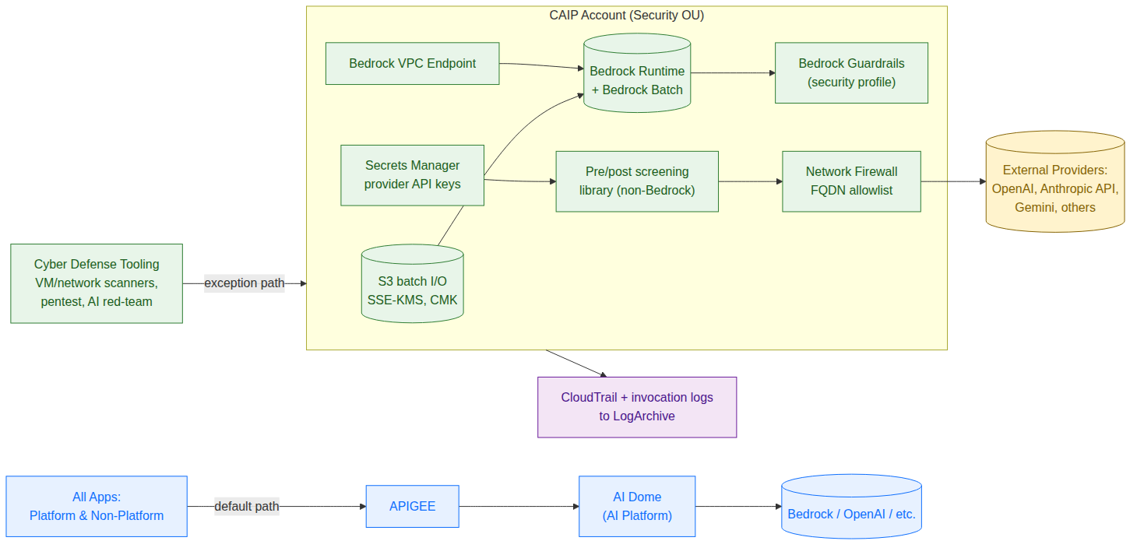
Figure 1. CAIP within the enterprise inference landscape.
Bedrock path. The calling tool authenticates with IAM and reaches Bedrock through a VPC endpoint. No API keys, no internet. Bedrock Guardrails (security profile) run on every call.
External provider path. The calling tool retrieves the provider’s API key from Secrets Manager, runs the Cyber Defense screening library, and sends the request out through Network Firewall. The firewall’s FQDN allowlist limits where calls can go. We do not break TLS on this path because the data in flight is sensitive.
Secrets and key management. Provider API keys live in Secrets Manager, encrypted with a customer-managed KMS key. Rotation is automated where the provider supports it (manual otherwise) on a 90-day cycle. IAM grants access to specific tool roles. Every retrieval shows up in CloudTrail.
Data plane. Two S3 buckets, one for batch input and one for output, both encrypted with the same KMS key. Bucket policies require aws:SourceVpce to match. Retention is 7 years to line up with our security log policy.
Identity. Federated through the IdP. No IAM users. There are three roles: Admin (break-glass, MFA required), Engineer, and Reader. Cross-account callers from each tool assume a per-tool role rather than a single shared service principal.
Screening. The Bedrock Guardrails security profile is tuned to allow legitimate vulnerability and exploit discussion (otherwise the model refuses to do the work) and tightened to block production secrets and customer identifiers in outputs. The non-Bedrock screening library uses the same denylist and writes equivalent logs. Direct provider SDK use is blocked at the egress firewall.
Observability. CloudTrail data events on Bedrock, S3, and Secrets Manager flow to LogArchive. Bedrock invocation logging captures full prompts and responses; the screening library does the same for non-Bedrock calls. Network Firewall flow logs cover every outbound provider connection. Bedrock spend lands in a CUR cost category. Non-Bedrock spend reconciles monthly from provider billing APIs into the same FinOps view.

5. Scope and Eligibility
Anything not in the table below stays on AI Dome. A workload qualifies for CAIP only if it is defensive security work owned by Cyber Defense and meets at least one of these conditions: it exceeds AI Dome’s payload limits, it has a token profile that disrupts the shared rate budget, or it needs filter tuning AI Dome cannot provide. New use cases need a one-page intake approved by the Cyber Defense lead before they are onboarded.
In Scope (CAIP) | Out of Scope (stays on AI Dome)
VM vulnerability scan triage and false-positive reduction | SOC alert triage
Network scan and reconnaissance output analysis | IR co-pilot
Pentest report synthesis and cross-engagement correlation | General application LLM use
SAST and DAST findings reduction | Customer-facing AI features
AI red-teaming of internally deployed AI services | Internal chat assistants
Malware static-analysis assistance | Compliance and policy summarization

6. Compensating Controls
Stepping outside AI Dome means giving up some of what AI Dome gives the rest of the company. We replicate those controls inside CAIP rather than leave them gone. The security-tier policy is intentionally different from the app-tier policy: it allows exploit discussion, captures full prompts and responses, controls its own egress, and retains for 7 years. One shared infrastructure cannot serve both well, which is the point of having a second account in the first place.
Capability provided by AI Dome | Compensating control in CAIP
Centralized cost attribution (all providers) | CUR for Bedrock, plus monthly reconciliation from external provider billing APIs into FinOps.
Centralized rate limiting | Bedrock account quotas and per-role token budgets via IAM session policies. Per-provider rate caps in the screening library.
PII redaction in flight | Bedrock Guardrails on the Bedrock path. Cyber Defense screening library on the non-Bedrock path. Same denylist on both.
Provider key management | AWS Secrets Manager with KMS encryption, 90-day rotation, scoped IAM access, and CloudTrail-logged retrieval.
Egress control to external providers | AWS Network Firewall with FQDN allowlist. Flow logs to LogArchive.
Prompt-injection screening | Pattern matching at the calling-tool ingress. Anomalies forwarded to SIEM.
Centralized audit trail | CloudTrail, Bedrock invocation logs, and screening-library logs to LogArchive at the same retention as AI Dome logs.

7. Delivery Roadmap
Approval requested: architecture review board sign-off to begin Phase 0.
Phase | Scope | Duration
0 | Account vending. VPC, Network Firewall, IAM, KMS, Secrets Manager scaffolding. | 2 weeks
1 | Bedrock path live. First production workload: VM scan triage batch. | 4 weeks
2 | Non-Bedrock path live (Secrets Manager, screening library, egress allowlist). Network scan and SAST/DAST workloads onboarded. | 4 weeks
3 | AI red-team workload. Privacy-reviewed Guardrails profile and screening library v1 in production. | 4 weeks
Dependencies. Privacy sign-off on the Guardrails profile and the non-Bedrock screening library (drafting starts in Phase 0). FinOps sign-off on the cost attribution model, including external provider reconciliation. Cloud Platform approval on the SCPs and the egress firewall ruleset. Network Security review of the FQDN allowlist.
Sponsors. CISO, Cloud Platform Lead, Privacy Lead, Network Security Lead. Owner. Cyber Defense Architecture.

8. References
- IBM Security. Cost of a Data Breach Report 2025. https://www.ibm.com/reports/data-breach
- AWS. Amazon Bedrock API restrictions (request size limits per model provider). https://docs.aws.amazon.com/bedrock/latest/userguide/inference-api-restrictions.html
- AWS. Amazon Bedrock service quotas and endpoints. https://docs.aws.amazon.com/general/latest/gr/bedrock.html
- Google Cloud. Apigee streaming requests and payload limits. https://cloud.google.com/apigee/docs/api-platform/develop/enabling-streaming
- AWS. AWS Network Firewall stateful rule groups (FQDN domain filtering). https://docs.aws.amazon.com/network-firewall/latest/developerguide/stateful-rule-groups-domain-names.html

9. Revision History
Version | Date | Author | Notes
0.1 | April 2026 | Cyber Defense Architecture | Initial draft for architecture review board.

