Supplementary Materials
Priced out of the formal market: A housing affordability index for Greater Kampala, Uganda, from online listings and spatial machine learning
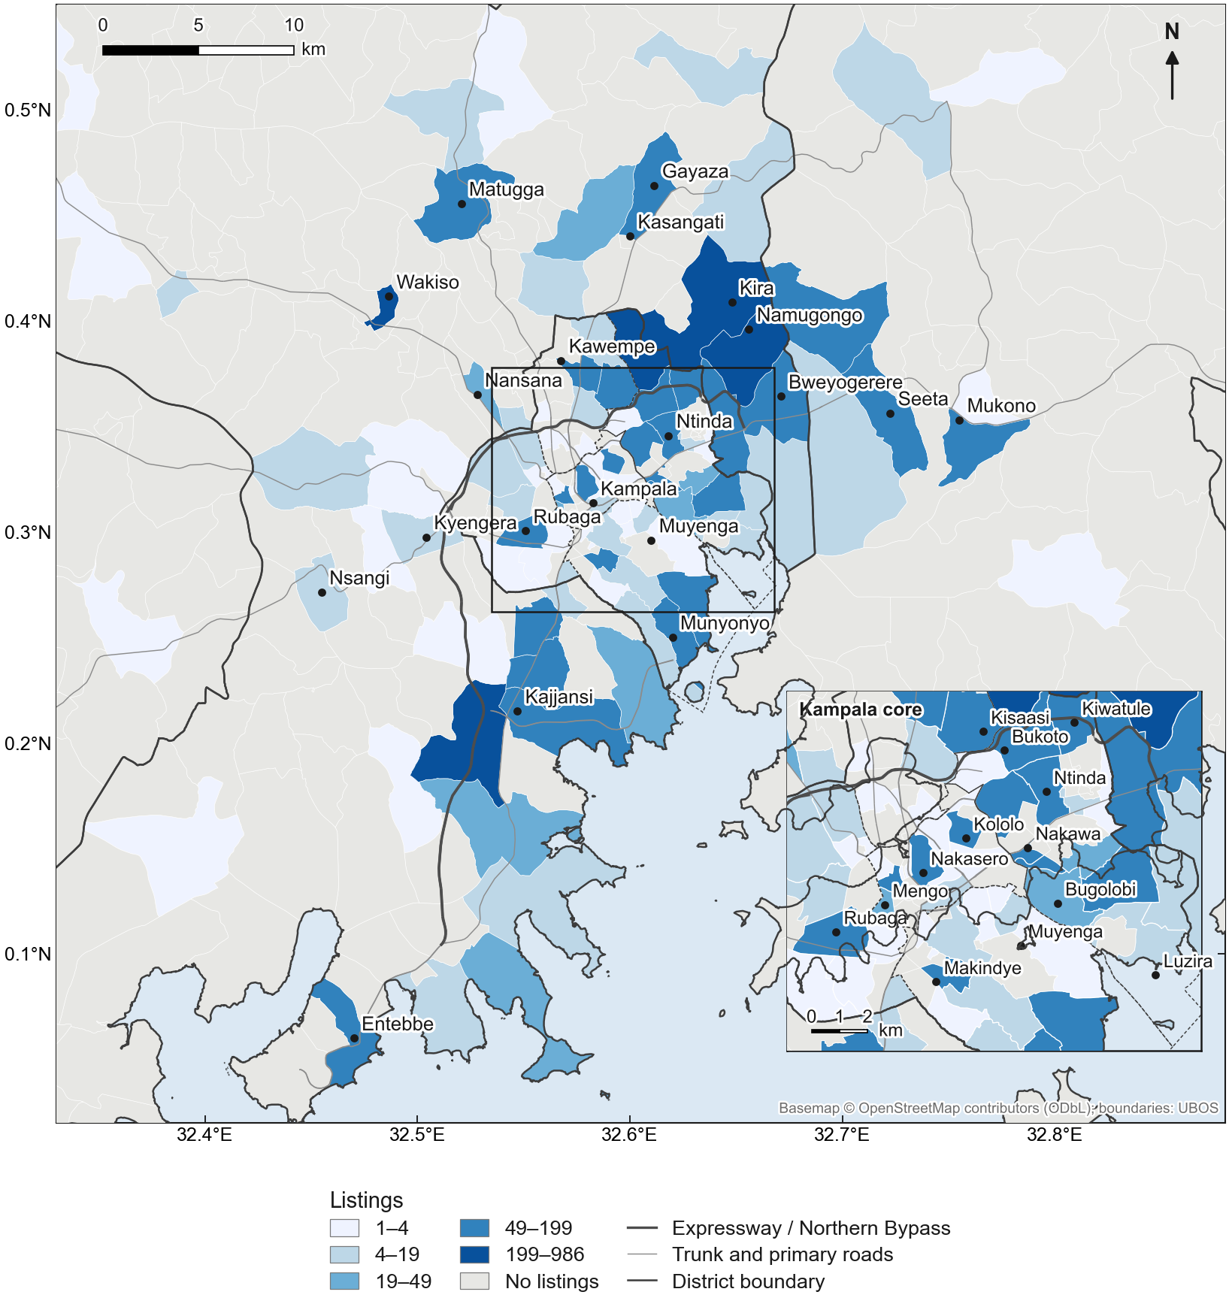
Figure S1. Listings located in each parish (1–2 bedroom rentals and house/apartment sales). Listings are geocoded to neighbourhoods, so parish assignment is only as precise as the neighbourhood point.
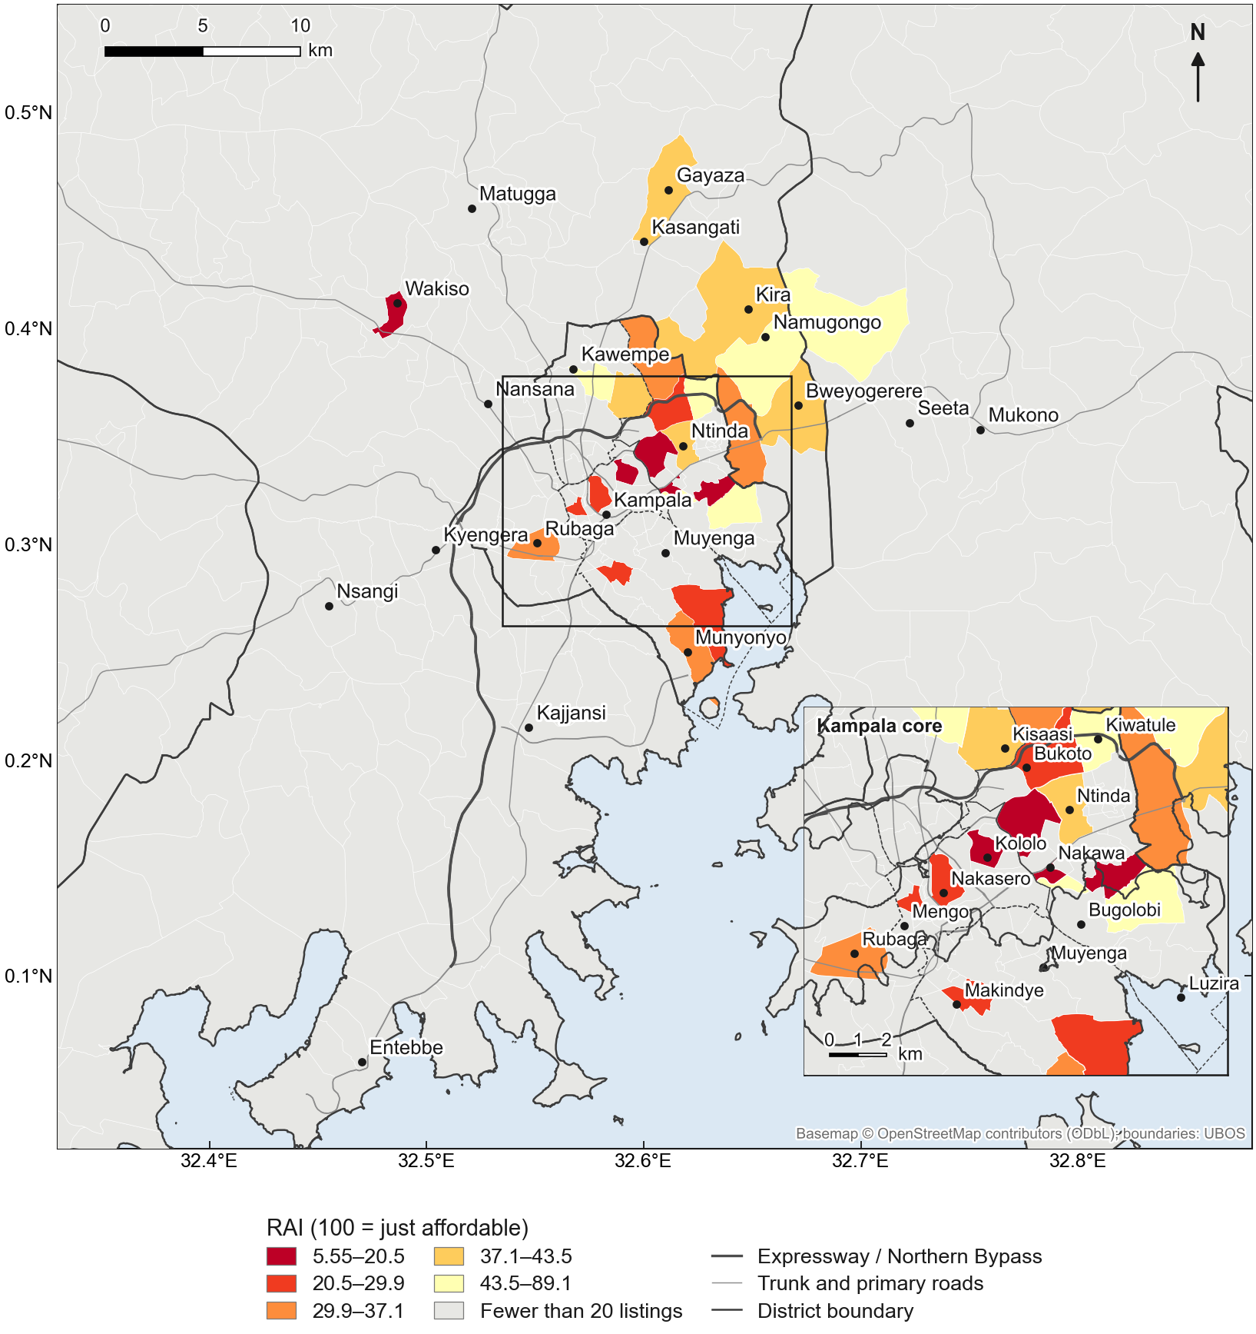
Figure S2. Rental Affordability Index by parish, for parishes with at least 20 rental listings (indicative; the sub-county maps are the primary results).
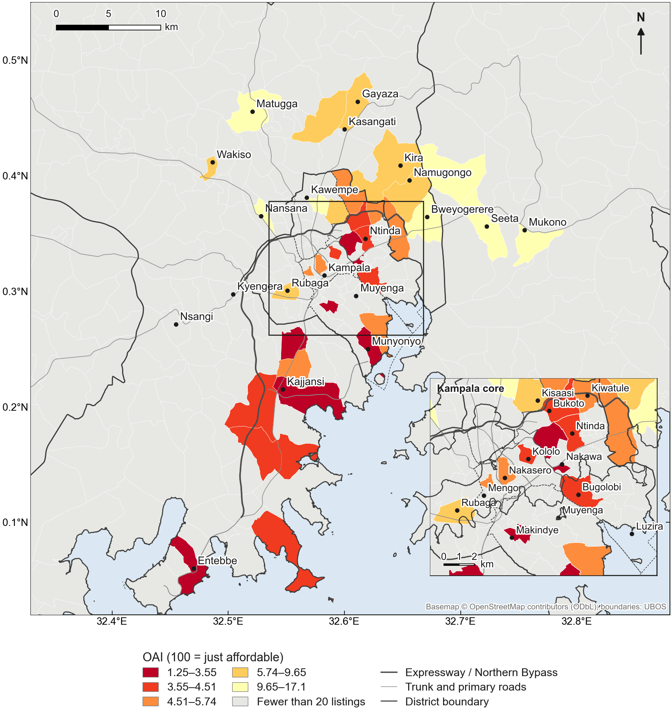
Figure S3. Ownership Affordability Index by parish, for parishes with at least 20 sale listings (indicative).
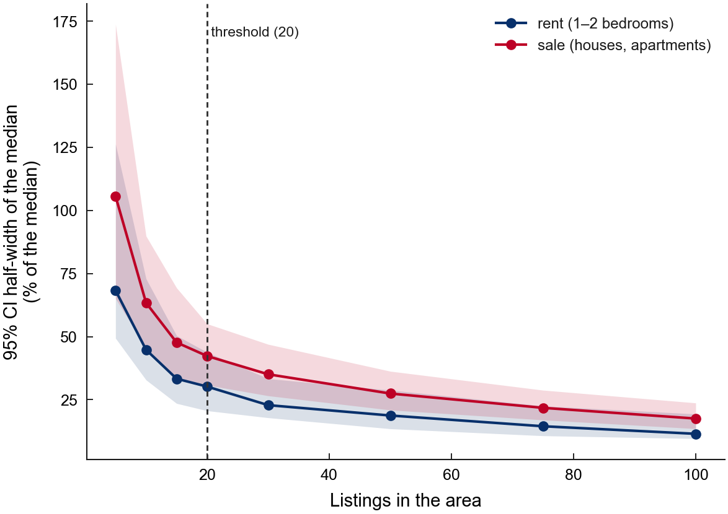
Figure S4. Precision of area medians by number of listings: 95% bootstrap interval half-width as a share of the median, from subsamples of sub-counties with at least 60 listings (30 draws × 500 resamples per size).
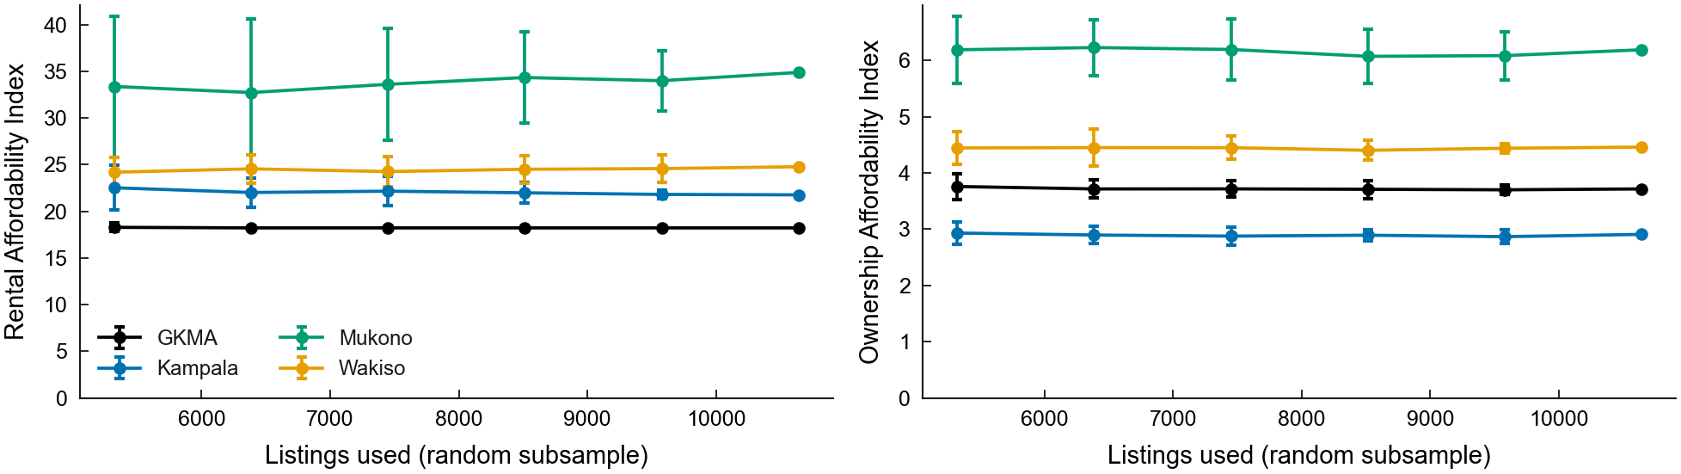
Figure S5. Stability of the affordability index as the sample grows: mean over 20 random subsamples of 50–90% of listings, with ±1.96 s.d.
Table S1. Ownership Affordability Index under alternative mortgage terms. Base: BoU 12-month mean lending rate (18.3%), 30% deposit, 20 years, 35% repayment cap; each column changes one term.
Area | Base | Rate 16% | Rate 22% | Deposit 20% | Deposit 50% | 15 years | 25 years | Cap 30%
GKMA | 3.7 | 4.2 | 3.1 | 3.3 | 5.2 | 3.6 | 3.8 | 3.2
Kampala | 2.9 | 3.3 | 2.5 | 2.5 | 4.1 | 2.8 | 3.0 | 2.5
Wakiso | 4.5 | 5.0 | 3.8 | 3.9 | 6.2 | 4.3 | 4.5 | 3.8
Mukono | 6.2 | 7.0 | 5.2 | 5.4 | 8.7 | 5.9 | 6.3 | 5.3

Table S2. Robustness of key results to the sample. Hedonic coefficients; * p < 0.05.
Sample | Listings | GKMA RAI | GKMA OAI | Wealth (sale) | ln plot size (sale) | Title stated (sale) | ln dist. Expressway (sale) | ln dist. CBD (rent)
Full sample | 10,643 | 18.2 | 3.7 | 0.533* | 0.511* | 0.120* | -0.221* | -0.396*
Neighbourhood-level locations only | 9,381 | 18.2 | 3.5 | 0.435* | 0.514* | 0.108 | -0.162* | -0.652*
Without Jiji | 6,907 | 18.2 | 3.5 | 0.441* | 0.468* | 0.122* | -0.210* | -0.162
Without RED | 4,614 | 16.7 | 3.7 | 0.604* | — | 0.058 | 0.024 | -0.403*
Without Uganda Property Centre | 9,765 | 18.2 | 3.9 | 0.508* | 0.512* | 0.104* | -0.185* | -0.661*

Table S3. Listing-based hedonic index and the UBOS Residential Property Price Index. Reported for completeness; most quarters rest on fewer than 20 listings and are not interpreted.
Area | Quarter start | Listings | Listing index | UBOS RPPI (rebased)
Wakiso | 2022-10-01 | 8 | 100.0 | 100.0
Wakiso | 2025-01-01 | 3 | — | 105.9
Wakiso | 2025-04-01 | 6 | — | 113.2
Wakiso | 2025-07-01 | 523 | — | 121.4
Wakiso | 2025-10-01 | 6 | — | 121.6
Wakiso | 2026-01-01 | 17 | — | 119.5
Wakiso | 2026-04-01 | 87 | — | 117.1
Wakiso | 2026-07-01 | 964 | — | —

Table S4. Share of households priced out (%) across burden thresholds of 10–80% of income.
Burden threshold | GKMA: rent | Kampala: rent | Wakiso: rent | Mukono: rent | GKMA: own | Kampala: own | Wakiso: own | Mukono: own
10% | 99.9 | 100.0 | 99.8 | 99.0 | 100.0 | 100.0 | 100.0 | 100.0
20% | 99.3 | 99.8 | 97.9 | 93.9 | 100.0 | 100.0 | 100.0 | 100.0
30% | 97.5 | 98.9 | 94.1 | 86.6 | 100.0 | 100.0 | 100.0 | 99.9
35% | 96.2 | 98.0 | 91.8 | 82.7 | 100.0 | 100.0 | 100.0 | 99.9
40% | 94.6 | 96.8 | 89.2 | 78.8 | 100.0 | 100.0 | 100.0 | 99.8
50% | 91.0 | 93.6 | 83.8 | 71.3 | 100.0 | 100.0 | 99.9 | 99.6
60% | 87.0 | 89.5 | 78.3 | 64.4 | 99.9 | 100.0 | 99.8 | 99.2
70% | 82.7 | 84.6 | 72.8 | 58.2 | 99.9 | 100.0 | 99.7 | 98.8
80% | 78.4 | 79.4 | 67.6 | 52.7 | 99.8 | 100.0 | 99.5 | 98.2

Table S5. Cleaning log. Location methods among resolved records: gazetteer exact 8,393; gazetteer contained name 2,568; district-level label 467; OpenStreetMap 342; sub-county 264; fuzzy 219; UBOS parish name 58.
Step | Records
raw records (all snapshots) | 13424
parsed | 13424
drop short-stay / nightly | 13424
drop missing price | 13418
drop listing_type unknown | 13418
location resolved | 12311
after de-duplication | 10823
inside GKMA study area | 10823
drop price outliers (flagged) | 10749
drop commercial | 10643

