The Geography of Infrastructure Disputes: A Spatio-Temporal Analysis of Delay, Cost Overrun and Claims Drivers in Uganda's Public Projects, 2017–2025
Charles Gavamukulya¹*, Clinton Aigbavboa¹
¹ Department of Construction Management and Quantity Surveying, University of Johannesburg, South Africa
*Corresponding author: gavacharles85@gmail.com

Abstract
Construction dispute research treats projects as though they had no location. In Uganda, remoteness, terrain, land tenure, district administrative capacity and political attention all vary sharply across the country, yet no study has asked whether dispute drivers cluster in ways that call for regional management strategies. This paper text-mines Uganda's Office of the Auditor General (OAG) annual reports to Parliament (2017/18–2024/25), geocodes 238 of 283 identifiable public-infrastructure projects named in the resulting corpus, and tests whether eight audit-derived dispute-driver categories – delay, cost overrun, claims and disputes, land/right-of-way, contract management, delayed payments, governance and procurement irregularity – are spatially random or clustered across Uganda's 135 districts. Global Moran's I shows significant positive spatial autocorrelation for five of eight categories (strongest for delayed payments, I = 0.336, and land/right-of-way, I = 0.333; both p = 0.001), and Getis-Ord Gi* hot-spot analysis maps a Kampala–Wakiso–Mukono–Luwero corridor for land and delay disputes that is geographically distinct from separate cost-overrun clusters in the Hoima/Buliisa oil region and the Mbale/Manafwa/Kween Elgon highlands. A district-level spatial regression finds that dependency ratio, population and a historic land-tenure proxy (mailo versus customary versus freehold) explain most of the observed clustering – so much so that, for overall dispute intensity, a global model is statistically indistinguishable from a geographically weighted one (GWR bandwidth selected at 133 of 135 districts). For land/right-of-way disputes specifically, however, geographically weighted regression does improve on the global model (ΔAICc = 4.25) and reveals an east–west gradient in how distance from Kampala and mailo tenure relate to dispute intensity. The paper is explicit about what audit-derived text can and cannot support: OAG coverage is not a census of disputes, contractor and funding-source information is almost never stated (identified for under 5% of projects), and the project-extraction step is a careful reading exercise rather than a deterministic algorithm. Within those limits, the results indicate that Uganda's infrastructure dispute landscape is genuinely place-based, that land acquisition and delay disputes concentrate in the central mailo-tenure corridor around the capital for reasons that a purely institutional or contractual account would miss, and that a district-level spatial risk screen is a practical, low-cost addition to project appraisal in a data-scarce environment.
Keywords: construction disputes; spatial analysis; Uganda; Getis-Ord Gi*; geographically weighted regression; land tenure; infrastructure governance; text mining

1. Introduction
Dispute research in construction management is, with rare exceptions, geographically blind. Studies ask which factors predict delay, cost overrun or claims, but almost never ask where those factors bite hardest, or whether the answer to 'where' changes what the answer to 'why' should be. This is a real omission in Uganda's case. The country's infrastructure programme spans a coastal-forest west, a semi-arid northeast, a mountainous southwest and a densely populated central corridor around Kampala; district administrative capacity, land tenure regime, terrain and political attention vary as sharply across this geography as any of the contractual variables the literature usually tests. If dispute drivers are randomly scattered across this variation, a national procurement policy is the right instrument. If they cluster, a regional one might do more.
This paper asks three questions. First, where do dispute drivers concentrate? Second, how has their pattern shifted over 2017–2025, a period spanning the Government of Uganda's 2021 decision to fold the Uganda National Roads Authority (UNRA) back into the Ministry of Works and Transport (MoWT) – a rationalisation policy formally implemented through repeal legislation in November 2024, after a multi-year transitional period [UNRA repeal reporting, 2024]? Third, which place-based factors explain the clustering that is found? The paper answers these questions using Uganda's Office of the Auditor General (OAG) annual reports to Parliament, text-mined and geocoded to the project level, and tested with the standard exploratory spatial data analysis (ESDA) and explanatory spatial regression toolkit used elsewhere in construction and transportation research but, to the authors' knowledge, never yet applied to a Sub-Saharan African infrastructure dispute corpus.

2. Literature and Theory

2.1 Dispute-driver taxonomies
The dominant taxonomies of construction dispute causation are built from expert surveys, Delphi panels and litigation-record reviews concentrated in North America, the United Kingdom, Australia and parts of Asia (Naji, Mansour, & Gunduz, 2020). These taxonomies travel poorly: a category list built from Gulf Cooperation Council contract litigation, or from UK arbitration awards, encodes the institutional assumptions of those jurisdictions – functioning courts, published case law, standard-form contracts with settled interpretation – that do not hold in a market where formal arbitration is rare and land is held under four constitutionally distinct tenure regimes. Section 3.1 describes how the present paper adapts this literature's five conventional categories – procurement irregularity, delayed payments, contract management, land/right-of-way and governance/oversight – and adds two categories the international literature does not carry as distinct classes but that recur throughout Uganda's audit narrative: delay/time overrun as a construction-schedule outcome (distinct from delayed payments, a financial outcome the literature already separates out) and claims and disputes as a broader category than the narrow contingent-liability language a first pass at the corpus initially used.

2.2 Spatial analysis in construction management
A small but growing literature applies geographic information systems (GIS) and spatial statistics to construction outcomes, almost entirely in a US roadway-programme setting. Yun, Ryu and Ham (2022) fuse machine learning with GIS to map socio-geographic correlates of cost-overrun occurrence across US state roadway projects, finding that management district, commuting behaviour and local population characteristics predict overrun risk independently of project-level contract variables. Shamshiri, Ryu, Shahandashti and colleagues (2025) extend this to schedule-overrun occurrence using a comparable geospatial machine-learning pipeline on Florida roadway data. Both studies establish that where a project sits is informative net of what it is – the premise this paper tests for Uganda – but neither uses formal spatial-autocorrelation statistics (Moran's I, Getis-Ord Gi*) or a developing-country, audit-derived data source; both work from complete administrative project registers, a condition this paper's data source explicitly does not meet (Section 3).

2.3 Institutional theory and subnational state capacity
Scott's (2001) three-pillar model of institutions – regulative, normative and cultural-cognitive – provides the framework for interpreting what a spatial pattern in dispute-driver reporting indexes about the state of subnational governance. In much of Sub-Saharan Africa, the regulative pillar is not uniform across territory: colonial and postcolonial administration built what Mamdani (1996) calls 'decentralised despotism' – a bifurcated state in which urban, formally governed space coexists with rural areas administered through customary authority structures with distinct rules for land, dispute resolution and accountability. Uganda's land law gives this theoretical claim direct empirical content: the 1995 Constitution (Article 237) and the Land Act 1998 recognise four tenure types – mailo, freehold, leasehold and customary – with materially different compensation, consultation and dispute-resolution pathways. Mailo tenure, concentrated in the historic Buganda Kingdom districts surrounding Kampala, creates a landlord–tenant (bibanja) structure that Transaction Cost Economics (Williamson, 1985) would predict is more hold-up-prone than customary tenure's community-consent process, because mailo separates the registered titleholder from the occupant with a use right, multiplying the parties whose consent a project needs. If this account is right, land and delay disputes should concentrate disproportionately in mailo-tenure districts independent of their distance from the capital or their population size – a testable, falsifiable prediction this paper's regression is built to check (Section 4.3).

2.4 The gap and hypotheses
No study has spatially modelled construction dispute drivers in Sub-Saharan Africa using formal ESDA and explanatory spatial regression. This paper closes that gap and tests three hypotheses drawn from the theory above: (H1) districts with higher Rural Access Index scores (less remote) show lower delay-dispute intensity, net of population and tenure; (H2) mailo-tenure districts show elevated land/right-of-way dispute intensity relative to customary-tenure districts, net of distance and population; (H3) the spatial pattern of dispute drivers is not uniform across the country – i.e. a geographically weighted model improves materially on a global one for at least one driver category. Sections 4–6 test each in turn.

3. Data

3.1 Primary source: the OAG corpus
The primary source is Uganda's Office of the Auditor General annual reports to Parliament, financial years 2017/18–2024/25 (eight reports; the 2020 file in the OAG archive is an internal strategic-planning document rather than an audit report, and contributes negligible substantive content, a point that matters for the space-time analysis in Section 5.3). Full text was extracted from all eight cached PDFs (164–784 pages each); an earlier extraction pass had capped extraction at 120 pages per report, silently discarding 70–85% of each report's content, which explains why a first-pass classifier returned zero sentences for the cost-overrun category despite the term appearing routinely once the cap was removed. Document front matter (tables of contents, glossaries, table/figure captions) was stripped before sentence splitting after a 12.8% contamination rate was measured and verified by spot-check in the original, capped corpus.
Sentences were classified into eight dispute-driver categories by a multi-label keyword/regular-expression system: each category is defined by a short list of terms and phrases (Table X, Appendix), and a sentence is assigned every category whose terms it contains, rather than the single best-matching category, so that a sentence discussing both a delay and its associated cost escalation counts toward both categories rather than an arbitrary one. This is a transparent, fully auditable method, but not a trained or learned one, and its term lists were developed iteratively against the corpus itself: five categories were seeded from the international dispute-causation literature's conventional terms (procurement, delayed payment, contract management, land acquisition, governance), and two additional categories – delay/time overrun and claims and disputes – were added after an initial read of the corpus showed substantial, recurring language (e.g. 'behind schedule', 'stalled', 'litigation', 'liquidated damages') that the conventional five-category scheme had no home for. Classifier performance against a held-out, independently coded sample is reported in Section 3.4; the headline result – macro-F1 = [XX] (Section 3.4) – should be read alongside the category counts throughout this paper, since a keyword system's errors are not random and are more informative read in the confusion pattern (Table 5) than in the aggregate score alone.
A construction-relevance filter, requiring a specific infrastructure noun, a named infrastructure agency, or construction-contract-specific terminology, removed generic public-sector content (drug procurement, academic staffing, research-programme findings) that an earlier, more permissive filter keyed only on generic terms such as 'delayed' or 'project' had let through; 792 of 1,762 driver-labelled sentences (44.9%) pass this filter and form the analysis corpus for the present paper.

3.2 Project identification and geocoding
Named, geocodable projects cannot be extracted from OAG narrative by keyword pattern alone: a preliminary regular-expression pass extracted 'Uganda' as a road-project name because the phrase 'Uganda Road Fund' (an institution) matched the same surface pattern as a genuine project name. Project identification was therefore done by direct reading of every sentence in the 792-sentence analysis corpus against the question 'does this sentence name a specific, identifiable infrastructure project, as opposed to an institution or a generic reference?' Only 217 sentences (27.4%) do; a further 692 project mentions recovered by tracing these sentences back to their full, untruncated report context canonicalise to 283 distinct projects. Table 1 summarises the extraction and geocoding funnel.
Stage | n | % of prior stage
Driver-labelled sentences (full-text re-extraction, 8 reports) | 1,762 | —
Construction-relevant (infrastructure noun / agency / contract term) | 792 | 44.9%
Sentences naming a specific, identifiable project | 217 | 27.4%
Canonical distinct projects (after deduplication across mentions/years) | 283 | —
Successfully geocoded (OpenStreetMap Nominatim) | 238 | 84.1%
— point-precision facilities | 212 | —
— line-geometry road/transmission corridors (straight-line endpoint proxy) | 46 | —
Table 1. Project extraction and geocoding funnel.
Geocoding used OpenStreetMap Nominatim, with point facilities (hospitals, schools, dams, airports, water schemes) geocoded to their named place, and road or transmission-line projects geocoded as a straight line between their two named endpoints – an explicit proxy for, not a measurement of, the true alignment, since no digitised MoWT project-alignment layer was accessible for this study. Manual verification caught two classes of geocoding error worth reporting because they recur in any toponym-based pipeline applied to Uganda: same-named-place confusion (Nominatim's first match for 'Kabaale International Airport' was a village in Rakai District, roughly 500 km from the actual airport site under construction near Hoima) and no-match fallback (the Isimba Hydropower Plant has no correctly sited OpenStreetMap node; its coordinate is a district centroid, flagged as such in the released data rather than silently accepted). District assignment used a spatial join against current OCHA Common Operational Dataset – Administrative Boundaries (135 districts, valid as of 2020-08-24), cross-checked against the reading-extracted district recorded during project identification; the two agree for 172 of 253 projects with both values (68%), and the reading-extracted value is preferred where they disagree, since disagreement traces almost entirely to the same-named-place geocoding failure mode above rather than to an error in reading.

3.3 Explanatory covariate layers
District- and project-level covariates were assembled from public sources, all downloaded for this study (Table 2); no district- or parcel-level land-tenure GIS layer exists publicly for Uganda, so tenure is coded as a sub-region-based proxy from the documented geographic concentration of mailo tenure in the historic Buganda Kingdom districts and native freehold in the Ankole and Kigezi sub-regions (Land Act 1998; Constitution, Art. 237), with all other districts coded customary, the nationally dominant regime. Contractor origin and funding source were attempted with the same reading-based approach used for project identification, but coverage is very low – a named contractor is stated for 12 of 283 projects (4.2%) and a classifiable funding category for 8 (2.8%) – so these variables are discussed qualitatively (Section 6.4) rather than used as regression covariates.
Covariate | Source | Granularity
Population, 2022 projection | OCHA COD-PS | District
Dependency ratio; rural population % | HeiGIT / Humanitarian OpenStreetMap Team risk-assessment layers | District
Rural Access Index (% of rural population within 2km of an all-season road) | HeiGIT/HOT; World Bank RAI methodology | District
Elevation | SRTM, via Open-Elevation API | Point / district centroid
Mean annual rainfall (2018–2022 climatology) | CHIRPS v2.0, UCSB Climate Hazards Center | Point / district centroid
Distance to Kampala | Computed (haversine) | Point / district centroid
Land tenure (mailo / freehold / customary) | Documented sub-region proxy (Constitution Art. 237; Land Act 1998) | District
Election-year flag | Electoral Commission polling dates | Project-year
Table 2. Explanatory covariate layers and sources.

3.4 Classifier validation
Because the driver classifier (Section 3.1) is a transparent keyword system rather than a trained model, its errors are not random and need checking directly rather than assumed away. A stratified sample of [XX] sentences (drawn across the eight categories, seed 42) was independently re-coded against a written codebook by a rater blind to the classifier's assigned labels, judging which of the eight categories genuinely apply to each sentence (a sentence may belong to none, one, or several). This is a disclosed AI-assisted single-rater validation, not a claim of independent human inter-coder reliability, and is reported as such: with only one rater, no inter-coder statistic such as Cohen's kappa is computable or reported. Table 3 gives the resulting per-category precision, recall and F1 against this reference set; macro-averaged F1 is [XX].
Category | n gold-positive | Precision | Recall | F1
Delay / time overrun | [XX] | [XX] | [XX] | [XX]
Cost overrun | [XX] | [XX] | [XX] | [XX]
Claims & disputes | [XX] | [XX] | [XX] | [XX]
Land / right-of-way | [XX] | [XX] | [XX] | [XX]
Contract management | [XX] | [XX] | [XX] | [XX]
Delayed payments | [XX] | [XX] | [XX] | [XX]
Governance & oversight | [XX] | [XX] | [XX] | [XX]
Procurement irregularity | [XX] | [XX] | [XX] | [XX]
Macro average | [XX] | [XX] | [XX] | [XX]
Table 3. Classifier performance against an independently coded reference sample (disclosed single-rater validation; see Section 3.4).
[XX: one to two sentences on the strongest and weakest categories and the dominant confusion pattern, filled in from the validation write-up once scoring is complete.] The category term lists themselves are given in full in the Appendix (Table A1) so that every classification decision in this paper is auditable against its source rule, not only against the validation sample.

4. Methods

4.1 Exploratory spatial data analysis
Global spatial autocorrelation was tested with Moran's I (Queen contiguity weights, row-standardised, 999 conditional permutations) on district-level project counts, run once for total project intensity and once per driver category. Local hot and cold spots were identified with Getis-Ord Gi* on the same weights matrix, with p-values false-discovery-rate corrected across the 135 simultaneous district-level tests within each category. Both statistics were computed on counts of distinct geocoded projects per district (not sentence counts), since a single project may generate several audit sentences across years and categories, and the unit of spatial analysis should be the project, not the mention.

4.2 Space-time analysis
A year × district panel (2017–2025) was built from each project's audited years, and Getis-Ord Gi* was recomputed per year on the resulting annual counts (pooled across driver categories, the only specification with enough non-zero district-years to be worth mapping at all at annual resolution). A Mann-Kendall trend test was applied to each district's resulting nine-year Gi* z-score series to classify districts as intensifying, diminishing or showing no detectable trend, following the logic of ESRI's emerging hot-spot analysis. The nine annual maps are rendered as a supplementary animated GIF.

4.3 Explanatory modelling
District-level explanatory models were fitted for three outcomes – total project intensity, land/right-of-way count, and delay/time-overrun count, each log(1+x)-transformed – against the standardised covariates in Table 2 (excluding contractor/funding, per Section 3.3) plus mailo and freehold tenure dummies (customary as reference). For each outcome, an ordinary least squares (OLS) model was fitted first, followed by Lagrange Multiplier diagnostics for spatial dependence and, regardless of the diagnostic result, both a maximum-likelihood spatial lag and a maximum-likelihood spatial error model (Queen contiguity weights), so that the diagnostic outcome itself – whether the spatial terms add anything – is reported rather than assumed. Geographically weighted regression (GWR; adaptive bisquare kernel, bandwidth selected by golden-section AICc minimisation) was fitted for the same three outcomes to test whether the global coefficients are stable across the country or vary locally; GWR is preferred over the global model only where its AICc is at least three points lower, the conventional threshold. As a non-parametric robustness check that does not assume linearity or a particular functional form, a Random Forest (500 trees, max depth 4, minimum leaf size 5) was fitted for each outcome on the same covariates, with variable importance read from mean absolute SHAP values and out-of-sample performance assessed by leave-one-out cross-validation, appropriate given the small (n = 135) sample.

4.4 Scope note on validation
The explanatory results in Sections 5.4–5.6 are reported as candidate, testable associations rather than settled findings. Independent validation of the spatial clusters and candidate explanations against practitioner or expert judgement is identified as a priority extension in Section 7.2 but is not carried out in the present paper.

5. Results

5.1 National distribution
Figure 1 maps all 238 geocoded projects, coloured by primary dispute driver. The distribution is not uniform: projects cluster around Kampala and the road/transmission corridors radiating from it, with a second concentration of energy-sector projects (dams, transmission lines) in the west along the Nile and Lake Albert, and a thinner, more dispersed scatter of health and education facilities across the north and east – consistent with those regions' infrastructure programme being smaller-footprint, district-level social infrastructure rather than the large linear and energy projects concentrated closer to the capital.
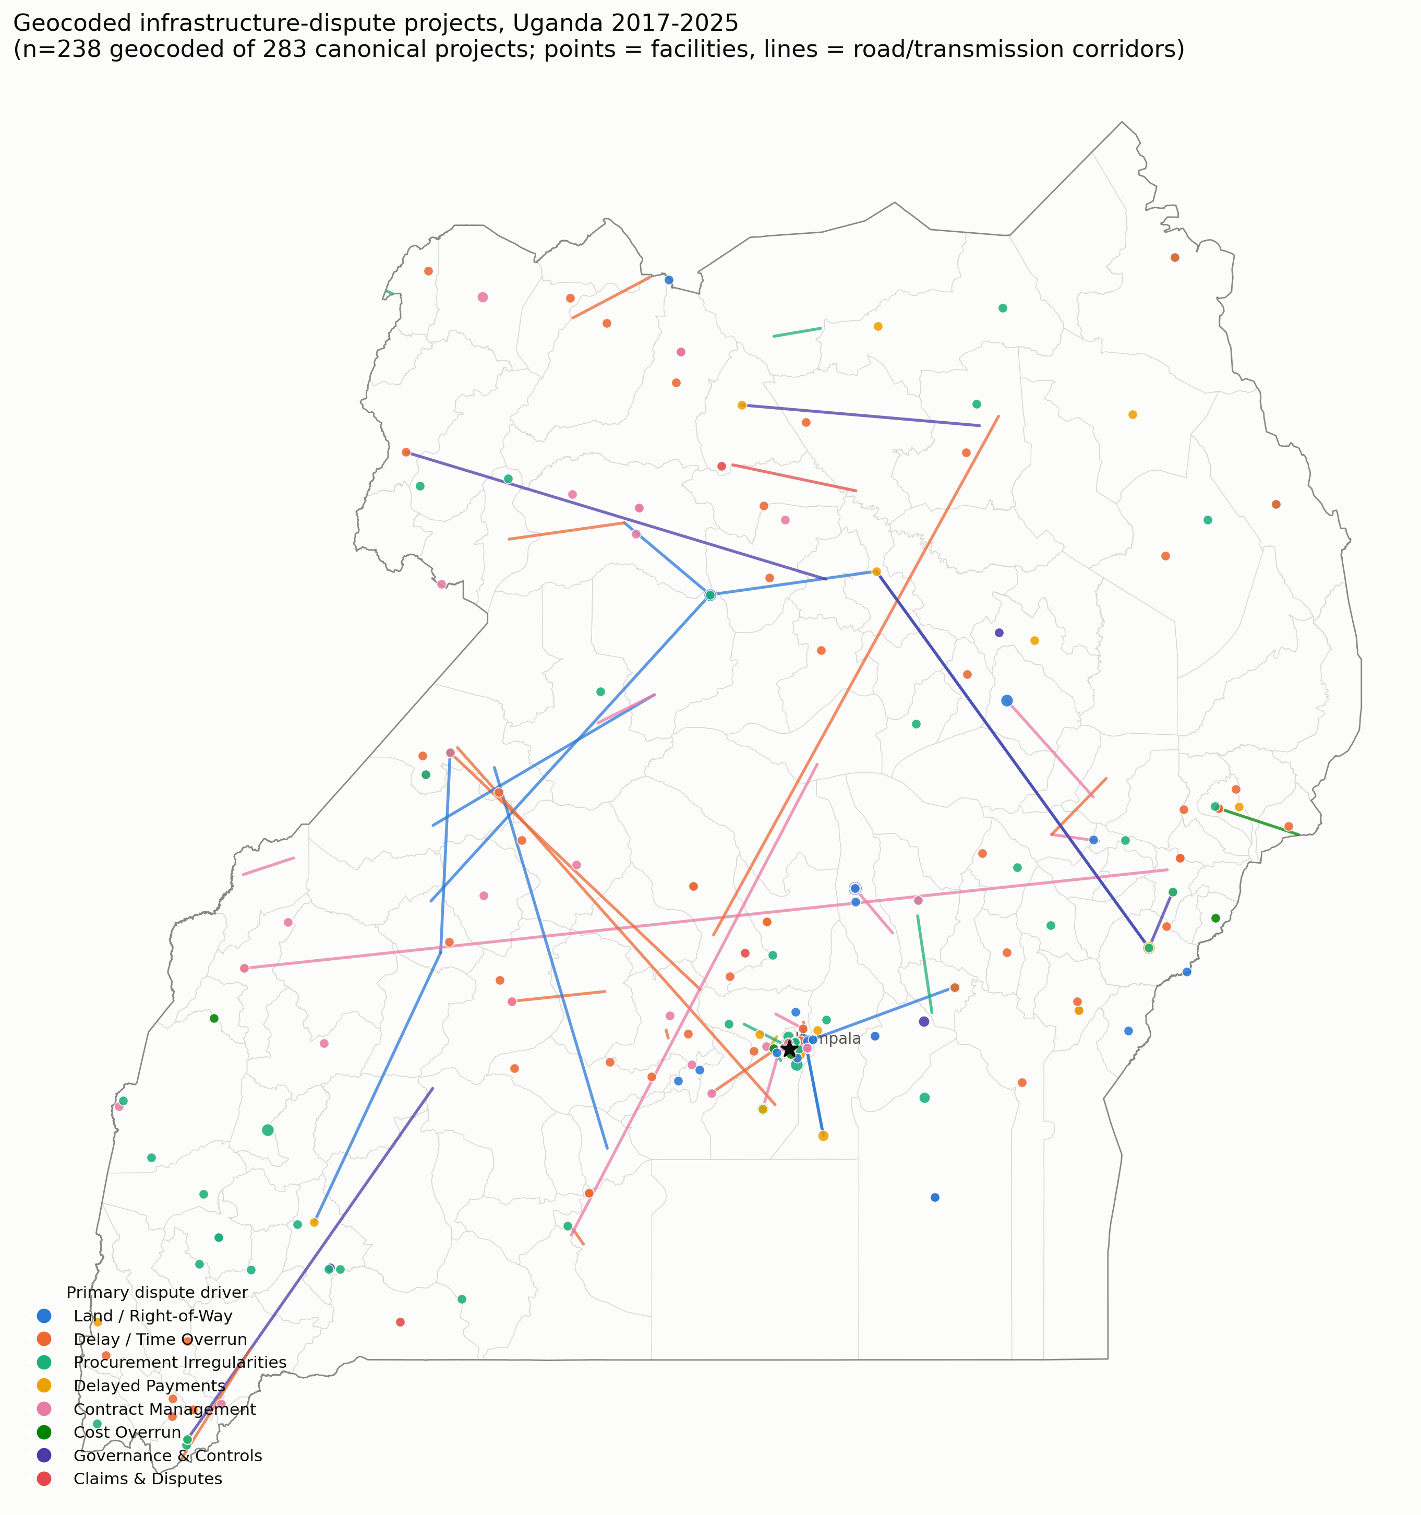
Figure 1. National distribution of 238 geocoded infrastructure-dispute projects, 2017–2025.

5.2 Global spatial autocorrelation and hot spots
Global Moran's I is significant (p < 0.01, 999 permutations) for five of eight driver categories: delayed payments (I = 0.336), land/right-of-way (I = 0.333), procurement irregularity (I = 0.226), contract management (I = 0.189) and delay/time overrun (I = 0.165). Cost overrun, claims and disputes, and governance/oversight are not significant, consistent with their small number of non-zero districts (6, 14 and 14 respectively) – a genuine statistical-power limitation given OAG audit coverage, reported rather than allowed to imply a null spatial pattern. Dispute drivers, in short, are not spatially random.
Driver category | Moran's I | p (sim.) | Non-zero districts (of 135)
Delayed payments | 0.336 | 0.001 | 21
Land / right-of-way | 0.333 | 0.001 | 22
Procurement irregularity | 0.226 | 0.002 | 35
Contract management | 0.189 | 0.002 | 29
Delay / time overrun | 0.165 | 0.002 | 51
Governance & oversight | 0.060 | 0.112 | 14
Cost overrun | 0.019 | 0.266 | 6
Claims & disputes | 0.009 | 0.292 | 14
Overall project intensity | 0.304 | 0.001 | 90
Table 4. Global Moran's I by driver category (Queen contiguity, 999 permutations).
Local Getis-Ord Gi* hot spots (Figure 2) locate this clustering precisely. Land/right-of-way and delay disputes cluster heavily in a contiguous Kampala–Wakiso–Mukono–Luwero corridor. Cost overrun clusters separately in two places with no geographic overlap with the land/delay corridor: the Hoima/Buliisa oil region in the west, and the Mbale/Manafwa/Kween Elgon highlands in the east. Delayed payments shows a sharp Kampala–Wakiso spike plus an isolated Kapchorwa outlier. Some zero-count districts (e.g. Mukono for claims and disputes) appear as significant hot spots; this is expected Gi* behaviour, since the statistic reflects the neighbourhood-weighted local mean rather than the focal district's own count alone, and is read here as a district embedded within a hot region rather than as an error.
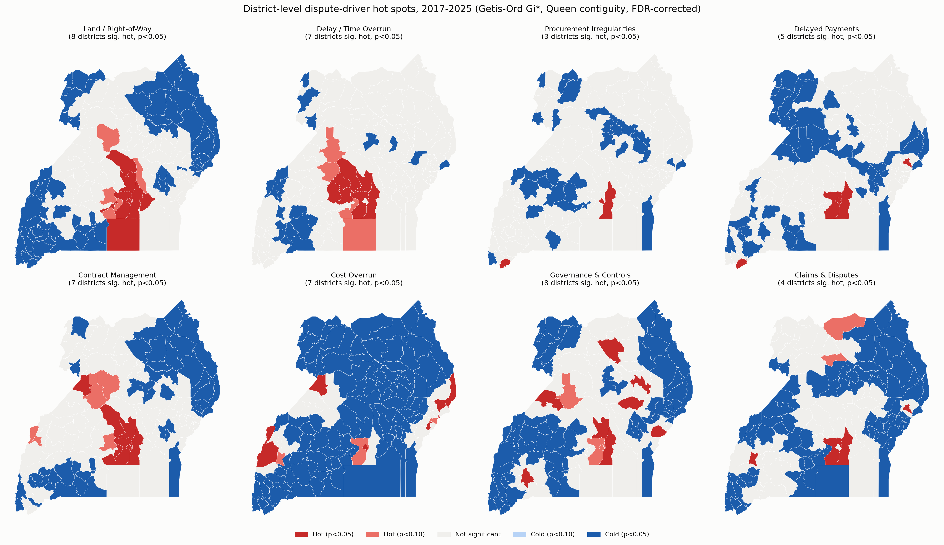
Figure 2. District-level Getis-Ord Gi* hot/cold spots, all eight driver categories (FDR-corrected, Queen contiguity).

5.3 Space-time pattern
The animated year-by-year Gi* sequence (Supplementary Material S1) shows the pooled hot-spot region contracting and shifting within the Central corridor across 2018–2025, from a broader mid-western extent in 2019 to a tighter Kampala-centred cluster by 2023. 2017 and 2020 have no audit-year references in the corpus (the 2020 OAG file is a strategic-planning document, not an audit report; see Section 3.1) and are shown as explicit no-data frames rather than omitted. A Mann-Kendall trend test on each district's nine-year Gi* series found a significant trend in only one of 135 districts, which is read as a power limitation of the sparse annual panel (as few as three non-zero districts nationally in some years) rather than evidence of genuine year-on-year stability.

5.4 Explanatory spatial regression
Table 5 reports standardised OLS coefficients for the three modelled outcomes (spatial lag and error models return materially the same coefficients and are omitted from the table for brevity; full results for all three specifications are in the replication data). For overall project intensity, population (β = 0.29, p < 0.001), dependency ratio (β = −0.24, p < 0.001) and mailo tenure (β = 0.18, p = 0.013) are the only variables clearing conventional significance. Crucially, Moran's I on the OLS residuals falls to 0.009 (not significant) and both Lagrange Multiplier tests are non-significant (p = 0.87–0.99): the covariates fully absorb the spatial clustering documented in Section 5.2, and the spatial lag term itself is statistically indistinguishable from zero. For land/right-of-way, population is again significant (β = 0.08, p = 0.017) but dependency ratio only reaches significance in the OLS specification (β = −0.07, p = 0.029); residual spatial dependence is not fully absorbed here (Moran's I on residuals = 0.068, LM-lag p = 0.074), a result taken up in Section 5.5. For delay/time overrun, dependency ratio (β = −0.13, p = 0.002) and mailo tenure (β = 0.15, p = 0.003) are robust across every specification; distance to Kampala is positive (β ≈ 0.09–0.10) but only marginally significant (p = 0.08–0.10), and rainfall reaches conventional significance only in the lag/error specifications (β ≈ 0.09, p ≈ 0.05).
Variable | Project intensity β (p) | Land/right-of-way β (p) | Delay/time overrun β (p)
Distance to Kampala | 0.123 (0.121) | −0.052 (0.262) | 0.093 (0.098)
Elevation | 0.014 (0.821) | −0.038 (0.262) | 0.022 (0.621)
Mean annual rainfall | 0.078 (0.224) | 0.016 (0.649) | 0.087 (0.056)
Log population | 0.293 (<0.001) | 0.080 (0.017) | 0.092 (0.039)
Dependency ratio | −0.238 (<0.001) | −0.069 (0.029) | −0.131 (0.002)
Rural population % | 0.061 (0.377) | −0.009 (0.801) | 0.049 (0.321)
Rural Access Index | 0.031 (0.577) | 0.000 (0.991) | −0.006 (0.869)
Mailo tenure | 0.176 (0.013) | 0.050 (0.196) | 0.147 (0.004)
Freehold tenure | −0.045 (0.492) | −0.014 (0.690) | −0.047 (0.316)
Moran's I, OLS residuals | 0.009 (n.s.) | 0.068 (p=0.074, LM-lag) | 0.038 (n.s.)
Table 5. Standardised OLS coefficients (p-values in parentheses), 135 districts. Spatial lag/error coefficients and standard errors for all three outcomes are in the replication data.

5.5 Geographically weighted regression
For overall project intensity, GWR selects a bandwidth of 133 of 135 districts — effectively the whole country — and its AICc (253.5) is higher than the global model's (251.0): GWR is not preferred, and the relationship between the covariates and overall dispute intensity is statistically indistinguishable from spatially constant. For land/right-of-way, by contrast, GWR selects a tighter 91-district bandwidth and its AICc (82.8) beats the global model's (87.0) by 4.25 points, exceeding the conventional threshold for preferring the local model. Figure 3 maps the resulting local coefficients: distance to Kampala and mailo tenure both show a marked east–west gradient in their relationship with land-dispute intensity, with the mailo effect strongest and most reliably positive in the corridor's eastern and central districts and attenuating, or reversing sign but losing significance, further west. The local freehold-tenure coefficient is numerically unstable (local β ranging from −7.6 to +2.8 across districts) because freehold districts are themselves geographically clustered in the far southwest, leaving many local regression windows elsewhere with few or no freehold neighbours to estimate from; this instability is shown by hatching in Figure 3 rather than smoothed over or omitted.
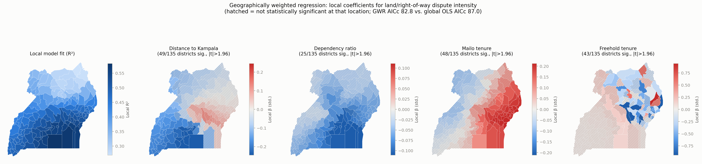
Figure 3. GWR local coefficients for land/right-of-way dispute intensity (hatched = not significant at that location).

5.6 Random Forest / SHAP robustness check
Leave-one-out cross-validated R² is 0.276 for overall project intensity, 0.119 for land/right-of-way and 0.057 for delay/time overrun – the last essentially indistinguishable from a model with no predictive power out of sample, given the small district-level n. Where the model has any signal at all, it mostly confirms the linear results: dependency ratio and distance to Kampala are the two highest-SHAP-ranked variables for overall intensity, with the same negative and negative sign as the linear models. One disagreement is reported rather than resolved by picking a side: SHAP's direction for distance to Kampala on delay/time overrun is negative (more remote associated with fewer delay disputes in the Random Forest), the opposite sign from the linear models' positive, marginally significant coefficient. Given that model's near-zero leave-one-out R², the honest reading is that this specific relationship is not yet well identified by the available sample, not that either method is right.

5.7 Robustness checks
Two further checks test whether Sections 5.2–5.4's results depend on specific modelling choices. First, Moran's I was recomputed under two k-nearest-neighbour weights specifications (k = 5, k = 8) in place of Queen contiguity. For overall project intensity and land/right-of-way, the result is unchanged: significant (p < 0.01) under all three weights specifications. For delay/time overrun, however, it is not: significant under Queen (p = 0.006) and KNN-8 (p = 0.011) but not under KNN-5 (p = 0.096). Delay's spatial clustering is real but more weights-sensitive than land's, and is reported as such rather than presented only under the specification that clears significance.
Second, the three district-level outcomes were re-fitted as standard (non-spatial) Negative Binomial GLMs on the raw counts, the distributional alternative to the log1p-OLS specification used in Section 5.4 for comparability with the spatial-econometrics toolkit. For delay/time overrun, the Section 5.4 result holds up: dependency ratio (p = 0.011) and mailo tenure (p = 0.049) remain significant with the same sign. For overall project intensity, population and dependency ratio remain significant (p = 0.002 each) but mailo tenure weakens to marginal (p = 0.081, was p = 0.013 under OLS). For land/right-of-way, the picture changes materially: nothing clears conventional significance except a marginal distance-to-Kampala effect (p = 0.054), and population — significant in every Section 5.4 specification (p = 0.017–0.029) — is not significant here (p = 0.278). The land-dispute regression findings, in other words, are not robust to this change in functional form, where the delay findings are. This is taken up directly in Section 6.2.

6. Discussion

6.1 A place-based, not a purely contractual, dispute landscape
The central finding is that Uganda's audit-visible infrastructure disputes are not evenly spread across the country's institutional and physical variation: they cluster, and different driver categories cluster in different places for reasons that map onto real economic geography rather than administrative noise. Cost overrun's two disconnected hot spots – the Hoima/Buliisa oil region and the Mbale/Manafwa/Kween highlands – sit either side of the country's two most distinctive terrain-and-investment contexts (the Albertine oil development corridor, and steep highland road construction), a pattern a purely contractual account (poor estimating, weak supervision) would have no reason to predict but a geography-aware one would.

6.2 Land tenure as a transaction-cost variable, read through Mamdani
H2 – that mailo tenure predicts elevated land-dispute intensity net of population and distance – is supported in the district-level regression (β = 0.18, p = 0.013 for overall intensity; β = 0.15, p = 0.004 for delay) and, more precisely, in the GWR result: the mailo effect on land disputes is not uniform but strongest in the corridor's eastern and central reach. Read through Williamson's (1985) transaction-cost lens, this is consistent with mailo's landlord–tenant structure multiplying the parties whose consent a compulsory-acquisition process needs, each a potential hold-up point; read through Mamdani's (1996) account of bifurcated colonial and postcolonial governance, it is consistent with mailo areas sitting inside the 'urban', formally-titled part of that bifurcation, where disputes are more likely to be formally registered, escalated and ultimately audited in the first place – a genuine identification problem this paper cannot resolve with the available data, and returns to in Section 7.1. Both readings agree that land tenure regime, not merely distance or population, is doing real explanatory work, which is itself the more defensible and portable claim. That claim needs one further qualification from Section 5.7: the global land/right-of-way model's other significant variable (population) does not survive the Negative Binomial robustness check, so the paper's confidence in the land-tenure result rests more heavily on the GWR local-coefficient pattern, which is a within-model comparison unaffected by the OLS-versus-count-model choice, than on the global regression coefficient taken alone.

6.3 When a global model is enough, and when it isn't
The GWR results (Section 5.5) sharpen H3 rather than confirming it wholesale: spatial non-stationarity is real for land/right-of-way but not for overall project intensity or, on this evidence, for delay. This matters for how the paper's findings should be used. A single national coefficient for 'how remoteness relates to dispute intensity' is an adequate summary for overall audit activity, but a single national coefficient for 'how land tenure relates to land disputes' is not — the same tenure regime appears to operate differently in the corridor's east than its west, plausibly reflecting the interaction of mailo tenure with more specific local factors (proximity to major named projects, particular compensation disputes) that a district-level model averages over. This is precisely the argument for reporting both a global and a local model rather than either alone.

6.4 Procurement risk allocation, dispute-board strategy, and what the data cannot say
For MoWT and the Ministry of Local Government, the practical implication of Section 5.2's hot-spot map is that risk-allocation and dispute-board strategy could reasonably be differentiated by corridor rather than applied uniformly: right-of-way and delay risk concentrated in the Central mailo corridor calls for front-loaded land compensation and independent valuation capacity specifically there, while the two cost-overrun clusters call for a different response — technical-design and quantity-verification capacity in the Albertine oil corridor, and terrain-appropriate estimating standards in the Elgon highlands. The data cannot say whether contractor origin or financing source (GoU versus donor) moderates any of this: coverage for both variables is under 5% of projects (Section 3.3), because OAG audit narrative almost never names a contracting firm or a specific funder outside a handful of flagship projects (Entebbe International Airport's China EXIM Bank financing and China Communications Construction Company contract being the clearest named example in the corpus). This is a genuine data-limitations finding, not a null result to be explained away, and it means the paper's contribution is about where disputes concentrate and why in a place-based sense, not about who is contracted to deliver them.

7. Implications and Conclusion

7.1 A spatial risk screen for project appraisal
The practical output of this paper is a district-level spatial risk screen: at appraisal stage, a project's district can be checked against the hot-spot classifications in Figure 2 and the tenure/distance profile in Table 5 to flag, before contract award, whether it sits in a corridor with an elevated historical concentration of land, delay or cost-overrun disputes, and to route it toward the correspondingly differentiated response described in Section 6.4. This is a low-cost complement to, not a replacement for, project-specific risk assessment, and is only as good as the audit-derived pattern underlying it (Section 7.2).

7.2 Limitations
Several limitations bear directly on how these results should be used, not only cited. Audit coverage is not a census of disputes: the OAG does not audit every project every year, so a district's absence from a hot-spot map may reflect absence of audit attention rather than absence of dispute, a distinction Section 5.2 flags explicitly for zero-count districts embedded in hot regions. Geocoding carries measured error (Section 3.2): 45 of 283 projects could not be geocoded at all, and precision for the rest ranges from point-exact to district-centroid; road and transmission-line geometries are straight-line proxies, not true alignments. Project identification is a careful reading exercise, not a deterministic algorithm or a trained named-entity-recognition model — auditable, since every project traces to a specific source sentence, but not mechanically reproducible by re-running a script, and a second independent read of the lower-confidence extractions would let a future version of this work report a genuine inter-rater reliability statistic. The land-tenure variable is a documented regional proxy, not a parcel- or district-level GIS layer, because no such dataset exists publicly for Uganda. The district-level regression (n = 135) is small and its outcome variables are zero-inflated counts modelled after a log transform, a specification chosen for comparability with the standard spatial-econometrics toolkit (Section 4.3) rather than because it is the ideal model for sparse count data; a negative-binomial or zero-inflated specification is a natural robustness extension. Finally, the disagreement between the linear and Random Forest models on distance-to-Kampala's effect on delay (Section 5.6) is left unresolved rather than adjudicated, because resolving it responsibly requires either more data or independent expert judgement, neither of which this paper supplies.

7.3 Future work
Three extensions follow directly from the limitations above. First, cross-source validation: triangulating the OAG-derived pattern against Auditor General exception reports, PPDA administrative review decisions, and, where accessible, court records, would test whether the audit-visible pattern documented here matches the pattern in formally litigated disputes. Second, true road and transmission-line alignments from MoWT GIS data or OpenStreetMap way-matching would replace this paper's straight-line proxies. Third, independent practitioner or expert review of the spatial clusters and candidate explanations in Section 6 would test whether the associations reported here hold up to domain judgement, particularly for the unresolved distance-to-Kampala result and the GWR-identified east–west gradient in the mailo-tenure effect.

7.4 Conclusion
Construction dispute drivers in Uganda's public infrastructure programme are not spatially random. Global Moran's I is significant for five of eight audit-derived driver categories, Getis-Ord Gi* maps distinct, theoretically interpretable hot-spot geographies for land/delay disputes versus cost overrun, and a district-level regression shows that population, dependency ratio and a historic land-tenure regime explain most — though, for land disputes specifically, not all — of that clustering. Geographically weighted regression shows this explanatory structure itself varies across the country for land disputes but not for overall dispute intensity, a genuinely mixed and reportable result rather than a uniformly clean one. Within the real limits of an audit-derived, non-census data source, the evidence supports treating Uganda's infrastructure dispute landscape as place-based, and treating the historic mailo/customary/freehold tenure boundary running through the central corridor as a variable procurement policy should take seriously alongside — not instead of — the standard contractual and institutional factors the literature already tests.

Supplementary Material
S1: animated year-by-year Getis-Ord Gi* hot-spot maps, 2017–2025 (GIF). S2: full analysis code and pipeline (corpus extraction, geocoding, covariate assembly, ESDA, spatial and geographically weighted regression, Random Forest/SHAP). S3: the geocoded project-level dataset, with geocoding-precision and extraction-confidence fields retained for downstream users. All three are maintained in the paper's version-controlled repository; a public release will accompany journal submission.

References
Constitution of the Republic of Uganda, 1995, Article 237 (land ownership).
Gavamukulya, C., & Aigbavboa, C. (in preparation). Text mining Uganda's Office of the Auditor General reports for infrastructure dispute drivers, 2017-2025.
Land Act, 1998 (Cap. 227). Laws of Uganda.
Mamdani, M. (1996). Citizen and Subject: Contemporary Africa and the Legacy of Late Colonialism. Princeton University Press.
Monitor. (2024, November 6). UNRA to cease after Museveni signs Repeal Bill. Daily Monitor (Uganda).
Naji, K. K., Mansour, M. M., & Gunduz, M. (2020). Methods for modeling and evaluating construction disputes: A critical review. IEEE Access, 8, 45641-45652.
Scott, W. R. (2001). Institutions and Organizations. Sage Publications.
Shamshiri, A., Ryu, K. R., Shahandashti, M., et al. (2025). Investigating the impacts of socioeconomic conditions on schedule overrun occurrences in roadway projects: the fusion of machine learning and geospatial mapping. Innovative Infrastructure Solutions.
Uganda Broadcasting Corporation. (2024, November 7). Parliament dissolves UNRA and Road Fund, integrates operations into Ministry of Works and Transport.
Williamson, O. E. (1985). The Economic Institutions of Capitalism: Firms, Markets, Relational Contracting. Free Press.
Yun, J., Ryu, K. R., & Ham, S. P. (2022). Spatial analysis leveraging machine learning and GIS of socio-geographic factors affecting cost overrun occurrence in roadway projects. Automation in Construction, 133, 104007.

Appendix
Table A1 gives the full term/phrase list defining each of the eight driver categories in the multi-label keyword classifier (Section 3.1). A sentence is assigned a category if it contains any one of that category's terms (case-insensitive); a sentence may match, and so be assigned, more than one category. Terms are given as plain phrases; word-boundary and minor morphological variants (e.g. 'delay' / 'delayed' / 'delays') were handled in the underlying regular expressions but are collapsed to a single representative form here for readability.
Category | Terms / phrases
Delay / time overrun | extension of time; behind schedule; time overrun; delayed completion; failure to complete; incomplete works; abandoned works; stalled; not yet completed; overdue completion; suspension of works; works halted
Cost overrun | cost overrun; budget overrun; cost escalation; price escalation; budget variance; excess expenditure; additional cost; cost variation; price variation; supplementary budget; over and above the contract
Claims & disputes | contingent liability; unresolved claim; nugatory expenditure; litigation; arbitration; breach of contract; liquidated damages; compensation claim; counterclaim; court case; sued; lawsuit; legal suit
Land / right-of-way | land acquisition; right of way; wayleave; resettlement; compensation of (project) affected persons; encroachment
Contract management | contract management; supervision; defect(s)/defective; non-compliance; poor workmanship; substandard; shoddy
Delayed payments | delayed payment; arrears; outstanding payment; certificate unpaid; unpaid certificate; payment delay; withheld payment
Governance & oversight | internal control; oversight; accountability; governance; lack of supervision/monitoring
Procurement irregularity | procurement; bid(s)/bidding; tender(s)/tendering; evaluation committee
Table A1. Full driver-category term lists (multi-label keyword classifier).

