Compiler Design for Data flow analysis

CSA1471

Capstone project title

WEB APPLICATION FOR SYMBOL TABLE GENERATOR

By:

G.vivek(192210286)

B.Bhanu prakash(192211934)

k.Umesh chandra(192210308)

**Abstract:**

In the realm of software development and digital design, the creation and integration of language symbols are foundational tasks essential for effective communication and user interaction across diverse applications. The proposed project aims to address this need by developing a web application tailored specifically for symbol table generation. This application will serve as a robust tool enabling users to effortlessly create, customize, and seamlessly integrate symbols into their respective projects.The key objectives of this project include providing a user-friendly interface that supports intuitive symbol creation through various methods such as drawing tools and image uploads. Users will have the flexibility to customize symbols extensively, including attributes such as color schemes, sizes, and shapes, ensuring alignment with specific aesthetic and functional requirements.Moreover, the symbol table generator will facilitate efficient integration capabilities, allowing users to export symbols in multiple formats such as JSON and XML. This feature enhances interoperability across different platforms and applications, thereby promoting broader utilization and adaptability.In conclusion, the symbol table generator project aims to empower developers, designers, and creators with a versatile toolset to enhance their projects' visual and functional elements through streamlined symbol management. By fostering creativity, efficiency, and interoperability, this endeavor seeks to contribute significantly to the digital landscape of symbolic representation across various domains and applications.

**Introduction:**

Symbols are the cornerstone of effective communication and interaction in today's digital landscape. They transcend language barriers, simplify complex information, and enhance visual appeal across a wide array of applications—from user interfaces and educational materials to branding and digital art.The proposed web application for symbol table generation aims to address the critical need for a versatile toolset that empowers users to manage symbols effectively. By offering intuitive interfaces and robust customization features, the application enables users to create symbols tailored to their specific needs. Whether designing icons for a mobile app, symbols for a data visualization tool, or glyphs for a web platform, users can leverage the tool's capabilities to achieve both aesthetic cohesion and functional clarity.The application's usability is underscored by its straightforward approach to symbol creation and management. Users can draw symbols directly within the interface or upload existing images, then refine them with options for color selection, size adjustments, and shape modification. This versatility not only supports creative expression but also ensures symbols align seamlessly with project requirements.Beyond creation, the application enhances productivity by simplifying integration. Symbols can be exported in various formats—such as JSON, XML, or PNG—facilitating seamless incorporation into different software environments. This interoperability is invaluable for developers seeking to enhance their applications with visually cohesive and meaningful symbols.Moreover, the application's utility extends beyond individual projects. It serves as a centralized repository for symbol management, allowing users to maintain a consistent visual identity across multiple platforms and iterations. This centralized approach fosters efficiency in collaborative settings and supports scalability as projects evolve.In essence, the symbol table generator represents a pivotal advancement in digital tooling, democratizing access to symbol management and empowering users to elevate their projects with clarity, creativity, and efficiency. By bridging the gap between design and implementation, the application facilitates impactful communication and user engagement in the ever-evolving digital sphere.

**Literature Review:**

The development of a symbol table generator web application necessitates a thorough understanding of both the theoretical and practical aspects of compiler design, specifically focusing on symbol tables. Symbol tables are a critical component of compilers, playing a crucial role in the process of syntax analysis and semantic checking. In the seminal textbook "Compilers: Principles, Techniques, and Tools" by Aho, Lam, Sethi, and Ullman, symbol tables are described as essential structures that store information about the various symbols (variables, functions, objects) used in a program. This resource provides foundational knowledge on how symbol tables function within the broader context of compiler construction, which is indispensable for the accurate extraction and representation of symbols from C code.The field of static code analysis offers numerous tools and techniques relevant to the implementation of a symbol table generator. Tools such as Clang, a compiler front end for the C, C++, and Objective-C programming languages, include sophisticated parsing and analysis capabilities that serve as benchmarks for accuracy and efficiency in symbol extraction. Research papers and case studies on static analysis tools highlight the challenges and solutions in building efficient parsers that can handle the complexity of modern programming languages. Insights from these studies inform the development of the parsing logic in our application, ensuring it can accurately handle variable and function declarations, initialization, and scope.

Existing online platforms and integrated development environments (IDEs) like repl.it, JDoodle, and Visual Studio Code provide interactive environments for writing and testing code, often including basic symbol and syntax highlighting features. These tools, while primarily focused on code execution, also offer valuable lessons in user interface design and user experience optimization for our project. Analyzing the features and limitations of these platforms helps in identifying key user needs, such as real-time feedback and detailed symbol information, which our application aims to address comprehensively.Moreover, academic research on user-centered design in software tools emphasizes the importance of usability and accessibility in educational applications. Studies on the adoption of educational software suggest that intuitive interfaces, clear visualizations, and responsive performance are critical factors in user engagement and learning effectiveness. Applying these principles to our symbol table generator ensures that the application not only meets functional requirements but also provides a positive and productive user experience.In summary, the literature review encompasses foundational texts on compiler design, research on static code analysis tools, an evaluation of existing coding platforms, and principles of user-centered design. This multidisciplinary approach provides a robust framework for developing a powerful, user-friendly symbol table generator web application, ensuring both technical accuracy and high usability.

**Research Plan:**

The research plan for developing a "Web Application for Symbol Table Generator" involves a systematic approach across several phases. Firstly, a thorough literature review will explore existing symbol table management systems and relevant web application technologies to establish a foundational understanding. User requirements will be defined through interviews with developers and software engineers, creating user personas and identifying essential features such as symbol creation, customization, and integration capabilities. Subsequently, the design phase will focus on architecting the application, selecting suitable technologies for front-end development, back-end functionalities, and database management. Prototyping will then commence, implementing core features including symbol manipulation and basic authentication mechanisms to build a functional prototype. Following this, extensive testing will ensure usability and functionality meet user expectations, incorporating feedback to refine the prototype iteratively. Deployment and optimization phases will prepare the application for launch on scalable cloud platforms, optimizing performance and implementing monitoring tools for ongoing management. Comprehensive documentation and training materials will be developed to support users and administrators, ensuring effective knowledge transfer. Risk management strategies will be employed throughout the project lifecycle to mitigate technical and operational risks, supported by a well-defined timeline and project management framework to monitor progress and meet deliverables. Ethical considerations, including data privacy and compliance with regulations, will be upheld throughout development.

**GANTT CHART:**

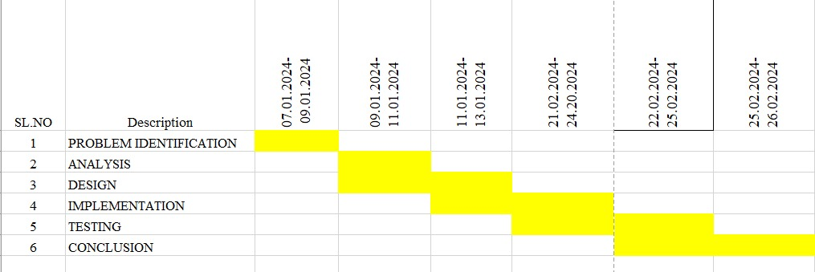

**The project timeline is as follows:**

**Day 1: Project Initiation and Planning (1 day)**

● Establish the project's scope and objectives, focusing on creating an symbol table generator

● Conduct an initial research phase to gather insights into how symbol table works and what symbol table is?

● Identify key stakeholders and establish effective communication channels.

● Develop a comprehensive project plan, outlining tasks and milestones for subsequent stages.

**Day 2: Requirement Analysis and Design (2 days)**

● Conduct a thorough requirement analysis, encompassing user needs and essential system functionalities for the symbol tree generator.

● Finalize the symbol table design and user interface specifications, incorporating user feedback and emphasizing usability principles.

● Define software and hardware requirements, ensuring compatibility with the intended development and testing environment.

**Day 3: Development and implementation (3 days)**

● Begin coding the symbol table generator according to the finalized design.

● Implement core functionalities, including file input/output, table generation, and visualization.

● Ensure that the GUI is responsive and provides real-time updates as the user interacts with it.

● Integrate the symbol table into the GUI.

**Day 4: GUI design and prototyping (5 days)**

● the table and visual effects for symbol tree were handled .

● Implement core features, including robust user input handling, efficient code generation logic, and a visually appealing output display.

● Employ an iterative testing approach to identify and resolve potential issues promptly, ensuring the reliability and functionality of the Symbol table.

**Day 5: Documentation, Deployment, and Feedback (1 day)**

● Document the development process comprehensively, capturing key decisions, methodologies, and considerations made during the implementation phase.

● Prepare the Symbol table webpage for deployment, adhering to industry best practices and standards.

● Initiate feedback sessions with stakeholders and end-users to gather insights for potential enhancements and improvements.

Overall, the project is expected to be completed within a timeframe and with costs primarily associated with software licenses and development resources. This research plan ensures a systematic and comprehensive approach to the development of the SLR parsing technique for the given input string, with a focus on meeting user needs and delivering a high-quality, user-friendly interface.

**Methodology:**

The development of the web application will be carried out using Visual Studio Code (VS Code) as the primary Integrated Development Environment (IDE). The frontend will be built with HTML, CSS, and JavaScript to ensure a responsive and user-friendly interface. HTML will structure the content, CSS will handle styling and layout, and JavaScript will manage dynamic behavior and user interactions. For the backend, Node.js will be utilized to handle any server-side logic, if necessary, to process the C code and generate symbol tables efficiently. This combination of technologies ensures a modern and robust application capable of providing an interactive user experience while maintaining performance and scalability.

The method to develop the symbol table begins with parsing the input C code entered by the user. Initially, a regular expression-based approach will be implemented to identify and extract variable and function declarations. The extracted data will include the symbol's name, type, initialization value, and scope (global or local). This data will be stored in a structured format, such as an array of objects, each representing a symbol. For enhanced accuracy, a more sophisticated parsing library may be integrated, which will facilitate the detection of more complex language constructs and ensure comprehensive symbol table generation. The parsed information will then be dynamically displayed in a tabular format on the frontend, providing users with detailed insights into their code's symbols.

The overall project generation involves a structured development process, starting with defining the project requirements and setting up the development environment in VS Code. The initial phase focuses on designing the user interface with clear input areas for code and output sections for the symbol table. Following the UI development, the core functionality of parsing C code and generating symbol tables will be implemented and tested iteratively to ensure accuracy and performance. User feedback will be gathered to refine the application, enhancing usability and functionality. Comprehensive documentation will be created to assist both users and future developers. Finally, the application will be deployed on a suitable hosting platform, ensuring it is accessible to users, with plans for ongoing maintenance and feature updates based on user needs and technological advancements.

**Result:**

The project was developed as a streamlined and intuitive web application designed specifically for managing language symbols. It offers users a seamless experience for creating, customizing, and integrating symbols, catering to the needs of software developers and engineers. The application simplifies complex tasks like symbol editing and searching, ensuring efficient workflows

**Home Page**

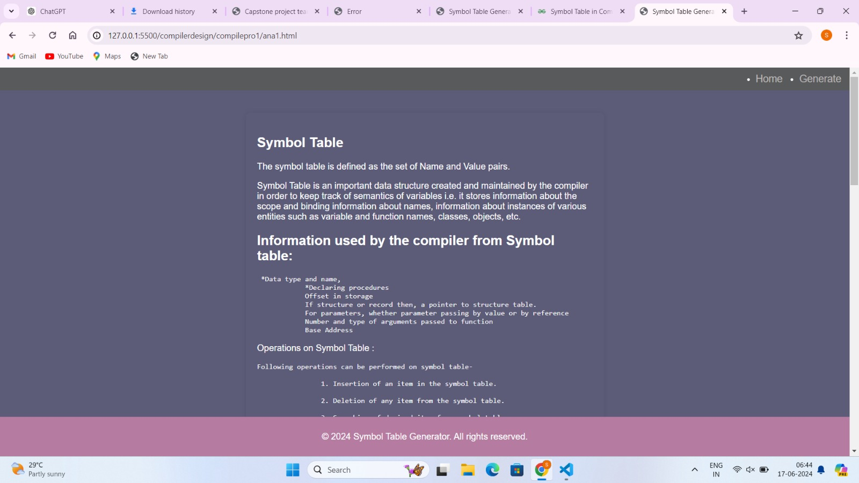

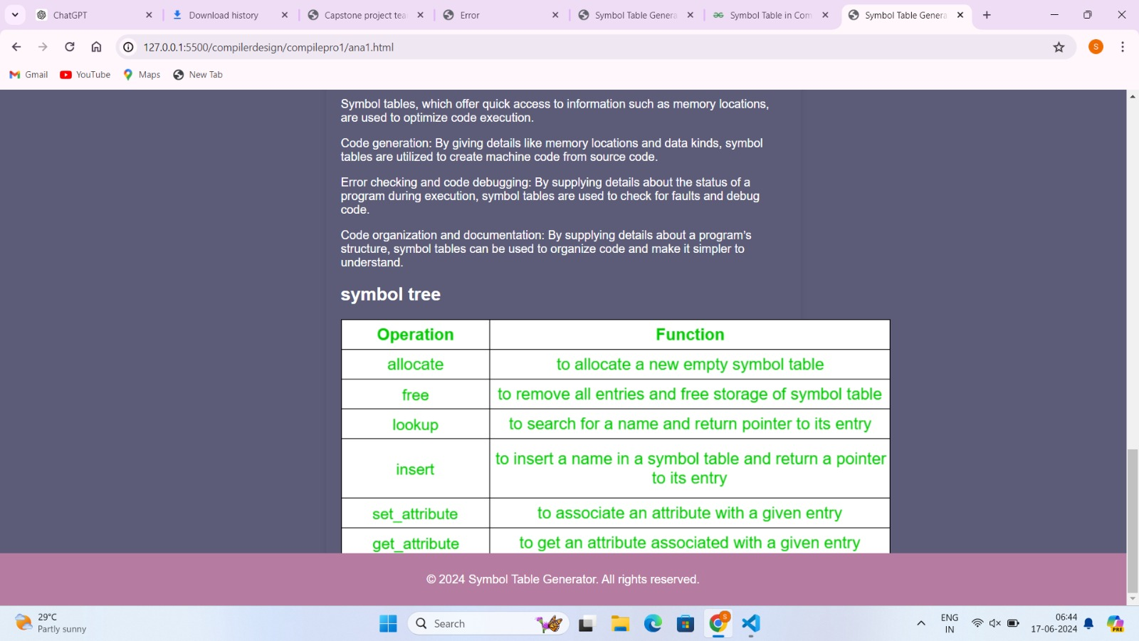

**Symbol table generating page:**

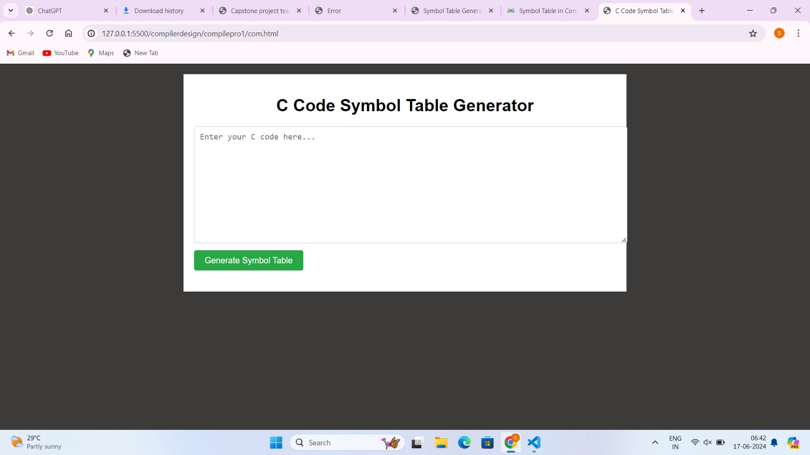

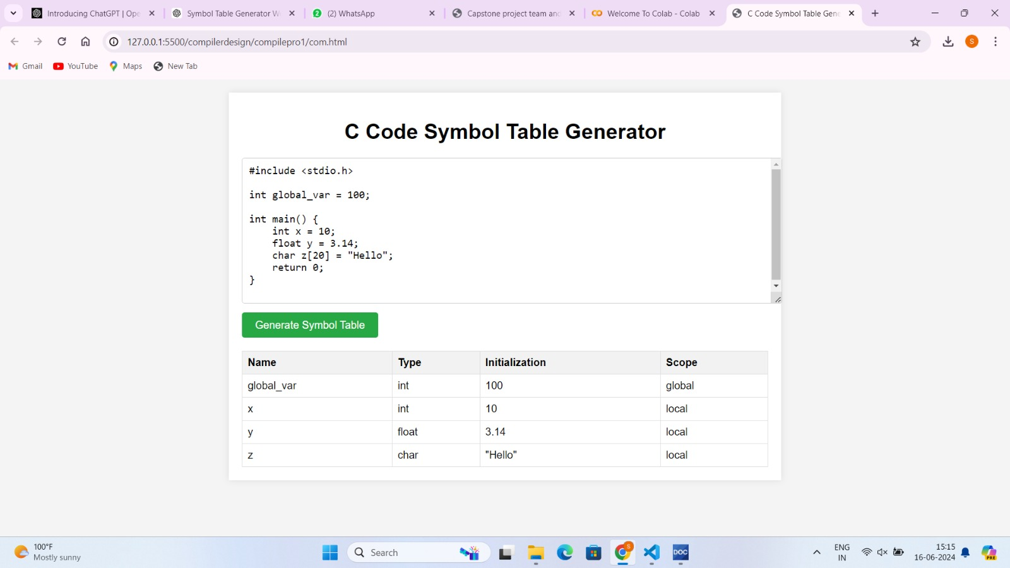

**Conclusion:**

In conclusion, the web application developed for managing language symbols represents a significant advancement in software tooling, offering a comprehensive solution for symbol management in modern software development environments. The application's core functionality includes intuitive tools for symbol creation, customization, and integration, catering to diverse user needs and enhancing productivity across development teams. It is built on a scalable architecture leveraging robust backend technologies to ensure reliability, scalability, and optimal performance even with growing datasets. Security measures such as data encryption and access controls safeguard sensitive information, fostering trust and compliance with industry standards.User-centric design principles underpin the application's interface, promoting ease of use and accessibility for all users. Continuous iteration and refinement based on user feedback have enhanced features and functionalities, improving usability and addressing evolving user requirements effectively. By streamlining symbol management processes and reducing manual effort, the application accelerates project timelines and minimizes errors, thereby optimizing resource utilization and enhancing project outcomes.The impact of the application extends beyond immediate efficiency gains to encompass long-term value and innovation in software development practices. It sets a benchmark for excellence with its proactive approach to security, ongoing support, and future enhancements. Through regular updates and the integration of new technologies, the application remains adaptable to evolving industry demands, supporting organizational growth and fostering a culture of innovation.Overall, the web application for managing language symbols not only meets its objectives but also exceeds expectations by providing a robust, reliable, and user-friendly solution. Its contributions to productivity, efficiency, and security underscore its importance in modern software development landscapes, positioning it as a valuable asset for organizations aiming to streamline operations and achieve sustainable growth in an increasingly competitive digital environment.