Guillermo Vargas

Lab 5 Write-up

**ENVI Section**

The ENVI part of this exercise consisted on using ENVI’s built in functions to manipulate the spatial domain of an image. First we familiarized ourselves with the meaning of spatial frequency. I noted that the spatial frequency is highly dependent on topographic changes of the object being sensed. For example, in the case of the Kilbourne Hole crater, the areas such as edges of the crater correspond to regions where there is a high contrast difference in the received electromagnetic radiation. The edges look like a dramatic change in the profile line; this compared to the areas where constant DN was present, where the spectral profile remained relatively within a range of values, quite constant.

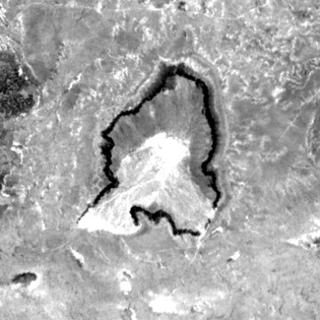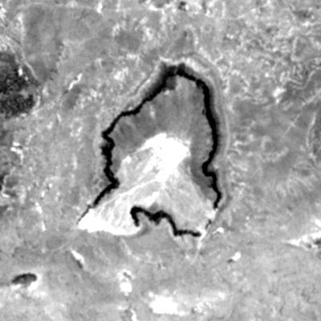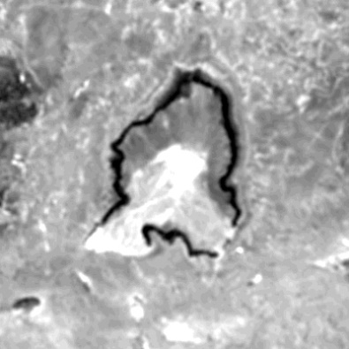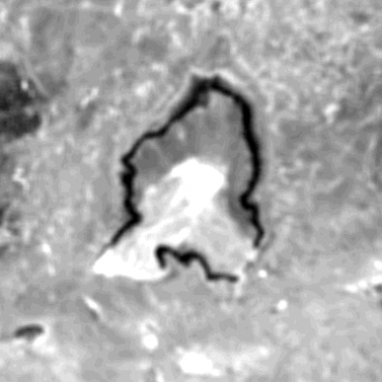For the first exercise, applying a low-pass filter. The results are pretty clear. For the three kernel sizes I used an amount of 0 add-back. The sharpness of the images went down as the size of the kernel increased. The edges were much less clear the higher the kernel size.

Here are the statistics for the 4 images:

|  |  |  |  |  |
| --- | --- | --- | --- | --- |
| Image | Min | Max | Mean | Std Deviation |
| Original Image | 34 | 96 | 55.889 | 6.546 |
| 3x3 Kernel | 34 | 92 | 55.4455 | 6.415 |
| 5x5 Kernel | 35 | 91 | 55.4094 | 6.324 |
| 7x7 Kernel | 35 | 90 | 55.3997 | 6.254 |

The basic statistics seem to be affected by the increasing kernel size. This is noted as a decrease in the value for the mean and the standard deviation. This is probably due to a reduced complexity in the spatial frequency of the image as the low pass filter is applied.

The linear features in the original image were much clearer. The effect of the low pass filter is to apply a blur to the image. The enhancement of this filter seems to be to decrease the edge complexity of an image, this could be useful when there is a lot of noise on an image.

*High Pass Filter*

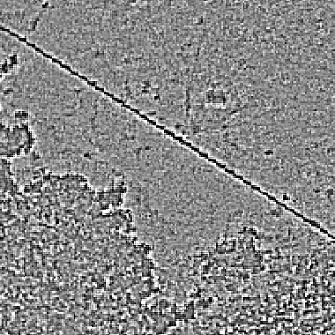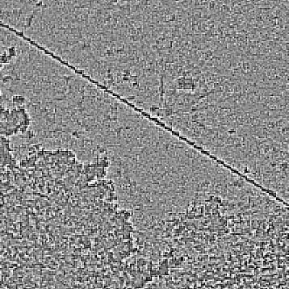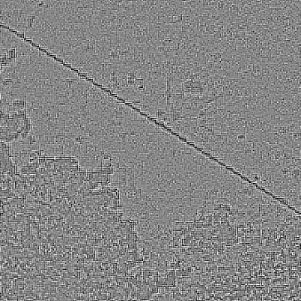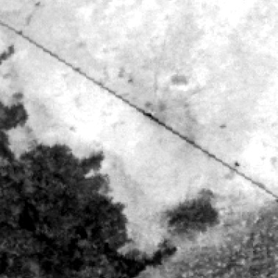For this part I applied a high pass filter without any add-back and the results were the following:

Here are the basic statistical computations:

|  |  |  |  |  |
| --- | --- | --- | --- | --- |
| Image | Min | Max | Mean | Std Deviation |
| Band 9 Original | 68 | 137 | 109.0348 | 11.17 |
| 3x3 Kernel | -123 | 106 | 0 | 7.724 |
| 5x5 Kernel | -396 | 319 | 0.00152 | 25.2931 |
| 7x7 Kernel | -833 | 764 | 0.006065 | 61.9393 |

In contrast to the low-pass filter, the high pass filter seems to have increased dramatically the edge features of the original image.

*Laplacian, Sobel, and Roberts Edge detection*

While applying the same initial conditions to the original image I came to the conclusion that the best filter for this particular image, and my previous geological knowledge of the field area is the **Laplacian Filter**. I reached this conclusion after looking at the results of the image. It seems like the *Sobel* filter introduces to many artifacts to the image and the *Roberts* convolution does not create a very distinct enhancement. The Laplacian filter seemed to give me a better and more accurate enhancement of the contacts between the volcanic units, fluvial channels, and the separation between natural and man-made features.

*Linear Filtering*

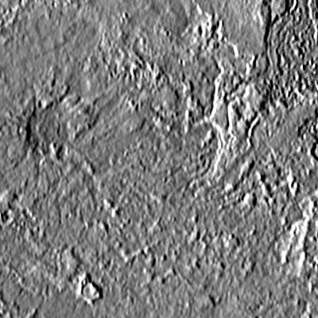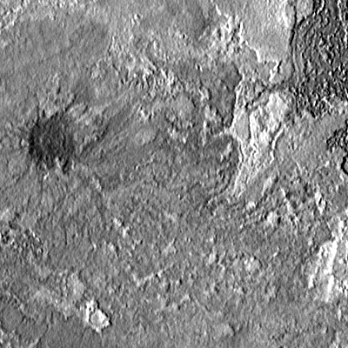In the last section of the lab, I used two different angles and two different sizes for the kernels. Using the 5x5 kernel seems to be giving a very good result in terms of showing the variations in spatial frequency caused by the topography. The following image shows the 3x3 kernel size (left) and the 5x5 kernel (right) directional filter at 0 degrees.

**MATLAB Section**

In this lab exercise, I replicated some of the functions available in ENVI. These were spatial transformation functions that are able to remove noise from an image by applying a median filter to the noisy image. The second function had a function of sharpening or enhancing the edge detail of the images. This was done by using a Laplacian filter which was defined in kernel form during class.

The images were taken in their original form, one of them containing some artificially generated noise in various locations, and other image had a layer of blur.

*Median Filter Function*

Applying the median filter, and experimenting with the size of the kernel, the errors were removed dramatically. The size of the kernel proved to be best when it was under a 5 x 5 matrix; the higher the kernel, the more detail that was lost from the image. In the end some information was lost, nevertheless the overall quality of the image was increased greatly. The following figure shows the dramatic change of this function. *The left image shows the original and the right image shows the results after the median filter was applied. (Resulting image is not 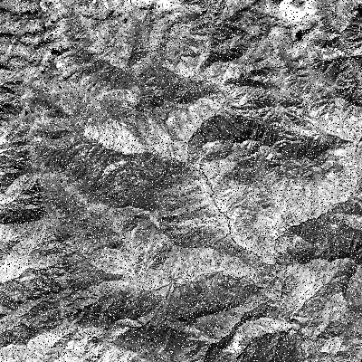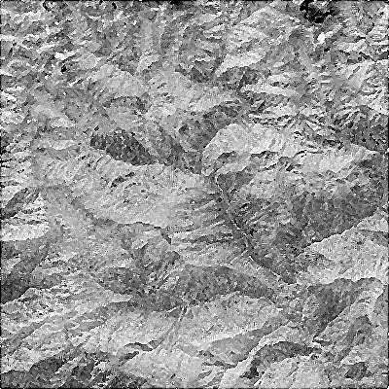transposed)*

*Unsharpen Function using Laplacian filter*

This functions objective was to increase the sharpness of a given image. This was accomplished by using the matrix form of the *Laplacian filter operation*. The filter was applied in one iteration to a given image and the result was a matrix with only the large changes in intensity were shown. To this resulting matrix the original was substracted and the detail of the image was enhanced. The following figure shows the improvement. *The left image is the original and the right image is the result of the sharpening filter operation.*

