Guillermo Vargas

Lab 8

**Dilation**

1. *What would be the effect of a dilation using the cross-shaped structuring element shown in Figure 4?*

I get a dilation of the image edges that is equal in the x and y directions, so the dilation becomes very uniform.

**Erosion**

1. *What would be the effect of an erosion using the cross-shaped structuring element shown in Figure 4?*

The effect of an erosion element of this size, generates an erosion pattern that is also uniform in the x and y direction

1. *Is there any difference in the final result between applying a 3×3 square structuring element twice to an image, and applying a 5×5 square structuring element just once to the image? Which do you think would be faster and why?*

I believe that the difference would be not too large but the processing of a 5x5 element over an image would take longer than the 3x3 element because of the number of operations that will be executed.

1. *Use erosion in the way described above to detect the edges of. Is the result different to the one obtained with dilation?*

The result of the erosion here does work similar to dilation, especially for the bottom dark circle. The erosion occurs mostly in the outer edges of the white square.

**Opening**

1. *Compare the results obtained with the different sizes.*

The results vary in that the larger the structuring element is, the more the opening operation effects the image. The depth at which the opening operation is done, also creates a larger effect.

1. The way I detect the small cells, and reject the larger ones, is applying a square element that would then expand in both x and y directions the elements. Then using MATLAB or an equivalent program, I would measure the radius of the remaining spots. Finally using an if statement I would reduce to zero all the spots that were above a certain size.

**Closing**

1. *Remove the lines*

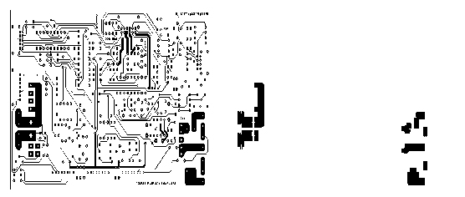

1. *Using closing to remove the features.*
2. *Remove the salt and pepper noise.*

**Thinning**

1. The image once a threshold operation is applied to it, displays really the edges of the original image in white. Once the thinning operation is applied, the border goes

**Thickening**

4.