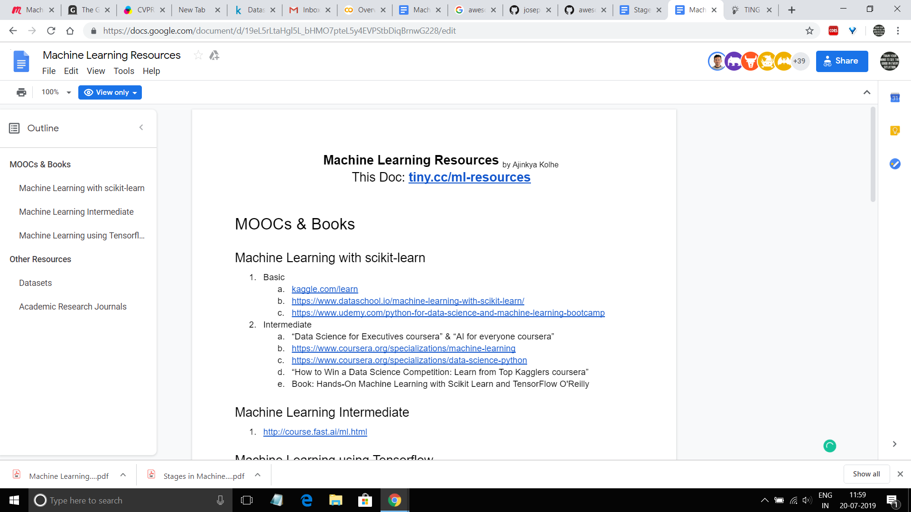

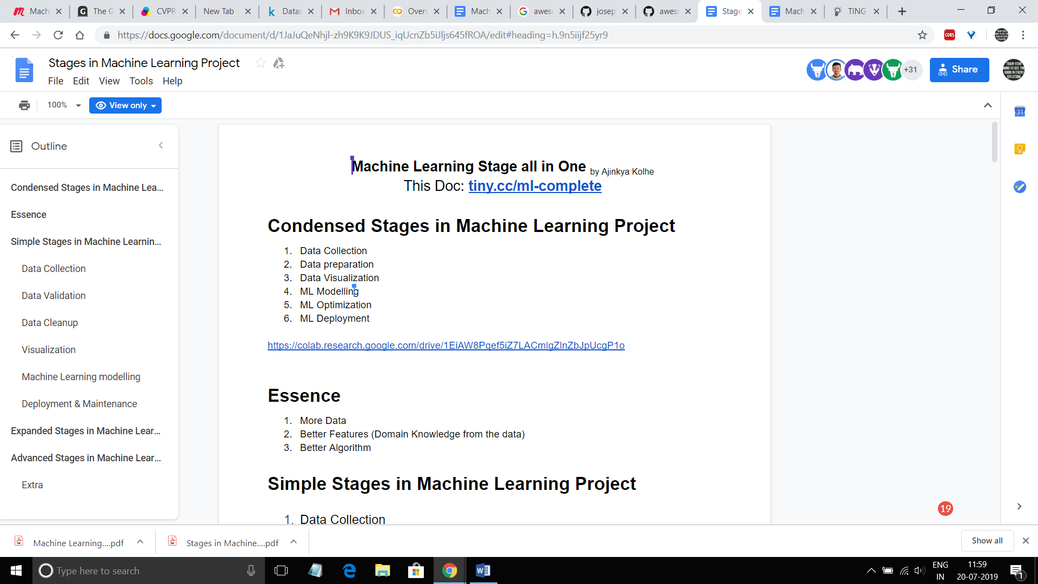

Introduction to Cloud Dataproc: Hadoop and Spark on Google Cloud Platform

[favorite_border](https://google.qwiklabs.com/favorite.json?item_id=672&item_type=CatalogItem)

Add to favorites

help

"Great things are never done by one person. They are done by a team of people." -Steve Jobs