

|  |
| --- |
| School of Computing  Faculty of Engineering |

Replacing the obsolete ABSP ratings system with an interactive online database

Gavin Dawson

Submitted in accordance with the requirements for the degree of  
BSc Information Technology

2014/2015

The candidate confirms that the following have been submitted*:*

|  |  |  |
| --- | --- | --- |
| **Items** | **Format** | **Recipient(s) and Date** |
| *Deliverables 1* | *Report* | *SSO (12/05/15)* |
| *Participant consent forms* | *Signed forms in envelop* | *SSO (12/05/15)* |
| *Deliverable 2* | *Software codes or URL* | *Supervisor, assessor (12/05/15)* |

Type of Project: ____________________________________

The candidate confirms that the work submitted is their own and the appropriate credit has been given where reference has been made to the work of others.

I understand that failure to attribute material which is obtained from another source may be considered as plagiarism.

(Signature of student)

© 2015 The University of Leeds and Gavin Dawson

# Summary

This project details the process of replacing the obsolete ABSP (Association of British Scrabble Players) ratings system with an interactive online database.

In order to build a full understanding of the requirements of the proposed solution, background research of the domain will be conducted. This report will also detail the process of creating the software product that will replace the existing obsolete system in its entirety.

This will include investigating possible approaches to solving the problem, technology choices, designing the software product, implementation of the designs and evaluation of a functioning prototype.

# Acknowledgements

I would like to take this opportunity to acknowledge the following people:

* My incredible fiancée Rachel for sharing this journey with me
* John Stell for his patience and wisdom throughout our many meetings
* My wonderful family for their support and for always treating me like I’m a genius

# Table of Contents

Summary iii

Acknowledgements iv

Table of Contents v

1 Background 1

1.1 Problem 1

1.2 Proposed solution 1

1.3 Aim 2

1.4 Objectives 2

1.5 Requirements 2

1.6 Related modules 3

1.7 Scrabble 3

1.8 The Association of British Scrabble Players 4

1.9 Competitive Matches 5

1.10 Tournament records 6

1.11 Player ratings 6

1.11.1 Player rank 6

1.11.2 Tournament divisions 7

1.11.3 Award considerations 7

1.11.4 World Scrabble Championships 8

1.12 Calculating player ratings 8

1.12.1 Pre-1999 8

1.12.2 1999-Present 9

2 Project management 10

2.1 Linear 11

2.2 Iterative 11

2.3 Incremental 11

2.4 Methodology selection 12

2.5 Schedule 12

3 Design 14

3.1 Database design 14

3.1.1 Database constraints 14

3.1.2 Current database 14

3.1.3 Database selection 14

3.1.4 Provided tables 15

3.1.5 Unused tables 19

3.1.6 Additional tables 19

3.2 Interface design 21

3.2.1 Interface constraints 21

3.2.2 Current interface 21

3.2.3 Study of similar websites 22

3.2.4 Page choices 28

3.2.5 Page designs 29

4 Implementation 40

4.1 Version control 40

4.2 Development environment 40

4.3 Complications with the implementation phase 40

4.3.1 Reduction of the number of pages and associated functionality 40

4.3.2 Inability to produce the necessary SQL statement 41

4.4 Database 41

4.5 ABSP branding 42

4.6 External resources 42

4.7 Creating page content 43

4.7.1 Populating tables 43

4.7.2 Populating pages using variables 45

4.7.3 Player profile picture 46

4.7.4 HTML content 46

4.8 Summary of implementation 47

5 Evaluation 47

5.1 User study 47

5.1.1 Purpose 47

5.1.2 Design overview 48

5.1.3 Method 48

5.1.4 Results 50

5.1.5 Discussion 55

5.1.6 Conclusion 55

5.2 Evaluation of project objectives 55

5.3 Evaluation of software solution requirements 56

6 Conclusion 58

6.1 Personal reflection on project processes and outcomes 58

List of References 60

Appendix A - External Materials 62

Appendix B - Ethical Issues Addressed 63

Appendix C – Project Information Sheet for user study participants 64

Appendix D – User study task instructions 66

Appendix E – User study questionnaire 67

Appendix F – Content Form for user study 68

# Background

## Problem

Currently all Scrabble players who are based in the United Kingdom are responsible for collating their own records from matches they have played and from tournaments they have attended. These records are then sent to the ABSP (Association of British Scrabble Players), where they are added to the existing records. Player ratings are calculated using a bespoke piece of software, which must be manually extracted and uploaded to the website by the records officer.

The player ratings list is the only meaningful information which is published to the website from all of the records that are stored.

The ABSP requires a new system to replace the current, obsolete, process of calculating player ratings manually. The ABSP propose adapting the existing website to dynamically generate player ratings. This new system must also provide players the opportunity to browse their own player record online.

Finally, as part of an ongoing effort by the ABSP to keep records as complete and accurate as possible, the new system must also allow users to supply missing records of their own match results using the website itself.

## Proposed solution

The solution proposed, will be a series of web pages that will read an online records database. The pages will then manage the player ratings list. This solution will also produce pages that will provide users with the ability to interrogate their own records.

The webpages will also make use of the record information that is currently being collected by the ABSP by producing various supplementary views that players may find interesting or useful.

The solution will also feature a method, whereby a player will be able to submit missing match records to the database, using a series of secure web forms.

## Aim

The aim of this project is to replace the obsolete ABSP ratings system with an interactive online database. This will be accomplished by implementing a new online database which will power dynamic web content on the ABSP website.

## Objectives

The objectives of the project are as follows:

* Select and adopt an appropriate methodology for developing the software product.
* Design a suitable software solution by acquiring knowledge from researching potential approaches to solving the problem.
* Design an appropriate user interface for the solution by examining established web development conventions and user interface design principles.
* Create a high-fidelity prototype of the proposed solution, which will be supplied with test data to develop functionality and demonstrate the user interface.
* Perform a user study to measure the perceived effectiveness of the solution from a presentation and usability standpoint.
* Evaluate the solution and determine to what extent the requirements of the problem were addressed.

## Requirements

The requirements that the software solution will aim to satisfy are as follows:

* Implement an online records database to replace the current offline solution.
* Calculate player ratings using the online records database.
* Produce a series of webpages to be displayed on the ABSP website that will read the online records database records and display meaningful information to all users.
* Provide a secure means by which a player can provide match results using the ABSP website. This includes new results and amendments to existing records.

## Related modules

Modules that have been studied which are relevant to this project are:

**COMP3442 Usability Design** – The module taught design fundamentals in regards to responsible design practices. The deliverable produced in this project will adhere to strict standards expected of by a professional software release in terms of usability. The deliverable will also comply with modern accessibility requirements.

**FOEN9001 Industrial Placement Year** – This module provided practical experience of working alongside clients to provide software deliverables within tight deadlines. It has also given the opportunity to learn specific technical knowledge of topics relevant to this proposed solution. Namely, front-end development for the web, working with PHP and MySQL databases. Another skill that has been acquired from this module is writing reports tailored for various levels of perceived knowledge. This included non-technical members of the public and senior business managers. This will be invaluable in keeping the report to a correct tone and level of detail.

**COMP2745 Requirements and Evaluation** – The module aided the project in how to identify requirements effectively and will continue to be useful in determining how to evaluate the project deliverable in terms of suitability and adherence to the requirements.

**COMP1745 Web Development** – Web development has provided a good foundation of knowledge for creating responsible content for the web. This includes accessibility needs of users and common practices and approaches. Knowledge gained in this module can be directly applied to producing a deliverable that is of a professional standard.

**COMP1551 Core Programming** – Core programming has provided exposure to a plethora of programming languages and approaches to developing software to provide solutions to numerous diverse problems. The experienced gained from this module will be helpful in understanding how to develop and implement an efficient and effective solution to the problem.

## Scrabble

Scrabble is an American family board game, which was trademarked in 1948 and is currently owned by Hasbro. However, the game has gone through much iteration and was originally invented in 1933 by Alfred Mosher Butts under the name of Lexico and later Criss Cross Words (Chew, 2015).

It wasn’t until Butts met an entrepreneur called James Brunot that the game’s rules and design were more fully refined. It was also then that the name Scrabble was trademarked and the game was widely distributed and became popularised.

The game uses anagrams, created in a crossword puzzle format, and is played between two and four players. Players take turns spelling dictionary words on a game board using letter tiles, which are placed either vertically (top to bottom) or horizontally (left to right). Each letter tile also features a numerical value, which determines how many points a letter is worth. Letter tiles values are assigned in a way so that the less frequently a letter is used in the language of the game that is being played then the higher that tile is worth. For example, in the English language the letters Z and Q are examples of the least frequently occurring letters used in words and both reflect this as being worth 10 points in the English language version of Scrabble.

A player receives the sum total of the values of each letter tile used in the construction of a word. The aim of the game is to finish the game with the highest possible score, which is achieved by creating words that either use a large number of letters or that use the tiles that are of a high value.

At the start of the game each player is assigned seven random letter tiles, which they must use to create a word on the board during their turn. Each time a player uses letter tiles to create a word they receive the same number of letter tiles at random at the end of that turn to ensure every player starts their turn with seven tiles. This process continues until there are no more tiles remaining in reserve.

With the exception of the first word played on the board at the start of a match, each new word constructed must contain at least one of the existing letter tiles on the game board. In addition to this, any contact that a player’s letter tiles make with any additional letter tiles must spell a valid word. At no point in a match must an invalid word be created from any move.

Scrabble is sold throughout the world in many formats including the classic board game, junior edition, travel edition and electronic games. In the United States, three out of five homes contain at least one of these iterations (Scrabble, 2015).

## The Association of British Scrabble Players

The Association of British Scrabble Players (ABSP) is a not-for-profit association formed in 1987 that works to promote the playing of Scrabble. The ABSP is responsible for the provision of a player ratings system for all of its members (Absp.org.uk, 2015).

They also coordinate tournaments for Scrabble players in the United Kingdom. Other focuses of the association are providing support and information for its players, members and tournament representatives.

The ABSP operates a website which they use to disseminate information to their community such as news articles, tournament timetables, contact details and general content related to the game of Scrabble.

## Competitive Matches

Members of the ABSP take part in sanctioned Scrabble tournaments in which they play competitive one-on-one matches against opponents. It is the outcome of these competitive, or rated, matches that is used to determine a player’s rating within the ABSP. Figure 1 illustrates the entities that are associated with this and the relationships that are present.

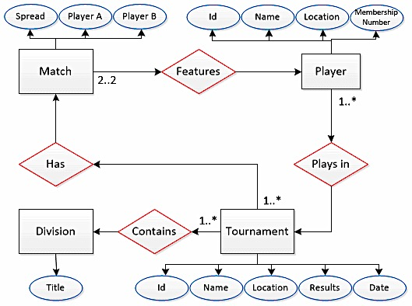

Figure 1. Entity relationship diagram representing a Scrabble tournament

For a member of the ABSP to begin to have an official rating, they must compete in at least one competitive match at a sanctioned tournament. Once they have taken part in a match, they can be considered an ABSP player.

A tournament is organised by the ABSP and must contain at least one division. A division is used to separate a large tournament on the basis of certain criteria (see chapter 1.9.2). Furthermore, a valid tournament must contain at least one match that will feature exactly two opponents. Competitive rated Scrabble matches are always played between just two players.

## Tournament records

The ABSP is responsible for storing and organising all of their members’ tournament record information. In order to provide a suitable solution for the problem, it is important to understand the types of data that are collected and for what purpose this data is acquired.

Every competitive match that takes place at an ABSP sanctioned tournament is recorded. This includes the two players that participated and their respective scores, the tournament in which the match took place and a unique identifier.

As well as this, each tournament is also recorded with name, date, list of divisions and location. In addition to this, a roster of all players that are registered for the tournament is created and a seed number is assigned to each player based on their respective ratings, with the highest rated player receiving the seed number of one and the next highest receiving two and so on. This continues until all players have received a seed. The order of each player’s finishing position within a tournament is also stored and saved. The performances of players are thus used to determine their final player ratings.

## Player ratings

A player rating is a calculated score that is derived from a player’s performances in competitive one-on-one Scrabble matches at tournaments that have been officially sanctioned by the ABSP. These ratings are essential to the association’s operations and will therefore need to be generated using the new system.

### Player rank

Players are ordered by their player ratings in descending order, with the highest rating receiving the highest rank of 1 and each subsequent player rating receiving the next rank in increments of 1.

In the event of two or more players having identical player ratings, all players would be assigned the rank they would have been assigned, had their player ratings been distinct and then they share that rank. The rank assigned to the player with the next highest rating would skip the rating numbers that would have been assigned to the players with identical player ratings had their player ratings been distinct (e.g. if Player A and Player B are both assigned the joint rank of 5 and Player C was the next highest rated player then Player C would receive the rank of 7).

Player ratings are primarily used to determine the rank order of all of ABSP members based on their most recent form. In addition to this, player ratings serve other important functions, which are as follows:

### Tournament divisions

Tournaments, that feature a large pool of participants, are split into divisions to ensure that each player participates in a reasonable number of games. The player ratings are used to determine certain entry criteria for divisions. This can include: a minimum player rating, a maximum player rating and also a player rating between two numbers.

In the event of a multi-divisional tournament, it is prudent to make every effort to ensure that players of similar ability are assigned to the same division. Scheduling a novice player to face a high-ranking opponent would provide no benefit to either individual in terms of development and in all likelihood not prove a competitive match.

### Award considerations

Player ratings are also used in identifying whether a member of the ABSP has achieved a level of excellence, which qualifies them for a title. The two possible titles are Expert and Grandmaster. To first register for consideration a player must play at least 30 rated Scrabble matches during a calendar year.

To attain the status of Expert they must satisfy one of the following three conditions throughout a five-year period:

* Achieve player rating of 180+ on three separate occasions
* Achieve player rating of 170+ on five separate occasions
* Maintain an average of 175+

For them to reach the status of Grandmaster a player must satisfy one of the following three conditions throughout a five-year period:

* Achieve player rating of 190+ on three separate occasions
* Achieve player rating of 180+ on five separate occasions
* Maintain an average of 185+

The Most Improved Player award is presented to the player who achieves the greatest positive difference between their player rating at the start the year and their player rating at years end. To be eligible for the award a player must play at least 30 rated matches during that given year.

Finally, the Highest Rated Player trophy is awarded to the ABSP member with the highest player rating at the end of each year.

### World Scrabble Championships

Player rating is a contributing factor in whether a player can be considered for a nomination to attend the World Scrabble Championships, as a rating is a direct interpretation of how well an individual has performed in their most recent matches. As only leading scrabble players are given the opportunity to enter the event, the player rating is an important indicator of a player’s suitability.

## Calculating player ratings

Since January 2011 the ABSP has employed a Weighted Rolling System to calculate its members player ratings. This system is the culmination of a long process of periodic improvements. The steps of the calculation process have been refined over time to produce player ratings that place increased significance on a player’s most recent match form and in turn are affected less by older match results.

### Pre-1999

The first iteration of this system was used up until January 1999. This initial process formed the foundation, which all other improvements have built upon (Absp.org.uk, 2015).

A player’s rating is calculated by first examining every one of their match results from each tournament they attended for the current calendar year and awarding them score of rating points for each record based on the outcome of each match. Each match outcome results in one of the following scores being awarded to the player:

* If the player is victorious against their opponent they receive an amount of rating points equal to that of the rating of their opponent at the time of the match plus fifty.
* If the player is defeated by their opponent they receive an amount of rating points equal to that of the rating of their opponent at the time of the match minus fifty.
* If the result of the match is a draw the player receives an amount of rating points equal to that of the rating of their opponent at the time of the match.

One further consideration must to be taken into account when performing this step of the calculation. Whereby, if the distance between the player’s and their opponent’s ratings at the time of the match exceeds plus or minus forty, the opponent’s rating will be raised or lowered to ensure the distance between the player’s and the opponent’s rating never exceeds plus or minus 40. The player then receives their opponent’s altered rating as rating points.

An example of this would be: Player A has a rating of 140 and Opponent B has a rating of 90. As the distance between the players is 50, Opponent B’s rating would be raised to 100 to ensure that the distance does not exceed plus or minus forty. Player A would then receive 100 rating points instead of 90.

The final step of the process is to sum all of the rating points awarded from each match result. That number is then divided by the total number of match records, which produces the player rating for that individual.

Although this system provided a fair indication of a player’s performance, it lacked the ability to show that the most recent form of a player should hold more significance. In addition to this, often manually calculating a player’s rating could be needlessly inefficient, as some players amass hundreds of match records over the course of a year and the system would therefore have to examine every record from that period (Absp.org.uk, 2015).

### 1999-Present

From 1999 it was decided that the ABSP would adopt the Weighted Rolling System, which uses the same processes as the previous system along with new features that addressed previous systems shortcomings.

Firstly, the match records, which are used in the calculations of a player’s rating, were limited to the 150 latest to emphasize the focus on recent form being a key factor in determining ratings. This change helps to remove the dependency of an entire year’s worth of records for calculations. This number was originally changed to 100 latest matches. This was increased to 150 in 2011 following a revision of the process.

The second change saw the calculation process augmented to incorporate a weighted sum. A player’s 150 latest records were processed in the same fashion as the old system and rating points were assigned based on the outcomes of the matches.

Weights were then added to match records starting with 225 being assigned to the most recent record and continuing, decreasing in number by one for each record until the oldest record is assigned 76. These weights place more importance on the most recent matches and an ever-diminishing importance on matches that happened further in the player’s record history.

The next step of the new system was to group all match records by tournament venue and combine all rating points for each grouping. Then for each tournament grouping, the combined rating points are then multiplied by the average of all the weights assigned to those matches, giving the number of weighted rating points for those tournaments.

The sum of all weighted rating points is then divided by the sum of all weights (which will always be 22,575 when all 150 records are available), which produces the player rating. This result is then rounded to the nearest whole number.

# Project management

To ensure that the development of the software solution is conducted and controlled effectively it must require project management. Project management is a growing field and as the filed has grown, so too has the amount of diverse ways in which it can be applied (Meredith and Mantel, 1995).

Project management employs methodologies, which have been developed across many business domains. A methodology can be explained as a model, which is used in the management of a project’s processes.

Broadly speaking, models can be classified as belonging to one of three categories. The first is linear, which is a sequential model that focuses on the completion of stages that lead to the next stage. The second category is often called iterative. This is characterised by constant revisiting of stages throughout a project’s life cycle, which promotes constant improvement. The final category is an amalgamation of the two previous categories. The main focus of which is that development takes place much like an iterative approach, yet is organised in a way in which processes can be halted at certain points; as it is with a linear approach (Ruparelia, 2010). This software development process will adopt the most suitable methodology by analysing prominent approaches.

## Linear

Waterfall is the most common linear approach. Sometimes referred to as cascade method, it operates by breaking the development of a project into discrete stages which are undertaken in a specific order where each stage is dependent on the completion of the previous stage (Ruparelia, 2010).

The main benefit of this approach is that it is highly structured and the linear approach can greatly improve the organisation of a project as it is separated into separate reasoned stages. This can help with identifying milestones that help with tracking progress of development (Hughey, 2015).

A drawback of this approach is that as each stage of the project is dependent on the completion of the previous stage, it does not accommodate returning to a previous stage. Each stage should have completion dates associated with them. Any revisiting of a stage after its completion date could be viewed as a delay in the project.

## Iterative

An advantage of an iterative approach is that it allows for constant improvement of the project as the whole processes is repeated constantly. Each one of these iterations can be thought of as a mini-project each with its own complete set of phases (Mantei and Teorey, 1988). In a software project, this can allow for features or functionality to be introduced as and when they are completed.

On the other hand, constantly seeking to improve the product and a lack of dated deadlines could then lead to a delay in the overall span of the project, if not properly managed.

## Incremental

Incremental delivery can be described as offering the strict planning and processes of the Waterfall model incrementally (Pressman, 2005). This approach allows for advantages of both linear and iterative methods, as the structured approach to processes is present throughout the development and improvements can be made due to multiple iterations.

This method requires a great amount of planning and design to implement so therefore may not be appropriate for small or short projects. As it incorporates Waterfall into its process, it requires all the planning of the overall system to be in place prior to the start of development. As many software projects have changing requirements it cannot always be applied (Kostigoff, 2015).

## Methodology selection

An incremental approach to project management will be adopted for this project’s development as it adopts the positive aspects of both linear and iterative approaches.

This project will benefit from the structure of a linear methodology as the requirements of the project have already identified which will allow for clear planning. The iterative aspects of the approach will allow for further refining of the features of the solution. As the development of the dynamic web content continues during the development of the solution, it will be easier to introduce working features as they are completed, rather than having to wait until all features have been finished.

In regards to addressing possible shortcoming of this approach, the project is of a sufficient scale to justify the amount of planning and design that must be undertaken to facilitate an incremental delivery.

## Schedule

Figure 2 shows the timeline of the project. Each task has been allocated sufficient time for completion and any overlapping of tasks should not occur with exception of the report itself as it will be an ongoing process until the project deadline.

The schedule is robust enough to accommodate minor changes to the overall plan. However every effort will be made to ensure the schedule is followed as strictly as possible.

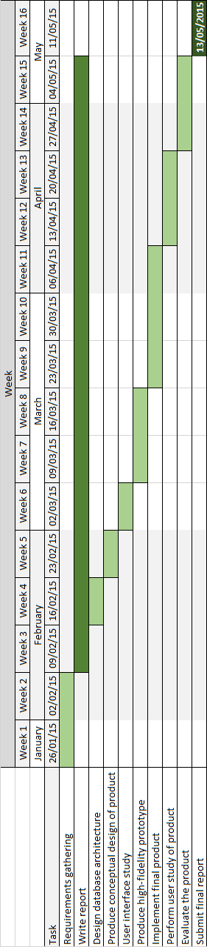

Figure 2. Gantt chart of project plan

# Design

The design of the software product consists of two distinct areas, the database that will provide the player records and the interface that will generate and display those records. This section will treat these areas as two separate concerns.

## Database design

### Database constraints

The new online database that the software solution requires was to be supplied by the ABSP. The tables and columns had been decided and the solution must be designed to accommodate these constraints. Any recommendations for adjustments to the design of the database would be considered. However, given the limited span of the project it was decided that time was better spent on other areas.

### Current database

The solution that the ABSP employs to store records and calculate player ratings is an offline MySQL database made up of numerous tables. At no time during this project was access given to this database. It was understood that all data stored in this database would be migrated into the new database that is to be used as part of the software solution.

Any data received as part of the development of the project was presented in the form of the new database architecture.

### Database selection

The solution will use an online MySQL database that will be managed and hosted by the ABSP.

It can be argued that MySQL was chosen as the relational database management system (RDBMS) due to its suitability in the context of satisfying the ABSP’s needs as a not-for-profit organization.

MySQL can be used for free by an organisation such as the ABSP, as its source code is available under the GNU General Public license, meaning that the ABSP will not need to purchase any proprietary software to implement their database.

MySQL is considered to be one of the easiest database management systems to setup and administrate (DuBois, 2005). This is an important factor to take into account as the ABSP does not employ a specialist to manage their website or current database. So any specialist setup or maintenance may incur additional cost. The choice of a MySQL database is commonly found on projects of this type in which dynamic web pages are developed using databases.

A MySQL database is the common choice for this sort of software solution. It can be used, in combination with a web server, to create the dynamic web content that is required by the project (DuBois, 2002). The software solution will need to read and write to the database via webpages and MySQL offers that functionality.

Proprietary alternatives to MySQL exist which would be applicable to this type of project such as IBM DB2, Informix or Microsoft SQL Server. However these systems cost money to acquire licenses or hardware to implement. This would not be appropriate for this project as besides the costs associated; a large system is not needed at this stage.

Open-source alternatives to MySQL and the closest match in terms of functionality is PostgreSQL. PostgreSQL actually offers more functions than MySQL. That being said, it is yet to match MySQL in terms of speed or stability. In addition to this, MySQL demands less in terms of hardware dedication (Kofler, 2015).

MySQL would appear to be the correct choice for this project due to its lack of cost, relatively high performance, good core stability, ease of installation and low maintenance needs.

### Provided tables

Figure 3 shows the database tables that have been selected and supplied by the ABSP that must be used as part of the software solution.

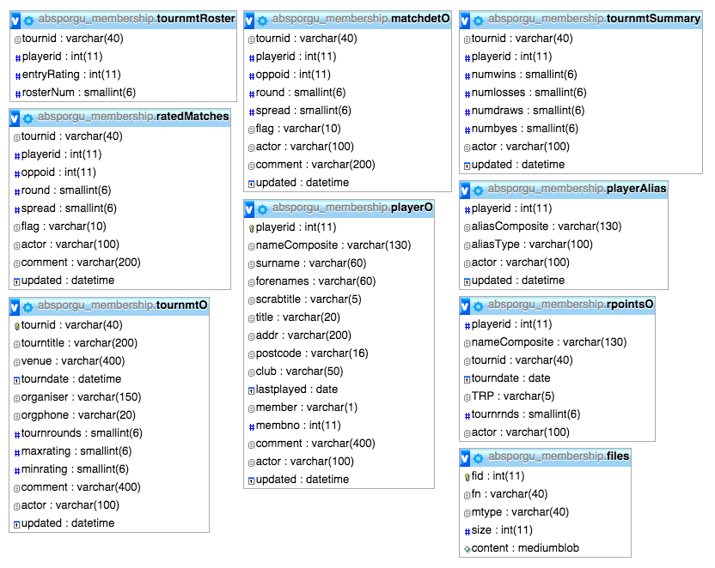

Figure 3. The absporgu_membership database tables supplied by the ABSP

Below is an explanation of the tables and their significance to the software solution:

**tournmtRoster** – Stores records of each player roster of every tournament division. Each record contains the following:

* tournid – Identifies a tournament and its particular division
* playerid – Identifies a single player record
* enrtyRating – The player rating of the individual at the time of the record
* rosterNum – A sequential number assigned to every record with a common tournid

The entryRating of each player will be used in calculations to determine the amount of rating points that are awarded in calculating player ratings.

**ratedMatches** – Stores the record of each rated match that has taken place at every sanctioned ABSP tournament. Each record contains the following:

* tournid – Identifies a tournament and its particular division
* playerid – Identifies a single player record
* oppoid – Identifies a single player record
* round – Indicates which round the match occurred in the tournament division
* spread – The points scored in the match by playerid minus the points scored by oppoid

It is noted that flag, actor, comment and updated are used by ABSP for administrative purposes and are deemed not part of this project.

The spread of match records could be considered a useful piece of information that a player may want to examine when looking at their match records.

When examining the ratedMatches table it is apparent that for each match record there exists two entries where both players involved are assigned the role of playerid and oppoid. For example, for a match at Tournament A between Player A and Player B two records exist. One where playerid is that of Player A and the oppoid is that of Player B and another where playerid is that of Player B and the oppoid is that of Player A. This poses a problem of redundancy as changes made to the first record would also need to be made to the other.

**tournmtO** – Stores each record of every sanctioned tournament. Each record contains the following:

* tournid – Identifies a tournament and its particular division
* tourntitle – Is the name of the overall tournament
* venue – Identifies the location geographically of the tournament
* tourndate – Identifies the date the tournament took place
* organiser – Is a name of the individual who organized the tournament venue
* orgphone – Is a contact number stored for the organizer
* tournrounds – Identifies the number of rounds that the tournament division contained
* maxrating – identifies the maximum allowed player rating that the tournament division would allow to compete
* minrating - identifies the minimum player rating required to compete in that tournament division

It is noted that actor, comment and updated are used by ABSP for administrative purposes and are deemed not part of this project.

The tourndate and tournrounds will be used in calculating player ratings as only the most recent records are taken into account and weighted sums involve knowing the chronological order of rated matches.

**playerO** – Stores a record each registered member of the ABSP. This table also includes past members. Each record contains the following:

* playerid – Identifies a single player record
* surname – Is the surname of the member
* forenames – Is the first and middle names of the member
* scrabtitle – Identifies any titles that a member has been designated (e.g. Expert or Grandmaster)
* title – Accommodates the inclusion of a formal title (e.g. Mr, Mrs or Dr etc.)
* addr – Is the address on record for the member
* postcode – Is the post code on record for the member
* club – Is the regional club that a member is associated with. In lieu of a club a location like a town or city is used
* nameComposite – Is a composition of forenames, surname and scrabtitle
* member – Indicates if an individual is an active member
* membno – Indicates the members assigned membership number

It is noted that actor, comment and updated are used by ABSP for administrative purposes and are deemed not part of this project.

Much of the playerO table is needed in development of the software product, as these player records will provide meaning to information to pages.

As a security precaution, the addr column had been redacted from any data records received by the ABSP so at no point were members contact addresses at risk of being released.

**tournmtSummary** – Stores a summary of each members match records for every tournament division they have competed in. This table also includes past members. Each record contains the following:

* tournid – Identifies a tournament and its particular division
* playerid – Identifies a single player record
* numwins – Identifies the number of wins the player had in the tournament division
* numlosses – Identifies the number of losses the player had in the tournament division
* numdraws – Identifies the number of draws the player had in the tournament division
* numbyes – Identifies the number of matches in which the player advanced due to an opponent not being present

It is noted that actor and updated are used by ABSP for administrative purposes and are deemed not part of this project.

Much of this table is needed to develop an effective solution as these records can be used to present meaningful information to players. For example, a sum of all wins, losses, draws and byes for every record of single player will provide the amount of rated matches that a player has had in their history.

### Unused tables

The following tables are not used as part of the project. However, they are included in software product files as they form part of the absporgu_membership database that the ABSP has provided.

**matchdetO** – This table is not needed as part of the project and was deemed out of scope.

**playerAlias** – This table stores any previous aliases used by ABSP members for historical record purposes.

**files** - This table is not needed as part of the project and was deemed out of scope.

### Additional tables

#### User logins

To provide a secure means by which a player can submit tournament records, the database will require a table to store login credentials that will be used by the website to determine if an individual can access secure pages. The absporgu_membership database supplied by the ABSP does not include any such table.

The project will include an absp_users table as seen in Figure 4, which will store login credentials for every member of the ABSP. Every record of username and password record will each be associated with the distinct playerid of every ABSP member.

A userRole will also be included to determine what type of permissions a registered user will have. Players will be assigned the role of Player, which will provide them with the ability to add or edit tournament records that correspond to their playerid. The ABSP representatives charged with curating the new ratings system will be assigned the role of Administrator. This will allow these users with the functionality to add or edit any record in the system.

Finally, the ability to lock accounts will be a feature of the design. This will ensure that access to secure areas of the site can be closely controlled. For example, a user’s account could become locked after a pre-determined number of incorrect login attempts are made using that account’s username.

|  |  |  |  |  |
| --- | --- | --- | --- | --- |
| **playerid** | **username** | **password** | **userRole** | **accountLocked** |
| 2191 | john_doe1 | johnDoePass | Player | FALSE |
| 101 | luke_freeborn1 | Frizbee1986 | Administrator | FALSE |
| 202 | john_smith22 | hardpassword#1! | Player | TRUE |

Figure 4. Design of absp_users table

#### Player ratings

The player ratings are not currently stored in the absporgu_membership database. In order produce player ratings the database will require a calculatedPlayerRatings table that is derived from the other existing tables to calculate and store the ratings of each player.

Figure 5 illustrates the columns that will be required in this table. The table will store the calculated player records in the playerRating column for each playerid. This will involve performing the weighted rolling system to the latest 150 rated matches on record from the ratedMatches table. As player ratings can still be calculated for players that have played less than 150 matches, the table will include a matchCount column, which will store the exact number of match results that were used.

The calculatedPlayerRatings table will also contain a peakRating column, which will provide the highest player rating that each player has achieved within the ABSP.

|  |  |  |  |
| --- | --- | --- | --- |
| **playerid** | **playerRating** | **peakRating** | **matchCount** |
| 2191 | 167 | 181 | 150 |
| 101 | 202 | 201 | 150 |
| 202 | 188 | 189 | 134 |

Figure 5. Design of calculatedPlayerRatings table

## Interface design

### Interface constraints

The project design phase was constrained by the need for the software product to fit within the overall style and branding of the current ABSP website (http://www.absp.org.uk/index.shtml). The ABSP website features a clean minimalist style, which is focused towards the provision of information, in lieu of bold presentation choices.

The webpages created for the software solution will eventually form part of the website’s navigation structure by replacing the existing ratings pages.

### Current interface

The interface currently in place to display player ratings on the ABSP website is a copy of the calculated player ratings list pasted onto a static webpage in three variations. The variations are in order of surname, the club they represent or by rank. Figure 6 shows the ratings list ordered by rank.

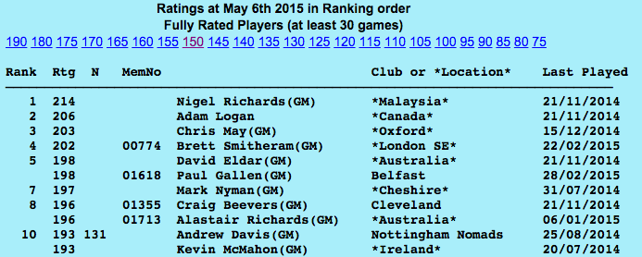

Figure 6. Screenshot of ABSP ratings list ordered by rank

The ratings are rendered in one large table with no pagination. There is no functionality available to reorder columns or refine the lists. The only functionality that is in place to help use the tables are numbers at the top of the table which scroll to points in the table where the player rating is equal to the number. The table is also difficult to read, as there are no borders between rows to separate records.

### Study of similar websites

The ABSP is a Scrabble players’ organization for residents of the United Kingdom. Similar organizations represent the residents of other countries much in the same capacity as the ABSP. In many cases these include the provision of a ratings system and a method of viewing player records online. In addition to these, there are also independent sites run by Scrabble enthusiasts who collate records to be shared online.

As they will largely store the same records information as the ABSP, examining these various sources of content provided insight into what types of meaningful presentation of records are possible. The following is an explanation of this.

#### North American Scrabble Players Association

The NASPA (North American Scrabble Players Association) is the North American equivalent of the ABSP. It operates as not-for-profit and with the exclusive permission of Hasbro to administrate competitive play within the United States and Canada (Chew, 2015).

Their website offers a number of ways to view the ratings of players. Firstly, the NASPA produce monthly ratings lists in the form of text files. They are ordered by the names of each player and display each player’s rating, ranking among active players, their membership expiration and the total number of games they have played. Figure 7 shows an example of a monthly list. These lists are presented as static and cannot be manipulated or ordered. The list is quite hard to read, as there are no visual devices in place to separate rows and columns like what would be visible in a standard table.

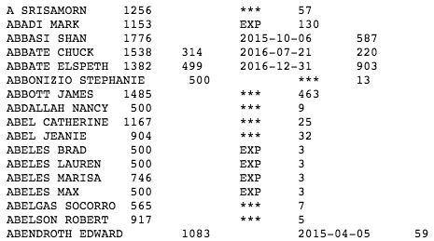

Figure 7. Screenshot of a monthly ratings list produced by the NASPA

Although these lists are limited in terms of functionality, they are extremely useful as a quick reference to view a player’s rating, rank or membership expiry date.

Another method of viewing records on the NASPA website is ranking search functionality. It is possible to query an up-to-date set of records to produce a list of player names and additional information using certain search criteria.

It is possible to produce a list of up to one hundred players, using searches of rating or rank, and by adding criteria such as a minimum or maximum number. This is achieved using a series of dropdown menus and text boxes within a statement of text. Filling in the blanks of the statement creates the search query as shown in Figure 8. A search button is then pressed to produce the list.



Figure 8. Screenshot of search statement used to search player ratings records used by NASPA

The output of the query produces an ordered list of records in a table featuring player name, player rating, rank and their membership expiry date. The results are displayed in a table, which has borders to separate each row and record. This improves the readability of the results.

This search is useful in producing meaningful lists of players ordered by something other than just alphabetical order of names.

In conclusion, the NASPA website offers some ways of viewing a limited amount of player record information. The search function is useful at filtering records into more specific lists. However, the website offers little detail about players other than their rating, rank and membership status.

Although this is an improvement on what the ABSP website currently employs, more meaningful representations of data would be ideal in regards to individual player’s information.

#### World English-Language Scrabble Players Association

WESPA (World English-Language Scrabble Players Association) is an organization formed in 2003, which represents the global players of the English language edition of Scrabble (Jegels, 2015).

The website produces a list of player ratings of players that from around the world who have played in competitive match tournaments of the English-language version of Scrabble. The list is in the form of a table and is ordered by the player rating of each player in the list. The information displayed for each player are their name, country that they are based, total number of matches played and the date of each player’s last rated match.

This tables presented by the website provide information in an easy to read way. Due to the alternating colours of the table rows, see Figure 9.

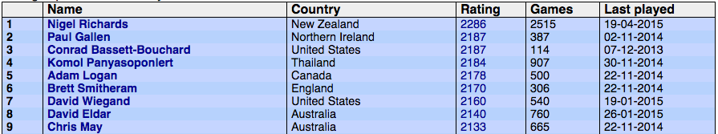

Figure 9. Screenshot of WESPA player ratings list table

A potentially useful feature of the WESPA website is the ability to view detailed information related to specific players. Each player listed in the table in Figure 9 is a link to a corresponding area for that player. These areas feature a series of pages that contain more detailed information. These include the following:

**Stats**

The Stats page contains various scores and statistics for the selected player that an individual may find useful. This includes a breakdown of players’ total matches into wins, losses and draws and scoring averages. The page also further classifies the total number of matches based on the score achieved by the player.

The page also displays personal historical records including a player’s highest and lowest ever scores, including links to the pages of the opponents who were involved in said matches.

The player’s nationality and corresponding national flag is included. A profile picture is also displayed on the page, which are good additions that also help to provide some other visual information besides solely figures.

Finally, the figures provided on the Stats page can also be filtered by date periods using a series of dropdowns. This is useful for individuals searching for records from a distinct period. Figure 10 shows an example of this page.

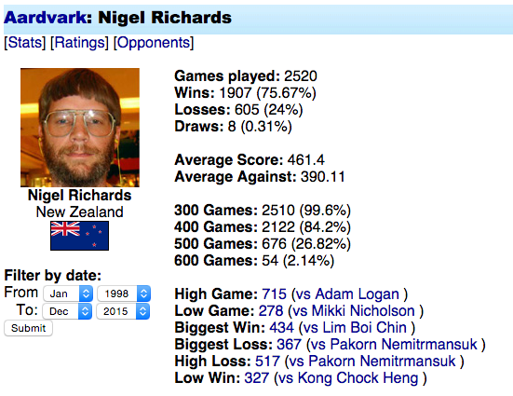

Figure 10. Screenshot of WESPA stats page for a single player

**Ratings**

This page shows a list of all tournaments, which the selected player has attended in ascending date order. Each table also shows the rating and rank of the player at the time of each tournament and any change in their player rating that resulted from that tournament. This table is interesting because it shows the progression of a player at distinct time periods.

Each tournament listed in the table is in turn a link to more detailed information regarding the chosen player’s performance at the chosen tournament. Figure 11 shows a table from a tournament of the results of the selected player.

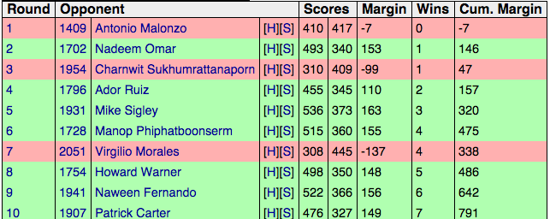

Figure 11. Screenshot of a player’s individual match records at a tournament on the WESPA website

The table includes the round in which the match took place, each opponent’s name and player rating, the scores obtained by both players in each match, the spread of scores and the cumulative number of wins and spreads as the tournament progressed. This table style differs from that of other tables found on the website as the use of green and red are used to indicate a victory or defeat. This works well as a quick visual indicator of tournament performance.

This is an incredible amount of detail that the website is able to display which is making use of the match records that are available to them. Presentation of the information is clear and informative. However, tables are presented as one long list, which can often contain hundreds of records. The tables could therefore benefit from some form of pagination.

**Opponents**

Finally the Opponents page features a table, which shows the head-to-head records of the chosen player and all opponents they have played in rated matches. It also shows how many times they have played, the amount of wins the selected player has achieved and their win percentage against each opponent.

The table follows the usual style of the website with the inclusion of the ability to order columns. It is possible to order the table by any of the columns, which is a useful feature. This page also features the same date filtering functionality of the Stats page.

The WESPA website displays some interesting representation of the records information available to it. The inclusion of specific player record information is a particular highlight.

#### Cross-Tables

Cross-tables is a volunteer-run project which is a partner website of NASPA. It provides statistical information using record information from competitive Scrabble matches in North America (Chew, 2015).

Similarly to other websites, Cross-Tables offers a player ratings list table. This table features a large number of columns of information regarding each player in the list. The columns are listed as the following:

* Name
* Number of games
* Number of wins
* Number of losses
* Number of ties
* Win percentage
* Number of first place finishes in tournaments (including specifically first division wins)
* Number of tournaments entered
* Estimated prize money won
* Average prize money per game
* Player ratings (including peak rating)
* Current rank

This large amount of information on one page is presented really well and shows the potential amount of useful information that can be made available from the stored records.

The table can also be reordered using any of the columns. Also like the tables featured on the WESPA website, rows feature an alternating colour to aid the distinction of separate rows.

The table can also be filtered using dropdown lists, which add either a minimum number of games or the amount of records to show in the table. These provide a level of customization functionality.

In addition to the detailed player ratings list, Cross-Tables provides many other pages dedicated to providing statistics from tournament records.

Similarly to WESPA, Cross-Tables provides a set of pages for each player in the ratings list, which provides further information. These pages offer largely the same tables as the WESPA website with the addition of some differing presentation.

One example of this is that tournament history for a single player and individual match results of those tournaments are shown in the same table, rather than one linking to another as on the WESPA website. Figure 12 shows how the individual match records of a tournament are shown as a dropdown list within the list of tournaments.

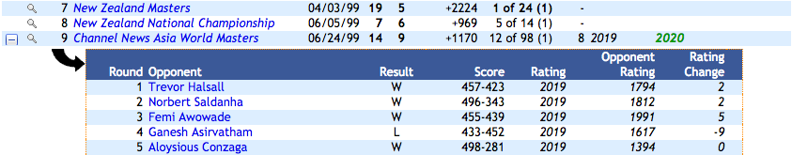

Figure 12. Screenshot of table within a table functionality on the Cross-Tables website

The use of dropdown menus to show more in-depth data within a table is a clever approach at providing the information. However, this requires all of the rows to be loaded and then hidden in the dropdown via a script, which means loading an individual’s entire history in one table will require a lot of loading.

Another feature which the Cross-Tables website uses a graph which illustrates the change over time of a player’s rating. As shown in Figure 13, this is a more visual method of providing the information.

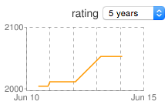

Figure 13. Screenshot of a graph of the rating history of a single player

This serves to offer an alternative to purely text-based information and shows the history of a player’s rating at a glance. Using the dropdown list can alter the period of time for which the graph displays the ratings.

#### Conclusions

Studying the websites has given insight into what can be presented on a website using the data stored in the absporgu_membership database. It has also shown various approaches that can be taken to provide an informative and enjoyable experience for users of the websites.

This project has used this insight to inform design choices for the software product’s interface.

### Page choices

Using the study of similar websites and discussions with the project owner, a definitive list of pages was decided with explanations of their importance. The list of pages were defined as the following:

**Ratings list**

This page will directly replace the current method of displaying player ratings on the ABSP website (see chapter 4.2.2). Instead of being a static list generated from the offline database, this page will dynamically generate player ratings using the absporgu_membership database tables.

**Player summary**

The player summary page will appear much like the Ratings list page in displaying a list of player records but will focus more on each players’ match records. Users will be able to view interesting numerical data about players.

**Single player summary**

As in the cases on WESPA and NASPA, there is potential to display useful information on a player-by-player basis. The Single player summary page will give the software project the functionality to view detailed information about a selected player.

**Single tournament summary**

As with the case of the Single player summary page, the data exists within the database to provide more meaningful information on the ABSP website. The single tournament summary will display statistical information about each match record of a single tournament and also a summary of the tournament.

**Member login screen**

In order for members to be authorized to provide records to the ABSP using the website a login page is required. This page will require a Username and Password that will be checked against a record in the absp_users. Once the login is successful they will be redirected to the Edit rated match records page.

**Edit rated match records**

In order for players to provide match records to the ABSP the Edit match records page is needed. This page will produce a complete list of rated match records for the playerid registered to the user that is logged in. Each record will have the option to be edited and submitted for review by the ABSP.

Each page uses the data stored in the absporgu_membership database to generate content or provide information.

### Page designs

#### Design considerations

In the interest of designing that presents information in the best way possible, certain choices have been made that will be present throughout every page’s design.

**Theme**

Firstly, the overall design of the pages will be in keeping with the minimalist functional style of the ABSP website. This limits the amount of creative choices that can be made in the design phase but will ultimately keep the focus towards developing a functional design.

**Presentation**

The structure and positioning of content on pages is important in controlling the attention of the user. Maintaining a simple uniform structure of elements throughout all of the pages will eliminate the need for users to have to look for content if it is always in the right place (Brinck, Gergle and Wood, 2002).

All pages designed will adopt a uniform consistent style of headings, content then tables where possible. This will ensure that the user will find information where they will come to expect to find it and make things easier for them when they continue to use the software product (Preece and Benyon, 1993).

Readability of the content that the pages will display is also of key importance. A common design choice is often to capitalize important words or titles. This can help to get the attention of users towards an important area of a page.

However, as the potential user base is quite diverse, any efforts to increase the simplicity of conveying information must be made. With regards to readability, the design choice has been taken to only display text in upper and lower case structure, because studies show that this structure 13% faster to read than capitalized text (Preece and Benyon, 1993).

Another consideration made towards the presentation of information is the use of page space. Particularly in the case of casual users of the Internet, using scrollbars to navigate to content is not often an action that is second nature. This creates a need for important information or content to be visible on the page when it loads. The page designs have ensured that space has been used efficiently to minimize the need for scrolling (Brinck, Gergle and Wood, 2002).

**Use of headings**

Headings are used to inform the reader of nature of the content that will follow it. In web design they are also important in catching the attention of users. Too many headings on a page can divide the users attention and unintentionally keep them away from the important content they are meant to see (Brinck, Gergle and Wood, 2002).

As most pages that this project requires are created to serve specific function, headings will be used to primarily for marking the main areas of interest on the pages.

**Table design**

From studying how similar websites present their record information, it is apparent that certain style choices regarding tables can have a significant impact in how users interact with the content on a page. The tables used in all designs will include functionality to enhance the users’ experience.

Firstly, the tables will feature pagination. One theme that arose during the study was the lack of the use of pages throughout the websites. This meant tables with hundreds of rows all on the same page. This led to a requirement to scroll through lengthy webpages to locate a specific record, which is of course inefficient.

Tables feature pagination to accommodate tables of any size with buttons to navigate through the pages. In addition, there will be a dropdown list, which will be utilised to determine how many rows will be displayed per page. This will give users the ability to choose how much information they wish to see on the page.

Another common design choice that will be employed is the alternating row shading to increase table readability. It was apparent from studying similar websites that tables that employed alternating row shades were much easier to read than plain lists.

Another design choice that the tables will incorporate is a search field. The ability to search through records in a table will aid users that are looking for a specific record in a table that could potentially contain thousands of rows. It can also be used to identify similar records that contain a matching field. At the very least it provides the user with another possible way of using the software product, which will only be an advantage.

**Accessibility**

All attempts to make the website as suitable for as many users as possible will be taken. The first consideration is to colour blindness. Many studies have determined that about 4% of people suffer with colour blindness to some degree (Brinck, Gergle and Wood, 2002). Although that represents a relatively small percentage of people, it is still the intention of this project to provide the same level of quality of product to as many users as possible. This will be achieved by minimizing the need for colour as the visual cue for any section of the site.

Pages will also be structured in standard patterns with elements nested correctly and elements will feature descriptive labels to aid screen reader for the visually impaired.

#### Ratings list

Figure 14 shows the design for the Ratings list page will feature a table, which will list features the following columns:

* Rank (Calculated rank order of the player)
* Rating (Calculated player rating)
* Member Number (Membership number on record)
* Name (Combination of surname, forenames and scrabtitle)
* Club (The club a player represents or geographical location)
* Last Played (Date of last rated match)

These columns are those that are required by the project to replace the current system’s method of displaying player ratings on the ABSP website.

In addition to the new table functionality that will be introduced, will be the ability to filter the table based on a qualifying number of games by the use of a dropdown list. Doing so will rename the text inside the brackets to match.

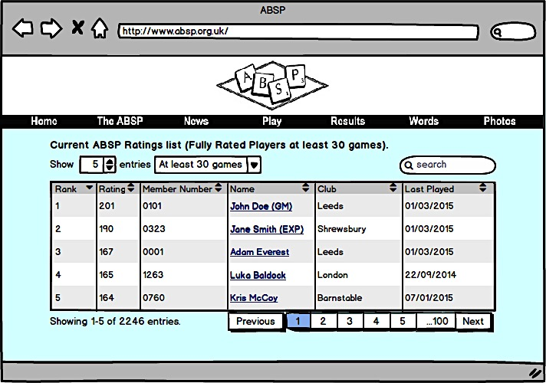

Figure 14. Design for the Ratings list page

Each player name will also act as a hyperlink that will navigate to that player’s corresponding Single player summary page (see chapter 4.2.5.4).

This design is a marked improvement on the current system, as the ratings list will be presented in a clear and clean format with easily distinguishable rows. Users will also be able to search through all the records and reorder all columns, which will aid finding a specific record.

#### Player summary

The player summary page will feature a table that will display the following fields:

* Name (Combination of surname, forenames and scrabtitle)
* Games (Total number of matches)
* W (wins)
* L (Losses)
* D (Draws)
* W% (Win percentage)
* Tourneys (Number of tournaments played in)
* Peak Rating (Highest player rating on record)
* Current Rating (Current player rating)
* Current Rank (Current rank with the organization)

This table is designed to show users of the system a more statistical account of each of the players on record. This will provide a large amount of useful information on one page that can be examined and manipulated using the table’s functionality (see Figure 15).

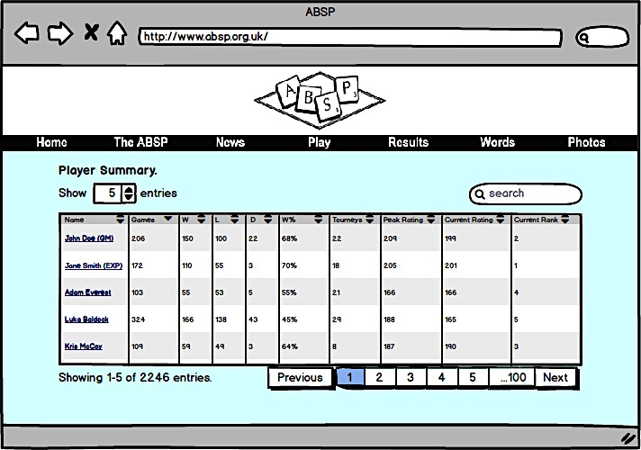

Figure 15. Design for Player summary page

As is with the Ratings list page, each player name will also act as a hyperlink that will navigate to that player’s corresponding Single player summary page (see chapter 4.2.5.4).

#### Single player summary

As shown in Figure 16, the Single player summary page will incorporate many of the design features of similar organizations websites to produce a varied page of useful information.

The page will feature a picture of the selected player and a table of general statistics similar to those presented on the player summary page. To add some variation to the presentation of information there will also be a line graph similar to the one on figure 13 (see chapter 4.2.3.3).

The page will also feature a table with the following columns:

* Tournament (Name of tournament)
* Date (Date of tournament)
* W (wins)
* L (Losses)
* D (Draws
* B (Byes)
* Spread (The scores obtained at the tournament minus the scores of all opponents)
* Old Rating (Player rating prior to tournament entry)
* Perf Rating (The changes to the player rating during the tournament)
* New Rating (The player rating at the end of the tournament)

This table will show details and statistics from each of the tournaments that the selected player has played in. This will provide a user with the ability to see detailed information about a player’s history and see how well they performed at a specific tournament.

Each tournament will also be a hyperlink to the corresponding Single tournament summary page (see chapter 4.2.5.5) for that tournament.

This page will provide a large amount of meaningful information to a user, by making use of all of the space available on the visible page. This will represent the clearest representation of the conscious thought process that has gone into providing the most amount of content that is visible on a page, without the need to scroll.

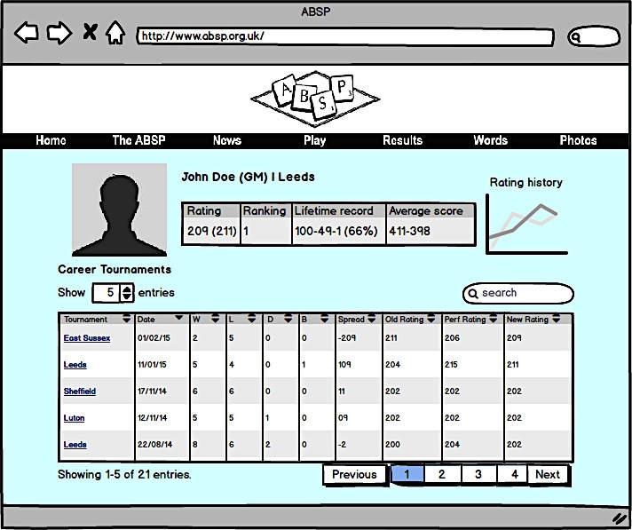

Figure 16. Design of the Single player summary page

#### Single tournament summary

As Figure 17 illustrates, the Single tournament summary page features a table containing the following columns:

* Place (Placing of the player)
* Seed (Seed number of the player)
* Name (Combination of surname, forenames and scrabtitle)
* W (wins)
* L (Losses)
* D (Draws
* B (Byes)
* Spread (The scores obtained at the tournament minus the scores of all opponents)
* Old Rating (Player rating prior to tournament entry)
* Perf Rating (The changes to the player rating during the tournament)
* New Rating (The player rating at the end of the tournament)

Similarly to the table on the Single player summary page (see chapter 4.2.5.4), the table will show statistical information for each player at the selected tournament. As many tournaments feature multiple divisions there will be a dropdown list containing each of the divisions to filter the table.

The heading and content at the top of the page will also be made up of information of the selected tournament that the page will read from the database and display.

This page will allow the website to show detailed results of a tournament in a clear and structured format.

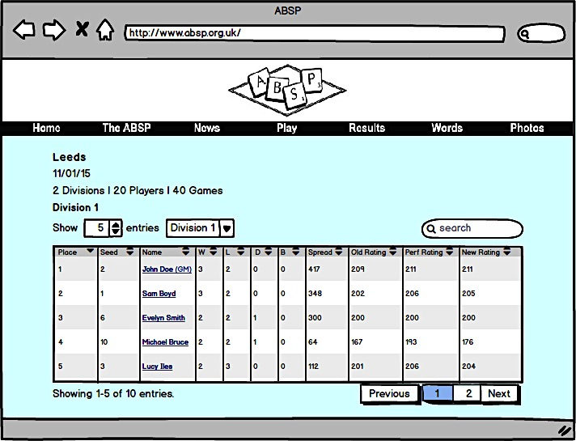

Figure 17. Design of the Single tournament summary page

As is with other pages, each player name will also act as a hyperlink that will navigate to that player’s corresponding Single player summary page (see chapter 4.2.5.4).

#### Member login screen

This page will serve as the login screen for members who wish to provide match records to the ABSP through the website.

Figure 18 shows the simple but functional design for the page. It will include only information that is necessary to the member to remove any confusion. It was also a deliberate choice to display a text label next to each text field rather than have the text fields be prefilled with ‘Username’ and ‘Password’ to remove any doubt that a less experienced user of the web may have with how to log in.

The page will also feature a ‘Forgotten password? Contact the ABSP.’ hyperlink that will direct them to the contact page on the ABSP website so they can resolve any issues with their login credentials.

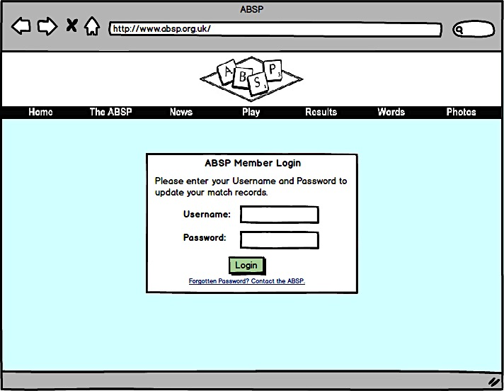

Figure 18. Design of the Member login screen

#### Edit rated match records

The edit rated matches page will be the destination that a member is redirected to once they have provided the correct login credentials. It will include a table with the following columns:

* Tournament (Name of tournament)
* Date (Date of the match)
* Round (Round of the tournament that the match took place)
* Opponent (Opponent of the selected player)
* Player score (The score achieved by the selected player in the match)
* Oppo score (The score achieved by the opponent in the match)
* Spread (The selected player’s score minus the opponents score)
* Edit (Provides cells for buttons)
* Submit (Provides cells for buttons)

This table will feature every record of every match that has been played at every tournament involving the logged in player.

Figure 19 shows a design of the page that shows a number of states. The normal state of the table will feature a row that contains an active edit button and an inactive submit button. Once a user presses the edit button on a row it will change the state of that row. The Player score and Oppo score cells will then be editable, the active edit button will become an active cancel button and the inactive submit button will become active. This will provide the user to edit match records and submit their revisions to the ABSP for approval.

This will provide a simple single-page process for inputting missing tournament records that will also be guarded against unauthorized entry due to the need to be logged and will require the ABSP’s approval before that database records are changed.

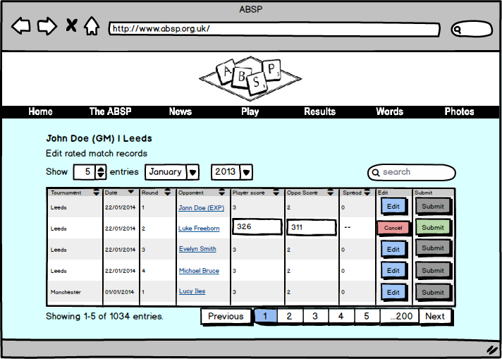

Figure 19. Design for the Edit rated match records page

The records for the player who is logged in will generate the page headings and as is with other pages, each player name will also act as a hyperlink that will navigate to that player’s corresponding Single player summary page (see chapter 4.2.5.4).

# Implementation

This section details how the designs of the software product were implemented as a functioning high-fidelity prototype and will also explain how that functionality was achieved. The prototype was developed constantly and working functionality was added incrementally.

## Version control

Throughout the development of the prototype a version control solution has been in place and used periodically. It was decided that an online GitHub repository would serve the needs of the project as it offers a popular user-friendly product with an easy to use GUI (graphical user interface). This allowed for rapid backups of the prototype files.

As there was no budget for this project GitHub was also selected, as it is possible to create free public repositories. A drawback of this approach is that a public repository can be viewed by anyone who visits your repository pages online. This however, caused no conflict with the project as at no point was sensitive information used in development.

## Development environment

The prototype was developed on a local development environment running on Mac OS X that was set up using AMPPS. AMPPS is a software stack that is used to install local server environments on a machine that runs Mac operating systems (AMPPS, 2015). It was chosen because of its simple installation method that it required very little configuration to create a working development environment.

## Complications with the implementation phase

### Reduction of the number of pages and associated functionality

Due the development of the prototype being extensively more complex than what was first anticipated, there was not enough time to develop all the pages that were detailed in the design phase. It was decided that development of the Member login screen and Edit rated match would be put on hold due to the amount of extra development that would be required make both pages fully functional.

### Inability to produce the necessary SQL statement

Unfortunately, the ability to practically calculate and display player ratings is not currently part of the prototype. This is due to confusion arising from how to formulate the SQL statement that is necessary in producing the derived table.

As explained in 1.10, the mathematical processes involved in calculating player ratings are understood and can be applied in a theoretical sense. However, currently there is no solution to the problem. The page structure exists to display these ratings once they can be calculated.

This issue is also true of displaying rated match scores.

## Database

As previously mention in section 4.1.1 the database structure for the project was decided by the ABSP. The structure was implemented into the prototype by creating an empty absporgu_membership database and then running a series of scripts. The scripts are written in PHP that were supplied by the ABSP.

The scripts worked by opening a connection to the newly created empty absporgu_membership database checking if the new table already exists and creating it if it did not. An example of one of the scripts is included below:

<?php

$dbhost="localhost";

$dbuser="USER_REMOVED";

$dbpass="PASS_REMOVED";

$db="absporgu_membership";

$dbnull=null;

$mysqli=new mysqli($dbhost, $dbuser, $dbpass, $db);

if (mysqli_connect_errno())

{ trigger_error("DB cnx failed ".mysqli_connect_error(), E_USER_ERROR);

}

$mysqli->query("create table if not exists `tournmtRoster` (

`tournid` varchar(40) NOT NULL,

`playerid` int,

`entryRating` int,

`rosterNum` smallint

)" );

$mysqli->close();

?>

Once the tables were in place, the database was then populated with test data that was also supplied by the ABSP. This data was treated prior to being received as part of this project by removing any contact information from the records. This ensured that none of the members’ sensitive information could be made public by any actions of this project.

The absporgu_membership database for the prototype is in place and can be read by the dynamic web pages using SQL statements on each page. This working database serves as proof of concept that the old offline database can be replaced by this new system.

## ABSP branding

It was explained at the start of the project that at no point would access be granted to the website files. As the software product is intended to be part of the working website, a way of incorporating the branding of ABSP website into the prototype was devised. This was to ensure that any implementation of the software product would not clash with the existing website’s assets or processes.

This involved creating a shell of the ABSP website header and navigation menu. This shell is a cosmetic facsimile that is non-functioning and served as page branding on each of the prototype’s dynamic web pages.

To ensure that any styling of the prototype would not clash with the website, a copy of the norm.css file that operates as the style sheet for the ABSP website was made and incorporated into the prototype. This meant that any styles added to any prototype content would have be implemented in a way that did not conflict with the existing styles of the website.

## External resources

To create the functionality for the prototype the project has used some third-party open source code. DataTables is a solution that adds paging, filtering and sorting functionality to regular HTML tables by using a mixture of CSS styling and jQuery scripts (Jardine, 2015). As the design of the software product calls for exactly that type of functionality, DataTables appeared to be a perfect solution.

The decision to use this code rather than writing a solution from scratch is one based largely on the issue of time. As the amount of time available to complete the project is limited it was decided that time was better spent on other areas of the project.

In order for DataTables to function correctly the project also requires the use of two jQuery files, which were sourced from <https://jquery.com/>. jQuery is a JavaScript library, which adds functionality to HTML.

All these files are included in the software product core files and are labeled appropriately.

## Creating page content

The dynamic pages of the prototype are in the .php file format and were written in a mixture of PHP and HTML, as the pages are required to read and write data from the database as well as produce the markup on the pages.

PHP was chosen as the solution as it can be used with HTML on the same page with no issues. In addition to that, PHP is the most widely used solution for a project of this type and boasts a large support community that is perfect for troubleshooting development problems (Skvorc, 2014).

### Populating tables

The tables on the pages were generated using regular HTML and the added functionality was provided by the DataTables solution (see chapter 5.5).

The content of each of the tables was generated through the following steps:

1. Run a SQL statement on the database that returns a derived table of results and assign it to a variable
2. Inside the HTML code for the table create a while loop just after the code that defines the columns and creates the table headings
3. Inside the while loop add the HTML markup for the table rows around the column titles that you wish to output and the while loop will produce each record contained in the derived table

The following is an example from without page styling for ease of reading:

<?php

$servername = "localhost";

$username = "root";

$password = "mysql";

$dbname = "absporgu_membership";

$orderby = '';

$sort = '';

// Create connection

$conn = new mysqli($servername, $username, $password, $dbname);

// Check connection

if ($conn->connect_error) { die("Connection failed: " . $conn->connect_error); }

$sql = "SELECT *, DATE_FORMAT(lastplayed,'%d/%m/%Y') AS formattedDate, sum(numwins) as wins, sum(numlosses) as losses, sum(numdraws) as draws, count(tournid) as tourneys FROM tournmtSummary join playerO on tournmtSummary.playerid=playerO.playerid group by tournmtSummary.playerid ORDER BY `tourneys` DESC";

$result = $conn->query($sql);

if ($result->num_rows > 0) { ?>

<table>

<thead>

<tr>

<th>Rank<th>

<th>Rating<th>

<th>Member Number<th>

<th>Name<th>

<th>Club<th>

<th>Last Played<th>

</tr>

</head>

<tbody ">

<?php while($row = $result->fetch_assoc()) { ?>

<tr>

<td><?php echo $row["playerRank"];?></td>

<td><?php echo $row["palyerRating "];?></td>

<td><?php echo $row["membno"];?></td>

<td<?php echo $row["forenames"];?> <?php echo $row["surname"];?></td></a>

<td><?php echo $row["club"];?></td>

<td><?php echo $row["formattedDate"];?></td>

</tr>

<?php } ?>

</tbody>

</table>

<?php

} else { ?>

<p>0 results</p>

<?php } $conn->close(); ?>

### Populating pages using variables

Pages that provide content on a specific player or tournament required more effort to produce outputs. For example, the Single player summary page (singleplayersummary.php) requires a playerid amongst other things to render a specific page.

To view a page for a player requires the user to first click on a player’s name on page that acts as a hyperlink to the Single player summary page. It is at that point where one needs to pass variables into the URL to carry over onto the next page. This is done by creating a variable and assigning a value to it. This value is specific to that record in which it appears. For example see the following record:

<td>

<a href="/fyp-dev-build/views/singleplayersummary.php?playerid=<?php echo $row["playerid"] . '&playername=' . $row["forenames"] . ' ' . $row["surname"]. '&location=' . $row["club"] . '&wins=' . $row["wins"] . '&losses=' . $row["losses"] . '&draws=' . $row["draws"] . '&winperc=' . round($winperans, 2) . '%' ;?>"><?php echo $row["forenames"];?> <?php echo $row["surname"];?></a>

</td>

Variables are passed into the URL with the values of the corresponding record. The destination page then uses those variables as variables in the SQL statement that produces the output for that specific player.

For example, the SQL statement that produces the derived table that provides all of the dynamic content for the page is as follows:

SELECT *, DATE_FORMAT(rpointsO.tourndate,'%d/%m/%y') AS dateformatted

FROM tournmtSummary

RIGHT JOIN rpointsO ON tournmtSummary.tournid=rpointsO.tournid

AND tournmtSummary.playerid=rpointsO.playerid

LEFT JOIN tournmtO ON tournmtSummary.tournid=tournmtO.tournid

WHERE rpointsO.playerid='$playerid'

ORDER BY tourntitle DESC

The example requires the variable $playerid to be brought into the page in the URL to make the statement valid.

### Player profile picture

Passing the $playerid variable into the URL is also part of the code that produces the player profile pictures on the Single player summary page (singleplayersummary.php). This is done by assigning the variable as part of the source of the image. The image also uses the oneeror event that defines a default image if there is an error with the regular image.

So this means that it is possible to store player profile images on the server in a folder. They must each be named the distinct playerid of their owner. So if an image exists on the server it will display on the page, if it does not it will display the default image instead. Below is the example code that performs the functionality minus the styling:

<?php

$filename = $playerid . 'PNG';

echo '<img src="/fyp-dev-build/images/profile-pics/';

echo $playerid;

echo '.PNG" ';

echo 'onerror="this.src=';

echo "'/fyp-dev-build/images/player-image.PNG'";

echo '"';

echo '>';

?>

### HTML content

The four pages that have been attempted all have core HTML put in place. The implementation phase has incorporated the considerations detailed in the design phase (see chapter 4.2.5.1). All attempted pages feature functioning tables that offer pagination, sorting and also filtering by way of search field

Figure 20 is a screenshot of the prototype Ratings list page (ratingslist.php). This is a good example of how well the design has translated into the implementation stage. The HTML aspects of the prototype were implemented well and very closely match the designs.

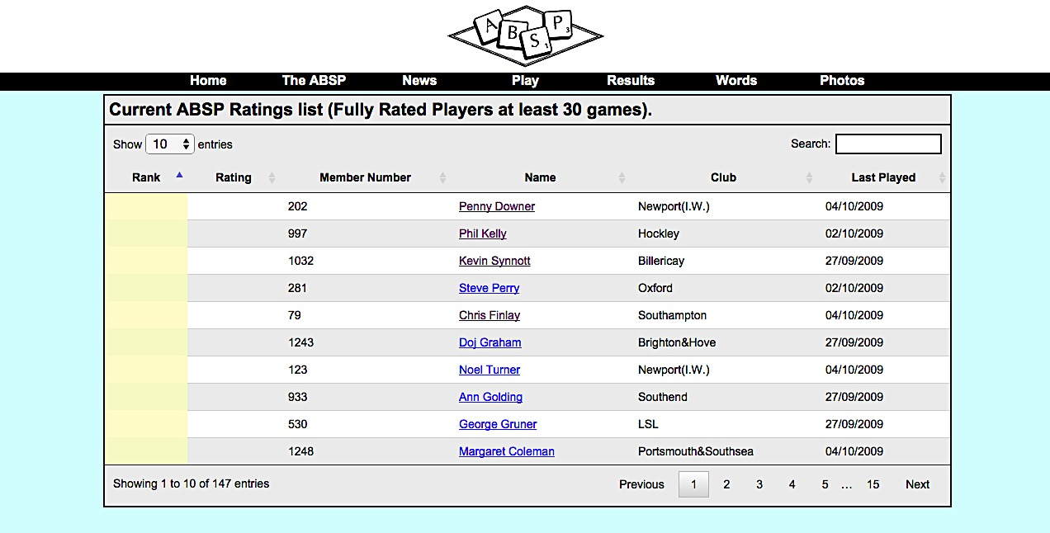

Figure 20. Screenshot of the prototype’s Ratings list page

## Summary of implementation

Though not everything could not be achieved during this implementation phase due to constraints involving time and understanding of a technical solution, there was still some significant progress made.

The prototype exhibits lots of promising functionality and is implemented to a high coding standard.

# Evaluation

## User study

### Purpose

The purpose of this user study is to measure the effectiveness of the software product in terms of presentation and usability from a user’s perspective. Users will interact with the prototype of the software product by completing a set of tasks devised to test functionality.

The results of this study will provide insight into how well the software product satisfies the requirement of displaying meaningful information by reading records from the online database and displaying them on web pages.

### Design overview

Participants were asked to perform three separate tasks, which required them to provide an answer to a question after completing each task. Providing the correct answer would be dependent on the user’s ability to use the software product’s functionality.

The design of each was a within participants model. This means that every participant took part in every condition of this study.

Each participant performed each task in the exact same order.

It is intended for task one to precede task two, as they are similar in design. Completing task one should provide an element of training which should be evident in task two. Participants should be familiar with the processes required to complete task two, having previously completed task 1.

Upon completion of all three tasks, each participant completed a paper-based survey of experiences and opinions. Responses of these surveys were collated and included as part of this study’s results.

### Method

#### Participants

A within participants design was chosen, as the study required each participant to complete each task. Participants were selected from a number of volunteers. Ten participants took part in the study, consisting of five males and five females with an average age of 21.7 (SD=0.61).

All participants completed the full study and each signed a consent form. The tasks and instructions given to each participant during the study were exactly the same without exception.

Participants were selected from a pool of volunteers who were all full-time University of Leeds students. Leeds University students were selected as participants due to a perceived level of experience using websites and common web functionality.

#### Materials

#### The tasks were completed using the webpages created for the software product and no other web content. Browser caches were cleared prior to each participant’s attempt at completing tasks to remove any influence from a previous participant from the study.

Each participant completed tasks in the same quiet location sitting at the same desk with a chair. Each participant conducted the study completely independently of other participants to minimize any influence on the results. The study was supervised at all times to ensure its integrity.

The participants attempted all tasks on the same MacBook Pro computer, viewing pages using the Google Chrome web browser.

The time spent completing tasks, notes about participants’ approaches to solving a task and if they were successful were recorded silently on paper. At no point during the tasks were the participants made aware of what was being noted. This ensured that their approaches to using the system were not influenced by any unintended information being received.

Questionnaires were completed and returned immediately after the tasks were completed within the quiet location to remove any outside influence and to collect experiences as soon as possible.

#### Procedure

This study required all ten participants to complete the same three tasks in order using the software product. These tasks were the following:

**Task one**

Starting on the Current ABSP Ratings list (ratingslist.php) page. The participant must determine how many players have their Club listed as Lincoln.

The task was considered complete once the participant alerted the instructor and provided an answer.

**Task two**

Starting on the Player summary (playersummary.php) page. The participant must locate the player named Diane Pratesi and find their win percentage.

The task was considered complete once the participant alerted the instructor and provided an answer.

**Task three**

Starting on the Single player summary (singleplayersummary.php) page for Chris Finlay. The participant must navigate to the Hampshire Grand tournamentpage where you must determine how many players won exactly seven games.

The task was considered complete once the participant alerted the instructor and provided an answer.

The participants were given no help or instructions regarding how to complete each task.

The following data was collected during the tasks:

* The amount of time a participant spent completing each task using a stopwatch
* The accuracy of the participant’s answers provided
* The participant’s first choice of functionality for completing tasks (either the search box or a combination of ordering columns and pagination)
* The questionnaire of each participants opinion and experiences of using the system

### Results

#### Time spent completing a task

Figure 21 illustrates the time spent by participants completing tasks one and two.

This figures show that task one had taken participants no longer than 12.43 seconds to complete and task two had taken no longer than 8.44 seconds to complete. The average times of all participants for completing the tasks were 8.10 seconds for task one and 6.28 for task 2. This reasons that all participants had no issues with performing either task or that although both tasks were relatively simple; they were completed in a timely fashion.

As designed, it appears that an element of training had occurred as in the case of all but one participant, it took less time to complete task two than task one. This shows that the system functions in a logical way, as participants were able to learn how find relevant content quickly and also become quicker at using the software product’s functionality after repeated use.

Figure 21. Time spent by each participant completing tasks one and two

#### Figure 22 shows the amount of time each participant spent completing task 3. It took participants no longer than 10.73 seconds to complete the task and on average participants spent 8.15 seconds. This continues to show that participants have had no issues in performing tasks.

Figure 22. Time spent by each participant in completing task three

#### Accuracy of answers provided

All ten participants determined the correct answer in all three tasks. As no misinterpretation of content had taken place, it should be inferred that the software product correctly presents information in a way in which a user would expect. This also showed that the software product had functioned correctly.

#### The participant’s first choice of functionality for completing tasks

Each task was designed in a way that required users to search for information using the software product’s search functionality. The participants were not informed of how to use any of this functionality necessary to complete each task.

It was possible to complete task one and two using one of two methods of searching. The two ways in which the tasks could be accomplished were using either:

* The search field at the top of every table.
* A combination of ordering columns in a table and navigating through table pages.

Figure 23 shows that collectively, participants used both search methods to complete tasks one and two. This proves that both methods were identifiable by a number of the participants. This should suggest that the methods for searching that the system uses are designed and implemented in ways that are expected by a software product of this type.

Figure 23. Count of search methods first used by all participants to complete tasks one and two

Task three was also accomplishable with either search method. However, it made logical sense to order columns displaying numbers in order produces a clear readable list in which the answer was visible.

This was reflected in the results, because every participant used this method to complete task three. This is also a positive reflection on the design of the system, as some participants had not used this method prior to this task.

Many participants had used only the search field to that point. This further demonstrates that the implementation of the search methods is consistent with existing design principles as participants located both search methods and use them correctly and effectively.

#### Questionnaire

Upon completion of the tasks, participants were each asked to complete a short questionnaire designed to collect opinions and experiences of using the system.

The questionnaire consisted of five statements and the participant was asked to indicate to what extent they agreed or disagreed with each statement. The five statements were as follows:

1. The software product fits the overall design of the website.
2. The information presented on pages was easy to understand.
3. The software product performed well.
4. The interface is well presented.
5. The interface was easy to use.

Responses were based on a scale ranging from Strongly agree through to Strongly disagree. The responses to each statement were extremely positive, ranging from 80% to 100% strong agreement from all participants and agreement in all other cases across all statements. Figure 24 illustrates the responses to each statement by all participants.

Figure 24. Percentage spread of agreement with questionnaire statements of all participants

There were no instances of disagreement recorded in any questionnaire with any of the five statements, which is also very encouraging.

Firstly, nine strong agreements and one agreement with statement one suggests that from a user perspective, the system fits into the style of the ABSP website. This is an important finding as the software product must be appropriate for the client in terms of visual appearance to be considered suitable.

Statements two, four and five were all devised to measure a participant’s perception of how well the system was designed to present information. The results show that all participants agreed with all statements. This validates the choices made throughout the design phase, as not only did participants agree that the presentation of the system was carried out well, they also perceived that the interface was simple enough to use without any training or explanation. As the potential user base for the software product features individuals with little experience of using the web, ease of use is a crucial consideration.

Finally, statement three was used to gauge responses of how the software product performed during the study. All participants strongly agreed with the statement, which is an overwhelming indication of how well the participants rated the system from a performance standpoint.

### Discussion

The results gathered from the performance of the participants from completing the three tasks appear to suggest that the software product functions correctly in the context of finding specific records using the products functionality.

The results also provide evidence that the software product is well designed as the all tasks performed by participants were all completed without any errors. This is testament to solid design and implementation phases. Analysis of the participants’ questionnaire responses also adds weight to the argument for the software product being well designed and implemented.

It is important to note that the tasks that were performed by the participants in this study were specifically intended to only test all fully completed features of the software product and to discount incomplete implementations. This measure was taken to ensure functionality was experienced as they were designed.

### Conclusion

In conclusion, the study provides strong evidence that the software product both designed and implemented well. Tasks used in this study are direct examples of tasks that end users will perform with the final software product. Participants were capable of performing all tasks with relative ease and without error.

In addition to this, the feedback gained from analyzing questionnaire feedback showed that from a user’s perspective, the software product is well designed, well implemented and easy to use. This forms a valid argument in favour of the success of the project.

## Evaluation of project objectives

This section will now evaluate how the project addressed the objectives that were defined in chapter one of this report (see chapter 1.3).

|  |  |
| --- | --- |
| **Objective** | **Proof** |
| **Select and adopt an appropriate methodology for developing the software product.** | The report reviewed possible project management methodologies and formed a recommendation. An incremental approach was used chapter 2) |
| **Design a suitable software solution by acquiring knowledge from researching potential approaches to solving the problem.** | A full design phase is present in the report and is fully explained and design choices are justified taking into account constraints (see chapter 3.1). |
| **Design an appropriate user interface for the solution by examining established web development conventions and user interface design principles.** | Evidence of this whole process is present in this report including justifications of all choices (see chapter 3.2). |
| **Create a high-fidelity prototype of the proposed solution, which will be supplied with test data to develop functionality and demonstrate the user interface.** | Evidence of this will be provided as a source code deliverable to supplement this report. Also a detailed breakdown of the process is present in this report (see chapter 4) |
| **Perform a user study to measure the perceived effectiveness of the solution from a presentation and usability standpoint.** | A full user study was conducted and is present in this report (see chapter 5.1). |

This project has addressed all the objectives that were set out and provided proof of each accomplishment.

## Evaluation of software solution requirements

This section will evaluate to what extent the requirements of the software solution have been met through the implementation of the prototype.

|  |  |
| --- | --- |
| **Requirement** | **Explanation** |
| **Implement an online records database to replace the current offline solution.** | The database provided by the ABSP was implemented into the software solution and functioned well. It acts as a replacement of the old offline database by performing the same functionality (see chapter 4.4). |
| **Calculate player ratings using the online records database.** | This requirement could not be achieved to the inability to formulate a suitable SQL statement to produce the necessary calculations. Everything needed to calculate the player ratings is present in the system. However, the prototype cannot produce the required results at this time. |
| **Produce a series of webpages to be displayed on the ABSP website that will read the online records database records and display meaningful information to all users.** | The prototype features a number of database-driven web pages that read database records and displays them in meaningful ways. Evidence of this can be found in the source code deliverable and within this report (see chapter 4.7). |
| **Provide a secure means by which a player can provide match results using the ABSP website. This includes new results and amendments to existing records.** | Unfortunately, due to time constraints it was not possible to implement this functionality into the prototype. Given more time it would be achievable but at this stage remains on hold. |

Of the four main requirements of the software solution two of them can be considered as achieved. This is not an ideal outcome. However, this still represents success as the project has produced a working piece of software that exhibits some interesting functionality that can be implemented by the ABSP.

Although not all requirements of the software solution were achieved, there are still many positives that can be drawn from the project. Given more time, achieving the remaining requirements would be entirely possible.

# Conclusion

The aim of this project was to replace the obsolete ABSP ratings system with an interactive online database. This was to be accomplished by implementing a new online database which will power dynamic web content on the ABSP website. Although not all requirements of the proposed software solution are implemented in the prototype, there is still a reasonable amount of useful functionality that represents a great improvement upon the current obsolete system.

First and foremost, the new online database is implemented in the prototype, which was the main requirement of the project. The solution also boasts a well-designed series of dynamic webpages that provide statistics and information from the new database.

In addition to this, the user study conducted to evaluate the suitability of the software product from a presentation and usability viewpoint concluded that there is evidence software product was designed and implemented well. Moreover, participants of the study unanimously agreed that the software product was well designed, well implemented and easy to use.

This forms a solid argument that the project as a whole was largely a success, despite its inability to satisfy all of the defined requirements.

## Personal reflection on project processes and outcomes

This section is my personal reflection on processes and outcomes of my Final Year Project.

Firstly I would like to reflect upon the outcome of my software product. Although it did not achieve everything that it set out to I am still filled with a tremendous sense of pride in knowing that the months of planning, designing and coding achieved a tangible functional product.

This has without a doubt been the most challenging piece of work I have ever undertaken both academically and professionally. I was not prepared for how much of my time I would spend agonising over the progress of the project even when I was nowhere near my computer. Looking back now I understand that it was probably just the pressure of knowing that this one piece of work would determine a large proportion of my overall grade.

For this project it was vital to have the correct technical knowledge. At the start of the project was unsure about my ability to write SQL statements to interact with the database. By speaking to my supervisor and by spending time working autonomously on the project, I am now able to say I have a more thorough working knowledge of SQL statements, although I am aware I still need more experience in these areas

One key skill I have had to employ during the process has been self-motivation. There were many times during the span of the project where it felt like I had nothing left to give the project. However, I kept telling myself it would all be worth it.

Another important skill that I needed to employ was time management. I would advise future students to reduce work down into smaller portions and to work continuously on these, as I found I had not anticipated the time required to produce a system of this size.

Now the project has reached its conclusion I have the opportunity to examine it with a critical eye. If I had to the opportunity to revisit any stage of the project it would undoubtedly it would be the planning stage. The time I allocated for the prototyping and implementation phases of the product fell well short of what was required in order to satisfy every requirement of the solution.

The problem was that as I was unfamiliar with producing a software solution of this type, estimated times for development were largely informed guesses do to the very specific nature of the proposed solution. It was my misfortune on this occasion that those estimations were a little too short. I am confident that I made the best choices regarding what to focus in the time I had.

I can end this report happily and without regrets knowing that like the rest of my time at University, I gave it my all.

# List of References

Chew, J. (2015). History of SCRABBLE. [online] Scrabble-assoc.com. Available at: http://www.scrabble-assoc.com/info/history.html [Accessed 9 May 2015].

Scrabble, (2015). *Hasbro*. [online]. Available at: http://www.hasbro.com/scrabble/en_US/discover/history.cfm [Accessed 12 Feb. 2015].

Absp.org.uk, (2015). *ABSP*. [online] Available at: <http://www.absp.org.uk/index.shtml> [Accessed 29 Apr. 2015].

Absp.org.uk, (2015). *ABSP - What are Ratings?*. [online] Available at: <http://www.absp.org.uk/results/JAGRatingsNotes.shtml> [Accessed 27 Apr. 2015].

Absp.org.uk, (2015). *ABSP - Basic ratings system*. [online] Available at: <http://www.absp.org.uk/results/JAGrn1.shtml> [Accessed 29 Apr. 2015].

DuBois, P. (2002). MySQL Cookbook. Sebastopol, California: O'Reilly & Associates.

DuBois, P. (2005). MySQL. Indianapolis, Ind.: Sams Pub.

Kofler, M. (2015). MySQL alternatives. [online] SearchITChannel. Available at: http://searchitchannel.techtarget.com/feature/MySQL-alternatives [Accessed 4 May 2015].

Meredith, J. and Mantel, S. (1995). Project management. New York: Wiley.

Ruparelia, N. (2010). Software development lifecycle models. SIGSOFT Softw. Eng. Notes, 35(3), p.8.

Hughey, D. (2015). The Traditional Waterfall Approach. [online] Umsl.edu. Available at: http://www.umsl.edu/~hugheyd/is6840/waterfall.html [Accessed 5 May 2015].

Mantei, M. and Teorey, T. (1988). Cost/benefit analysis for incorporating human factors in the software lifecycle. Commun. ACM, 31(4), pp.428-439.

Pressman, R. (2005). Software engineering. Boston, Mass.: McGraw-Hill.

Kostigoff, S. (2015). Methodology:: Development Models. [online] Myprojects.kostigoff.net. Available at: http://myprojects.kostigoff.net/methodology/development_models/development_models.htm [Accessed 5 May 2015].

Chew, J. (2015). Frequently asked questions - NASPAWiki. [online] Scrabbleplayers.org. Available at: http://www.scrabbleplayers.org/w/Frequently_asked_questions [Accessed 10 May 2015].

Jegels, L. (2015). WESPA Home Page. [online] Wespa.org. Available at: http://www.wespa.org/index.shtml [Accessed 10 May 2015].

Brinck, T., Gergle, D. and Wood, S. (2002). Designing Web sites that work. San Francisco: Morgan Kaufmann Publishers.

Preece, J. and Benyon, D. (1993). A Guide to usability. Wokingham, England: Addison-Wesley.

AMPPS, (2015). WAMP, MAMP and LAMP Stack : AMPPS Tour. [online] Ampps.com. Available at: http://www.ampps.com/tour [Accessed 11 May 2015].

Skvorc, B. (2014). Why Choose PHP Over Alternatives?. [online] SitePoint. Available at: http://www.sitepoint.com/why-choose-php/ [Accessed 11 May 2015].

# Appendix A - External Materials

Other than any external materials that are mentioned explicitly in the report, there have been no additional materials used to complete this project.

# Appendix B - Ethical Issues Addressed

The main risk associated with the project was the continued involvement of Derek Sergeant. As Derek is the project owner and the representative of the ABSP, his participation was essential.

If Derek were to decide to end his affiliation with the ABSP at any point during the project it would have been difficult to proceed. There was no suitable contact identified who would be available in the event of Derek’s departure.

One other possible risk was that due to issues with security access to the live ABSP website. Derek was unable to provide an accurate estimate of how long any changes that were submitted to the live site would take to go live. This had potential to cause delays. Ultimately, this risk was never applicable as at no point was any aspect of this project submitted for inclusion on the live ABSP website.

# Appendix C – Project Information Sheet for user study participants

**Project Information Sheet**

**Project Title**: Replacing the obsolete ABSP ratings system with an interactive online database

You are being invited to take part in a student project. Before you decide, it is important for you to understand the aim of the project and what participation will involve.

Please take time to read the following information carefully and discuss it with others of you wish. Ask if there is anything that is not clear or if you would like more information. Take time to decide whether or not you wish to take part. Thank you for reading this.

**Project Aim**: The solution proposed, will be a series of web pages that will read an online records database. The pages will then manage the player ratings list. This solution will also produce pages that will provide users with the ability to interrogate their own records.

The webpages will also make use of the record information that is currently being collected by the ABSP by producing various supplementary views that player’s may find interesting or useful.

The solution will also feature a method whereby a player will be able to submit missing match records to the database using a series of secure web forms.

**Why have I been chosen?** You have been selected as you have extensive experience with navigating the web and have used websites that use databases to generate dynamic content.

**Do I have to take part?** It is up to you to decide whether or not to take part. If you do decide to take part you will be given this information sheet to keep (and be asked to sign a consent form) and you can still withdraw at any time. You do not have to give a reason.

**What will happen to me if I take part?** You will perform three tasks centered on navigating and using functionality of a website. You will be issued a questionnaire to answer upon completion of the tasks.

**Will my taking part in this project be kept confidential?** Yes. Only demographic information about the group as a whole will be recorded. Your name will not be published in this study.

**What type of information will be sought from me and why is the collection of this information relevant for achieving the project’s objectives?** Your performance in the three tasks will be measured to determine the suitability of the system. Your questionnaire feedback will help form a consensus about how users perceive the systems suitability.

**What will happen to the results of the project?** The results of this project will be published in a report to be submitted for assessment at the end of the undergraduate module COMP3860 Research Project in the School of Computing at the University of Leeds.

**Contact for further information**: *ll10gd@leeds.ac.uk*

If you decide to participate in this project, you will be given a copy of this information sheet and a signed consent form to keep. Thank you very much for taking the time to read this information sheet.

# Appendix D – User study task instructions

You will be performing **three** short tasks throughout this study, which are centered on finding information on a series of webpages. Each task will be prepared by the instructor and will be conducted on a MacBook Pro that will be presented to you at the start of each task.

You are required to sit at the desk provided to you for the duration of the study.

Before each task read the instructions carefully. Once you are satisfied signal to the instructor and the test will begin. It is also important to not that navigating to other pages is encouraged in some cases necessary to complete a task.

* *For each task you* **must not***use any of the top navigation bar in the header of the website as that does not function as part of the software solution.*

**Task 1**

You will start on the **Current ABSP Ratings list** page. From here you must determine how many players have their Club listed as Lincoln. Once you are satisfied that you have obtained the correct answer, signal to the instructor to end the task.

**Task 2**

You will start on the **Player summary** page. From there you must locate the player named Diane Pratesi and find their win percentage. Once you are satisfied that you have obtained the correct answer, signal to the instructor to end the task.

**Task 3**

You will start on the **Single player summary** page for Chris Finlay. From this page you must navigate to the Hampshire Grand **Single tournament summary** page where you must determine how many players won **exactly seven** games. Once you are satisfied that you have obtained the correct answer, signal to the instructor to end the task.

You will now be asked to complete a short questionnaire.

# Appendix E – User study questionnaire

**Questionnaire**

Please indicate your agreement with each statement by placing a tick in the corresponding box.

|  |  |  |  |  |  |  |
| --- | --- | --- | --- | --- | --- | --- |
|  |  | Strongly agree | Agree | No opinion | Disagree | Strongly disagree |
| 1. | The software product fits the overall design of the website |  |  |  |  |  |
| 2. | The information presented on pages was easy to understand |  |  |  |  |  |
| 3. | The software product performed well |  |  |  |  |  |
| 4. | The interface is well presented |  |  |  |  |  |
| 5. | The interface was easy to use |  |  |  |  |  |

Thank you for your participation.

# Appendix F – Content Form for user study

**Consent Form (User Testing)**

**Title of Project:** Replacing the obsolete ABSP ratings system with an interactive online database

**Name of Project Student**: Gavin Dawson

|  |  |  |
| --- | --- | --- |
| *Initial the box if you agree with the statement to the left* | | |
| 1 | I confirm that I have read and understand the information sheet dated *07/05/15* explaining the above project and I have had the opportunity to ask questions about the project. |  |
| 2 | I understand that my participation is voluntary and that I am free to withdraw at any time without giving any reason and without there being any negative consequences. In addition, should I not wish to answer any particular question or questions, I am free to decline. *Insert contact details here of project student.* |  |
| 3 | I understand that my responses will be kept strictly confidential. I understand that my name will not be linked with the project materials, and I will not be identified or identifiable in the report or reports that result from the project. |  |
| 4 | I agree for the data collected from me to be used in future research. |  |
| 5 | I agree to take part in the above project and will inform the project student should my contact details change. |  |

________________________ ________________ ____________________

Name of participant Date Signature

(*or legal representative*)

_________________________ ________________ ____________________

Project student Date Signature

*To be signed and dated in presence of the participant*