Refrigeration

**What is refrigeration?**

A refrigeration system, in general, is the process of cooling, and it entails removing heat and disposing of it at a higher temperature. As a result, refrigeration is a technology that moves heat from a lower to a higher temperature.

Refrigeration is used in air conditioning and heat pumps, in addition to cooling applications. Physics and thermodynamics are the fundamental principles, and they apply to all applications.

The preservation of perishable food goods by storing them at low temperatures is one of the most well-known applications of refrigeration. Refrigeration systems are also commonly employed to provide humans with thermal comfort via air conditioning.

**Applications of Refrigeration**

The followings are the applications of refrigeration system

* In the chemical industry, cooling systems are often used to separate and liquefy gases and vapors.
* These are ideal for the production of ice.
* Refrigeration is most commonly used to keep perishable items fresh in cold storage.
* A refrigeration system is utilized to cool the water if it is necessary.
* In the manufacture and heat treatment of steel, it is used to manage the humidity of the air.
* In oil refineries, for cooling the oil to remove wax.
* In the pharmaceutical industry, for the preservation of tablets and medicines.
* They’re also employed in medical areas to preserve blood, medicinal fields, tissues, and other things.
* In hospitals, theaters, and other public places, air conditioning is used for comfort.

**Diagram:**

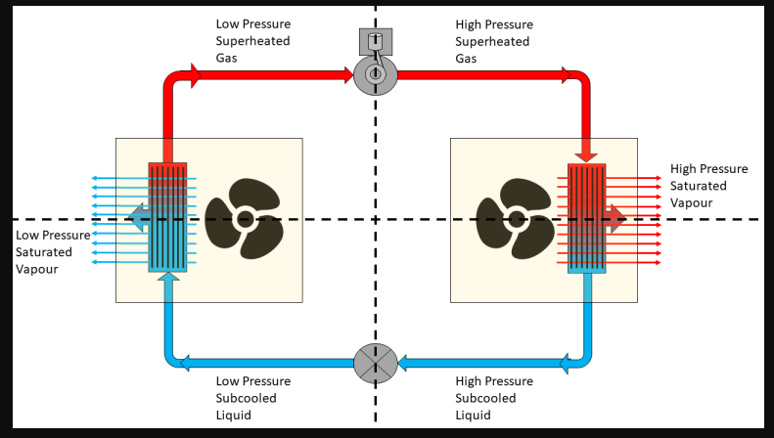

**Methods of refrigeration**

The following are the common methods of refrigeration

* Ice refrigeration
* Dry ice refrigeration
* Steam jet refrigeration
* Throttling refrigeration
* Liquid refrigeration
* Air refrigeration

**Ice refrigeration**

The ice is retained in the refrigerator’s cabinet and serves as a cooling system. Food was refrigerated and preserved using ice. Most ancient cultures, including the Chinese, Greeks, Romans, and Persians, collected snow and ice on a seasonal basis for ages.

Snow and ice were stuffed into tunnels with straw or other insulation, and the Persians kept the ice in a pit. Ice rationing allowed foods to be preserved during hotter temperatures.

Ice has its own cooling properties, with a melting point of 0 °C (32 °F) at sea level. Ice must absorb 333.55 KJ/kg of heat to melt. Foods stored at or around this temperature have a longer shelf life.

**Dry ice refrigeration**

Dry ice (frozen carbon dioxide) is cooled by melting upwards in the non-cyclic refrigeration method. Dry ice refrigeration systems are utilized in laboratories, workshops, and portable coolers for small-scale applications.

At normal atmospheric pressure, solid carbon dioxide has no liquid state and transitions from solid to vapor at temperatures of -78.5 °C (-109.3 °F). It works well for keeping items at low temperatures during the sublimation process. Total loss refrigeration refers to systems in which the refrigerant evaporates and escapes into the atmosphere.

**Steam jet refrigeration**

Steam is fed through a high-efficiency vacuum ejector in this method of refrigeration, and it is ejected into a separate, closed vessel that is part of a cooling water circuit. The water evaporates in the closed vessel due to the partial vacuum, releasing heat through evaporative cooling.

The cooled water is now fed to the air cooler through the cooling circuit, while the evaporated water from the ejector is collected in a separate condenser before being returned to the cooling circuit.

**Join our Newsletter**

Top of Form

Bottom of Form

**Throttling refrigeration**

The refrigeration method is linked to the throttling effect. It’s just the process of lowering the liquid refrigerant’s pressure as it goes through the expansion device. By lowering the pressure, the liquid refrigerant flashes into a vapor, which cools the system.

**Liquid refrigeration**

Liquid nitrogen is useful as an extreme coolant for short overclocking sessions because it boils at -196 °C, much below the freezing point of water. To trap nitrogen and prevent excessive temperature swings, evaporation designs ranging from cut-out heat sinks with pipes linked to copper containers are used.

After the nitrogen has evaporated, however, it must be supplied. In a typical liquid nitrogen cooling installation. On top of the processor or graphics card, copper or aluminum pipes are mounted. Liquid nitrogen is discharged into the pipe after it has been substantially insulated against condensation, resulting in a temperature reduction of 100 degrees Celsius.

**Air refrigeration**

The refrigerant in air refrigeration systems is air, which compresses and expands to provide heating and cooling capability.

One of these is air cycle refrigeration, which offers a good alternative to CFC refrigerants as well as low energy usage and capital costs in certain applications. Refrigeration systems of this type are extensively employed in scientific, industrial, and commercial applications.

**Types of refrigeration**

The followings are the common types of refrigeration:

* Mechanical compression refrigeration
* Evaporative cooling
* Absorption refrigeration
* Thermoelectric refrigeration
* Vapor compression refrigeration
* Vapor absorption refrigeration

**Working principle**

 The working principle of refrigeration is less complex and can be easily understood. A refrigerator is a machine that extracts heat from a body that is at a low temperature and then rejects it to a body that is at a high temperature. A refrigerator is a machine whose primary function is to cool a particular thing.

Heat does not transfer from a low-temperature body to a high-temperature body without the assistance of external labor, according to the second rule of thermodynamics (Clausius statement). As a result, external labor is required to operate a refrigerator.

With the help of an external source, a heat engine can run in a reversible cycle. Heat is absorbed from a cold body and rejected by a hot body in this cycle. As a result, the engine is known as a heat pump. Heat is extracted from the cold body and refused to the hot body in the refrigerator as well. As a result, the refrigerator uses a reversed heat engine cycle.

## ****What is Reversed Carnot Cycle?****

**Reversed Carnot Cycle**is a type of **Refrigeration Cycle** that is exactly opposite (*or reverse*) to the Carnot Cycle. The processes that involved in the Carnot and Reversed Carnot Cycle are same but the procedure and working sequence is different and quite opposite each other.

The Carnot Cycle is used to convert the convert the heat into the mechanical work whereas; the Reversed Carnot Cycle (*or refrigeration system*) is used to absorb the heat from the system and rejects to the surroundings (*or environment*) to maintain the system cool (which we called refrigeration effect).

## ****Processes in Reversed Carnot Cycle:****

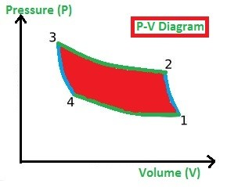

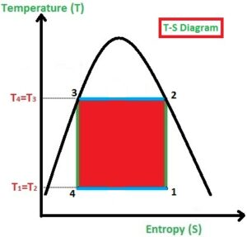

This process is used to build the refrigeration system so the working process is all about achieving the cooling environment in the system or space. As like Carnot Cycle, the Reversed Carnot Cycle too consists of four processes. They are

* Isentropic or Adiabatic Process (1-2)
* Isothermal Compression Process (2-3)
* Isentropic or Adiabatic Expansion Process (3-4)
* Isothermal Expansion Process (4-1)

#### ****Isentropic or Adiabatic Compression Process (1-2):****

In the Isentropic (or adiabatic) Compression process (1-2), the gas is compressed. Due to the compression of gas, the [**pressure**](https://mechanicalbasics.com/fluid-mechanics-hydraulic-machines/)**is** increased highly and **volume**will be decreased slightly (observe the P-V Diagram) and at the same time, the **Entropy** (S) remains constant (which we called as an isentropic process).

#### ****Isothermal Compression Process (2-3):****

In the Isothermal Compression process (2-3), the heat is added at a **constant temperature**. Due to the prolonged compression of gas, the **pressure is** increased slightly and **volume**will be decreased highly (observe the P-V Diagram) and at the same time, the **Temperature**(T) remains constant. (Observe the T-S diagram)

#### ****Isentropic or Adiabatic Expansion Process (3-4):****

In the Isentropic Expansion process (3-4), the **pressure** is decreased highly and **volume** will be increased slightly (observe the P-V Diagram) and at the same time, the **Entropy**(T) remains constant. (Observe the T-S diagram)

#### ****Isothermal Expansion Process (4-1):****

In the Isothermal Expansion process (4-1), the heat is rejected by the gas to the surroundings at a **constant temperature**, the **pressure**is decreased slightly and **volume** will be increased highly (observe the P-V Diagram) and at the same time, the **Temperature**(T) remains constant (Observe the T-S diagram)**.**

## ****COP Of Reversed Carnot Cycle:****

**COP** stands for **Coefficient Of Performance** that is used to estimate the performance of the Cycle. As this is the Refrigeration Cycle, the COP of the cycle is estimated as the ratio of the amount of heat absorbed by the source to the net-work done.

The net work done on the system can be explained as the difference between the heat absorbed by the source and the heat rejected by the source (Here, the source will be the gas that is used in the refrigeration process).

So, the mathematical expression of the COP of the Reversed Carnot Cycle is

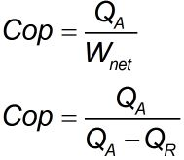

## ****Limitations Of Reversed Carnot Cycle:****

The limitations are the drawbacks of any system or cycle. So, even Reversed Carnot Cycle does consist of Limitations in its way. Let us see the limitations of Reversed Carnot Cycle

* The application of isentropic and isothermal processes back to back is impossible because, in the isentropic process, the pressure increases fastly which requires a **high speed**, and in the isothermal process, the pressure increase slowly which requires **low speed**so, achieving high and slow processes back to back is impossible in real life.
* Another side, the addition, and rejection of heat at constant temperature are impossible because whenever the heat is added to any source, the temperature will be increased usually which is **impossible to restrict**.

So, according to the limitations of Reversed Carnot Cycle, we can conclude that the construction of Reversed Carnot Cycle is **impossible** in real life.

## ****Applications Of Reversed Carnot Cycle:****

The Carnot cycle and Reversed Carnot Cycles are Ideal cycles which means the construction of such cycles in real life is impossible. So, we can say that the **applications of both cycles do not exist**. But we can say that the Reversed Carnot Cycle is an ideal cycle for the Refrigeration System and Effect.

## ****Conclusion:****

The Reversed Carnot Cycle construction is impossible but it is being an ideal cycle for the refrigeration system, the process looks the same like Carnot Cycle but the sequence of applying each process is reversed.

We can say that the heat engine is a system that work done by the system but when it comes to the refrigeration system (or Reversed Carnot Cycle) the work is done on the system. As the cycle is ideal, the coefficient of performance of the refrigeration is also high and it is impossible to achieve by any other process.

**The Vapor Compression Refrigeration Cycle**

The compression refrigeration cycle consists of circulating a liquid refrigerant through four stages of a closed system. As the refrigerant circulates through the system, it is alternately compressed and expanded, changing its state from a liquid to a vapor. As the refrigerant changes state, heat is absorbed and expelled by the system, lowering the temperature of the conditioned space.

[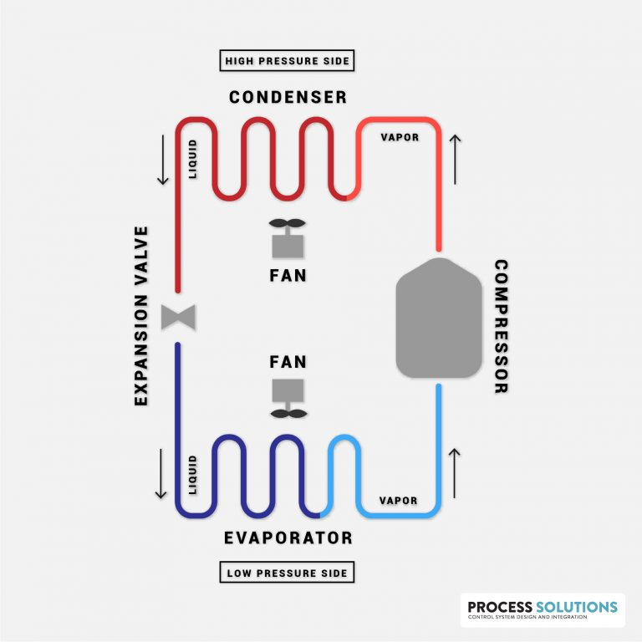](https://processsolutions.com/wp-content/uploads/2020/07/Vapor-Compression-Refrigeration-Cycle.jpg)

**Stage 1: Compression**

In the first stage of the refrigeration cycle, refrigerant enters a compressor as a low-pressure vapor. The compressor compresses the refrigerant to a high-pressure vapor, causing it to become superheated. Once the refrigerant is compressed and heated, it leaves the compressor and enters the next stage of the cycle.

**TIP:**

There are several styles of compressors that can be used in the refrigeration cycle, including scroll, screw, centrifugal, or reciprocating compressors.

**Stage 2: Condensation**

After leaving the compressor, the hot vapor refrigerant enters the next stage of the cycle, condensation. During the condensation stage, the refrigerant enters a condenser and flows through a series of S-shaped tubes. As the hot vapor flows through the condenser, cool air is blown across the tubes by a fan.  
  
Because the air being blown across the tubes is cooler than the refrigerant, heat transfers from the tubing to the cooler air. This heat transfer causes the hot vapor refrigerant to reach its saturated temperature, which then changes its state to a high-pressure liquid. Once the refrigerant is in a high-pressure liquid state, it is ready to leave the condenser and move on to the metering and expansion stage of the cycle.

**Stage 3: Metering and Expansion**

The third stage of how compression refrigeration systems work consists of the high-pressure liquid refrigerant entering a metering device or expansion valve. The metering device works to maintain high-pressure on the inlet side, while also expanding the liquid refrigerant and lowering the pressure on the outlet side. During the process of expansion, the temperature of the liquid refrigerant is also reduced.

**Stage 4: Evaporation**

In a cool, low-pressure liquid state, the refrigerant is now ready to enter the evaporation stage, which is where the heat is finally removed from the space being conditioned.  
  
In the evaporation stage, the cool liquid refrigerant leaves the metering device and enters coiled tubes in an evaporator. Fans are then used to blow warm air from the conditioned space across the evaporator coils. The cooler refrigerant in the evaporator coils begins absorbing the heat out of the warmer air, reducing the temperature in the conditioned space  
  
Meanwhile, as the refrigerant absorbs heat from the air, it begins to boil and changes to a low-pressure vapor. The low-pressure vapor is then pulled back into the compressor, and the cycle starts over.

**About Process Solutions, Inc.**

Located near Seattle, Washington, Process Solutions has over 30 years of experience providing high quality and reliable control systems. With over 100 engineers and technicians on staff and an output of over 3,000 industrial control panels per year, Process Solutions is the Northwest largest control systems integrator. In addition to custom control panel design, build and commissioning, Process Solutions’ control systems services include PLC and HMI programming, robot system integration, energy management and [industrial refrigeration control systems](https://processsolutions.com/airixa/), SCADA software, and DAQuery machine monitoring software.

UNIT OF REFRIGERATION AND COP

The standard unit of refrigeration is ton refrigeration or simply ton denoted by TR. It is equivalent to the rate of heat transfer needed to produce 1 ton (2000 lbs) of ice at 32 0 F from water at 32 0 F in one day, i.e., 24 hours. The enthalpy of solidification of water from and at 32 0 F in British thermal unit is 144 Btu/lb. Thus

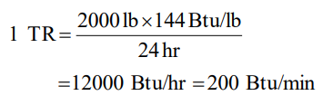

In general, 1 TR means 200 Btu of heat removal per minute. Thus if a refrigeration system is capable of cooling at the rate of 400 Btu/min, it is a 2 ton machine. A machine of 20 ton rating is capable of cooling at a rate of 20 × 200 = 4000 Btu/min. This unit of refrigeration is currently in use in the USA, the UK and India. In many countries, the standard MKS unit of kcal/hr is used. In the MKS it can be seen that

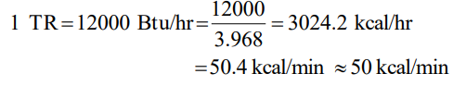

If Btu ton unit is expressed into SI system, it is found to be 210 kJ/min or 3.5 kW. Refrigeration effect is an important term in refrigeration that defines the amount of cooling produced by a system. This cooling is obtained at the expense of some form of energy. Therefore, it is customary to define a term called coefficient of performance (COP) as the ratio of the refrigeration effect to energy input.

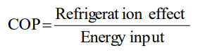

While calculating COP, both refrigeration effect and energy input should be in the same unit.