Student Management System (LMS) - Project Report

Course / Module: Object-Oriented Software Engineering / Application Development
Target Word Count: Under 2,000 Words
Technologies Used: C#, .NET Framework 4.8, Windows Forms, Microsoft SQL Server, ADO.NET

1. Problem Statement (ca. 360 Words)

1.1 The Practical Problem
In many university departments and colleges, day-to-day student administration still relies heavily on paper forms, emails, and disconnected Excel spreadsheets. While spreadsheets work fine when managing twenty or thirty students, they break down rapidly as cohorts grow.

From our analysis of typical departmental workflows, we identified three major recurring issues:
- Scattered and Inconsistent Records: Student data is kept across different offices. For instance, admissions holds student contact info, lecturers keep separate attendance and coursework sheets, and accounts handles tuition payments. If a student changes their contact number or home address, it usually only gets updated on one sheet. This leads to conflicting records and lost communications.
- Manual Workload and Human Errors: At the end of every term, staff spend days copying marks from test papers into spreadsheets, checking attendance registers session by session, and calculating whether students have reached the 80% attendance threshold required to sit exams. It is very easy to miss a mark or mistype a grade during this manual transfer.
- No Student Privacy or Self-Service: Students have no private way to check their standing. To see their grades or attendance rate, they have to email lecturers or queue outside administrative offices. Sometimes, entire class mark sheets are printed on noticeboards or emailed in bulk, exposing every student's grades and registration numbers to their classmates.

1.2 Our Solution
To solve these issues, we built a centralized desktop Student Management System using C# Windows Forms connected to Microsoft SQL Server. The system serves as a single source of truth:
- All core records—students, courses, enrollments, attendance, fees, and grades—are stored in a normalized SQL Server database (StudentDB), removing duplicate files.
- We created a role-based login system: administrators access a complete management dashboard to run day-to-day tasks, while students log into an isolated portal (StudentProfileForm) to view their own profile, active courses, and results.
- The system automatically combines course enrollments, grades, and attendance rates into an instant on-screen report card (ReportCardForm), eliminating manual compilation for staff.

2. Requirements (ca. 370 Words)

2.1 Who the Application is For
The application is built for two main user groups:
- Administrative Staff & Lecturers: University staff who need an easy-to-use desktop interface to register students, assign courses, take attendance, enter grades, and check records without needing to write SQL queries.
- Students: Enrolled learners who need private, on-demand access to view their contact information, check which courses they are registered in, and see their exam grades and attendance status.

2.2 Features Included and Why
Every feature was designed to tackle a specific problem identified in our research:

- Role-Based Login (`LoginForm`, `RegisterForm`): Users log in with a username and password. The system checks their role (Admin vs. Student) and opens the corresponding screen. This prevents students from opening administrative tools or editing records.
- Student Information (`StudentRecordsForm`): Admins can add, update, and search student profiles. We added validation rules to ensure mandatory fields like email, name, and date of birth cannot be saved blank.
- Courses & Enrollment (`CourseManagementForm`, `CourseEnrollmentForm`): Admins create courses with credit values and assign students to them. Instead of long dropdown lists with hundreds of names, we built a search box with auto-complete on Student ID, which makes selecting students fast and avoids enrolling the wrong person.
- Attendance Logging (`AttendanceForm`): Staff mark class attendance (Present, Late, Absent) by date and course, maintaining a clear record for exam eligibility.
- Grading Engine (`GradesForm`): Allows teachers to enter letter grades and feedback comments for enrolled students per subject.
- Fee Records (`FeesForm`): Tracks tuition payments and pending balances so staff can verify financial status.
- Student Profile View (`StudentProfileForm`): When students log in, they immediately see their details, registered courses, and published grades in one place.
- On-Screen Report Card (`ReportCardForm`): Admins can search any Student ID to generate a full report card showing courses, grades, and calculated attendance percentages, with the option to export official report summaries to text files. When opened from a student account, it displays only that student's report and hides both the search bar and export button completely, guaranteeing that students cannot access other people's marks or download unauthorized records.

3. Design (ca. 370 Words + UML Diagrams)

3.1 Architecture
We organized the codebase into a standard 3-Tier Architecture to keep presentation, business models, and database access clean and decoupled.

Figure 1 — System Architecture Diagram

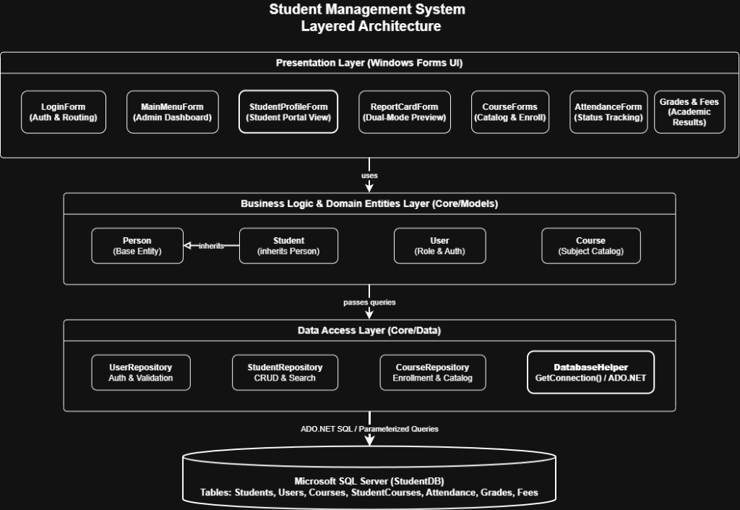
System Architecture Diagram showing the 3-tier layered architecture: Presentation Layer (Windows Forms UI), Business Logic and Domain Entities Layer (Core/Models), Data Access Layer (Core/Data), and Microsoft SQL Server database

- Presentation Layer (`Forms`): Windows Forms containing user controls (TextBox, DataGridView, Button). Forms collect user input, validate required fields, and show feedback messages.
- Business Models (`Core/Models`): Defines real-world entities. We used OOP inheritance: Student inherits common fields (FirstName, LastName, Email, Phone) from a base Person class, adding student-specific properties like RegNumber and EnrollmentDate.
- Data Access Layer (`Core/Data`): Repositories (StudentRepository, CourseRepository) and DatabaseHelper manage ADO.NET connections, parameter binding, and query execution. Forms never hardcode connection strings directly.

📸 SCREENSHOT NEEDED — LoginForm (Figure 2)
Open the application and take a screenshot of the LoginForm screen. Show the split-panel login interface with the username/password fields and the Login button. This demonstrates the entry point and role-based authentication mentioned in Section 2.

📸 SCREENSHOT NEEDED — MainMenuForm / Admin Dashboard (Figure 3)
Log in as an Admin user and screenshot the MainMenuForm. It should show all 8 module buttons (Student Records, Course Management, Course Enrollment, Attendance, Grades, Fees, Student Profile, Student Report Card). This shows the admin's central management hub.

3.2 Process Interaction: Student Login & Report Card
The sequence diagram below shows the flow when a student logs in to check their report card:

Figure 4 — Sequence Diagram: Student Login to Report Card View

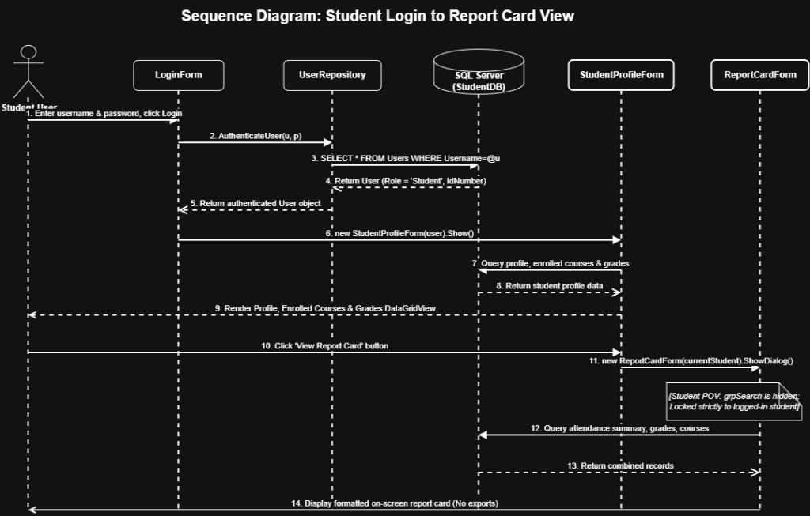
Sequence Diagram showing the full interaction flow: Student enters credentials in LoginForm, UserRepository authenticates against SQL Server, StudentProfileForm loads profile data, student clicks View Report Card, ReportCardForm opens in locked student mode with search hidden

📸 SCREENSHOT NEEDED — StudentProfileForm / Student Portal (Figure 5)
Log in as a Student user and screenshot the StudentProfileForm. Make sure the screenshot shows:
- The student's personal details (name, email, reg number) at the top
- The enrolled courses list
- The grades list
- The "View Report Card" button visible in the header
This demonstrates the student's self-service portal and the starting point of the sequence diagram above.

📸 SCREENSHOT NEEDED — ReportCardForm (Admin View) (Figure 6)
From the Admin dashboard, open Student Report Card. Type a student's registration number in the search box and screenshot the result. Show:
- The search panel at the top with the Student ID input
- The generated on-screen report card below (courses, grades, attendance percentage)
This shows the admin's ability to look up any student's full academic summary.

📸 SCREENSHOT NEEDED — ReportCardForm (Student View) (Figure 7)
From the Student Profile screen, click the "View Report Card" button and screenshot the report card that opens. Notice that:
- The search bar is completely hidden
- The report card is locked to the logged-in student's ID
- The title says the student's name
This proves the privacy feature — students cannot search for other students' records.

3.3 Class Design

Figure 8 — UML Class Diagram

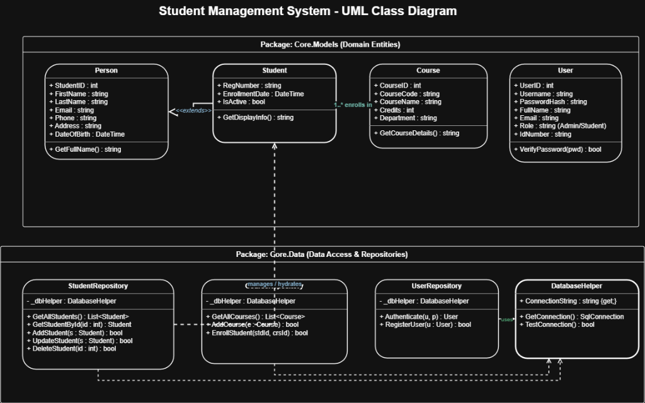
UML Class Diagram showing two packages: Core.Models containing Person (base entity), Student (extends Person), Course, and User classes with their attributes and methods; and Core.Data containing StudentRepository, CourseRepository, UserRepository, and DatabaseHelper with their methods and dependency relationships

Justification: Having Student inherit from Person makes the codebase clean and extensible. If the university introduces a Lecturer role in the future, it can simply inherit from Person without altering existing tables. Centralizing connections in DatabaseHelper means changing database credentials requires editing only one line in App.config.

📸 SCREENSHOT NEEDED — CourseEnrollmentForm or AttendanceForm (Figure 9)
Open either the Course Enrollment or Attendance form and screenshot it while using the auto-suggest search box. Start typing a Student ID and capture the dropdown suggestions appearing. This shows the smart search feature mentioned in Section 2 that replaces slow dropdown lists.

4. Personal Reflection (ca. 370 Words)

4.1 What Worked Well
Working through this project gave me practical, hands-on experience in building a desktop database application from scratch. Several design decisions turned out very successful:

- Using Parameterized SQL Queries: Right from the beginning, we avoided string concatenation for queries. Using SqlCommand.Parameters.AddWithValue() protected the system from SQL injection and prevented crashes caused by student names with apostrophes (e.g., "O'Connor").
- Form Constructor Overloading: Instead of building two separate report card forms for admins and students, we used an overloaded constructor (public ReportCardForm(Student student)). When this constructor is called from the student profile, the form hides the search bar, locks the student ID, and loads their data automatically. This saved time and prevented code duplication.
- Search Auto-Suggest Over Dropdowns: In our early prototypes, selecting students in enrollment and grading was done via simple dropdown lists. Once we loaded dozens of records, scrolling through dropdowns became frustrating and error-prone. Replacing them with an auto-suggest search box based on RegNumber made data entry much faster.

4.2 Challenges and Difficulties
We also encountered several unexpected problems during development:
- Windows Forms DPI Scaling Glitches: When testing on different laptops, we noticed that Windows display scaling (like 125% or 150% on high-resolution screens) clipped buttons and shifted text. For example, our login button text was cut off to "LOGI". We had to adjust button sizes, set AutoScaleMode.Font, and tweak margins to make sure the interface looked right on all screens.
- Database Schema Inconsistencies: Early on, teammates created database tables locally with slight typos (such as naming attendance attenderce or missing the Fees table). This led to runtime exceptions when running someone else's branch. We fixed this by creating a single, clean DatabaseSetup.sql script that sets up all tables properly with primary and foreign keys.
- Git Merge Conflicts on Designer Files: Working on Windows Forms .Designer.cs files in a team caused frequent Git conflicts because Visual Studio re-orders generated code whenever controls are moved.

4.3 Key Lessons Learned
- Use Automated Database Migrations: Managing SQL scripts manually is error-prone. In future projects, I will use an ORM like Entity Framework Core with automatic migrations so everyone's database stays synchronized.
- Modern UI Frameworks: Windows Forms is great for quick desktop tools, but handling responsive scaling is tedious. For future apps, I would choose WPF or a web framework like React.

5. Future Work (ca. 360 Words)

5.1 Further Development
While the current desktop application fulfills all basic LMS operations, it could be expanded in several ways:

- Web and Mobile Access (ASP.NET Core API): The system currently requires installing the desktop app on a Windows PC. By converting the data layer into an ASP.NET Core Web API, we could build a mobile app (using .NET MAUI or Flutter) and a web portal. This would let students check their results and attendance directly from their phones.
- Automated Email and SMS Notifications: Adding an email service (like SendGrid) would allow the system to send automated alerts whenever a student's attendance drops below 80%, or when new exam grades and fee notices are published.
- Dedicated Lecturer Portal: Currently, only admins and students have distinct logins. Adding a dedicated Lecturer role would allow teachers to log in, view only their assigned classes, and record attendance or grades in the lecture hall without needing full administrative privileges.
- QR Code Attendance Scanning: Instead of staff manually ticking attendance boxes, students could scan a dynamic QR code on the lecture screen using their phones, logging their attendance in real time.

5.2 Making the Product Sustainable
To ensure the application remains maintainable and secure over the long term, we would make the following structural improvements:
- Adopt Entity Framework Core: Replacing raw ADO.NET commands with an ORM would make database queries strongly typed, eliminate boilerplate data-mapping code, and simplify writing automated unit tests.
- Automated CI/CD Workflows: Setting up GitHub Actions to automatically build the project and run test suites on every pull request would catch broken code before it is merged into the main branch.
- Secure Password Hashing: While the current system validates passwords, moving to industry-standard salted hashing like BCrypt or Argon2id would bring security up to professional standards.
- Cloud Database Hosting: Migrating from a local SQL instance to Azure SQL Database would provide automatic daily backups, disaster recovery, and reliable access across campus networks.

Screenshot Checklist Summary

Use this checklist to make sure you have all the screenshots before submitting:

Figure # | Form to Screenshot | What to Show
Fig 2 | LoginForm | Split-panel login screen with username/password fields and Login button
Fig 3 | MainMenuForm | All 8 module buttons on the admin dashboard
Fig 5 | StudentProfileForm | Student details, enrolled courses, grades list, and "View Report Card" button
Fig 6 | ReportCardForm (Admin) | Search panel with a Student ID entered, and the generated report card below
Fig 7 | ReportCardForm (Student) | Report card with search bar hidden, locked to the student's own ID
Fig 9 | CourseEnrollmentForm or AttendanceForm | The auto-suggest search dropdown while typing a Student ID

