Expeiment No:01
Roll No: 24141012
Name: Ishwari Gavhane

Title:Binary Search technique using array and recursion.Analyse time and space complexity.

Algorithm:
The program assumes the array is sorted (required for binary search). It uses low, high, and mid pointers to repeatedly divide the array in half.If the middle element matches the key → return its position.If the key is smaller → search the left half, else the right half. If not found after all checks → return -1.

Program:
<1> Binary Search Technique Using Array

#include <stdio.h>
int binarySearch(int arr[], int size, int key) {
int low = 0, high = size - 1, mid;
while (low <= high) {
mid = (low + high) / 2;
if (arr[mid] == key)
return mid;
else if (arr[mid] < key)
low = mid + 1;
else
high = mid - 1;
}
return -1;
}
int main() {
int i;
int arr[100], n, key, result;
printf("Enter number of elements: ");
scanf("%d", &n);
printf("Enter %d elements in sorted order:\n", n);
for (i = 0; i < n; i++)
scanf("%d", &arr[i]);
printf("Enter element to search: ");
scanf("%d", &key);
result = binarySearch(arr, n, key);
if (result != -1)
printf("Element %d found at position %d.\n", key, result + 1);
else
printf("Element %d not found in the array.\n", key);
return 0;
}
Output:
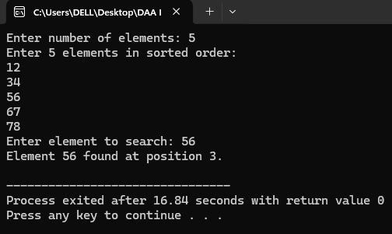

Program:
<2>Binary Search Technique Using Recursion
#include <stdio.h>
int binarySearch(int arr[], int low, int high, int key) {
if (low > high)
return -1;
int mid = (low + high) / 2;
if (arr[mid] == key)
return mid;
else if (arr[mid] > key)
return binarySearch(arr, low, mid - 1, key);
else
return binarySearch(arr, mid + 1, high, key);
}
int main() {
int i;
int arr[100], n, key, result;
printf("Enter number of elements: ");
scanf("%d", &n);
printf("Enter %d elements in sorted order:\n", n);
for ( i = 0; i < n; i++)
scanf("%d", &arr[i]);
printf("Enter element to search: ");
scanf("%d", &key);
result = binarySearch(arr, 0, n - 1, key);
if (result != -1)
printf("Element %d found at position %d.\n", key, result + 1);
else
printf("Element %d not found in the array.\n", key);
return 0;
}
Output:
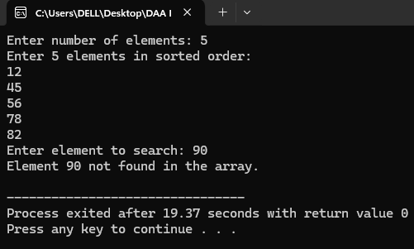

Real World Application:
1. Searching records in databases
2. Dictionary
3. File system indexing
4. Built-in library functions
5. Version control tools
6. Finding square roots or cube roots numerically.
7. Optimization problems
8. E-commerce search

Application Program For E-Commerce Search:

#include <stdio.h>
#include <string.h>
int binarySearch(char arr[][50], int n, char key[50]) {
int low = 0, high = n - 1;
while (low <= high) {
int mid = (low + high) / 2;
int result = strcmp(arr[mid], key);
if (result == 0)
return mid;
else if (result < 0)
low = mid + 1;
else
high = mid - 1;
}
return -1;
}
int main() {
int n,i, index;
char products[100][50], searchItem[50];
printf("Enter number of products: ");
scanf("%d", &n);
getchar();
printf("Enter %d product names in sorted order:\n", n);
for ( i = 0; i < n; i++) {
fgets(products[i], 50, stdin);
products[i][strcspn(products[i], "\n")] = '\0';
}
printf("\nEnter product name to search: ");
fgets(searchItem, 50, stdin);
searchItem[strcspn(searchItem, "\n")] = '\0';
index = binarySearch(products, n, searchItem);
if (index != -1)
printf("\n? Product '%s' found at position %d.\n", searchItem, index + 1);
else
printf("\n? Product '%s' not found in the list.\n", searchItem);
return 0;
}

Output:
