Experiment No:02
Roll No:24141012
Name: Ishwari Gavhane

Title:Quick sort and merge sort using array.Analyse time and space complexity.

Algorithm For Quick Sort:
Quick Sort is a divide-and-conquer sorting algorithm that works by selecting a pivot element from the array, then partitioning the other elements into two subarrays: Elements less than the pivot Elements greater than the pivot Then it recursively sorts the two subarrays.
Choose a pivot elementCommon choices: first element, last element, middle element, or a random element. Partition of a array : Rearrange elements so that: All elements smaller than the pivot are on the left.All elements greater than the pivot are on the right.After partitioning, the pivot is in its correct sorted position.Recursively apply the above steps to: The left subarray (elements less than pivot) The right subarray (elements greater than pivot) Base case: When the subarray has 0 or 1 element → it’s already sorted.
Algorithm For Merge Sort:
Merge Sort is a divide-and-conquer sorting algorithm.
It divides the array into smaller subarrays, sorts them individually, and then merges them back together in a sorted manner. Divide the array into two halves. Recursively sort each half. Merge the two sorted halves into one sorted array.
Program:Quick Sort
#include <stdio.h>
int i,j;
void swap(int *a, int *b) {
int temp = *a;
*a = *b;
*b = temp;
}
int partition(int arr[], int low, int high) {
int pivot = arr[high];
int i = (low - 1);

for ( j = low; j < high; j++) {
if (arr[j] < pivot) {
i++;
swap(&arr[i], &arr[j]);
}
}
swap(&arr[i + 1], &arr[high]);
return (i + 1);
}

void quickSort(int arr[], int low, int high) {
if (low < high) {
int pi = partition(arr, low, high);
quickSort(arr, low, pi - 1);
quickSort(arr, pi + 1, high);
}
}

void display(int arr[], int n) {
for ( i = 0; i < n; i++)
printf("%d ", arr[i]);
printf("\n");
}

int main() {
int n, arr[100];

printf("Enter number of elements: ");
scanf("%d", &n);

printf("Enter %d elements:\n", n);
for ( i = 0; i < n; i++)
scanf("%d", &arr[i]);

printf("\nOriginal array: ");
display(arr, n);

quickSort(arr, 0, n - 1);

printf("Sorted array using Quick Sort: ");
display(arr, n);

return 0;
}
Output:
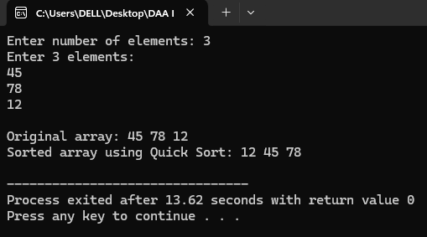
Program:Merge Sort
#include <stdio.h>
int i,j;
void merge(int arr[], int left, int mid, int right) {
int n1 = mid - left + 1;
int n2 = right - mid;

int L[n1], R[n2];

for ( i = 0; i < n1; i++)
L[i] = arr[left + i];
for ( j = 0; j < n2; j++)
R[j] = arr[mid + 1 + j];

int i = 0, j = 0, k = left;

while (i < n1 && j < n2) {
if (L[i] <= R[j])
arr[k++] = L[i++];
else
arr[k++] = R[j++];
}

while (i < n1)
arr[k++] = L[i++];
while (j < n2)
arr[k++] = R[j++];
}

void mergeSort(int arr[], int left, int right) {
if (left < right) {
int mid = (left + right) / 2;

mergeSort(arr, left, mid);
mergeSort(arr, mid + 1, right);

merge(arr, left, mid, right);
}
}

void display(int arr[], int n) {
for ( i = 0; i < n; i++)
printf("%d ", arr[i]);
printf("\n");
}

int main() {
int n, arr[100];

printf("Enter number of elements: ");
scanf("%d", &n);

printf("Enter %d elements:\n", n);
for ( i = 0; i < n; i++)
scanf("%d", &arr[i]);

printf("\nOriginal array: ");
display(arr, n);

mergeSort(arr, 0, n - 1);

printf("Sorted array using Merge Sort: ");
display(arr, n);

return 0;
}

Output:
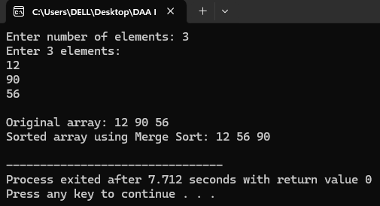
Applications of Quick Sort:
- Databases
2. Search Engines
3. E-commerce Websites
4. Operating Systems
5. Computer Graphics
6. Network Systems
7. Data Analytics Tools
8. Libraries and Programming Languages

Applications of Merge Sort:
1. External Sorting
2. Database Systems Linked Lists Sorting
3. Sorting in Parallel Processing
4. Sorting Log Files
5. Data Analytics and Reporting
6. File Management System
7.E_commerce Websites
8. Genomics and Bioinformatics

Application Program for Search Engines:
#include <stdio.h>
#include <string.h>
typedef struct {
char title[100];
int relevance;
} SearchResult;
void swap(SearchResult *a, SearchResult *b) {
SearchResult temp = *a;
*a = *b;
*b = temp;
}
int j;

int partition(SearchResult arr[], int low, int high) {
int pivot = arr[high].relevance; // pivot = last element
int i = low - 1;

for ( j = low; j < high; j++) {
if (arr[j].relevance > pivot) {
i++;
swap(&arr[i], &arr[j]);
}
}
swap(&arr[i + 1], &arr[high]);
return (i + 1);
}

void quickSort(SearchResult arr[], int low, int high) {
if (low < high) {
int pi = partition(arr, low, high);
quickSort(arr, low, pi - 1);
quickSort(arr, pi + 1, high);
}
}
int i;
void displayResults(SearchResult arr[], int n) {
printf("\nRanked Search Results:\n");
printf("---------------------------\n");
for ( i = 0; i < n; i++) {
printf("%d. %s (Relevance: %d)\n", i + 1, arr[i].title, arr[i].relevance);
}
}

int main() {
int n;

printf("Enter number of search results: ");
scanf("%d", &n);
getchar();

SearchResult results[n];

for (i = 0; i < n; i++) {
printf("Enter title for result %d: ", i + 1);
fgets(results[i].title, 100, stdin);
results[i].title[strcspn(results[i].title, "\n")] = '\0';

printf("Enter relevance score for result %d: ", i + 1);
scanf("%d", &results[i].relevance);
getchar();
}
quickSort(results, 0, n - 1);
displayResults(results, n);

return 0;
}
Output:
