Experiment No:04
Roll No:24141012
Name: Ishwari Gavhane
Title:Greedy method to solve problems of Optimal Merge Pattern
Algorithm:
The Optimal Merge Pattern Problem deals with finding the minimum total cost of merging multiple sorted files (or data lists) into one single sorted file. Given:Several sorted files of different sizes (number of records or pages).The cost of merging two files = sum of their sizes.
Goal:Merge all files into one final file with the least total merging cost.Idea (Greedy Method):Always merge the two smallest files first.Repeat the process until all files are merged into one.This ensures minimum total cost because smaller merges early prevent large additions .
Program:
#include <stdio.h>
#include <limits.h>
int i,j;
void findTwoSmallest(int arr[], int n, int *first, int *second) {
*first = *second = INT_MAX;
int firstIndex = -1, secondIndex = -1;
for ( i = 0; i < n; i++) {
if (arr[i] < *first && arr[i] != -1) {
*second = *first;
*first = arr[i];
secondIndex = firstIndex;
firstIndex = i;
} else if (arr[i] < *second && arr[i] != -1 && i != firstIndex) {
*second = arr[i];
secondIndex = i;
}
}
if (firstIndex != -1) arr[firstIndex] = -1;
if (secondIndex != -1) arr[secondIndex] = -1;
}

int optimalMerge(int files[], int n) {
int totalCost = 0, count = n;
while (count > 1) {
int first, second;
findTwoSmallest(files, n, &first, &second);
int mergeCost = first + second;
totalCost += mergeCost;
for ( i = 0; i < n; i++) {
if (files[i] == -1) {
files[i] = mergeCost;
break;
}
}
count--;
}
return totalCost;
}

int main() {
int n;
printf("Enter number of files: ");
scanf("%d", &n);
int files[n];
printf("Enter sizes of files:\n");
for ( i = 0; i < n; i++) {
scanf("%d", &files[i]);
}
int minCost = optimalMerge(files, n);
printf("\nMinimum total merge cost = %d\n", minCost);
return 0;
}

Output:
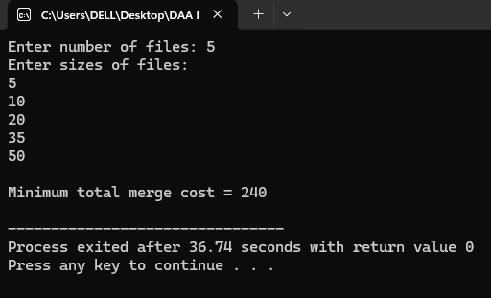
Applications:
1.File Merging in External Sorting
2.Data Compression Algorithms
3.Tape Drive Merg
4.Document or Log Merging
5.Database Query Optimization
6.Cloud Data Synchronization
7.Parallel Computing Task Scheduling
Application Program for Tape Drive Merg
#include <stdio.h>
#include <limits.h>
int i,j;
void findTwoSmallest(int arr[], int n, int *first, int *second) {
*first = *second = INT_MAX;
int firstIndex = -1, secondIndex = -1;
for ( i = 0; i < n; i++) {
if (arr[i] < *first && arr[i] != -1) {
*second = *first;
*first = arr[i];
secondIndex = firstIndex;
firstIndex = i;
} else if (arr[i] < *second && arr[i] != -1 && i != firstIndex) {
*second = arr[i];
secondIndex = i;
}
}
if (firstIndex != -1) arr[firstIndex] = -1;
if (secondIndex != -1) arr[secondIndex] = -1;
}

int optimalMerge(int tapes[], int n) {
int totalCost = 0, count = n;
while (count > 1) {
int first, second;
findTwoSmallest(tapes, n, &first, &second);
int mergeCost = first + second;
totalCost += mergeCost;
for ( i = 0; i < n; i++) {
if (tapes[i] == -1) {
tapes[i] = mergeCost;
break;
}
}
count--;
}
return totalCost;
}

int main() {
int n;
printf("Enter number of tapes: ");
scanf("%d", &n);
int tapes[n];
printf("Enter lengths of tapes:\n");
for ( i = 0; i < n; i++) {
scanf("%d", &tapes[i]);
}
int minCost = optimalMerge(tapes, n);
printf("\nMinimum total merge cost = %d\n", minCost);
return 0;
}

Output:
