Experiment No:05
Roll No:24141012
Name:Ishwari Gavhane
Title:Minimum cost spanning tree of a given undirected graph using prims algorithm and kruskals algorithm and compare.
Algorithm Of Prims Algorithm:
Prim’s algorithm grows the MST starting from a single vertex and keeps adding the cheapest edge that connects a vertex in the MST to a vertex outside it.Steps (Conceptually):Start with any vertex as the MST (initially only one vertex).Find the edge with the minimum weight that connects a vertex in the MST to a vertex outside the MST.Add that edge and the connected vertex to the MST.Repeat step 2 until all vertices are included in the MST.Key Idea:Builds MST vertex by vertex.Always adds the nearest vertex to the growing MST.
Algorithm Of Kruskals Algorithm:
Kruskal’s algorithm builds the MST by sorting all edges by weight and adding them one by one, but only if they don’t form a cycle.
Steps (Conceptually):Sort all edges in the graph in ascending order of weight.Take the smallest edge.If adding it doesn’t form a cycle, include it in the MST.If it forms a cycle, skip it.Repeat step 2 until the MST has V-1 edges (where V = number of vertices).Key Idea:Builds MST edge by edge.Avoids cycles using a disjoint-set (union-find) structure.
Program of prims algorithm:
#include <stdio.h>
#define INF 9999
#define V 5
int v,i,count;
int minKey(int key[], int mstSet[]) {
int min = INF, min_index;
for ( v = 0; v < V; v++)
if (mstSet[v] == 0 && key[v] < min)
min = key[v], min_index = v;
return min_index;
}

int main() {
int graph[V][V] = {
{0, 2, 0, 6, 0},
{2, 0, 3, 8, 5},
{0, 3, 0, 0, 7},
{6, 8, 0, 0, 9},
{0, 5, 7, 9, 0}
};
int parent[V], key[V], mstSet[V];
for ( i = 0; i < V; i++) key[i] = INF, mstSet[i] = 0;
key[0] = 0;
parent[0] = -1;
for ( count = 0; count < V - 1; count++) {
int u = minKey(key, mstSet);
mstSet[u] = 1;
for ( v = 0; v < V; v++)
if (graph[u][v] && mstSet[v] == 0 && graph[u][v] < key[v])
parent[v] = u, key[v] = graph[u][v];
}
for ( i = 1; i < V; i++)
printf("%d - %d\n", parent[i], i);
return 0;
}

Output:
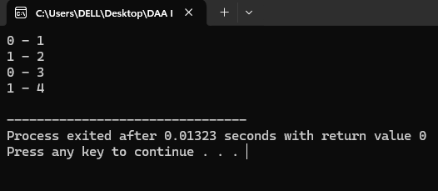
Program of Kruskals algorithm:
#include <stdio.h>
#include <stdlib.h>

typedef struct {
int u, v, w;
} Edge;

int cmp(const void *a, const void *b) {
return ((Edge*)a)->w - ((Edge*)b)->w;
}

int find(int parent[], int i) {
if (parent[i] == i) return i;
return parent[i] = find(parent, parent[i]);
}

void unionSet(int parent[], int rank[], int x, int y) {
int xroot = find(parent, x);
int yroot = find(parent, y);
if (rank[xroot] < rank[yroot]) parent[xroot] = yroot;
else if (rank[xroot] > rank[yroot]) parent[yroot] = xroot;
else parent[yroot] = xroot, rank[xroot]++;
}
int i;
int main() {
int V = 4, E = 5;
Edge edges[] = {{0,1,10},{0,2,6},{0,3,5},{1,3,15},{2,3,4}};
qsort(edges, E, sizeof(edges[0]), cmp);
int parent[V], rank[V];
for ( i=0;i<V;i++) parent[i]=i, rank[i]=0;
for ( i=0;i<E;i++) {
int x = find(parent, edges[i].u);
int y = find(parent, edges[i].v);
if (x != y) {
printf("%d - %d\n", edges[i].u, edges[i].v);
unionSet(parent, rank, x, y);
}
}
return 0;
}

Output:
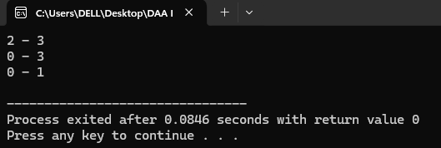
Applications:
- Telecommunication Network
- Computer Networks
- Electrical Grid Design
- Water Supply Networks
- Road/Railway planning
- Pipeline Networks
- Clustering in data mining
- Image segmentation
Application Program for Image Segmentation:
#include <stdio.h>
#include <stdlib.h>
#include <math.h>

#define WIDTH 5
#define HEIGHT 5
#define INF 9999

typedef struct {
int u;
int v;
double w;
} Edge;

int parent[WIDTH*HEIGHT];

int find(int x) {
if(parent[x] == x) return x;
return parent[x] = find(parent[x]);
}

void unionSet(int x, int y) {
int px = find(x);
int py = find(y);
if(px != py) parent[px] = py;
}

int main() {
int image[HEIGHT][WIDTH] = {
{10, 12, 11, 50, 52},
{11, 13, 12, 51, 53},
{10, 12, 11, 50, 52},
{200, 202, 201, 250, 252},
{201, 203, 202, 251, 253}
};

int numPixels = WIDTH*HEIGHT;
Edge edges[2*numPixels];
int eCount = 0;

for(int i=0;i<HEIGHT;i++) {
for(int j=0;j<WIDTH;j++) {
int idx = i*WIDTH + j;
parent[idx] = idx;
if(i+1<HEIGHT) {
edges[eCount].u = idx;
edges[eCount].v = (i+1)*WIDTH + j;
edges[eCount].w = fabs(image[i][j] - image[i+1][j]);
eCount++;
}
if(j+1<WIDTH) {
edges[eCount].u = idx;
edges[eCount].v = i*WIDTH + (j+1);
edges[eCount].w = fabs(image[i][j] - image[i][j+1]);
eCount++;
}
}
}

for(int i=0;i<eCount-1;i++)
for(int j=i+1;j<eCount;j++)
if(edges[i].w > edges[j].w) {
Edge temp = edges[i];
edges[i] = edges[j];
edges[j] = temp;
}

double threshold = 20.0;
for(int i=0;i<eCount;i++) {
if(edges[i].w < threshold) {
int uRoot = find(edges[i].u);
int vRoot = find(edges[i].v);
if(uRoot != vRoot)
unionSet(uRoot, vRoot);
}
}

int label = 1;
int labels[numPixels];
for(int i=0;i<numPixels;i++) {
if(parent[i] == i) labels[i] = label++;
}
printf("Segmented Image Labels:\n");
for(int i=0;i<HEIGHT;i++) {
for(int j=0;j<WIDTH;j++) {
int idx = i*WIDTH + j;
printf("%d\t", labels[find(idx)]);
}
printf("\n");
}

return 0;
}

Output:
