Experiment No:06
Roll No:24141012
Name:Ishwari Gavhane
Title:Shortest path to other vertices using Dijkstras algorithm from a given vertex in a weighted connected graph.
Algorithm:
Dijkstra’s algorithm finds the shortest path from a single source vertex to all other vertices in a weighted, connected graph with non-negative edge weights.It is a greedy algorithm: at each step, it chooses the vertex with the smallest known distance from the source that has not been processed yet.Once a vertex is processed, the shortest distance to it is final.The algorithm updates the distances of adjacent vertices to reflect shorter paths if found.
Program:
#include <stdio.h>
#include <limits.h>

#define V 5
int v,i,count;
int minDistance(int dist[], int sptSet[]) {
int min = INT_MAX, min_index;
for ( v = 0; v < V; v++)
if (!sptSet[v] && dist[v] <= min)
min = dist[v], min_index = v;
return min_index;
}

void dijkstra(int graph[V][V], int src) {
int dist[V], sptSet[V];
for ( i = 0; i < V; i++) dist[i] = INT_MAX, sptSet[i] = 0;
dist[src] = 0;

for ( count = 0; count < V - 1; count++) {
int u = minDistance(dist, sptSet);
sptSet[u] = 1;
for (v = 0; v < V; v++)
if (!sptSet[v] && graph[u][v] && dist[u] != INT_MAX
&& dist[u] + graph[u][v] < dist[v])
dist[v] = dist[u] + graph[u][v];
}

printf("Vertex\tDistance from Source %d\n", src);
for ( i = 0; i < V; i++)
printf("%d\t%d\n", i, dist[i]);
}

int main() {
int graph[V][V] = {
{0, 10, 0, 5, 0},
{0, 0, 1, 2, 0},
{0, 0, 0, 0, 4},
{0, 3, 9, 0, 2},
{7, 0, 6, 0, 0}
};

int source = 0;
dijkstra(graph, source);

return 0;
}

Output:
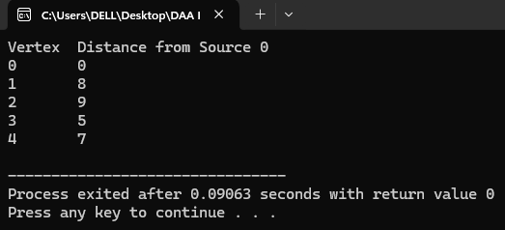
Applications:
1.Routing in Networks
2.GPS and Navigation Systems
3.Telecommunication Networks
4.Traffic Engineering
5.Robotics and Path Planning

Application program of Telecommunication Networks:
#include <stdio.h>
#include <limits.h>

#define V 6
int i,v,count;
int minDistance(int dist[], int sptSet[]) {
int min = INT_MAX, min_index;
for (v = 0; v < V; v++)
if (!sptSet[v] && dist[v] <= min)
min = dist[v], min_index = v;
return min_index;
}

void dijkstra(int graph[V][V], int src) {
int dist[V], sptSet[V];
for ( i = 0; i < V; i++) dist[i] = INT_MAX, sptSet[i] = 0;
dist[src] = 0;

for ( count = 0; count < V - 1; count++) {
int u = minDistance(dist, sptSet);
sptSet[u] = 1;
for ( v = 0; v < V; v++)
if (!sptSet[v] && graph[u][v] && dist[u] != INT_MAX
&& dist[u] + graph[u][v] < dist[v])
dist[v] = dist[u] + graph[u][v];
}

printf("Telecommunication Network: Shortest distances from Node %d\n", src);
for ( i = 0; i < V; i++)
printf("Node %d -> Node %d : %d\n", src, i, dist[i]);
}

int main() {
int network[V][V] = {
{0, 10, 0, 0, 15, 0},
{10, 0, 12, 0, 0, 15},
{0, 12, 0, 22, 0, 1},
{0, 0, 22, 0, 3, 0},
{15, 0, 0, 3, 0, 5},
{0, 15, 1, 0, 5, 0}
};

int sourceNode = 0;
dijkstra(network, sourceNode);

return 0;
}
Output:
