Baseline Reference Scenario - Prepared in R Studio

Carbon Counters

3/18/2021

## Code Setup

# Attach packages  
library(tidyverse)  
library(tidyr)  
library(here)  
library(janitor)  
library(plotly)  
library(kableExtra)  
library(effsize)  
library(stargazer)  
library(broom)  
library(plotly)  
  
# Read in data files and clean up, created in carbon inventory script. These files contain # of acres of each ag class according to calag (excludes landfire).   
  
ag_12 <- read_csv(here::here("results", "ag_final_12.csv")) %>%   
 dplyr::select(! c(pixels, sqmeter))  
ag_16 <- read_csv(here::here("results", "ag_final_16.csv")) %>%   
 dplyr::select(! c(pixels, sqmeter))  
ag_19 <- read_csv(here::here("results", "ag_final_19.csv")) %>%   
 dplyr::select(! c(pixels, sqmeter))  
  
# change column names  
colnames <- c("class", "acres","abvgc", "soilc", "noemit", "net", "year")  
colnames(ag_12) = colnames  
colnames(ag_16) = colnames  
colnames(ag_19) = colnames  
  
#Add in rangeland values from cal ag  
  
# First, use carbon inventory to get average carbon values per acre  
inventory <- read_csv(here("results", "inventory_16.csv")) %>%   
 clean_names  
  
# crop report #s https://countyofsb.org/agcomm/cropReportArchive.sbc  
  
range_acre_19 <- 573678  
range_acre_12 <- 584125  
range_acre_16 <- 586047  
  
# assign total # of grassland acres from carbon inventory, then subtract from rangeland acreage to get shrubland weight  
range_grass <- 239987.991  
range_shrub <- range_acre_16 - range_grass  
range_weights <- c(range_grass, range_shrub)  
  
# get average aboveground and soil carbon storage per acre of grassland and shrubland  
shrub_grass <- inventory %>%   
 filter(landcover_classification %in% c("Grassland","Shrubland")) %>%   
 mutate(soil_avg = total_soil_carbon_mt_c/acres) %>%   
 mutate(abvg_avg = total_aboveground_carbon_mt_c/acres)  
  
# calculate average aboveground and soil carbon for rangeland  
avg_soil_rangel <- weighted.mean(shrub_grass$soil_avg, range_weights)  
avg_abvg_rangel <- weighted.mean(shrub_grass$abvg_avg, range_weights)  
  
# prepare rows to add to ag inventories  
range_data <- data.frame(class = "Rangeland", "acres" = c(range_acre_12, range_acre_16, range_acre_19), "abvgc" = 0, "soilc" = 0, "noemit" = 0, "net" = 0, "year" = c(2012, 2016, 2019)) %>%   
 mutate(abvgc = avg_abvg_rangel*acres) %>%   
 mutate(soilc = avg_soil_rangel*acres) %>%   
 mutate(net = abvgc+soilc)  
  
# make combined dataframe to make calculations easier  
  
all_ag_df <- rbind(ag_12, ag_16) %>%   
 rbind(ag_19) %>%   
 rbind(range_data) %>%   
 filter(class != "Total")   
  
# calculate per acre storage and nitrous oxide emissions  
best_at <- all_ag_df %>%   
 filter(year == 2016) %>%  
 mutate(best_abvg = (abvgc/acres)) %>%  
 mutate(best_soil = (soilc/acres)) %>%  
 mutate(best_overall = ((abvgc+soilc)/acres)) %>%  
 mutate(worst_n2o = (noemit/acres))  
  
# wide format dataframe  
all_ag_df_wide <- all_ag_df %>%   
 pivot_wider(names_from = class,  
 values_from = c(acres, abvgc, soilc, noemit, net)) %>%   
 clean_names()

## Run linear regressions

## First, we'll make a data frame of years out to 2030  
   
predict_df_30_acres <- data.frame(year = c(2012, 2016, 2019, 2030))  
  
# Next we will build models to fit a linear regression to each crop category along with total ag acreage  
  
select_ag <- all_ag_df_wide %>%   
 dplyr::select(2:41)  
  
ag_names <- colnames(select_ag)  
  
res_list_plots <- vector("list", length = length(ag_names)) %>%   
 setNames(ag_names)  
  
# first, linear regressions  
  
fx_lm <- function(name) {  
  
 lm_loop <- lm(all_ag_df_wide[[name]] ~ year, data = all_ag_df_wide)  
   
}  
  
all_lms <- lapply(ag_names, fx_lm) %>%   
 setNames(ag_names)  
  
all_lms[[1]] # cool

##   
## Call:  
## lm(formula = all_ag_df_wide[[name]] ~ year, data = all_ag_df_wide)  
##   
## Coefficients:  
## (Intercept) year   
## -1700970.1 845.7

# Now we will use these models to predict acreage (total and per crop type) in 2030  
  
fx_predict <- function(lm) {  
   
 predict_run_loop <- predict(lm, newdata = predict_df_30_acres)  
 predict_df_loop <- data.frame(predict_df_30_acres, predict_run_loop)  
 predict_df_loop <- predict_df_loop  
   
}  
  
looped_predict_dfs <- lapply(all_lms, fx_predict) %>%   
 setNames(ag_names)  
  
looped_predict_dfs[[1]] # great

## year predict_run_loop  
## 1 2012 611.5671  
## 2 2016 3994.4333  
## 3 2019 6531.5830  
## 4 2030 15834.4650

# These plots compare real data to the regression  
  
for (name in ag_names) {  
 plot <- print(ggplot() +   
 geom_point(data = all_ag_df_wide, aes(x = year, y = all_ag_df_wide[[name]])) +  
 geom_line(data = looped_predict_dfs[[name]], aes(x = year, y = predict_run_loop)) +  
 theme_minimal() +   
 labs(x = "year",  
 y = paste(name)))  
   
}

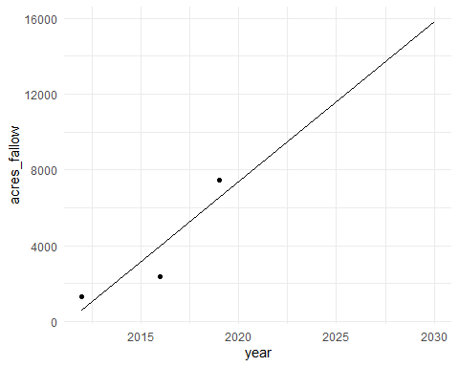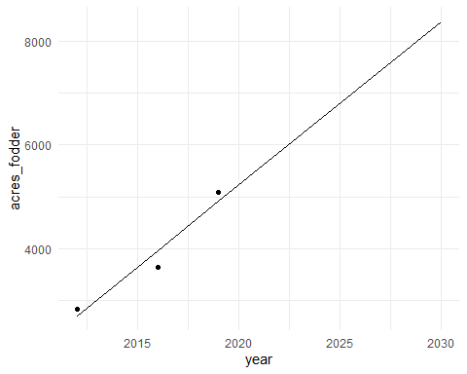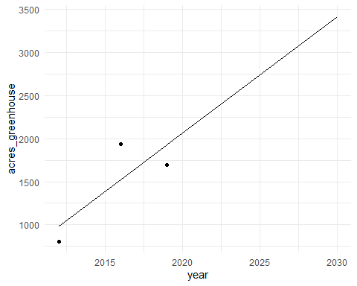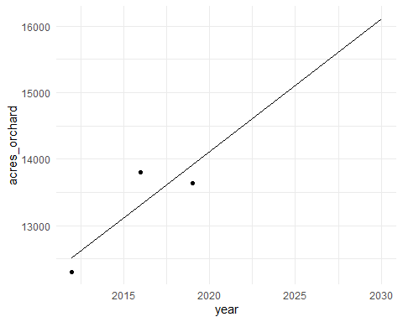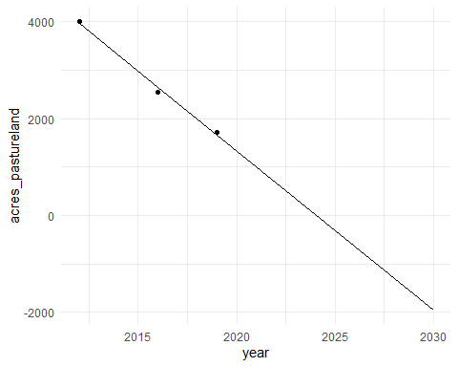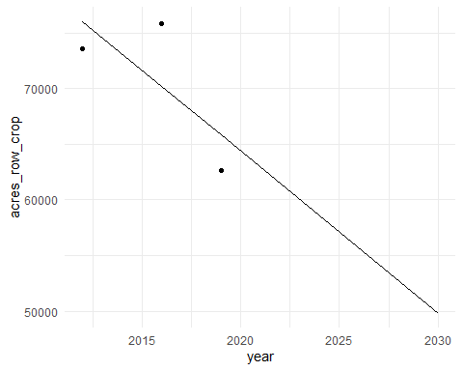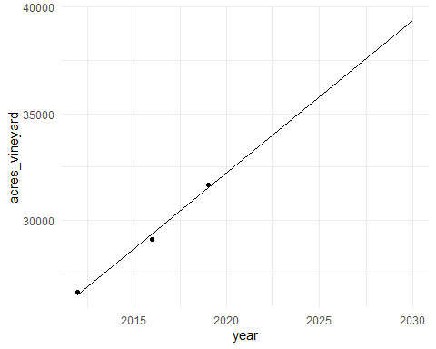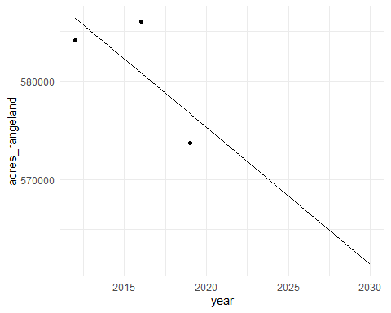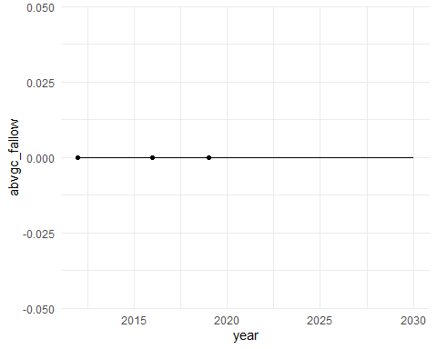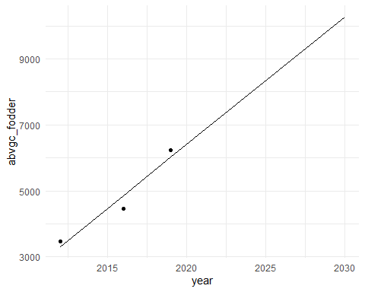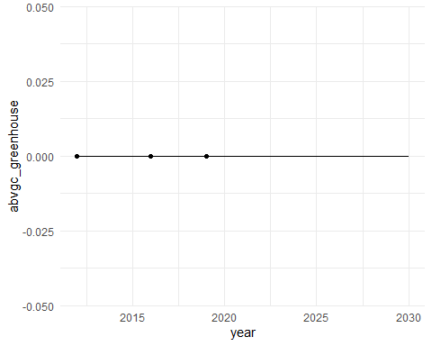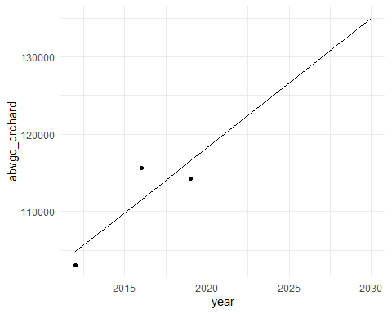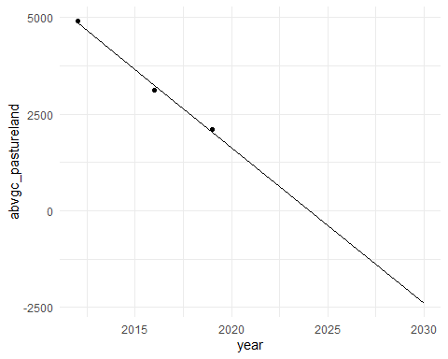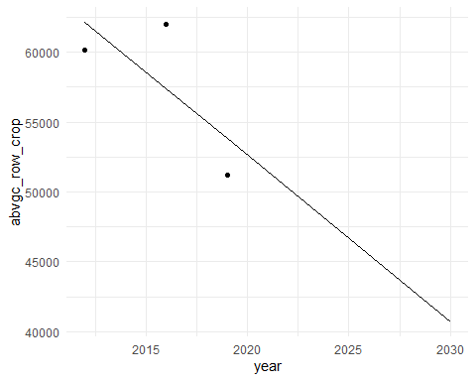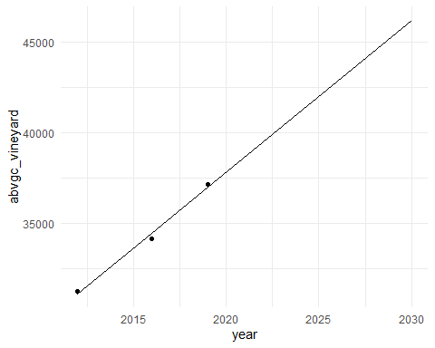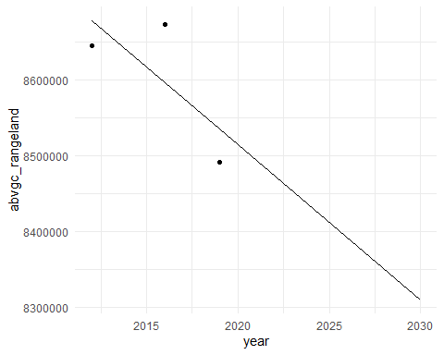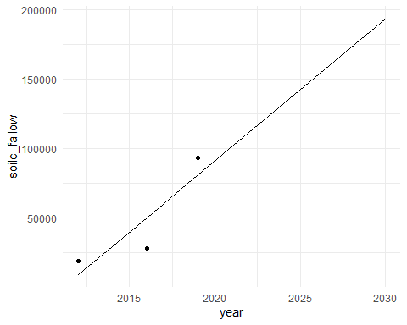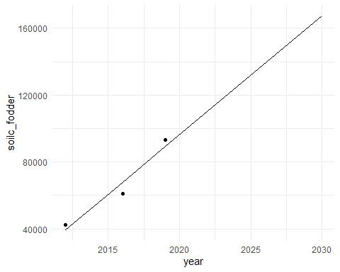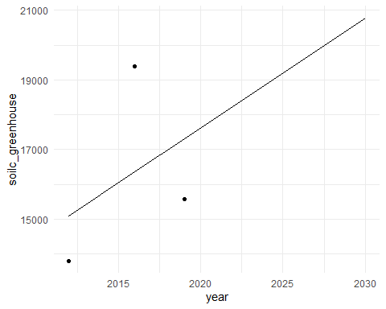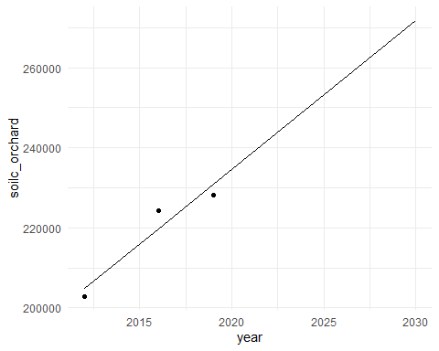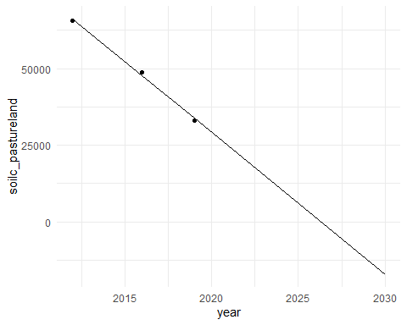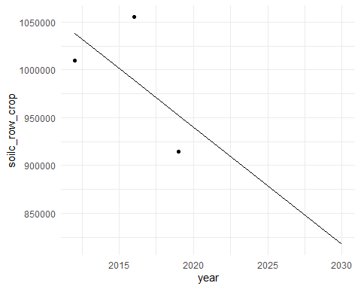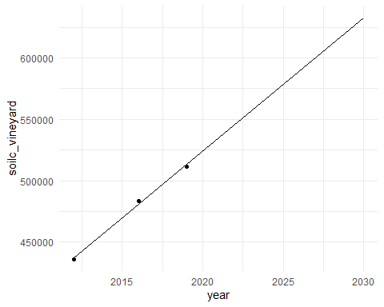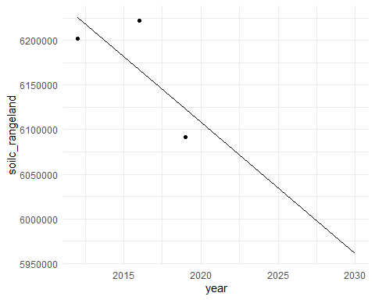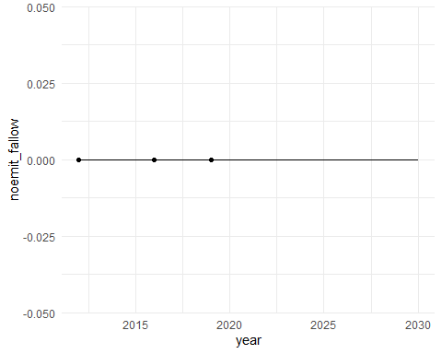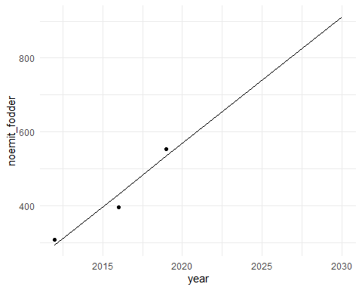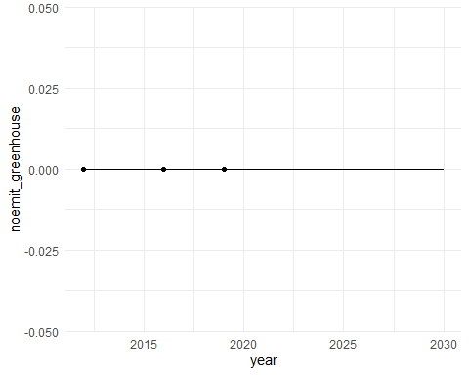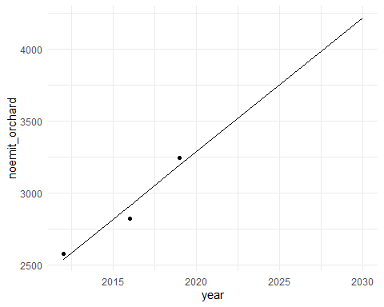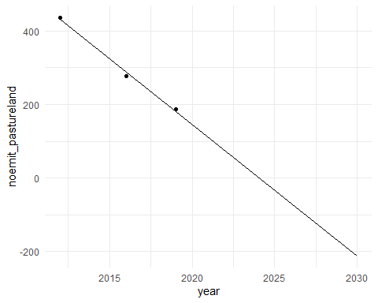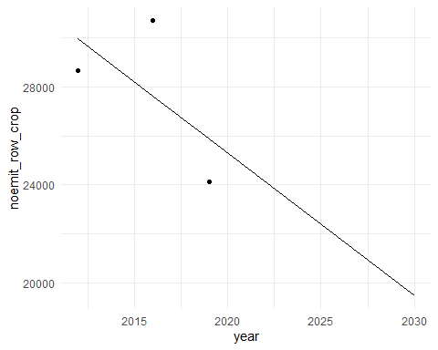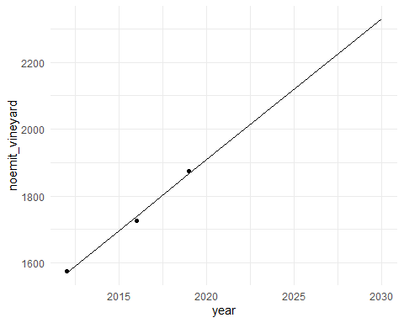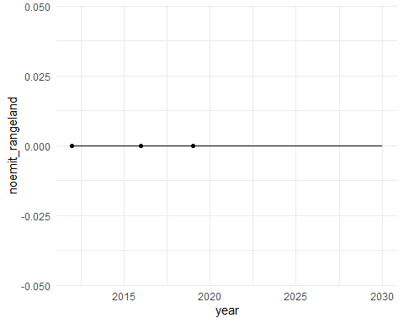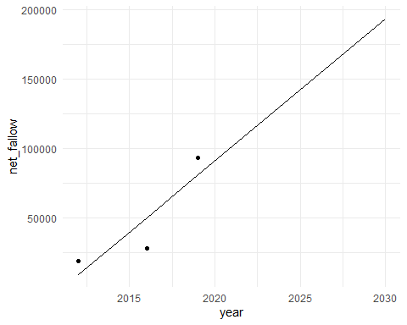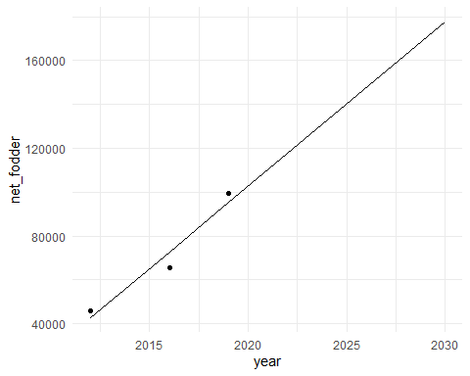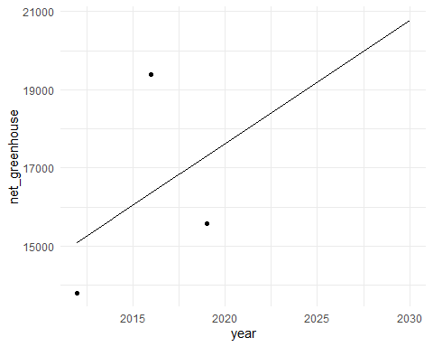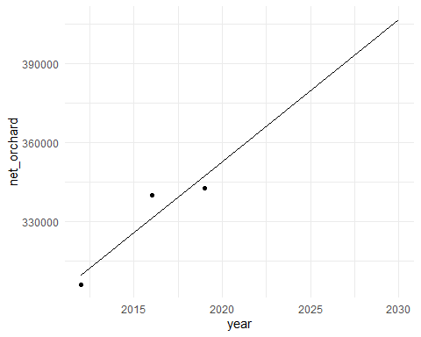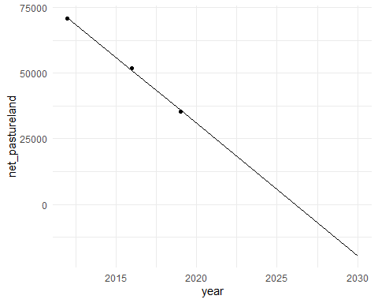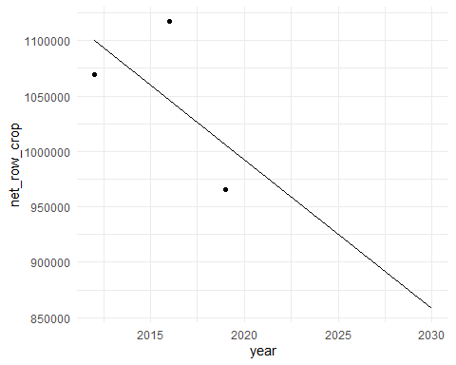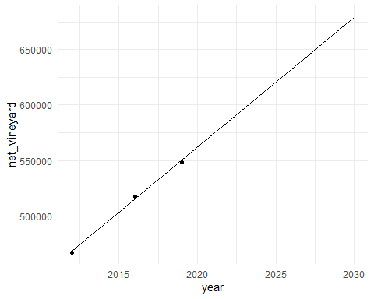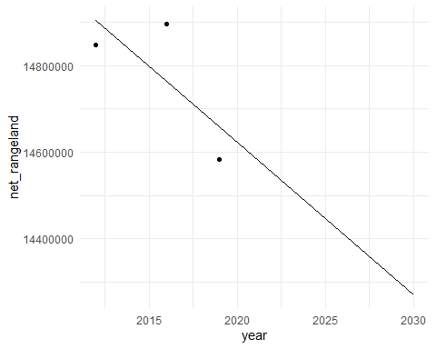

## Clean and prepare results for use

#create big dataframe of all predicted values (same units), easier for doing visualizations  
  
#first, change column names  
for(name in ag_names){  
   
 colnames(looped_predict_dfs[[name]]) <- c("year", name)  
   
}  
  
# merge dataframes, common column = year  
all_predict_df<- looped_predict_dfs %>%   
 reduce(full_join, by = "year")  
  
# make this dataframe tidy  
tidy_predict_df <- all_predict_df %>%   
 pivot_longer(!year,  
 names_to = c("variable", "land_class"),  
 names_sep = "_",  
 values_to = "value")  
  
# add totals  
totals_predict <- tidy_predict_df %>%   
 group_by(variable, year) %>%   
 summarise(value = sum(value)) %>%   
 mutate(land_class = "total_allclasses") %>%   
 relocate(year, variable, land_class, value)  
  
# put it together  
final_predict_df <- bind_rows(tidy_predict_df, totals_predict)  
  
# do the same for observed values  
  
tidy_observed <- all_ag_df %>%   
 pivot_longer(cols = 2:6,  
 names_to = "variable",  
 values_to = "value") %>%   
 rename(land_class = class) %>%   
 relocate(year, variable, land_class, value)  
  
totals_observed <- tidy_observed %>%   
 group_by(variable, year) %>%   
 summarise(value = sum(value)) %>%   
 mutate(land_class = "total_allclasses") %>%   
 relocate(year, variable, land_class, value)  
  
final_observed_df <- bind_rows(tidy_observed, totals_observed)