Display repetitions do not improve search efficiency in parallel search tasks

Gavin Jun Peng Ng, Simona Buetti, Dolcos Sanda, Dolcos Florin, & Alejandro Lleras

TODO:

* CITE
* Fill in XXX
* Effect sizes
* Figure and table captions
* Better figures (?)

**Introduction**

Contextual cueing is a phenomenon in visual search tasks whereby response times are faster in displays where contextual information is repeated compared to novel displays. As the name suggests, there are two elements in contextual cueing. *Context* refers to information that co-occurs with the target, such as the spatial layout (CITE), identity (CITE), or motion trajectory (CITE) of the stimuli in the search display. *Cueing* refers to the guidance of attention due to top-down influences. Contextual cueing thus refers to situations in which attention is guided by top-down influences from the contextual information that has been learned (CITE). Typically, the context is the spatial layout of the stimuli in the search display (e.g. CITE). In these experiments, half of the search displays would be repeated (i.e. the spatial layout of the search stimuli remains identical throughout the experiment), while the other half would be novel (i.e. the spatial layout is randomly generated each time). Response times to the repeated displays are observed to be faster than that to the novel displays, suggesting that observers (implicitly) learned the context which allowed their attention to be rapidly cued to the target location.

Given that contextual cueing effects arise due to selective attention, it is no surprise that selective attention is necessary for the development of contextual cueing (Jiang & Chun, 2001 CITE). In a series of experiments, observers were tasked to search for a target with a pre-defined color among distractors of the same color (“candidates”) or a very different color (“lures”)[1]. When the spatial layout of the candidates was repeated and that of the distractors was random, contextual cueing was observed even though only half the context was repeated. Furthermore, in the reverse scenario when the spatial layout of the candidates was random and that of the lures were repeated, the contextual cueing effect was abolished. Chun and Jiang (CITE 2003 book) thus argued that contextual cueing is dependent on selective attention. Importantly, they argue that the attentional process in these tasks with both candidates and lures is markedly different in the standard contextual cueing paradigm where all distractors are candidates. They argue that in candidate-only displays, candidates are first attended to by selective attention before being rejected (e.g. Duncan & Humphreys, 1989; Treisman & Sato, 1990; Book CITE). On the other hand, in mixed displays, lures are first filtered by a preattentive process (e.g. Palmer, 1995) since they differ from the target on at least one salient feature (CITE Book). Selective attention then evaluates and rejects the candidates. This process of selection and rejection, which does not take place for lures, is proposed to be the locus of the contextual cueing effect.

However, there is recent evidence that the rejection of lures is not a preattentive process of filtering, but instead an active process of rejection (CITE). The Contrast Signal Theory, like most theories of search (e.g. CITE), proposes that visual search is a two-stage process. It first begins with a parallel accumulation of evidence at all locations across the display. This evidence is a contrast signal between each location and the target template, and evidence is accumulated toward a ‘non-target’ threshold. Locations that reach this threshold are rejected in the first stage; these items will not be selected by attention for further processing. This evidence accumulation process occurs in parallel and is stochastic, and results in a logarithmic increase in response times as a function of set size (CITE Buetti and Townsend etc.). Note that this is in contrast to a preattentive filtering process as suggested by Jiang and Chun (CITE), which is associated with no meaningful increase in response times as a function of set size (CITE). This first stage ends when a certain period of time has passed without any accumulators reaching threshold, and the output is a list of locations that require attentional scrutiny. Attention and/or eye movements are then directed to these locations in the second stage. In sum, according to Contrast Signal Theory, lures do not get filtered out en masse by a preattentive process (e.g. CITE). Rather, all items in a search display, including lures, are processed in parallel in the first stage of visual search.

It is unclear what the fate of these lures, that are rejected in the first stage, is with regard to contextual cueing. On the one hand, since they undergo an active process of evidence accumulation, they might be implicitly learned and form the context for contextual cueing. On the other, since they are discarded from further processing after reaching threshold, they might not contribute to contextual cueing. In the present study, we examined the contextual effect in mixed displays with both candidates and lures, and in lure-only displays. We first present the response time analyses of the contextual cueing effect from all three experiments before presenting the analyses regarding awareness of the repeated displays.

**Experiment 1**

The main aim of the study was to examine the effect of lures on contextual cueing. To do that, we required a large range of set sizes in order to observe the logarithmic slope (if any) that would reflect the evidence accumulation process (see Buetti et al., 2016 for details CITE). Thus, in the first experiment we sought to examine the contextual cueing effect at small set sizes, using the standard paradigm, to determine the feasibility of using smaller set sizes in order to prevent crowding of the display when lures were added in the subsequent experiment.

**Methods**

**Participants**

All participants were recruited from the subject pool from the University of Illinois at Urbana-Champaign. Participants were given course credit for taking part in the experiment. All participants were tested with the Ishihara color plates (CITE) and determined to be non-colorblind. All participants also had normal or corrected-to-normal vision. We aimed to collect 20 participants per experiment.

**Stimuli and apparatus**

The target was a red letter T that was rotated 90 degrees either clockwise or anti-clockwise. Participants had to respond to the target orientation. The distractor stimuli were red letter ‘L’s rotated either 0, 90, 190, or 270 degrees clockwise. The experiment was programmed and ran in MATLAB using the Psychophysics Toolbox (CITE).

In each search display, the stimuli were distributed across a 6-by-6 grid. This grid subtended xxx degrees of visual angle horizontally and xxx degrees vertically. There was a total of 12 displays (six for set size 4 and six for set size 8) that were repeated throughout the entire experiment. Each of these 12 repeated displays had unique target locations. A separate set of 12 target locations, which did not overlap with those in the repeated displays, was randomly selected and served as the target locations for the novel displays. This was done to equate target location probability between the repeated and novel displays. The novel displays were never repeated and were checked against the repeated displays to ensure that there were also no repeats. All stimuli were presented against a 1024 x 768 pixel black background on a 22-inch (400mm x 300mm) cathode ray tube monitor with a refresh rate of 85Hz. Participants viewed the display, unrestrained, from a distance of approximately 59cm.

**Design and procedure**

There were two within-subject independent variables: display type (repeat or novel) and set size (4 or 8). Participants viewed 25 blocks of 24 trials each, for a total of 600 trials. In each block, half the trials were repeated while the other half was novel. Within the repeated and novel trials, half were set size 4 while the other were set size 8. There was thus a total of 4 cells, with 150 trials in each cell. Trial order was randomized.

Before the start of the experiment, participants were presented with the following instructions:

*The best strategy for this task, and the one that we want you to use in this study, is to be as receptive as possible and let the unique item "pop" into your mind as you look at the screen. The idea is to let the display and your intuition determine your response. Sometimes people find it difficult or strange to tune into their “gut feelings”, but we would like you to try your best. Try to respond as quickly and accurately as you can while using this strategy. Remember, it is very critical for this experiment that you let the unique item just ‘pop’ into your mind.*

These instructions were obtained from CITE. Passive search has been shown to increase the magnitude of contextual cueing.

The experiment began with a block of six practice trials to familiarize the participant with the experiment and to emphasize the passive instructions. Recording of experimental data began after the practice block after the participant acknowledged that they were ready to begin by pressing the left or right arrow key. Each trial began with a fixation cross that lasted 1000ms, after which the search display appeared. Participants had 5 seconds to respond to the identity of the target by pressing the left arrow when the T was rotated to the left (90 degrees anti-clockwise), or the right arrow when the T was rotated to the right (90 degrees clockwise). A loud beep was provided when an incorrect response was made or when no response was made after 5 seconds; no feedback was provided for correct responses. Each trial terminated when a response was made, or when 5 seconds passed without any response. A blank screen was then presented for 1 second before the next trial.

At the end of the experiment, participants were presented with two questions. They were first asked: “Some of the trials had the same arrangement of objects in the display. Did you notice?”. Participants responded either “yes” or “no”. After which, the next question was presented: “'What proportion of trials do you think had repeated spatial arrangements?”. Participants responded by entering a number between 0 and 100 on the keyboard.

**Results**

Analyses for all experiments were conducted in R (CITE). For each participant, response times beyond 2.5 standard deviations of each condition were excluded from analyses. Trials on which participants made an error were also excluded. This led to the removal of 4.4% of trials.

To increase the signal-to-noise ratio, the data was split into 5 epochs of 5 blocks each, with a total of 30 trials per cell per epoch (e.g. CITE). A 2 (display type) by 2 (set size) by 5 (epoch) repeated measures ANOVA on RT was performed. RTs were faster for novel (*M* = 837ms, *SD* = 192ms) compared to repeated (*M* = 799ms, *SD* = 164ms) displays, *F*(1, 19) = 5.09, *p* = .0361, ωp² = xxx. RTs was faster with four (*M* = 723ms, *SD* = 121ms) compared to eight (*M* = 914ms, *SD* = 178ms) distractors, , *F*(1, 19) = 126.81, *p* <.001, ωp² = xxx. Lastly, RTs decreased as a function of epoch (from epoch 1 to 5: *M* = 863, 8323, 819, 794, 782 ms, *SD* = 197, 188, 180, 164, 158 ms), *F*(4, 76) = 10.48, *pc* = .0033, ε = 0.472, ωp² = xxx. There were no significant interactions: set size by display, *F*(1, 19) = 3.47, *p* = .0779, ωp² = xxx; set size by epoch, *F*(4, 76) = 1.66, *p* = .169, ωp² = xxx; display by epoch, *F*(4, 76) = 2.38, *p* = .0593, ωp² = xxx; three-way interaction, *F*(4, 76) = 0.55, *p* = .0702, ωp² = xxx.

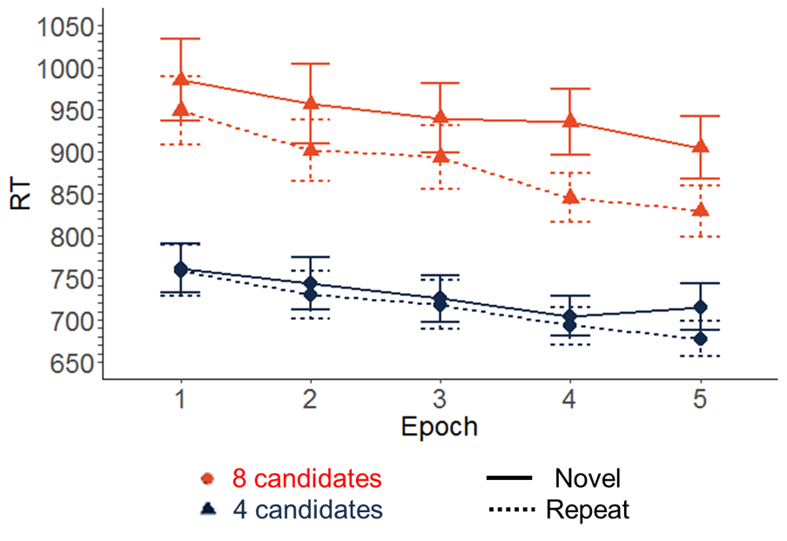

*Figure 1.* Response times for novel displays (solid lines) were significantly longer that that for repeated displays (dashed lines), for both set size 8 (orange circles) and set size 4 (black triangles). The average magnitude of the contextual cueing effect was larger in set size 8 (61ms) compared to set size 4 (15ms).

**Experiment 2**

The main purpose of Experiment 1 was to evaluate the size of the contextual cueing at small set sizes, because in Experiment 2 we wanted to add lures. Although the contextual cueing effect was observed with both 4 and 8 candidates, the effect was greater with 8 candidates (61ms on average) compared to 4 candidates (15ms on average). Thus, the decision was made to use 8 candidates in Experiment 2, where we investigated the effect of lures on the contextual cueing effect by varying the number of lures. Similar to Chun and Jiang (2001 CITE), here we presented observers with displays consisting of both candidates and lures. However, instead of using a single set size for lures, we varied lure set size while keeping candidate set size at 8. This allows us to examine whether lures were processed in contextual cueing experiments. If lures are processed in repeated displays, as proposed by Contrast Signal Theory, response times should increase logarithmically as a function of lure set size (CITE). Buetti et al. (2016 CITE) have previously shown that this is the case in normal search tasks with both candidates and lures, though it is unclear whether lures will still be processed when their context is repeated. In contrast, if lures are filtered out by a preattentive process, then there should be no effect of lure set size on response times (e.g. CITE). In addition, if lures contribute to contextual cueing, then search efficiency (as indexed by the search slopes) should increase in repeated displays. Searching through the same context of lures repeatedly should be faster (more efficient) than searching through novel displays.

**Method**

Twenty participants were recruited from the same subject pool as Experiment 1. These participants did not take part in any of the other experiments in this paper. All methods are identical to Experiment 1, except for the following changes: in addition to the candidate Ls, there were symmetric orange diamonds (lures). Each display always contained 8 candidates. There were 4 different lure set sizes: 0, 5, 10, 20. As such, there were 3 repeated displays per set size and a total of 12 repeated displays throughout the entire experiment. In the repeated displays, both lures and candidates, as well as the target, was always in the same location.

**Results**

For each participant, response times beyond 2.5 standard deviations of each condition were excluded from analyses. Trials on which participants made an error were also excluded. This led to the removal of 3.4% of trials.

A 2 (display type) by 4 (lure set size) by 5 (epoch) fully within ANOVA was performed. RTs for repeated (*M* = 990ms, *SD =* 174ms) displays were faster than novel (*M* = 953ms, *SD* = 178ms) displays, *F*(1, 19) = 4.64, *p* = .0443, ωp² = xxx . RTs increased with lure set size (set size 0, 5, 10, 20, respectively: *M* = 916, 962, 978, 1030 ms, *SD* = 152, 183, 167, 185 ms), *F*(3, 57) = 9.68, *p* <.001, ωp² = xxx, RTs decreased as a function of epoch (from epoch 1 to 5: *M* = 1042, 981, 947, 953, 935 ms, *SD =* 189, 164, 165, 172, 174 ms), *F*(4, 76) = 12.17, *pc* < .001, ωp² = xxx, ωp² = xxx. The main effects were qualified by a significant display type by epoch interaction, *F*(4, 76) = 6.80, *p* < .001, ωp² = xxx. Follow-up t-tests revealed that RTs for repeated displays were faster than that for novel displays only in the last two epochs at ⍺ = .05/5 = .01 after applying Bonferroni correction (Table 1).

|  |  |  |  |  |
| --- | --- | --- | --- | --- |
| Epoch | *t*(79) | *p* | *M* (SD) | Effect size |
| 1 | -0.16 | .877 | - 3 (191) |  |
| 2 | 1.42 | .161 | 23 (142) |  |
| 3 | 2.01 | .0482 | 36 (162) |  |
| 4 | 4.65 | <.001 * | 80 (154) |  |
| 5 | 2.88 | .00507 * | 51 (160) |  |

*Table 1.* XXXXX. Asterisks indicate statistical significance at p < .01 (after Bonferroni correction).

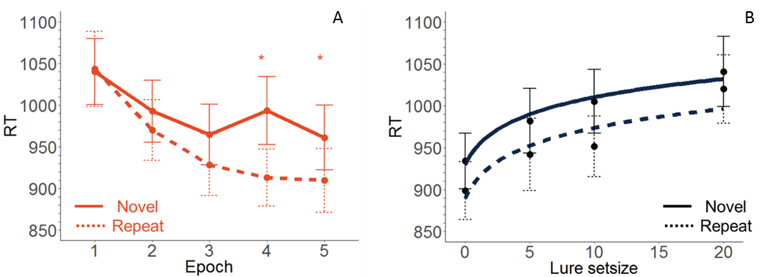

*Figure 2. (A)* Response times for novel displays (solid lines) were significantly longer than that for repeated displays (dashed lines) in Epochs 4 and 5. *(B)* There was no significant difference in logarithmic slopes between novel (solid lines) and repeated (dashed lines) displays, indicating that there was no difference in search efficiency.

There were no other significant interactions: set size by display, *F*(3, 57) = 0.24, *p* = .868, ωp² = xxx; set size by epoch, *F*(12, 228) = 1.12, *p* = .341, ωp² = xxx; three-way interaction, *F*(12, 228) = 1.34, *p* = .198, ωp² = xxx.

To determine whether the logarithmic RT by set size slopes were meaningfully different between the novel and repeated displays, the Bayes factor was calculated for a model with display type as a predictor. Bayes factors are preferred over null hypothesis testing when the goal is to provide evidence for null effects (CITE). The analysis revealed moderate evidence (CITE) for the hypothesis that there was no meaningful difference in slopes between the novel and repeated displays, BF01 = 3.33. Search efficiency did not improve with repeated displays.

**Experiment 3**

Experiment 2 showed that the magnitude of the contextual cueing effect was not affected by lure set size, even though lures contributed to processing times. If it is indeed true that lures do not contribute to contextual cueing despite being processed, then we should not observe any contextual cueing with lure-only displays.

**Method**

Twenty-two participants were recruited from the same subject pool as previous experiments. One subject did not complete the experiment due to a computer error, and an extra participant was ran because one participant in the original 21 had an average RT that was more than 2.5 standard deviations higher than the group mean. These participants did not take part in any of the other experiments. All methods are identical to Experiment 1, except for the following changes:

1. All distractors were now symmetric orange diamonds (lures),
2. There were 5 different set sizes: 0, 3, 9, 19, 31.
3. There were 13 instead of 12 repeated displays (an additional one for the target-only display). There were 3 repeated displays for each of the non-zero set sizes, and one for the target-only display (set size 0).
4. A recognition test was implemented at the end of the experiment

The recognition phase of the experiment started by asking participants whether they noticed anything unusual with the experiment. If they answered ‘Yes’, they were prompted to describe it by using the keyboard. Regardless of whether they answered ‘yes’ or ‘no’, they were informed on the next screen that some of the displays were repeated, and were asked whether they had noticed this or not. After which, they were asked what percentage of the trials they thought were repeated. Participants were then informed that they will be presented with a recognition test.

The recognition test consisted of 104 trials in total. Each of the 13 repeated displays was presented 4 times, twice with the target rotated 90 degrees clockwise and twice anti-clockwise. Thirteen novel displays, which were never presented in the search task, were created. These novel displays were also presented 4 times, two with the target rotated 90 degrees clockwise and twice anti-clockwise. This was to equate for learning within the recognition task. The target location for these novel displays were the same as the target locations for the novel displays in the search task to equate for target probability. The recognition test was blocked such that each repeated and novel display was presented once before it was presented again.

On each trial, the display was presented until a response was made. Participants pressed the ‘z’ key to indicate that they have seen the display before during the search task, and the ‘/’ key to indicate that the current display was a novel one. Upon response, the confidence rating screen was presented. Participants had to indicate their level of confidence in their response, ranging from 1 (‘completely guessing’) to 5 (‘completely confident’). Upon response, a blank screen was presented for xxx ms before the next trial began.

**Results**

One participant was excluded from analyses as they had a mean RT that was more than 2.5 standard deviations away from the overall group mean. An additional participant was ran to replace this subject. Response times beyond 2.5 standard deviations of the mean of each participant were excluded from analyses. Trials on which participants made an error were also excluded. This led to the removal of 4.5% of trials.

A 2 (display type) by 5 (set size) by 5 (epoch) analysis of variance (ANOVA) was performed. The only significant main effect was that of set size, *F*(4, 76) = 24.24, *p <* .001, ωp² = xxx. Display type was not significant, *F*(1, 19) = .0672, *p* = .798, ωp² = xxx, and neither was epoch, *F*(4, 76) = 2.357, *pc* = .11, ε = 0.491, ωp² = xxx. There were no significant interactions: set size by display, *F*(4, 76) = 0.99, *pc* = .381, ε = 0.504, ωp² = xxx; set size by epoch, *F*(16, 304) = 1.47, *pc* = .194, ε = 0.389, ωp² = xxx; display by epoch, *F*(4, 76) = 0.20, *pc* = .85, ε = 0.589, ωp² = xxx; three-way interaction, *F*(16, 304) = 0.85, *pc* = .497, ε = 0.255, ωp² = xxx.

The lack of a significant difference in response times between repeated and novel displays suggest that lure processing does not contribute to contextual cueing. The Bayes factor for a model with display type as a factor indicated that there was strong evidence (CITE) that the response times for repeated and novel displays were not meaningfully different, BF01 = 13.757

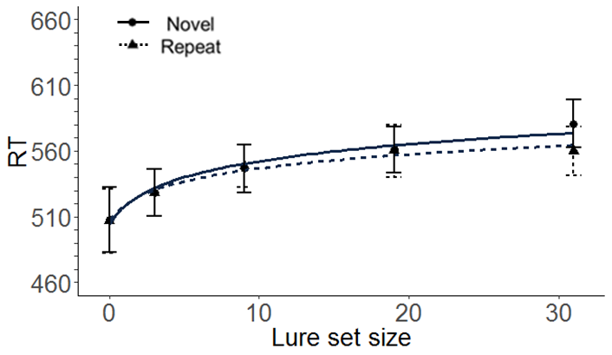

*Figure 3.* Response times (in ms) as a function of lure set size. Repeated displays are represented by the solid line, while novel displays are represented by the dashed line. Although response times increased logarithmically as a function of set size, suggesting that lures were processed, there was no statistically significant contextual cueing effect.

**Awareness of repeated displays**

At the end of each experiment, participants were asked if they noticed that some displays were repeated. The participants for the following analyses were the same as those reported previously, with the exception of Experiment 3. One subject did not complete the recognition test as was thus excluded from the analyses. The noticing rate for Experiments 1,2, and 3 were 30%, 25%, and 30% respectively. We next turn to the results of the recognition test in Experiment 3. One-sample t-tests were conducted for each of the lure set sizes (0, 3, 9 ,19, 31) to determine whether *d’* was significantly different from zero. Table 2 shows the results. None of the comparisons were statistically significant at α = .01 (after Bonferroni correction), suggesting that participants, *on average*, did not report any conscious awareness of the repeated display.

|  |  |  |  |  |
| --- | --- | --- | --- | --- |
| Lure set size | *t*(18) | p | *d’* | Effect size |
| 0 | 2.21 | .0407 | .457 |  |
| 3 | -0.725 | .478 | -0.0709 |  |
| 9 | -0.266 | .794 | -0.02 |  |
| 19 | -0.161 | .874 | -0.0168 |  |
| 31 | 1.856 | .08 | 0.127 |  |

**General discussion**

In Experiments 2 and 3, we found converging evidence that lures do not contribute to contextual cueing. This is consistent with the findings in Jiang and Chun (2001 CITE), and with the idea that the locus of the contextual cueing effect is in the second stage of visual search, where focused attention is directed to objects (or groups of objects). However, our results suggest that these lures nevertheless contribute to response times due to a parallel evidence accumulation process. This is evident from the fact that response times increase logarithmically as a function of lure set size, while search efficiency in repeated displays are not meaningfully different from search efficiency in novel displays.

Thus, lure processing does not benefit from context repetition. According to the Contrast Signal Theory, this is the result of the rejection of locations that contains lures in the first stage of visual processing. Only information about the locations that require further attentional scrutiny is passed on to the second stage. Thus, the locations of the lures are not learned even though they are presented repeatedly. Just as Jiang and Chun (2001 CITE) suggested, contextual information is learned only for distractors that undergo processing by selective attention.

It should be noted, though, that several studies have found evidence of contextual cueing in lure-only displays. However, it is unclear whether these studies truly reflect the influence of lures. In Geyer CITE, the search display was preceded by placeholders which previewed the spatial locations before the distractors appeared. Thus, the search process in this scenario would be different from a typical contextual cueing experiment. There would not be a process by which lures are first rejected; the context that is learned in this case would be the spatial layout of the placeholders, rather than the layout of the lures. Similarly, Harris and Remington (CITE) also had a paradigm that deviated from the typical contextual cueing experiment. The target was a sideways T, while the distractors were the letter H. When the display first appears, *all* items on the screen were the letter H; the target only transformed from an H to a sideways T when it was fixated upon. This could have led to a different evidence accumulation process (the initial search is virtually a target-absent search), or a different strategy adopted by observers.

Other studies report very small contextual cueing effects in lure-only displays (12 – 33ms; CITE). In fact, in Kunar et al, (CITE), the contextual cueing effect for set size 8 was only marginally significant (p = .09), after collapsing across the last 3 epochs (the main effect of display repetition was not statistically significant). Nevertheless, they found a statistically significant contextual cueing effect with 12 lures. Thus, the lack of a significant contextual cueing effect in our experiments with lures could possibly be due to a lack of power. However, we believe that this is unlikely to be the case. Firstly, we had more than 1.5 times the number of participants (20 vs. 12). Secondly, Bayes factors analyses in our experiments revealed strong evidence for the lack of any effect of lures on contextual cueing.

In conclusion, our results show that lure processing does not benefit from context repetition, even though they are processed. This suggests that lure locations are not stored in memory and is consistent with the Contrast Signal Theory, which proposes that locations containing lures are rejected in the first stage of visual processing and thus not stored in memory. However, it could possibly be the case that locations are in fact stored in memory but are too slow or weak to impact parallel processing. Further research would be necessary to provide a definite statement on this issue.

1. Jiang and Chun (2001 CITE) referred to these as the “attended” and “unattended” color respectively. However, these terms are inappropriate since they imply that all similar distractors are attended, and all non-similar distractors are unattended. We thus prefer to use the term “candidate” to describe a distractor that is very similar to the target such that selective attention is required to distinguish it from the target, and the term “lure” to describe a distractor that is sufficiently different from the target such that the visual system can distinguish it from the target without selective attention (e.g. CITE Buetti and the Zelinsky).