LAB4

0412237

陳逸豐

4-1

1. Introduction (5%)

In this lab, we are going to implement the conditional VAE, and it can generate the corresponding images to the label we give as the condition.

2. Experiment setups (20%):

A. How you implement a (conditional) VAE

As the model below, the VAE is composed of an encoder and a decoder, and the output of encoder are the average and the variance; the output of decoder is the reconstruct image. The encoder is learn to minimize the KL divergence of the output and the N(0,1). The decoder is learn to minimize the reconstruction error between the output and the input image.

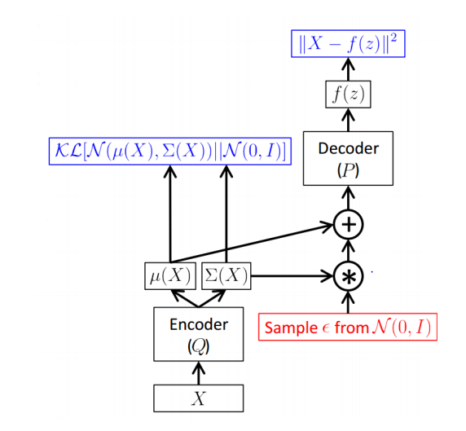

B. How you provide labels as additional input channels to both the encoder and the decoder

In encoder, Transform the input label to the one hot vector and append one-hot vector to each pixel of images.

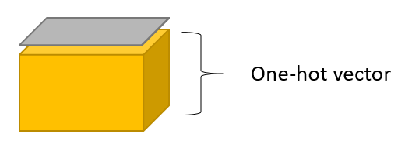

In decoder, concatenate noise and one-hot vector

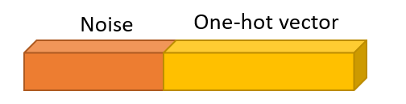

3. Results (30%):

A. Results of your disentanglement experiments

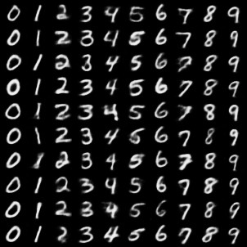

B. Loss curve during the training phase

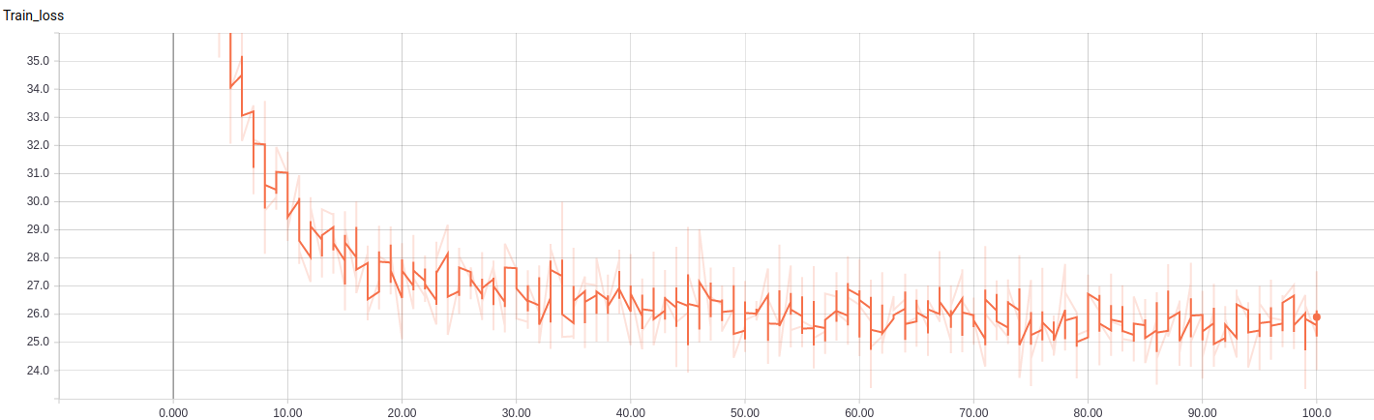

4. Discussion (15%)

In this cVAE, we can use data to learn a probability distribution rather than use standard normal distribution which may have better result.

4-2

1. Introduction (5%)

In this lab, we are going to implement infoGAN which is a variation of GAN.

2. Experiment setups: (20%)

A. How you implement InfoGAN

i. Adversarial loss

Use cross entropy of the fake image and cross entropy of the real image to do the adversarial loss.

ii. Maximizing mutual information

The goal of discriminator is to classify the image is real or not, so it will minimize adversarial loss; the goal of generator is to generate the image which cannot be classify by discriminator, so it will maximize adversarial loss.

iii. How you generate fixed noise and images

use random noise and concatenate the one hot vector as input of generator.

B. Which loss function of generator you used

I use the first one in the spec which is the binary cross entropy, ℒG = −ℒ𝐷 = 𝐸𝑥~𝑝𝑟 [log𝐷(𝑥)] + Ex~pg [log(1 − 𝐷(𝑥))]

3. Results (30%):

A. Results of your samples (shown as in the expected results section)

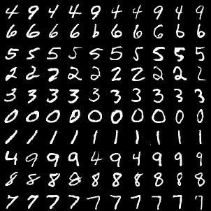

Every row shares the same one hot vector but different noise.

Every column shares the same noise but different one hot vector

B. Training loss curves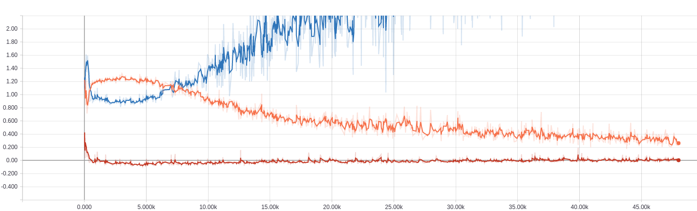

4. Discussion (15%)

I think the result of infoGAN is better cVAE, though cVAE is more stable on the label, but infoGAN share more style when share the same noise.