PRODUCT REQUIREMENTS DOCUMENT
A portfolio
with a universe of its own
Gavin Soares | 2D Pixel-Art Space Station
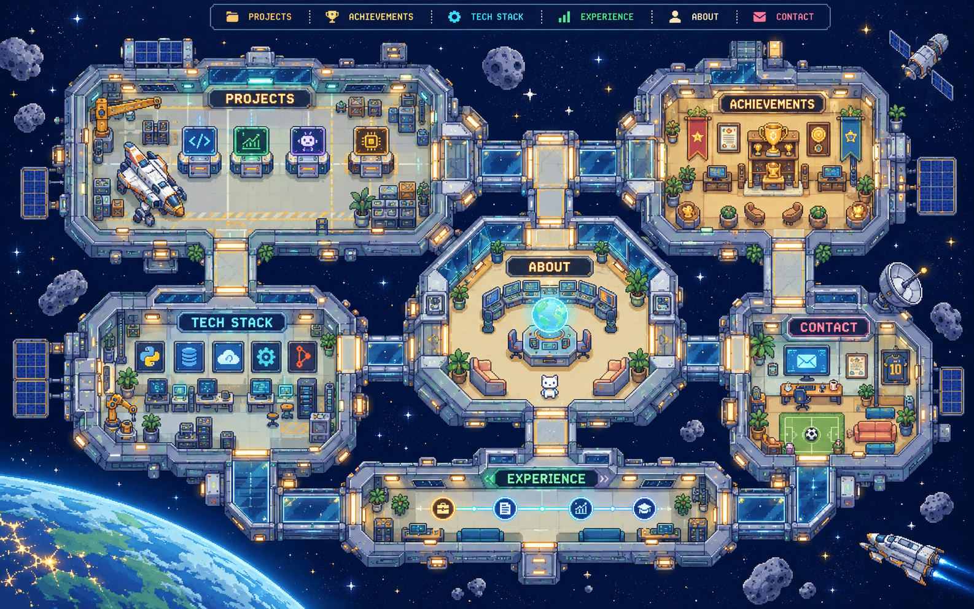
Selected visual direction: one connected, top-down space station that acts as the portfolio itself.
Document version 1.0 | 5 October 2026
Prepared as a build-ready product and interaction specification
Owner: Gavin Soares
01 / PRODUCT BRIEF

Executive summary
This document defines the product, visual system, content structure, interactions, implementation approach, and acceptance criteria for Gavin Soares's first public portfolio website.
The portfolio is a single, full-screen, top-down 2D pixel-art space station. Visitors arrive at a navigable station map and explore named areas for About, Projects, Achievements, Tech Stack, Experience, and Contact. The station is the complete experience: it is not a hero illustration beside a conventional portfolio page, and it is not a collection of separate themed project worlds.
The map supplies the memorable first impression; clear controls and readable content supply the useful portfolio. Every station is a real, keyboard-accessible navigation point. Selecting one guides the visitor to that module, then opens a readable content surface while preserving the sense of place.
One-line product statement A personal portfolio presented as a cohesive 2D pixel-art orbital station, where each station module organizes a real part of Gavin's professional story.

Product at a glance
Attribute | Requirement
Primary outcome | Help recruiters, engineering peers, and collaborators quickly understand Gavin's strengths, proof of work, and how to contact him.
Experience | Single connected top-down map; module navigation; readable detail panels; deep links and direct routes.
Visual identity | Hand-crafted 2D pixel-art in deep navy, muted blue, teal, warm cream, and small amber highlights.
Platform | Responsive web site, optimized for desktop first and fully usable on touch devices.
Build posture | Static-first, content-driven, fast, accessible, and maintainable by a first-time portfolio owner.

What success feels like
- A visitor understands who Gavin is and what he builds within the first few seconds.
- The world feels carefully crafted and memorable, while content remains easy to scan and share.
- Projects, awards, skills, and experience are each grouped in one obvious place.
- A hiring manager can reach a project case study, résumé, or contact link without getting lost in the game-like presentation.
02 / OUTCOMES

Goals, audience, and boundaries

Goals
- Create a distinctive visual portfolio that feels personal to Gavin rather than like a generic developer template.
- Communicate software engineering, full-stack development, and AI/ML work through verifiable projects and outcomes.
- Organize all projects together, all achievements together, all technologies together, and all internships/roles together.
- Make navigation intuitive for both curious visitors and time-constrained recruiters.
- Keep the site straightforward to update as projects, roles, and awards change.
- Make it responsive, accessible, and performant without relying on a 3D engine or a backend.

Primary audiences and their needs
Audience | What they need | Portfolio response
Recruiter / hiring manager | Fast evidence of fit, results, role, skills, résumé and contact. | A concise identity intro, featured projects, grouped experience, visible résumé and contact actions.
Engineering interviewer | Technical depth, design decisions, constraints, ownership and working demos/code. | Project details with role, stack, architecture summary, outcomes, GitHub/demo links and honest status.
Peer / collaborator | A sense of personality, interests and what Gavin is currently exploring. | A warm About module, visual world, current-focus note and low-friction contact links.

In scope
- One connected station map, six content modules, a small global navigation layer, responsive and accessible interactions.
- About/profile, projects, achievement archive, grouped tech stack, experience/mission log, and contact.
- Static portfolio content, résumé download link, external project links, metadata, deployment readiness, and QA.

Out of scope for version 1
- Accounts, CMS, database, server-side contact form, comments, chat, or editable visitor profiles.
- 3D/WebGL gameplay, physics, quests, unlockable sections, separate planet/world per project, or endless scrolling game mechanics.
- Invented project metrics, unverified claims, or public details from confidential work.
03 / DESIGN DIRECTION

The world: a compact orbital research station
Art direction should feel like a small, welcoming pixel-art spacecraft viewed from directly above. Use the map as the full viewport canvas and give each portfolio category a clear physical home.

Core visual rules
Rule | Implementation guidance
Top-down 2D | Orthographic view, flat sprite art and crisp silhouettes. Avoid isometric perspective, volumetric lighting, 3D orbit cameras, or a floating island.
One connected place | A central command deck joins the hangar, archive, engineering bay, mission log and communications module with visible corridors.
Pixel-art craft | Use a consistent pixel grid, deliberate palette, readable object scale, and restrained highlights. Never mix realistic 3D props with pixel sprites.
Portfolio first | Every area signals its content category using a label, icon, shape, and actual accessible control. Decoration alone is not navigation.
Warm and polished | Deep-space navy around the station; cool steel-blue structures; teal navigation lights; warm cream rooms; amber used sparingly for attention.
Readable by default | Use pixel type only for short labels. Use a clean sans-serif for paragraphs, project descriptions, controls, and small screens.

Palette proposal
Token | Suggested value | Use
Deep space | #101B35 | Background and deep shadows
Station steel | #253858 | Walls, frame, corridor edges
Nebula blue | #4B75B8 | Interactive outlines, selected state
Signal teal | #35C5C3 | Active route, focus ring, status light
Warm cream | #F7F2E7 | Interior floors and readable panel surface
Amber | #F4BC66 | Award highlights, selected status, sparing accents
Text ink | #172033 | Body text on light surfaces

Typography and UI language
- Use one crisp pixel/display face for tiny in-world signage and a highly legible sans-serif for UI and body content.
- Limit the system to two font families and a compact scale: display title, section title, body, metadata, utility label.
- Write short, human labels: Projects, Achievements, Tech Stack, Experience, About, Contact. Cosmic flavor can appear in room names and small status copy; it must never obscure meaning.
Design restraint Pretty detail should frame the work. Keep decorative stars, blinking lights, plants, screens, and props low contrast so projects and navigation win the visual hierarchy.

04 / VISUAL REFERENCES

Selected concept and style boundary

Approved space-station concept
The image below is the selected art-direction reference: it demonstrates a connected top-down station, distinct rooms, visible connecting corridors, category labels, and a central command deck. It is a concept mockup, not a requirement to reproduce each prop or every pixel. The implementation should simplify it into reusable, lightweight sprites and clear hit targets.
Figure 1. Generated concept for this portfolio's selected space theme. Treat as direction, not a finished site screenshot.

Style reference supplied by Gavin
This image is included only to communicate the qualities Gavin responded to: a complete 2D pixel world, compact readable landmarks, charming detail, and a map that feels like a place. The final site must use a new space-station setting, new composition, new assets, new signage, and new narrative. Do not reproduce the village, buildings, characters, paths, or layout.
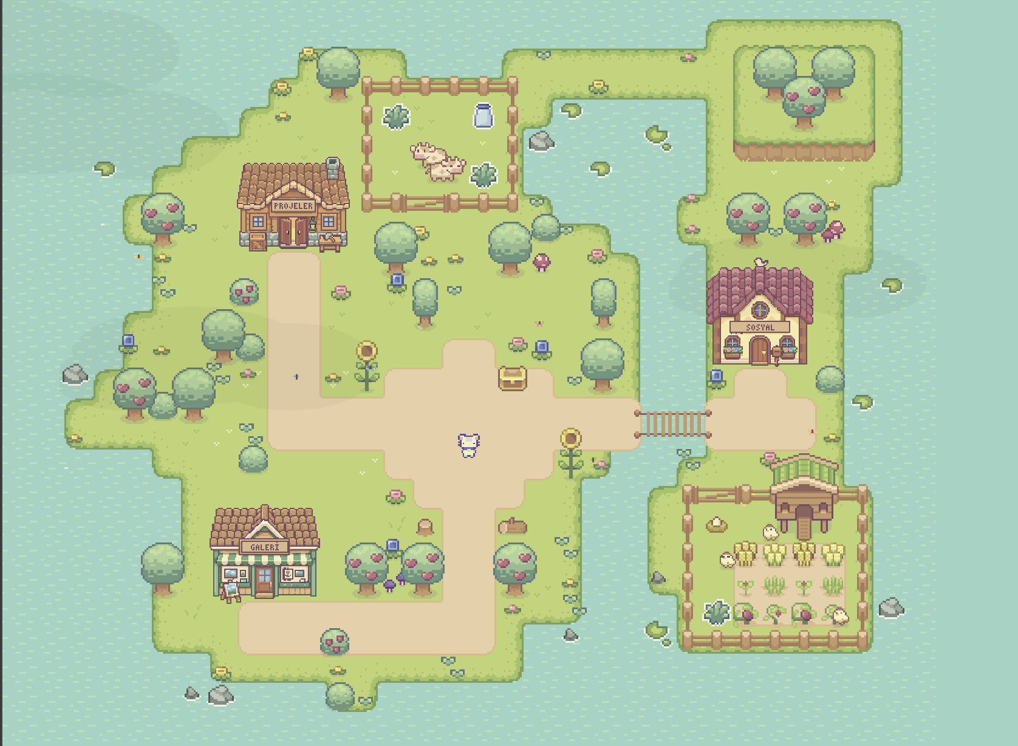
Figure 2. User-provided pixel map: style/interaction reference only. Do not copy its village theme or layout.
Hard visual boundary The website is a 2D station world edge to edge. Do not place a small map beside a conventional portfolio page, turn it into a 3D scene, or theme individual project pages as unrelated worlds.

05 / INFORMATION ARCHITECTURE

One map, six destinations
The map is the primary landing screen. A slim global navigation strip may sit at the top edge, but should feel like the station's control/status bar and stay visually quiet. The map itself fills the available area. On desktop, the full connected layout should be visible without scrolling at a common laptop viewport; if the viewport is too small, allow guided pan/zoom and offer the navigation strip as an immediate route.
Station module | Content grouped here | Suggested visual anchor
Command Deck / About | Identity, short intro, education, current focus, résumé action. | Central room with a planetarium/table hologram and a small character/desk detail.
Project Hangar | All selected projects in one browsable list, with featured projects first. | Docked shuttles or labeled project bays; each bay opens a project detail.
Achievement Archive | All hackathon wins, placements, awards, publications/certificates if verified. | Display wall, medals, trophy pedestal, or archive terminals.
Engineering Bay / Tech Stack | Technologies grouped by language, framework, data, AI/ML, tools/cloud. | Workbench consoles with readable category labels, not a scattered logo wall.
Mission Log / Experience | All internships, jobs, leadership, and verified dates/responsibilities. | A single timeline terminal or corridor with mission entries in chronological order.
Communications / Contact | Email, GitHub, LinkedIn, résumé/contact alternatives. | Comms desk, signal dish, or message console; no pretend live chat.

Navigation model
- Arrival: show the entire station map and concise greeting/status label. Every module's name is visible or available from the persistent control strip.
- Choose a module: click/tap the labeled room or choose the same item from global navigation. The active room is highlighted and the route is indicated.
- Travel: a small astronaut/rover marker glides along a corridor to the module. The map gently centers on it only when needed.
- Read: a centered content panel opens over the map. It uses a calm opaque/near-opaque surface with clear headings, links, and close/back controls.
- Return/share: close returns to the map; browser back works; each module can be opened from a shareable URL fragment such as #projects.

Information hierarchy
- Layer 1: identity and immediate routes to About, Projects, Experience, and Contact.
- Layer 2: category overview and scannable summaries.
- Layer 3: detailed project or role content, links, and evidence.
- A visitor should never need to explore decorative objects to discover core content.
06 / MODULE REQUIREMENTS

What each station contains

A. Command Deck / About
- Name: Gavin Soares. Use the final approved name styling and pronouns only if Gavin supplies them.
- Opening line: one sentence describing the kind of engineer and problems he works on; draft is a placeholder, not final copy.
- Short bio (60–100 words): education, technical interests, approach to building, and current focus. Avoid a long autobiography.
- Education: degree, institution, city, dates, most recent approved CGPA/honours if wanted. Verify current values before publishing.
- One primary CTA: View Projects. Secondary CTA: Download Résumé. Both destinations must work.
- Optional small “currently exploring” line, editable in one content data file.

B. Project Hangar
- Present a single grouped portfolio collection. Use 3–6 projects for launch, with one to three marked featured; final selection confirmed by Gavin.
- Each item: name, short problem statement, description, role/ownership, tech stack, project status, dates, evidence/results, image, and live/demo/source links where public.
- Project panel opens with a strong summary, then problem → approach → implementation → outcome → links. Keep it scannable with subheads and bullets.
- Use explicit labels such as Live, Prototype, In Progress, or Archived only when accurate. Missing demos should not produce fake buttons.
- Potential candidate set from existing context: Zenith, Money Council, NourishNet, CityPulse, InfluenceIQ, ScreenSmart, trekking/route-planning platform, Predictive Maintenance, Draft XI. Confirm current status and select the strongest public-safe work.

C. Achievement Archive
- Group all verified awards and notable placements in one module; newest first or prominently featured by distinction.
- Candidate achievements to verify: HackFusion 2026 first place (CityPulse); Auraflix 2025 first place (InfluenceIQ); Coherence AIML 2025 second place (ScreenSmart); Neural Nexus 2.0 2025 second runner-up (trekking/route-planning platform). Confirm exact event names, team attribution, project names, dates, and award wording.
- Each achievement should link to evidence when available: event result, certificate, project, or organizer page. Do not use unverifiable trophies as evidence.
06 / MODULE REQUIREMENTS (CONTINUED)

Skills, experience, and contact

D. Engineering Bay / Tech Stack
- Show actual tools Gavin can discuss, in categorized groups rather than a decorative badge cloud.
- Candidate groups: Languages (Python, JavaScript, C++, SQL); Frontend (React, React Native); Backend (Node.js, Express, FastAPI); Data (PostgreSQL, MongoDB, Firebase); AI/ML (scikit-learn, TensorFlow, Pandas, NumPy, NLP/LLM integration); Tools/Cloud (AWS, Docker, Git, Postman). Confirm proficiency and current stack before publishing.
- Do not add self-rated skill bars or percent meters. If proficiency levels are desired later, use evidence-backed tags such as Used in production / Project experience / Learning.

E. Mission Log / Experience
- One timeline containing all internships, employment, leadership, and meaningful experience entries, newest first.
- Every entry: organization, role title, start/end or current status, location/remote if useful, one-line remit, 2–4 contribution bullets, verified technologies, and public-safe outcomes.
- Existing resume context lists a Full Stack Development Internship at Rayeva; dates vary between source copies. Treat employer/date/description as candidate content and verify before launch.
- Keep confidential details out. Describe only approved public work at a high level; do not reveal private customer, compensation, unreleased product, or internal data.

F. Communications / Contact
- Show one visible, tappable email action and verified LinkedIn, GitHub, and résumé links as applicable.
- Use mailto for version 1. A real contact form would need service selection, privacy copy, spam handling, and server-side validation; it is not in scope now.
- Include accessible copy-to-email interaction with a visible confirmation and a working fallback link.

Content voice
- Clear, specific, confident, and honest. Prefer a concrete result and personal contribution over broad claims.
- Use first person in About, concise third-person/neutral labels in metadata, and active verbs in project and experience summaries.
- Avoid excessive space puns, generic statements like ‘passionate coder’, unverified metrics, and invented status labels.
07 / INTERACTION DESIGN

Movement, timing, and feedback
Animation should make the station feel alive and help visitors understand where they are going. Motion is an accent and orientation cue; it should not delay access to content or demand interaction with a game.
Moment | Expected behavior | Timing / constraints
First load | Starfield and station fade into their stable map state; intro/status copy appears with the map. | Overall reveal 450–700 ms; never show a mandatory splash screen or progress gate.
Ambient world | A few star twinkles, slow beacon pulse, and restrained console lights. | Long loops of 3–8 s; no rapid flashing; pause/reduce when tab is hidden or reduced motion is requested.
Room hover/focus | Room outline brightens, a location beacon pulses once, tooltip/label becomes prominent. | 120–200 ms; same feedback for keyboard focus as pointer hover.
Station travel | Small astronaut/rover follows a short corridor route; selected destination stays highlighted. | 350–650 ms; skip the travel animation if reduced motion or if user chooses direct navigation.
Map pan/zoom | A small, restrained camera nudge keeps the destination comfortably visible. | 250–450 ms; no large zoom or disorienting rotation; keep map controls available.
Content panel | Panel fades/slides a few pixels into a centered readable position; background dims slightly. | 180–280 ms; motion stays under 320 ms and never blocks close/back navigation.
Panel close | Panel dissolves and focus returns to the launching room/button. | 150–220 ms; no forced camera reset if user was exploring the map.
Project item hover | Card thumbnail/terminal brightens and a short summary is exposed without changing layout drastically. | 120–180 ms; touch gets a visible selected state instead of hover-only information.

Input and control
- Mouse/touch: tap/click a module; pinch or dedicated +/- buttons may zoom on the desktop map. Do not require precision dragging.
- Keyboard: Tab through global nav and room targets; Enter/Space opens; Escape closes a module panel; arrow keys may move between room controls when focus remains in the map.
- On-device: provide an obvious nav menu/list; do not hide the only navigation behind map hotspots.
- Provide a persistent ‘Map / Home’ control in every open module. Keep browser Back/Forward behavior in sync with the selected section.
- No audio on load. Any optional sound must be user-controlled, muted by default, and fully nonessential.
Reduced motion behavior When prefers-reduced-motion is active, remove travel and camera motion, stop ambient loops, and use immediate state changes or a very short fade. The selected module and destination must still be obvious.

08 / RESPONSIVE BEHAVIOR

A map that still works on a phone
Viewport | Layout and behavior | Must remain true
Large desktop (≥1280 px) | Whole station visible at initial fit; slim top control strip; module panels centered and wide enough for project case studies. | World feels immersive; module names and quick routes are legible.
Laptop / tablet landscape (768–1279 px) | Map scales proportionally. Allow subtle pan/zoom where necessary. Navigation list remains visible or one tap away. | No clipped modules; the visitor can get to every category without hunting.
Mobile portrait (<768 px) | Use a simplified connected station map with larger room buttons and a compact bottom/top navigation. If the full map cannot remain legible, use a responsive station schematic that keeps all modules connected and discoverable. | Tap targets are at least 44×44 CSS px; labels do not become tiny; all content panels fit the screen.
Small phone (<380 px) | Prefer a simplified, scroll-free station overview with a direct section menu; open content as a full-screen, vertically scrolling panel. | No horizontal page scroll; map art may crop only when a clear map/home control and all destinations stay accessible.

Mobile-specific details
- Do not shrink the desktop map until room text is unreadable. Redraw/reflow the map as a simpler 2D layout at narrow widths.
- Keep labels attached to tappable rooms; minimum touch target 44 × 44 CSS px, with spacing between neighboring targets.
- Content panels become full screen or near full screen, use natural vertical scrolling, and retain a fixed close/back control within reach.
- Avoid requiring hover, long press, pinch, or drag for ordinary browsing. Add explicit controls for zoom and map overview.
- All modules remain reachable with one or two clear actions from arrival.

Small map interaction guide
- Optional visible controls: Zoom in, Zoom out, Reset view, and Open navigation list.
- Set and document a sensible minimum/maximum zoom; never permit zoom so far that visitors lose all context.
- If panning is supported, preserve normal vertical page scrolling when the visitor is outside the map interaction area.
09 / TECHNICAL PROPOSAL

Build the map as a lightweight web interface
This is a proposed implementation stack for a first version, chosen to support a content-rich responsive site with a small interactive map and simple deployment. Use the current stable versions at project creation; do not freeze version numbers in this PRD.
Layer | Recommendation | Why / implementation note
Framework | Next.js App Router | Structured routes, layouts and metadata; static-friendly for a mostly content-only portfolio.
UI | React + TypeScript | Reusable room, panel, project, award, and timeline components with safer content structures.
Styling | Tailwind CSS plus small custom CSS where useful | Fast token-driven layout and responsive states; use CSS variables for art/UI palette.
World map | Responsive SVG/HTML composition with optimized PNG/WebP pixel-art sprites | SVG provides scalable positions and real interactive regions; actual text remains live HTML/SVG text, never flattened into a single inaccessible image.
Animation | CSS transitions/keyframes plus requestAnimationFrame only if needed; add Motion only if a real interaction needs it | Keep bundle and implementation complexity low; avoid canvas/WebGL/Three.js for version 1.
Content | Typed local data modules (e.g., src/data/portfolio.ts) | Projects, awards, experience, skills and profile can be updated without editing the map artwork.
Icons | Small original pixel-art icons plus a consistent accessible SVG icon set for controls | Use custom sprites for atmosphere and ordinary UI icons for recognizable affordances.
Hosting | Vercel as the proposed deployment path | Straightforward deployment for a Next.js site; final provider/account domain to be chosen by Gavin.
Contact | mailto links and external profile links | Avoid a backend or collecting information in v1.

Suggested component boundaries
Component | Responsibility
StationMap | Compose background/world layers, corridors, rooms and map controls; expose module destinations.
StationRoomButton | Semantic focusable room target with label, active/focus/hover state and module ID.
TravelMarker | Decorative but state-driven astronaut/rover position; honors reduced motion.
GlobalNavigation | Equivalent direct routes to every module and a compact mobile section menu.
ModuleDialog | Accessible modal/panel lifecycle, focus trap/restore, close button, Escape behavior and scrollable content.
Projects / Achievements / Skills / Experience | Render typed content lists from local data; keep content semantics outside the map artwork.
ContactActions | Email and verified external links with descriptive accessible names.

Route and state model
- Use stable human-readable fragment routes such as #about, #projects, #achievements, #stack, #experience, and #contact, with a proper base route that loads the map.
- Directly loading a fragment opens the correct module without requiring a prior map click. Browser Back closes or returns to the previous section predictably.
- Maintain selected module as the source of truth; keep the highlight, panel, URL, and accessibility announcement synchronized.
- No API or database is needed for version 1. Do not place secrets in a static portfolio repository.
10 / QUALITY REQUIREMENTS

Accessibility, performance, SEO, and privacy

Accessibility
- Aim for WCAG 2.2 AA for the portfolio UI: sufficient text/control contrast, visible keyboard focus, semantic landmarks and headings, operable controls, and understandable error/status messages.
- Provide an HTML list/navigation equivalent for all map destinations. The artwork itself must not be the only way to discover sections.
- Use real buttons/links for actions; each room has a clear accessible name such as ‘Open Projects’.
- Use a dialog pattern for overlays: accessible title, focus moved into panel, Tab contained while open, Escape closes, and focus returns to the launching control.
- Alt text for informative project images; empty alt for decorative pixel art. Do not describe every tiny visual decoration to screen readers.
- Support prefers-reduced-motion. Avoid flashes and do not communicate state by color alone.
- Text content stays selectable, resizable, and screen-reader accessible. Aim for body text of at least 16 CSS px in the actual site.

Performance
- Render the map as a few optimized layers/sprites; avoid one enormous image or dozens of oversized animation frames.
- Compress artwork, use appropriate responsive image sizes, lazy-load off-screen project screenshots, and preload only the primary display font if needed.
- Keep initial JavaScript modest; animate with CSS where possible; do not include a 3D engine or unnecessary animation package.
- Set practical QA targets: first useful view appears quickly on a mid-range mobile connection; navigation and content are interactive without noticeable delay; no layout jumps when map assets load.
- Check production Lighthouse/Core Web Vitals after deployment and fix any regression caused by image weight, font loading, or layout instability.

SEO and sharing
- Unique page title and description; Open Graph and social sharing image; favicon; canonical URL; robots and sitemap as applicable.
- Use semantic page headings and meaningful text for project/award content; social preview should use the station artwork with readable name/title.
- Every module fragment should be copyable and resolve to the right content. External project/profile links should be descriptive.

Privacy and security
- Do not collect visitor personal data in version 1; no analytics unless Gavin explicitly chooses a privacy-respecting option later.
- Do not publish phone, home address, private documents, customer information, private repository URLs, compensation, or confidential intern work.
- Open external links safely where appropriate; use direct HTTPS destinations; verify résumé visibility and remove metadata not meant to be public.
11 / CONTENT BLUEPRINT

Content data and draft copy

Typed content model
Entity | Required fields | Optional fields
Profile | name, headline, intro, education, currentFocus, resumeUrl | location, pronouns (only if supplied), social URLs, profileImage
Project | id, name, summary, description, role, stack[], status | date, outcomes[], image, demoUrl, repoUrl, featured, category
Achievement | id, title, event, placement, year, project | team, evidenceUrl, image, description
SkillGroup | id, label, items[] | evidence labels, relatedProjectIds
Experience | id, organization, role, startDate, endDate/status, summary | location, contributions[], stack[], publicOutcome, link
Contact | email | github, linkedin, résumé, other verified URLs

Draft homepage language (review before use)
Headline direction Gavin Soares — Computer Engineering student building thoughtful software across full-stack and AI.

This is a working copy direction based on existing context, not approved final copy. Update the student status, areas of focus, and precise wording to match Gavin's current situation and desired roles.

Project detail template
Field | Prompt for the final content
One-line summary | What does it do, for whom, and why does it matter?
Problem | What need or constraint motivated the work?
My role | What did Gavin personally own or implement? What did teammates own?
Approach | What design or technical choices shaped the implementation?
Outcome | What can be measured or demonstrated? Include proof; otherwise omit metrics.
Links | Which demo, source repository, poster, or evidence page is safe and stable to share?

Content verification items
- Confirm current education dates, latest CGPA (an earlier resume states 9.56/10.00 through Semester IV), and whether academic figures should appear publicly.
- Confirm Rayeva role title, dates, description, and exact public-safe scope; source resume copies differ on the end date.
- Confirm any later or incoming role details and confidentiality restrictions before publishing names, responsibilities, or dates.
- Confirm each project title, collaborator attribution, live/demo/source availability, current status, and metrics.
- Confirm award names, placements, years, event capitalization, and project association.
- Supply desired email, GitHub, LinkedIn, résumé URL, domain, and profile photo/avatar choice.
12 / ACCEPTANCE CRITERIA

Definition of done
ID | Acceptance criterion | How to verify
AC-01 | Initial viewport presents the complete connected 2D station as the primary experience. | Open at common desktop width; verify no separate conventional-page hero beside a decorative map.
AC-02 | Projects, Achievements, Tech Stack, Experience, About, and Contact each have one clearly named station module. | Compare map destinations and nav list against the six-module inventory.
AC-03 | Each module can be reached by map target, global navigation, keyboard, and direct fragment URL. | Click, tab/enter, paste fragment URLs, then use Back/Forward.
AC-04 | Opening a module displays readable real text, not text embedded only in a flattened image. | Select/copy text, inspect DOM and use a screen reader.
AC-05 | A visitor can open and close a module without losing map context; focus returns to the triggering control. | Keyboard interaction and screen-reader test.
AC-06 | All core content remains available with reduced motion enabled. | Enable OS/browser reduced-motion setting and traverse every section.
AC-07 | Mobile layout exposes every module and content without horizontal page scrolling or tiny hotspots. | Test 320, 375, 768 px widths and touch interactions.
AC-08 | No hover-only controls, broken external links, placeholder buttons, invented metrics, or unverified award claims ship. | Manual content/link audit against the approved content checklist.
AC-09 | Performance and rendering are checked with optimized assets and without a 3D/WebGL dependency. | Inspect dependency tree, production build, Lighthouse report, console/network errors.
AC-10 | Page title, description, share preview, favicon, and résumé/contact routes are configured and verified. | Inspect metadata/social preview and open destinations on desktop/mobile.

Test matrix
Area | Minimum check
Browsers | Current Chrome, Firefox, Safari, and Edge on representative desktop and mobile devices.
Input | Mouse, keyboard only, touch, screen reader smoke test, reduced motion.
Layout | Wide desktop, 13-inch laptop, tablet landscape/portrait, 320–430 px phone.
Content | Deep links, long project title, missing image, long role, empty optional URLs, updated content values.
Reliability | Direct refresh on module URL, Back/Forward, unavailable external project link, image load failure.

13 / DELIVERY PLAN

Build in reviewable stages
The site is starting from zero. Build in clear increments so the map composition and actual portfolio content can be validated before polish. Keep each stage runnable and reviewable.
Stage | Build output | Review gate
0. Content and asset inventory | Confirm bio, résumé, projects, awards, roles, links, and what can be public. Decide domain and avatar/character direction. | No invented copy remains; content fields and privacy constraints are approved.
1. Foundation | Next.js + TypeScript project, tokens, fonts, responsive canvas, semantic navigation, empty module dialog, route fragments. | Can open every empty module by click, keyboard, and direct URL.
2. Static map prototype | Top-down station art layout, six named zones, corridor connections, visible nav, placeholder content panels. | Composition reads as one 2D station; no 3D; mobile destinations stay clear.
3. Content integration | Typed content data, featured projects, awards, tech groups, experience timeline, profile/contact copy. | All factual claims and outbound links checked by Gavin.
4. Interaction and motion | Travel marker, selection/hover/focus, gentle pan/zoom, dialog transitions, reduced-motion mode. | Motion is short, purposeful, keyboard/touch parity works.
5. Responsive/accessibility pass | Mobile map simplification, dialog treatment, screen-reader labels, focus management, contrast/focus/reduced motion. | Acceptance checks pass across widths and input modes.
6. QA and launch | Asset optimization, metadata, resume, links, production build, deployment, domain, final visual review. | No broken links, console errors, or private information; launch checklist complete.

Suggested Codex handoff prompts
Use these as staged prompts when starting the implementation. Review each working result before moving to the next stage.
Prompt 1 — Foundation Set up a new Next.js App Router project with TypeScript and Tailwind. Build a full-viewport responsive portfolio shell with a deep-space palette, six semantic destinations, a compact global nav, hash-based section state, and an accessible centered dialog. Use placeholder content only. Do not create the map art yet and do not use a 3D library.

Prompt 2 — Station map Create an original top-down 2D pixel-art orbital station as the complete portfolio canvas. Compose one connected station with Command Deck/About at center, Project Hangar, Achievement Archive, Engineering Bay/Tech Stack, Mission Log/Experience, and Communications/Contact. Use original assets and the supplied generated concept only as art direction. Do not reproduce the supplied village image, use isometric/3D, make the map a side illustration, or flatten labels/content into a bitmap. Add accessible real room controls and mobile reflow.

Prompt 3 — Content and interactions Add approved typed portfolio data and detail views for projects, awards, technologies, experience, about, and contact. Add concise room-selection feedback, a small corridor-following travel marker, gentle map centering, direct URLs, browser back/forward, close/focus restore, and reduced-motion behavior. Keep interactions short and ensure all content works without animation.

Prompt 4 — QA Test every module with mouse, keyboard, touch, direct URL, browser Back/Forward, reduced motion, and small mobile widths. Check contrast, focus, dialog semantics, asset weight, route refresh, metadata, external links, and content accuracy. Fix issues rather than masking them with animation.

14 / RISKS AND LAUNCH

Risks, decisions, and release checklist

Key risks and mitigations
Risk | Mitigation
The map looks beautiful but visitors cannot find the content. | Persistent named navigation, unmistakable room targets, clear route labels, direct links, and simple module panels.
Pixel detail makes labels too small on mobile. | Create a simplified mobile map composition and keep real text labels at readable sizes.
Animations slow down or disorient visitors. | Keep timing short, avoid forced intros, offer reduced motion, and make every section accessible without animation.
Generated concept is too detailed to build exactly. | Use it as composition and art direction; simplify into a small coherent sprite library with consistent grid and palette.
Portfolio copy contains conflicting/stale information. | Keep content in one typed data module and use the verification checklist before public launch.
Internship content exposes confidential information. | Publish only approved public-safe summary; omit customer names, internal metrics, private data, and compensation.
The project becomes an unbounded game. | Keep version 1 to map exploration, clear station modules, readable project panels, and modest movement cues.

Launch checklist
- ☐ All public profile facts, education values, role dates, award wording, project roles, and claims have been verified.
- ☐ All links open the intended destination; no empty or placeholder CTA remains.
- ☐ Résumé is current, public-safe, accessible, and downloadable; private document metadata has been reviewed.
- ☐ Map is a connected full-screen 2D station on desktop and a clear, navigable schematic on mobile.
- ☐ Keyboard, focus, screen reader labels, reduced motion, touch target size, and contrast are checked.
- ☐ Images and fonts are optimized; production build is error-free; social card and page metadata are checked.
- ☐ No API keys, secrets, private customer details, contact data not intended for public display, or unpublished work are included.
- ☐ Domain, HTTPS, redirect behavior, favicon, and public résumé/contact paths are verified after deployment.

Decisions captured in this PRD
Decision | Selected direction
Theme | Space station, not village or football.
Representation | Full-screen, connected, top-down 2D pixel-art world.
Structure | One home for each content category; all projects together; all awards together; all tech together; all experience together.
Animation | A few restrained ambient effects, room feedback, short character travel, subtle centering, accessible reduced-motion fallback.
Content surface | Readable semantic panels opened from the station, with shareable section fragments.
Build posture | Static-first Next.js/React/TypeScript with lightweight HTML/SVG/CSS and optimized art assets; no 3D engine or backend in v1.

APPENDIX A

Portfolio inspiration references
These are references supplied by Gavin. Use them to study craft, pacing, personality, interaction, and presentation patterns. The portfolio must remain its own space-station concept; do not copy another site's distinctive environment, artwork, copy, or exact layout.

Primary references Gavin called out
Somehow Living — Immersive personal-site reference; study how a personal environment can carry navigation and identity.
Russel Daniel Paul — Minecraft portfolio — Interactive game-world reference; take the idea of a navigable world, not its Minecraft setting.
Özgür Güler — Crafted, playful environment and handmade-detail reference; use the feeling of a cohesive world, not the village theme or layout.

Additional portfolio references shared
Kush Bothra
Manixh
Mukund Kapoor
Sahil Codex
Rahul G
Nurlab
Ashish Gogula
Dev Chauhan
Anjil
Priyanshu
Nikhil Who
SRBH
Royalbeck Design
Note: Ashish Gogula appeared twice in the original link list and is listed once here. Direct domain links are used in place of the supplied t.co redirect links.

What to learn from the examples
Patterns seen in accessible references | How this PRD uses them
Immersive worlds (Somehow Living, Russell Daniel Paul, Özgür Güler): Gavin likes a personal site that feels like a place, with handmade details. | Keep the site as one explorable world, but make it an original space station. Borrow the idea of world-based navigation, not a village or game setting.
Clear grouping (Mukund Kapoor) and concise positioning (Rahul Palamarthi, Nikhil Rajpurohit): visitors can find the person, work, experience, and contact quickly. | Keep Gavin's identity and six agreed categories clearly labeled. Make the Projects and Contact routes obvious from arrival.
Interaction craft (Sahil Codex, Ashish Gogula): useful demos and small details in how interfaces move and respond add personality. | Polish hover/focus/selection states and include verified demo/source links. Keep motion brief and useful instead of making the site an animation gallery.
Evidence of work (Dev Chauhan, Saurabh Sharma): projects, open-source work, and contribution links support professional claims. | Link to current demos, repositories, results, or pull requests where public. Do not show stale activity metrics or unsupported claims.

Kush Bothra, Manixh, Nurlab, Anjil, Priyanshu, and Royalbeck Design remain linked above. Readable page text was not available consistently for those references, so no specific design claims are assigned to them.
APPENDIX B

Technical and accessibility references
Official product documentation to consult during implementation. This is an implementation proposal; versions and hosting details should be checked when the project is created.
Next.js App Router documentation — Framework routing, layouts, navigation, server/client component boundaries.
Next.js installation guide — Project creation and baseline setup.
React Learn — Component, state, rendering, and event fundamentals.
Tailwind CSS: Next.js guide — Official Tailwind setup for a Next.js application.
Vercel: Next.js deployments — Proposed hosting and deployment reference.
W3C: WCAG 2.2 — Accessibility success criteria and conformance reference.
MDN: prefers-reduced-motion — Respecting operating system motion preferences.
WAI-ARIA Authoring Practices: Dialog (Modal) Pattern — Keyboard and focus behavior for content overlays.

Implementation notes for the first build
- Prefer a static site and local content data; the first portfolio does not need a database or login.
- Treat the map as a lightweight responsive composition and the content as semantic UI. Keep labels and links as real text.
- Use the generated visual concept as an art-direction reference; prepare original sprite assets and a lower-detail mobile composition before production.
- Before public deployment, check the final profile copy and all project/experience facts directly with Gavin.

