1. 請問感冒(ICD9CM=460~466)醫療費用和高血壓(ICD9CM=401~405)醫療費用是否顯著不同?

libname exam 'Z:\Downloads\2022.11.29\2022.11.29';

/*Question 1*/

**data** h; set exam.H_nhi_ipdte96;

length check $**10**;

keep fee_ym ICD9CM_1-ICD9CM_5 check check2 MED_DOT ID IN_DATE;

array icd9cm (**5**) ICD9CM_1-ICD9CM_5;

do i=**1** to **5**;

/*high blood pressure*/

do j=**401** to **405**;

if icd9cm(i) = j and check = Missing THEN check='hbp';

else if icd9cm(i) = j and check = 'sick' THEN check='hbp & sick';

end;

/*sick*/

do g=**460** to **466**;

if icd9cm(i) = g and check = Missing then check = 'sick';

else if icd9cm(i) = g and check = 'hbp' then check = 'hbp & sick';

end;

end;

if check = Missing or check = 'hbp & sick' then delete;

**RUN**;

/* Normal distribution */

**proc** **univariate** data = h normal;

var MED_DOT;

**run**;

**proc** **npar1way** data = h wilcoxon;

class check;

var MED_DOT;

**run**;

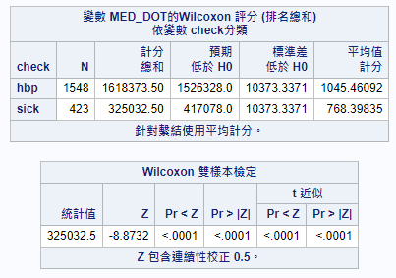

**非常態分布，使用獨立樣本無母數分析，P-value < 0.05，感冒和高血壓醫療費用沒有顯著不同**。

1. 請問住院檔中的糖尿病患者有幾人?

糖尿病患者的定義為「當年度有三次以上的住院與糖尿病相關，即主診斷或次診斷是糖尿病(ICD9CM=250)」

/*Question 2*/

**proc** **sort** data = exam.H_nhi_ipdte96exam.H2_1;

by ID;

**data** h2_2; set exam.H_nhi_ipdte96;

array icd9 (**5**) ICD9CM_1-ICD9CM_5;

do f=**1** to **5**;

if icd9(f) = **250** then diabetes = **1**;

end;

if diabetes ^= **1** then delete;

keep ID count MED_DOT ICD9CM_1-ICD9CM_5 diabetes;

**proc** **print**;

**run**;

**data** h2_3; set h2_2;

by ID;

if first.id then count=**0**;

count+**1**;

**run**;

**data** h2_4; set h2_3;

if count<**3** then delete;

by ID;

if last.id;

**proc** **print**;

**run**; **61人**

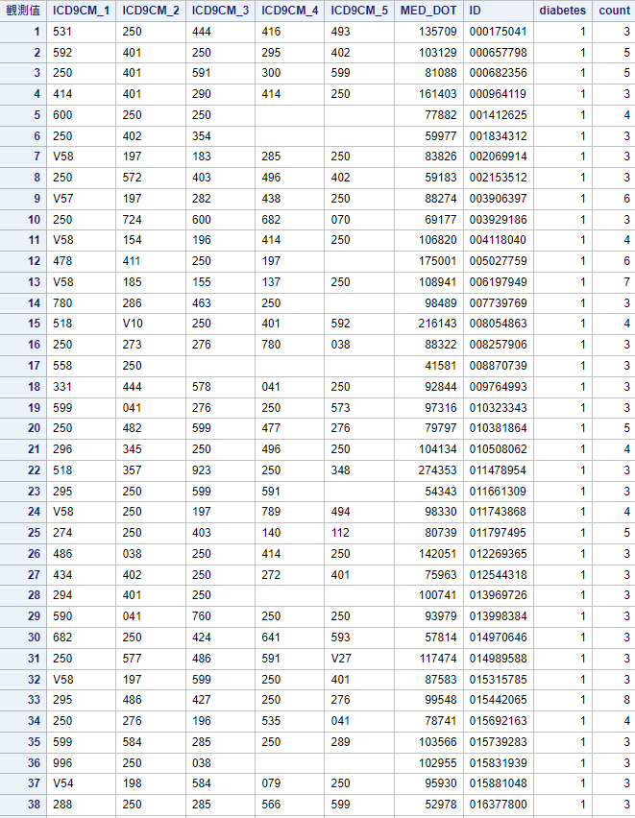

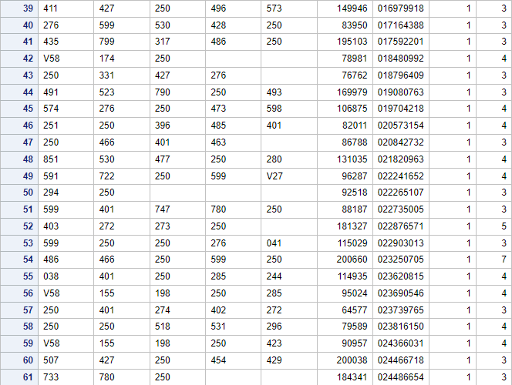

3. 請問糖尿病患者的感冒醫療費用和高血壓醫療費用是否顯著不同?

/*Question 3*/

**proc** **sort** data=H;

by ID;

**proc** **sort** data=H2_4;

by ID;

**data** H3;

merge H H2_4;

by ID;

**run**;

**data** h3_1; set H3;

if diabetes ^= **1** then delete;

if check = Missing then delete;

drop Missing;

**run**;

/* Normal distribution */

**proc** **univariate** data = h3_1 normal;

var MED_DOT;

**run**;

**proc** **npar1way** data = h3_1 wilcoxon;

class check;

var MED_DOT;

**run**;

**非常態分布，使用獨立樣本無母數分析，P-value > 0.05，糖尿病患者的感冒醫療費用和高血壓醫療費用有顯著不同。**

