作業三

1.

請問traffic.dat資料檔中，是平面道路(surface) 且下午車流量大於2000的路是哪些？

**data** surface;

infile 'Z:\Downloads\範例資料04\Traffic.dat';

input type $ Name $ **9**-**38** AMTraffic PMTraffic;

if type = 'surface' and PMTraffic > **2000**;

**run**;

**proc** **print** data = surface;

**run**;

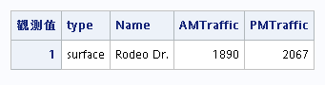

請問traffic.dat資料檔中，是平面道路(surface) 或下午車流量大於2000的路是哪些？

**data** surface;

infile 'Z:\Downloads\範例資料04\Traffic.dat';

input type $ Name $ **9**-**38** AMTraffic PMTraffic;

if type = 'surface' or PMTraffic > **2000**;

**run**;

**proc** **print** data = surface;

**run**;

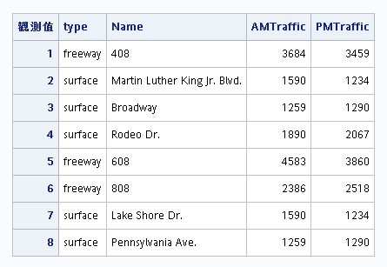

2.

•Bands資料檔裡，找出8PM>40且10PM>50

**data** Music2;

infile 'Z:\Downloads\範例資料04\Bands.csv' dlm = ',' dsd missover;

input BandName :$30. GigDate :MMDDYY10. EightPM NightPM TenPM ElevenPM;

if EightPM>**40** and TenPM>**50**;

list;

**run**;

**proc** **print** data = music2;

format GigDate MMDDYY10.;

**run**;

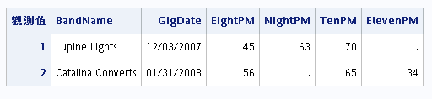

•Bands資料檔裡，找出8PM>40或10PM>50

**data** Music2;

infile 'Z:\Downloads\範例資料04\Bands.csv' dlm = ',' dsd missover;

input BandName :$30. GigDate :MMDDYY10. EightPM NightPM TenPM ElevenPM;

if EightPM>**40** or TenPM>**50**;

list;

**run**;

**proc** **print** data = music2;

format GigDate MMDDYY10.;

**run**;

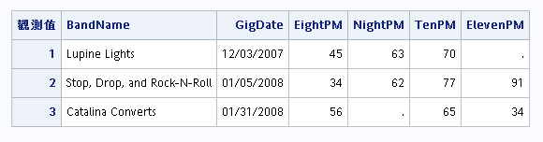

林沅 108029064