Caribbean Magazine

**5 Travel Hacks**  **A Traveler’s**

Travelling to the Caribbean Going to places make us see the

Is always an beauty of the world outside?

adventure

**Travel Hacks A Traveler’s**

Travelling to The Going to places make us see the

Caribbean is fun beauty of the world outside

Table of Content

CAYMAN ISLANDS 3

HISTORY 3

RELIGION 3

**MUSIC** 3

FESTIVALS 3

SPORTS 3

CUBA 4

HISTORY 4

FOOD 4

RELIGION 4

**MUSIC** 4

FESTIVALS 4

GRENADA 5

HISTORY 5

FOOD 5

RELIGION 5

MUSIC 5

FESTIVAL 5

THE DOMINICAN REPUBLIC. 6

**HISTORY** 6

**FOOD** 6

RELIGION 6

MUSIC 6

JAMAICA 7

HISTORY 7

**FOOD** 7

RELIGION 7

MUSIC 7

FESTIVAL 7

WHAT IS CULTURE? 8

WHAT IS CULTURAL IDENTITY? 8

WHAT IS CULTURAL DIVERSITY? 8

**WHAT IS CULTURAL HERITAGE?** 8

WHAT ARE THE BENEFITS OF CARIBBEAN CULTURE? 8

**CAYMAN ISLANDS**

**HISTORY**

Cayman Islands is a British overseas territory, it has three islands in the western Caribbean Sea.

**Grand Cayman**, the largest island, is known for its beach resorts and various scuba diving and snorkeling sites. **Cayman Brac** is a popular launch point for a deep-sea fishing excursion. **Little Cayman** the smallest island is home to diverse wildlife including endangered iguanas.

Let us take a look at the foods they eat such as

* Turtle stew
* Conch stew
* Johnnycake
* Cayman style lobster
* Coconut shrimp
* Cayman style lobster
* Cayman style beef

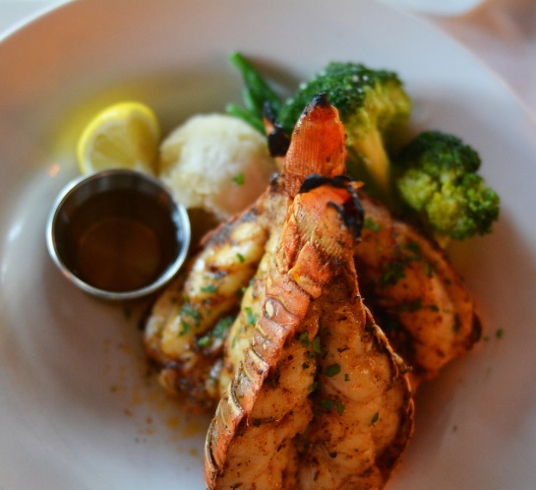

**RELIGION**

 Christianity in Cayman is the religion with the denominations of Anglican, Catholicism, and Baptist are all represented on the island.

**MUSIC**

The music in Cayman includes a wide selection of international Pop music, Rake, Scrate , Reggae, and Rocksteady music.

**FESTIVALS**

The Cayman National Cultural Foundation, established in 1984, helps to preserve and promote the organization of festivals such as Cayman International Story Telling Festival

Pirates Week Festival.

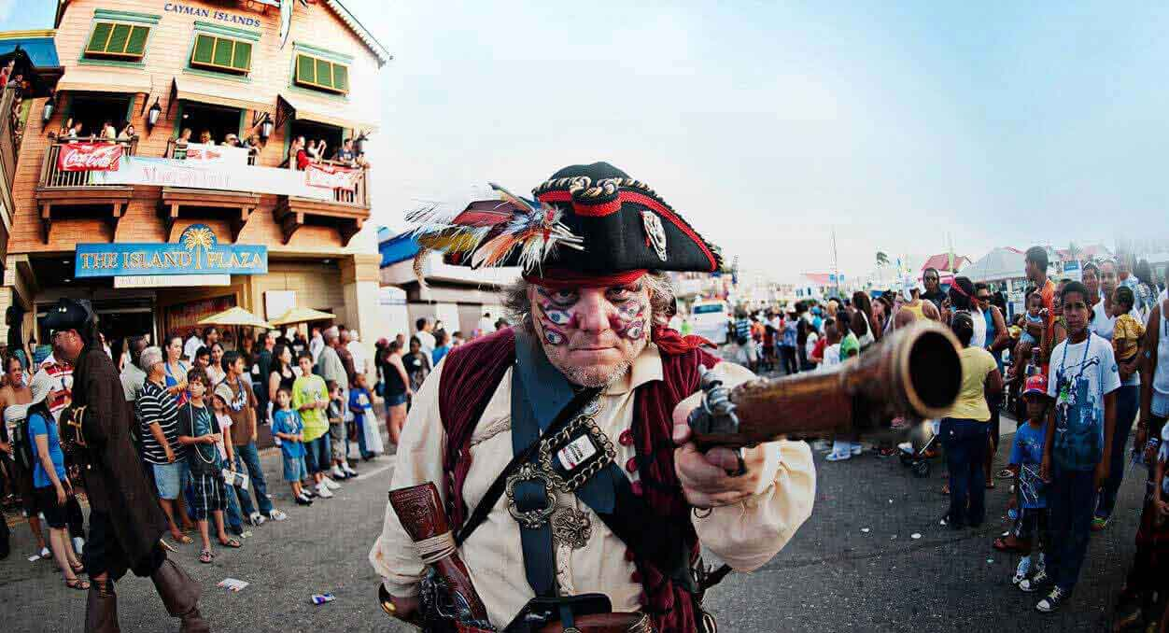

**SPORTS**

The popular team sports of the Cayman Islands are:

* Football
* Netball
* Basketball
* Cricket
* Squash
* Rugby

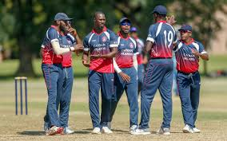

Many of these have an active association that runs Lethes and Field teams that travel internationally to complete track and field swimming and sailing and boxing are popular in Cayman. Caymanians have competed in world cross events.

**CUBA**

**HISTORY**

Cuba- Cuba officially the Republic of Cuba is a country comprising the island of Cuba, as well as Isla de la Juvenud and several minor archipelagos. Cuba is located in the northern Caribbean where the Caribbean Sea, Gulf of Mexico, and the Atlantic Ocean meet, Cuban is also North f Jamaica.

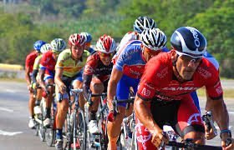

**FOOD**

Cubans eat food now let us take a look at their foods. Cubans cuisine is a blend of African, Spanish, and other Caribbean Cuisines. Some Cuban recipes share spices and techniques with Spanish and African cooking with some Caribbean influence in spice and flavour. This results in a blend of several different cultural influences.

Let us look at the food now, they are:

* Rapa Vieja
* Ajiaco
* Tasajo
* Comida criolla

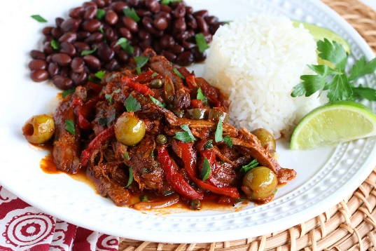

**RELIGION**

Cuba’s prevailing religion is Christianity primarily Roman Catholicism.

**MUSIC**

 Music in Cuba is Folk music top. Cuba has five basic genres of Afro-Cuban music; these include rumba, son, Cancion, Cubana, danzon, and punto guajira. This section discusses the origin of the three most common genres rumba, son, and dazon and they have had the importance they have had in making the Afro-Cuban Culture in Cuba.

**FESTIVALS**

 Cubans have festivals let take a look at some of them.

* Festival de la Trava Longina
* Avana Juzz Festival
* Havana International Book Fair
* Festival del Habano
* Memorial Guillermo Barreto Festival
* Santiago Alvares Memorial International
* Documentary Festival
* International Documentary Festival
* International Pepe Sanchez Trava Festival

Those are the festivals in Cuba.

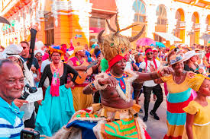

**GRENADA**

**HISTORY**

 Grenada- Grenada is a Caribbean country compromising the main island, also called Grenada, and smaller surrounding islands, Dubbed the “Spice Isle”, the hilly main island is home to numerous nutmeg plantations. Its also the site of the capital, St.Gorge’s Whos colourful homes, Georgian building and the early-18th century Fort George overlook narrow Carenage Harbour. To the south is Grand Anse Beach with resorts and bars.

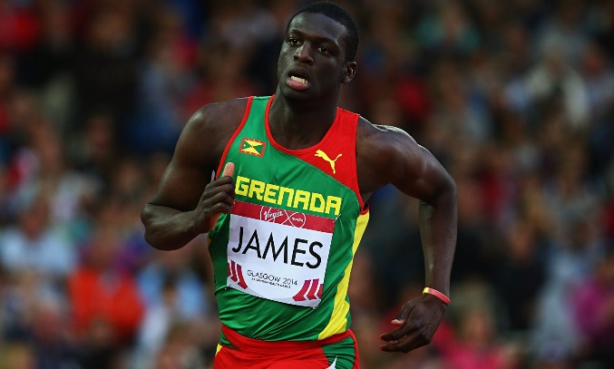

**FOOD**

Food in Grenada is very cheap so lets take a look at some types of food, which includes

* Curried Goat
* Callaloo Soup
* Fresh Cocoa Bean Flesh
* Pelau
* Lambia
* Oil Down

Those are the traditional main dishes in Grenada.

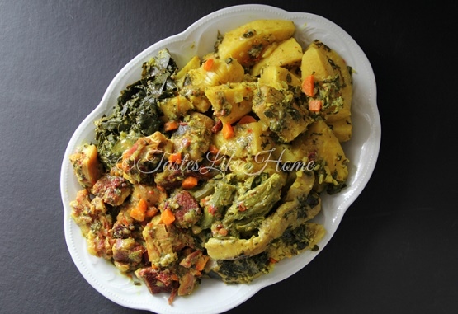

**RELIGION**

Grenada religion is protestant for 9.2%(this also includes Pentecostal 17.2%) Seventh Day Adventist 13.2% Anglican Sibling Baptist 3.2% , Church of God 2.4%, Evangelical 1.9% Methodist 1.6% , other 1.2%) Jehovah witness 1.2% Rastafarian 1.2% other 5.5% none 5.7% unspecified 1.3%)

**MUSIC**

Popular music of Grenada are Calypso music, Soca music, and to a lesser extent Reggae and Dancehall. Soca produced in Grenada has a distinct style taking on the name “jab jab” Soca.

**FESTIVAL**

Top Cultural Events, Concerts, and Festival in Grenada here are some of them:

* Pure Grenada Music Festival
* Carriacou Regatta Festival
* Grenada Chocolate Festival
* Carriacou Parang Festival
* Drum Festival

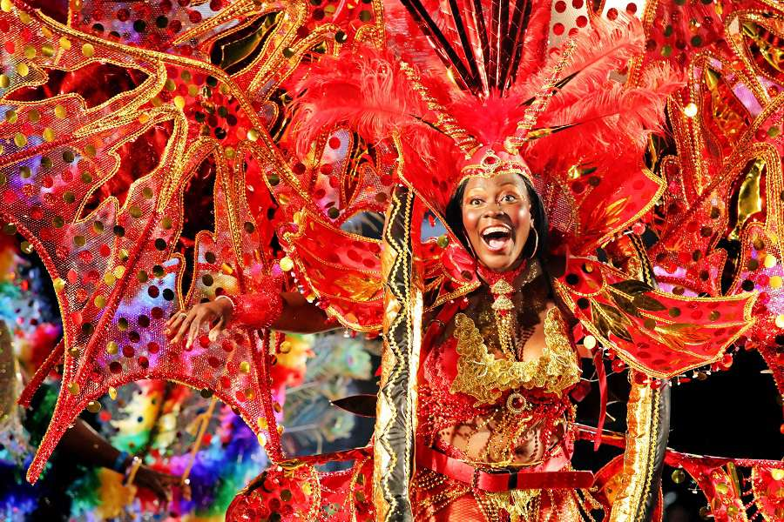

**THE DOMINICAN REPUBLIC**.

**HISTORY**

The Dominican Republic is a Caribbean nation that shares the island of Hispaniola with the Haiti to the west, it is known for its beaches, resorts, and golf. Its terrain comprises rainforest, savannah, and highlands, including Durate, the Caribbean's Tallest Mountain Capital City Santo Domingo has Spanish landmarks like the Gothic cathedral Primada de America dating

back 5 centuries in its zana Colonial district.

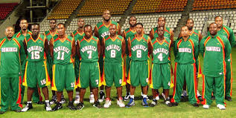

**FOOD**

Food in Dominican Republic is very tasty there are foods like:

* Sancocho
* Tostones
* Manyit
* Ensalada Verde
* Habichuelas con Dulce
* Pollo Gisada
* Arroz Blanco

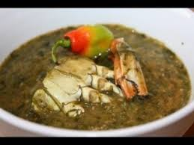

**RELIGION**

Roman Catholic is the most common religious affiliation in the Dominican Republic. In a Survey carried out between July and August of 2018, more than 44% of Dominican respondents claimed to be catholic faith where the second most chosen religion was Evangelism, with 9.5% percent of the people interviewed.

**MUSIC**

The Dominican Republic is mainly known for the merengue and bachata music, both of which are the most popular forms of music in the country.

* Dominican Republic Festival
* Here are some Dominican Republic Festivals:
* Merengue Festival
* Isle of Light Festival
* Gulaya Festival Dominican Republic

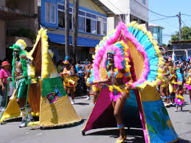

**JAMAICA**

**HISTORY**

 Jamaica, a country in the Caribbean has a lot of mountains and it also has 14 parishes. It has a lot of rainforests it is also surrounded by water. It is known for its resorts and beaches its Prime minister is Andrew Holness. Jamaica is famed as the birthplace of reggae music. Its capital is Kingston, Kingston is the home to the Bob Marley museum.

**FOOD**

Jamaican Food is really tasty Here are some of them:

* Oxtail
* Curry mutton
* Curry Goat
* Pepper pot Soup(Soup)
* Ackee and Saltfish
* Stew chicken
* Rice and peas
* Rundown.

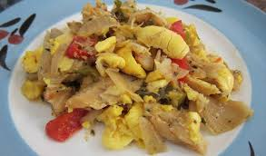

**RELIGION**

Most Jamaicans are protestants. The Largest group of churches are Pentecostal and Seventh-day Adventist. Churches here s a smaller group using the name Church of God

**MUSIC**

Jamaica music is mostly dancehall and reggae most of Jamaicans songs are known to be song in patois

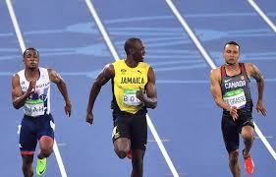

**FESTIVAL**

There are festivals in Jamaica here are some of them

* Ocho Rios Jazz Festival
* Reggae Sumfest
* Montego Bay Yach Club Faster Regatta
* Accompong marron Festival
* Saint Ann Kite Festival

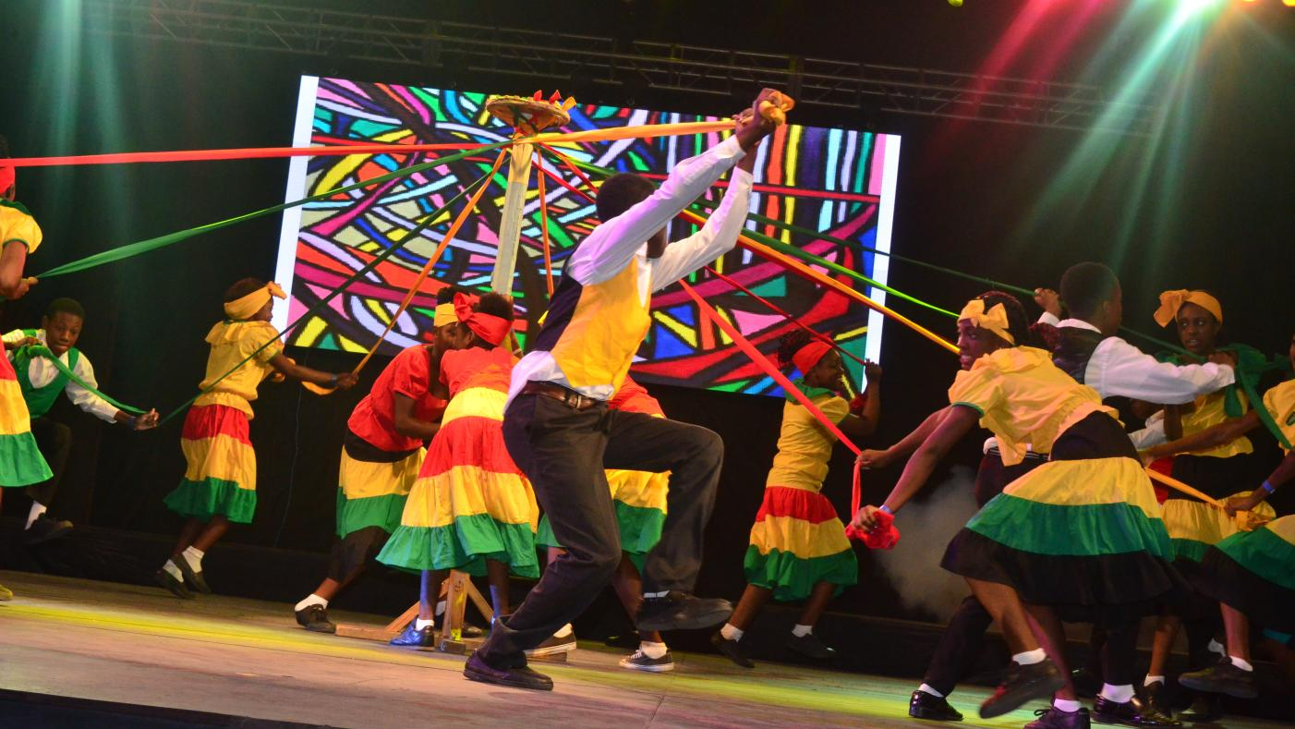

**WHAT IS CULTURE?**

Culture is the way of life of a particular group of people including the way they speak, dress, cook dance make music, educate their young and rule their country.

**WHAT IS CULTURAL IDENTITY?**

Cultural identity means belonging to a group, it is also a part of a person’s self-conception and perception and is related to nationality, ethnicity, religion, social class, generation, locality, or any kind of social group that has its own distinct culture.

**WHAT IS CULTURAL DIVERSITY?**

Cultural diversity is the existence of a variety of ethnic groups within a society.

**WHAT IS CULTURAL HERITAGE?**

Cultural heritage is the legacy of physical artifacts and intangible attributes of a group or society that is inherited from past generations.

WHAT ARE THE BENEFITS OF CARIBBEAN CULTURE?

1. It helps to raise awareness
2. It allows opportunity to express ourselves and have a sense of history.
3. It gives us a sense of individuality.