Terraform Community Edition
Target Architecture & Manual Developer Workflow
Software Approval Design - Google Cloud Landing Zone

Purpose
This document describes the proposed operating model for using HashiCorp Terraform Community Edition (Terraform CLI) to deploy City of Calgary Google Cloud Landing Zone components. Terraform is a command-line binary and can execute from an approved workstation. Terraform code related to Google Cloud Landing Zone components is pushed and approved on GitHub Repo,later developers can clone repo to an approved developer workstation, execute terraform locally using service account impersonation, and its authoritative state is stored remotely in Google Cloud Storage.
Decision requested
Approve Terraform Community Edition / Terraform CLI for the local execution model described in this document: City-controlled source code in GitHub, manual execution from an approved workstation, Application Default Credentials (ADC) with Google Cloud service account impersonation for privileged access, and a Google Cloud Storage backend for Terraform state.

Initial approval boundary
Execution  Manual, from approved City workstation | Source control  City of Calgary GitHub organization
Identity  ADC + service account impersonation | State  Remote Google Cloud Storage backend

Not part of this approval
No HCP Terraform / Terraform Enterprise platform, no CI/CD pipeline, and no long-lived service account private key on the developer workstation. GitHub Actions and Google Cloud Build remain future automation options and are not being selected by this design.

Prepared for City of Calgary Software Team
Architecture and Manual Developer Workflow
Figure 1 presents the complete initial operating model: Git approval before privileged execution, local Terraform CLI execution, ADC with service account impersonation, GCS remote state, and deployment to Google Cloud Landing Zone components.
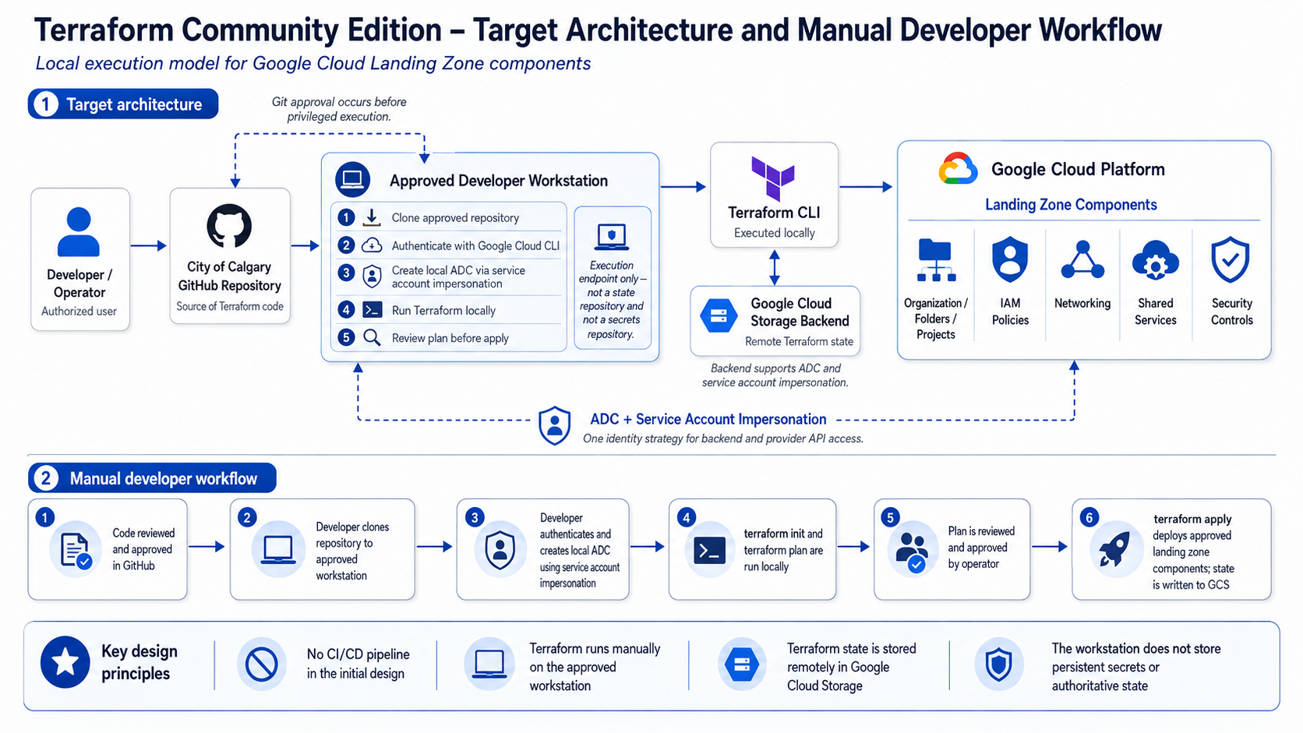
Figure 1 - Terraform Community Edition target architecture and manual developer workflow
1. Target Architecture
The developer workstation is an execution endpoint; Google Cloud remains the authoritative platform for identity, state, and deployed resources.

The proposed design intentionally separates source control, execution, identity, state, and the target cloud environment. Terraform itself is only the command-line execution engine. It does not become a server, control plane, credential store, or state platform.
Core design principle
The approved developer workstation is an execution endpoint, not the authoritative Terraform state repository and not a repository for long-lived service account keys or application secrets. Terraform state is stored in Google Cloud Storage, while privileged Google Cloud access is obtained through service account impersonation.

Architecture components
Component | Role in this design | Boundary / responsibility
City of Calgary GitHub repository | Authoritative source for Terraform Landing Zone code. | Code review and Git approval occur before privileged execution.
Approved developer workstation | Local execution endpoint used to clone the repository and run Terraform CLI. | Not authoritative state storage; no long-lived service account key is required.
Terraform CLI | Reads the approved configuration, calculates a plan, and applies approved changes. | Runs as a local process; no Terraform server is introduced.
ADC + service account impersonation | Provides Terraform with short-lived credentials for the designated deployment identity. | User must be authorized to impersonate the deployment service account.
Google Cloud Storage backend | Stores authoritative Terraform state remotely. | Access is controlled with Google Cloud IAM; state is not dependent on one laptop.
Google Cloud Landing Zone | Target environment for organization/folder/project, IAM, networking, shared-service, and security components. | Google Cloud IAM determines what the deployment identity can change.

2. Authentication and Execution Boundary
One identity strategy can cover Terraform provider access and the Google Cloud Storage backend.

Google Cloud recommends Application Default Credentials (ADC) for Terraform authentication. For a local development workstation, Google Cloud explicitly supports creating local ADC credentials using service account impersonation. Terraform then discovers those credentials automatically. [1]
The HashiCorp GCS backend also supports ADC and service account impersonation. This allows the same deployment identity strategy to be used for both Terraform state access and Google Cloud provider API operations. [2]
Proposed authentication pattern
The operator signs in using their authorized City identity, then creates local ADC credentials that impersonate the approved Terraform deployment service account. The deployment service account holds the infrastructure permissions; the human operator receives only the ability to impersonate that account.

Example authentication command
gcloud auth application-default login --impersonate-service-account=SERVICE_ACCOUNT_EMAIL
Required authorization
Control | Requirement
Human identity | Only authorized City users may perform the manual Terraform execution.
Impersonation permission | The operator requires the Service Account Token Creator capability on the designated deployment service account (or an equivalent controlled role design). [1]
Deployment service account | Receives only the Google Cloud IAM roles required by the approved Landing Zone components.
State backend access | The impersonated identity receives only the required access to the designated Terraform state bucket/prefix.
Workstation security boundary
- No service account JSON private key is required for the standard execution path. Google Cloud recommends more secure alternatives such as impersonation instead of service account keys where possible. [1]
- Terraform state is not stored as the authoritative state on the workstation.
- Credentials, .tfstate files, saved plan files, and other sensitive execution artifacts must not be committed to GitHub.
- The local ADC configuration created by gcloud is credential material and must be protected by the workstation/user profile controls. It is used for authentication; it is not treated as an application secrets repository.
3. Manual Developer Workflow
The proposal deliberately places Git approval before privileged infrastructure execution.

Change-control principle
The privileged Terraform run occurs only after the proposed code has gone through the City Git review/approval process. The operator executes the approved repository version rather than developing unreviewed infrastructure changes during the privileged session.

1 | Code reviewed and approved in GitHub  Terraform changes are committed to the City repository and reviewed through the City Git approval process before privileged execution. | Approval gate
2 | Clone the approved repository  The authorized operator clones the repository, or pulls the approved commit/branch, to the approved City workstation. | Approved source
3 | Authenticate and impersonate  The operator authenticates and creates local ADC using the designated deployment service account through impersonation. | Short-lived access
4 | Initialize and generate a plan  Run terraform init to connect to the GCS backend and install required providers, then run terraform validate and terraform plan locally. | No cloud change yet
5 | Review the Terraform plan  The operator verifies that the proposed resource changes match the approved Git change and expected Landing Zone outcome. | Human review
6 | Apply approved changes  Run terraform apply. Terraform calls Google Cloud APIs using the impersonated identity and writes the resulting authoritative state to the GCS backend. | Privileged execution

4. State, Source Control and Operational Controls
The workstation is temporary execution context; GitHub and Google Cloud provide the durable control points.

4.1 GitHub source control
The City GitHub repository is the authoritative source for the Terraform configuration. The manual execution model does not bypass source control: approval of code occurs before the operator enters the privileged execution phase.
- Use the City-controlled repository and approved branch/commit for deployment.
- Require peer review / approval according to the City repository governance model before execution.
- Do not store service account keys, state files, secrets, or local credential files in the repository.
- Commit the Terraform dependency lock file where appropriate so provider selections are reproducible across operator workstations.
4.2 Google Cloud Storage remote state
Terraform state is stored in a pre-existing Google Cloud Storage bucket configured as the Terraform backend. HashiCorp documents that the GCS backend stores state as an object in GCS, supports state locking, can use ADC, and supports service account impersonation. HashiCorp also recommends enabling Object Versioning to assist recovery from accidental deletion or human error. [2]
- The GCS copy is the authoritative Terraform state; a developer laptop is not the system of record.
- Bucket access is restricted using Google Cloud IAM to the approved deployment identity and required administrators.
- Object Versioning should be enabled for recovery of previous state versions. [2]
- The backend and provider can use the same impersonated identity strategy, reducing the need for separate credential mechanisms.
Why this matters for software approval
Approving the Terraform CLI does not introduce a new hosted Terraform control plane. Durable source is in City GitHub, durable state is in Google Cloud Storage, and Google Cloud IAM remains the authority for privileged infrastructure access.

4.3 Landing Zone deployment target
Google describes a landing zone (cloud foundation) as a modular and scalable configuration that provides a secure foundation for enterprise workloads. Google also identifies Infrastructure as Code, including Terraform, as an approach for repeatable and modular landing-zone deployment. [3]
In this design, Terraform may deploy approved Landing Zone components such as resource hierarchy, IAM policies, networking, shared services and security controls. The exact permissions remain constrained by the deployment service account.
5. CI/CD Position and Approval Boundary
Automation is intentionally deferred; it is not a prerequisite for the initial Terraform CLI operating model.

No CI/CD pipeline is being proposed as part of this initial approval. Terraform is a command-line binary and can execute from an approved workstation. The City has not yet selected whether a future automated execution model should use GitHub Actions or Google Cloud Build.
Deferring CI/CD avoids coupling the Terraform software approval to a separate pipeline-platform decision. When the City selects its preferred automation platform, the same approved Terraform codebase, GCS state model and Google Cloud deployment identity can be adapted to that runner through a separate design review.
Current operating model
Manual local execution is the initial approved model. GitHub Actions and Google Cloud Build are future implementation options, not requirements for using Terraform Community Edition in this phase.

Approval boundary
Included in this design | Not included in this design
• Terraform Community Edition / CLI  • City GitHub repository  • Approved developer workstation  • ADC + service account impersonation  • Google Cloud Storage remote state  • Google Cloud Landing Zone deployment | • HCP Terraform / Terraform Enterprise platform  • Terraform server or control plane  • GitHub Actions pipeline  • Google Cloud Build pipeline  • Long-lived service account private keys as the standard path  • Unreviewed code executed with privileged access
Recommended approval statement
Approve HashiCorp Terraform Community Edition / Terraform CLI for internal City of Calgary use to deploy Google Cloud Landing Zone components using the manual local execution model described in this document. Approved code is sourced from the City GitHub organization; Terraform executes on an approved workstation; Google Cloud authentication uses ADC with service account impersonation; and authoritative Terraform state is stored remotely in Google Cloud Storage.

References
[1] Google Cloud - Authentication for Terraform
[2] HashiCorp Developer - Terraform GCS Backend
[3] Google Cloud Architecture Center - Landing zone design in Google Cloud
[4] Google Cloud - Set up ADC for a local development environment

