Unmanaged Google Accounts
Enterprise Transfer, Remediation, Service Restriction, and SSO Enforcement Guide
Admin Runbook | M365-authoritative operating model | Google Workspace / Cloud Identity governance

Document purpose
This guide extends the unmanaged user transfer runbook with enterprise licensing scenarios, Google service restriction design, OU/access group structure, SSO enforcement guidance, and edge-case remediation for users accepting Google transfer invitations.

Prepared for: Identity Governance, Google Workspace/Cloud Identity Administration, Security, Privacy, Service Desk
Example enterprise domain used in scenarios: calgary.ca
Operating assumption: Microsoft 365 remains the approved email and productivity platform. Google productivity tools are disabled by default unless an exception is approved.
Document status: Draft enterprise guidance for validation, pilot testing, and operational planning

Important: This document is guidance, not legal advice. Validate final controls with Google Workspace licensing, security, privacy, records, and legal stakeholders before production rollout.

Table of Contents
- 1. Executive Summary
- 2. Evidence from Transfer Testing
- 3. Target Operating Model
- 4. Admin Transfer Lifecycle Flow
- 5. Recommended OU and Access Group Model
- 6. Licensing and Service Access Model
- 7. Can the Organization See or Manage User Data Without Workspace Productivity Licenses?
- 8. Admin Steps: Transfer and Remediation Process
- 9. Admin Steps: Restrict Google Services by OU and Groups
- 10. Admin Steps: Prepare for SSO Enforcement
- 11. Edge Cases and Failure Scenarios
- 12. Pilot Execution Plan
- 13. Service Desk and User Communications
- 14. Checklists
- 15. Official Google References
- Appendix A. Evidence Screenshots from Testing

1. Executive Summary
This guide provides an enterprise operating model for handling unmanaged Google accounts that use an organizational domain. It focuses on the administrator side of the transfer/remediation process, the impact of transferring users when the organization does not license Google productivity tools, and the controls required to support the end goal of SSO enforcement.
The target operating model assumes Microsoft 365 is the authoritative platform for email and productivity. Google Workspace or Cloud Identity is used for identity governance, domain ownership, SSO, and controlled access to approved Google services. Google Drive, Docs, Sheets, Slides, Gmail, Gemini, YouTube, Photos, Pay/Wallet, and third-party OAuth access are disabled by default unless explicitly approved.
Primary design principle
Treat unmanaged account transfer as an identity governance, data protection, and SSO-enforcement project. Do not treat it as only a Google account migration.

Program objective | Required outcome
Control unmanaged identities | Identify unmanaged Google accounts using the corporate domain and resolve them through transfer, rename, or exception review.
Protect user and organizational data | Require users to review and export personal/important data before accepting transfer.
Prevent shadow Google productivity usage | Keep Google productivity services disabled by default where Microsoft 365 is the approved platform.
Prepare for SSO enforcement | Move users through staging/pilot OUs before enforcing Microsoft Entra ID SSO and MFA.
Support exceptions | Enable approved Google services only by documented exception group and business justification.

2. Evidence from Transfer Testing
The attached transfer screenshots show the expected unmanaged account workflow.
Evidence page | What it shows | Enterprise interpretation
Page 1 | Admin conflict prompt: Google detects that a user already exists as an unmanaged individual account. Admin can email the existing user a transfer request or create a new user path that forces rename/remediation. | This proves a conflict exists when a managed account address collides with an unmanaged consumer account.
Pages 2-3 | Transfer email received by the user. The email tells the user that the organization is requesting transfer and warns that the organization can access/delete data and control services after transfer. | User communication must clearly explain privacy, data ownership, and backup expectations.
Page 4 | User acceptance page. It shows benefits of upgrading to a work account and warns that the account may be managed. It also recommends exporting data before accepting. | Backup and service-impact review must happen before broad invitations are sent.

Key finding
The testing confirms that the transfer invitation is not only a login change. It changes the account control model. Once accepted, the account becomes managed by the organization and can be subject to service restrictions, SSO, policies, and lifecycle governance.

3. Target Operating Model
The recommended enterprise operating model is default-deny for Google productivity services and exception-based access for approved use cases.
Service area | Default position | Exception path
Email | Microsoft 365 / Exchange Online remains authoritative. Gmail remains off unless a specific migration decision is made. | Do not change MX records or activate Gmail for the domain unless the organization approves a mail platform change.
Drive, Docs, Sheets, Slides | Off for default transferred users if M365 is the productivity standard. | Enable through an approved access group or OU only where business, security, privacy, and records teams approve.
Gemini / AI services | Off by default. | Enable through AI exception process, with privacy and data handling approval.
YouTube, Photos, Pay/Wallet, Maps history | Off or restricted by default, based on policy. | Approve only if business use is documented. Personal use should be moved to a personal Google account.
Google Cloud Console | Off by default for general users. | Enable for technical users through Cloud exception groups and IAM governance.
Third-party OAuth apps | Restricted by default. | Allow only approved apps through API controls and app access governance.
SSO | Pilot first, then enforce by OU/group. | Maintain break-glass admin accounts with strong MFA and documented emergency process.

4. Admin Transfer Lifecycle Flow
Use the following lifecycle to manage unmanaged account remediation from discovery through SSO enforcement.
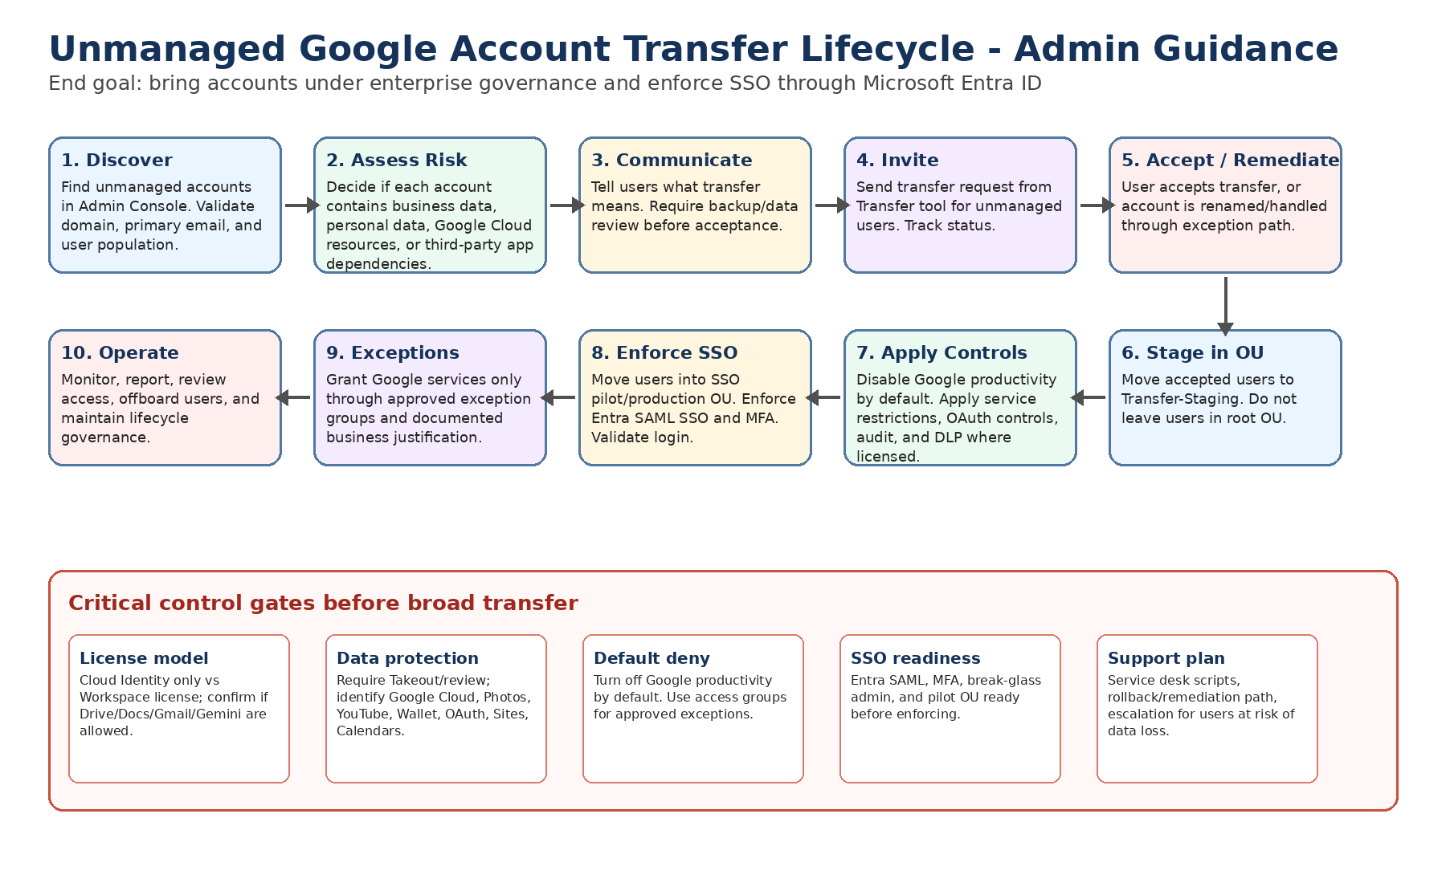
Control point
Do not send transfer invitations broadly until the licensing model, OU structure, Google service restrictions, backup guidance, SSO plan, and support workflow are ready.

5. Recommended OU and Access Group Model
Use OUs to apply inherited baseline policies and access groups to grant approved exceptions across the OU structure.
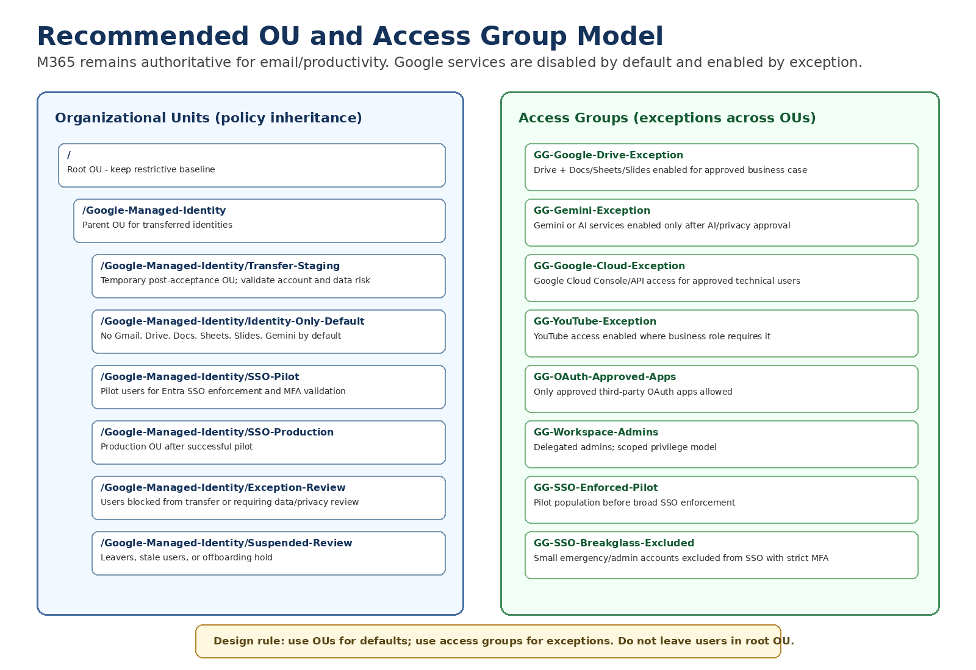

OU / group | Purpose | Key controls
/Google-Managed-Identity/Transfer-Staging | Temporary landing zone immediately after users accept transfer. | Disable productivity services. Validate login, data risk, and service needs before moving forward.
/Google-Managed-Identity/Identity-Only-Default | Long-term default OU for managed accounts that do not require Google productivity. | Gmail, Drive/Docs, Gemini, YouTube, Photos, Wallet/Pay disabled unless approved. SSO ready.
/Google-Managed-Identity/SSO-Pilot | Controlled pilot group for Entra SSO and MFA enforcement. | Apply SSO, MFA, session controls, and help desk monitoring.
/Google-Managed-Identity/SSO-Production | Production OU for users fully onboarded into SSO. | SSO enforced, app access governed, audit reviewed.
/Google-Managed-Identity/Exception-Review | Users with complex data, personal content, Google Cloud, YouTube, Wallet, or OAuth dependency risk. | Pause transfer or restrict access until review complete.
Access group: GG-Google-Drive-Exception | Enable Drive/Docs only for approved users. | Grant service access without changing core OU membership.
Access group: GG-Google-Cloud-Exception | Enable Cloud Console only for approved technical users. | Coordinate with Google Cloud IAM and billing governance.
Access group: GG-Gemini-Exception | Enable AI services only after AI governance approval. | Restrict to approved roles and data handling rules.

6. Licensing and Service Access Model
Accepting a transfer invitation changes the account ownership model; it does not automatically mean the user receives a full Google Workspace productivity experience. Service access depends on license assignment, service status, OU/group policy, and product availability.
Scenario | Likely result | Risk | Admin mitigation
Cloud Identity / identity-only model; no Workspace productivity license | User becomes a managed identity. Gmail and certain Workspace productivity services may not be available unless licensed and enabled. | User expects to continue Drive/Docs access from personal account period but service may be unavailable. | Communicate before transfer; use staging OU; evaluate if temporary license or exception is required for data review.
Workspace license exists but service is disabled | User has a license, but disabled services are hidden or blocked when they sign in. | User believes data is lost because apps no longer appear. | Create temporary data-retrieval exception process where approved.
Gmail not activated because M365 is authoritative | Email continues in Outlook/M365. Gmail should remain off and MX records should not be changed. | Confusion if user tries Gmail and expects corporate mail. | State clearly: email remains Outlook; Google account is for governance/approved services only.
Workspace license assigned accidentally | User may get Drive/Docs/Gmail/Gemini access depending on service settings. | Shadow Google productivity usage starts again. | Disable auto-license where possible; restrict services by OU; use exception groups.
Services enabled at root OU | Transferred users landing in root OU may inherit broad access. | Users get unintended Google services before review. | Set restrictive root baseline before inviting users; immediately move accepted users to staging OU.

Enterprise policy wording
In this operating model, Microsoft 365 remains the approved platform for email and productivity. Transferred Google accounts are managed identities by default. Gmail, Drive, Docs, Sheets, Slides, Gemini, and other Google services are not enabled unless approved through an exception process.

7. Can the Organization See or Manage User Data Without Workspace Productivity Licenses?
After acceptance, Google indicates the organization can manage the account and may access or delete account data. However, the practical ability to view, export, retain, investigate, or recover data depends on licensing, service status, admin privileges, and product-specific tools.
Question | Answer for enterprise planning
Can the organization manage the account after transfer? | Yes. The account becomes managed by the organization. The admin can apply policies, suspend the account, manage identity lifecycle, and restrict services.
Can the organization guarantee users will keep normal access to old Drive/Docs data without licenses? | No. Access can change if Drive/Docs are not licensed or are disabled by policy. This is why backup and staged review are required before acceptance.
Can admins see all user data immediately with Cloud Identity only? | Do not assume full productivity data visibility. Identity controls are available, but data-level admin actions depend on enabled services, licenses, and admin tools.
Can disabling services delete data? | Turning off a service may block access but does not necessarily equal immediate deletion. However, Google warns policies and insufficient licensing/storage can cause data impact. Treat this as a data-loss risk until validated.
What should users do before accepting? | Use Google Takeout and review personal/business data, third-party apps, Photos, YouTube, Wallet, Maps, Sites, secondary calendars, and Google Cloud resources.

Safe guidance to users
If the account contains any important personal or business data, do not accept the invitation until backup is complete and the project team confirms what services will remain available after transfer.

8. Admin Steps: Transfer and Remediation Process

8.1 Locate unmanaged users
Step 1: Go to https://admin.google.com and sign in as a Super Administrator.
Step 2: Go to Menu > Directory > Users.
Step 3: Select More options > Transfer tool for unmanaged users.
Step 4: Wait up to 24 hours after domain verification if users do not appear immediately.

8.2 Send transfer invitations
Step 1: In the Transfer tool, filter for users with Request status = Not sent.
Step 2: Select one pilot user or a small pilot group first. Do not start with broad production population.
Step 3: Click Email transfer request.
Step 4: Confirm the request is sent and record the request date, user, business unit, and pilot wave.

8.3 Monitor invitation status
Step 1: Return to Transfer tool for unmanaged users.
Step 2: Filter by Sent, Accepted, or Cancelled request status.
Step 3: Resend requests only after the user communication/reminder window has passed.
Step 4: If the user does not respond, follow the non-responsive user escalation and rename/remediation path.

8.4 Post-acceptance staging
Step 1: Search for the accepted user under Directory > Users.
Step 2: Move the user immediately into /Google-Managed-Identity/Transfer-Staging.
Step 3: Confirm baseline services are disabled according to policy.
Step 4: Validate login path and decide when the user can move into SSO-Pilot or Identity-Only-Default.

9. Admin Steps: Restrict Google Services by OU and Groups
Google documentation states that admins can turn services on or off for users in the Admin console. Users see only the services that are turned on for them. The recommended model is to disable services by default at root/identity OU and enable only through exception OUs or access groups.

9.1 Turn Google Workspace services off by default
Step 1: Go to Admin console > Apps > Google Workspace.
Step 2: Open Service status.
Step 3: Select the OU that represents default transferred users, such as /Google-Managed-Identity/Identity-Only-Default.
Step 4: For Gmail, Drive and Docs, Calendar, Meet, Chat, Sites, Keep, and other Workspace services, set Service status to Off unless explicitly approved.
Step 5: Save changes and allow time for propagation. Google notes changes can take up to 24 hours, but typically happen faster.

9.2 Restrict additional Google services
Step 1: Go to Admin console > Apps > Additional Google services.
Step 2: Review services such as YouTube, Google Photos, Google Pay, Google Maps, Search and Assistant, Gemini, NotebookLM, Google Cloud, and Web & App Activity.
Step 3: Turn services Off for default OUs where they are not approved.
Step 4: Create exception groups for services that require approved business access.

9.3 Use access groups for approved exceptions
Step 1: Create Google Groups such as GG-Google-Drive-Exception, GG-Gemini-Exception, GG-Google-Cloud-Exception, and GG-OAuth-Approved-Apps.
Step 2: Return to the service configuration page.
Step 3: Use service access customization to enable the service for the specific access group while keeping it off for the default OU.
Step 4: Document the requestor, business justification, approval date, expiry/review date, and data classification conditions.

9.4 Restrict third-party OAuth access
Step 1: Go to Admin console > Security > API controls.
Step 2: Open App access control.
Step 3: Classify approved, limited, and blocked applications.
Step 4: Restrict untrusted third-party apps for default users.
Step 5: Create a review process for business-required OAuth applications before users are transferred at scale.

10. Admin Steps: Prepare for SSO Enforcement
The end goal is to enforce SSO. Do not enforce SSO on newly transferred users until the pilot OU, exception handling, and break-glass strategy are ready.
Phase | Admin action | Exit criteria
Phase 0 - Baseline | Create restrictive OUs, disable services by default, create exception groups, confirm super admin access. | Admin console stable; service matrix approved.
Phase 1 - Transfer pilot | Invite a small group of unmanaged users. Move accepted users into Transfer-Staging. | User acceptance tested; backup/comms validated.
Phase 2 - SSO pilot | Move selected users to SSO-Pilot. Configure Microsoft Entra ID SAML SSO and MFA. | Users can sign in through Entra ID; service desk scripts validated.
Phase 3 - Production enforcement | Move users into SSO-Production. Enforce SSO for target OUs/groups. | Login success rate acceptable; break-glass tested; monitoring active.
Phase 4 - Operations | Run access reviews, service exception reviews, and offboarding controls. | Recurring governance process operational.

Break-glass requirement
Maintain a small number of emergency admin accounts that are excluded from SSO, protected with strong MFA, monitored, and stored in a controlled emergency access process. Without this, an SSO misconfiguration can lock administrators out.

11. Edge Cases and Failure Scenarios
The following scenarios should be included in project risk planning before transfer invitations are sent at scale.
# | Scenario | What can happen | Risk | Mitigation
1 | User accepts but no Google productivity license exists | Drive/Docs/Gmail may not be accessible after transfer. | User believes data is lost. | Require Takeout; consider temporary licensed exception for data review; communicate M365-only model.
2 | Service disabled by OU after acceptance | App disappears or returns access denied. | User cannot retrieve data through normal UI. | Use Transfer-Staging OU and temporary retrieval exception where approved.
3 | Transferred user lands in root OU | User inherits unintended services or settings. | Shadow Google usage or policy gap. | Set restrictive root baseline and move users immediately to staging OU.
4 | Gmail not enabled because M365 is authoritative | User cannot use Gmail for corporate mail. | Confusion and support calls. | State email remains Outlook; do not change MX records.
5 | Workspace license assigned accidentally | Drive/Docs/Gmail/Gemini may become available. | Unapproved productivity usage. | Disable auto-licensing; service off by default; exception groups only.
6 | User has personal data mixed with business data | Personal data becomes subject to organization management. | Privacy complaint or personal data exposure. | Require review and backup; allow rename path for personal accounts.
7 | User ignores transfer request | Unmanaged account remains outside control. | Conflict remains; SSO cannot govern identity. | Resend and escalate; later require rename or create managed account conflict path.
8 | Admin creates managed user instead of transfer | Unmanaged account may be forced to rename/temp account path. | User confusion; access to old content may be disrupted. | Use invite-first for accounts with possible business data.
9 | User is member of Google Family group | Transfer may not be supported. | Acceptance fails. | User leaves family group or organization uses rename/remediation path.
10 | Conflict is on alias/alternate email | Transfer tool may not handle it. | User not visible or not transferable. | Confirm primary email. Use manual account review.
11 | Domain recently verified | Unmanaged users may not appear for up to 24 hours. | False assumption no unmanaged accounts exist. | Wait and re-check before closing discovery.
12 | User has Google Cloud projects or billing | Projects, IAM roles, billing, APIs may be tied to unmanaged account. | Service disruption or billing risk. | Inventory Cloud resources before transfer; coordinate with cloud admins.
13 | User has YouTube channel/Brand Account | Ownership/admin access may behave differently after transfer or service restrictions. | Loss of channel access or business interruption. | Identify YouTube assets and approved owner migration before transfer.
14 | User has Google Photos or personal subscriptions | Photos/Wallet/Pay/subscriptions may be affected by org control or service off policy. | Personal data concerns; payment/subscription disruption. | Move personal services to personal Gmail before acceptance.
15 | User uses Sign in with Google for third-party apps | OAuth restrictions may block apps after transfer. | User loses access to external services. | Review connected apps; approve business apps via API controls.
16 | User has Google Sites or secondary calendars | Some pre-transfer assets may not be manageable after transfer. | Loss of manageability or ownership confusion. | Inventory and migrate ownership before acceptance.
17 | Takeout not completed before acceptance | After transfer, service restrictions may block export. | User cannot easily export personal/important data. | Make Takeout/backup a required pre-acceptance step.
18 | Retention/Vault/DLP policies apply immediately | Data may be retained, deleted, blocked, or investigated based on policy. | Unexpected data impact. | Review policy impact before transfer; stage pilot.
19 | SSO enforced before user is ready | User cannot sign in if Entra mapping/MFA is wrong. | Lockout and support disruption. | Use SSO-Pilot OU and validate UPN/email mapping before enforcement.
20 | Google 2-Step Verification conflicts with Entra MFA | User faces extra prompts or blocked sign-in. | Poor user experience or lockout. | Define MFA source of truth; test with pilot users.
21 | Super admin or break-glass accounts impacted by SSO | Admins can lock themselves out. | High-severity outage. | Exclude controlled break-glass accounts from SSO; test recovery.
22 | Outlook mail flow/quarantine blocks invite | User never receives invitation. | Transfer stalled. | Coordinate with M365 mail/security team; check junk/quarantine.
23 | User leaves organization during migration | Unmanaged account may remain active with corporate identity. | Offboarding gap. | Prioritize leavers; suspend managed accounts once transferred; force rename path if needed.
24 | No documented exception expiry | Temporary exceptions become permanent. | Governance drift. | Every exception group membership requires expiry and review date.

12. Pilot Execution Plan
Wave | Scope | Activities | Go/no-go criteria
Pilot 0 | IT administrators and test accounts only | Validate transfer invitation, backup guidance, root OU restrictions, service off behavior, and SSO pilot. | No lockouts; service matrix works; documentation validated.
Pilot 1 | Small business unit with low Google dependency | Send invitations, move users to staging, validate Outlook email remains unchanged, test SSO. | Support tickets manageable; no unresolved data-loss issues.
Pilot 2 | Users with known Google usage | Pre-review Drive/Cloud/YouTube/OAuth dependencies; use exception handling. | All high-risk accounts have remediation plan.
Production | Phased business units | Transfer waves, SSO enforcement waves, recurring exception review. | Metrics meet threshold and support model is stable.

13. Service Desk and User Communications
Provide the following guidance to users before they accept the invitation.
- Your corporate email remains in Outlook/Microsoft 365. This change does not move your mailbox to Gmail.
- The Google account transfer brings the account under organizational management.
- Some Google services may be turned off after the transfer because Microsoft 365 is the approved productivity platform.
- Back up or move personal content before accepting. Use Google Takeout where appropriate.
- If you use Google Drive, YouTube, Photos, Google Cloud, Maps, Wallet, subscriptions, or Sign in with Google, contact the project team before accepting.
- After transfer, sign-in may be routed through corporate SSO and MFA.
User says | Service desk response
I cannot see Drive after accepting. | Confirm OU, license, and service status. If policy blocks Drive, escalate to data-retrieval/exception process.
I use this account for YouTube or Photos. | Pause transfer if not accepted; after acceptance, escalate for service-specific review.
I never received the invite. | Check Outlook junk/quarantine and verify admin sent request. Resend if needed.
I cannot sign in after transfer. | Check SSO OU placement, Entra account mapping, MFA state, and Google account suspension status.
I do not want personal data managed by the organization. | Use rename/remediation path instead of accepting transfer if policy allows.

14. Checklists
Before broad invitations | Complete?
Domain verified and transfer tool accessible
Restrictive root baseline configured
Transfer-Staging OU created
Identity-Only-Default OU created
SSO-Pilot and SSO-Production OUs created
Gmail, Drive/Docs, Gemini, YouTube, Photos/Pay service status reviewed
OAuth app restrictions configured
Exception groups created and approval workflow defined
User backup/Takeout guide distributed
Service desk scripts and escalation path ready
Entra SSO/MFA tested with pilot accounts
Break-glass admin strategy tested

15. Official Google References
- Find and add unmanaged users: https://knowledge.workspace.google.com/admin/users/find-and-add-unmanaged-users
- Before using the transfer tool: https://knowledge.workspace.google.com/admin/users/before-using-the-transfer-tool
- Use the transfer tool to migrate unmanaged users: https://knowledge.workspace.google.com/admin/users/use-the-transfer-tool-to-migrate-unmanaged-users
- Turn a service on or off for Google Workspace users: https://support.google.com/a/answer/182442?hl=en
- Cloud Identity editions: https://cloud.google.com/identity/docs/editions
- Can't sign in to the Admin console: https://knowledge.workspace.google.com/admin/support/troubleshooting/cant-sign-in-to-the-admin-console
- Domain in use recovery: https://support.google.com/a/contact/domain_in_use

Appendix A. Evidence Screenshots from Testing

Page 1 - Admin conflict flow showing transfer request vs create-new-user remediation option.
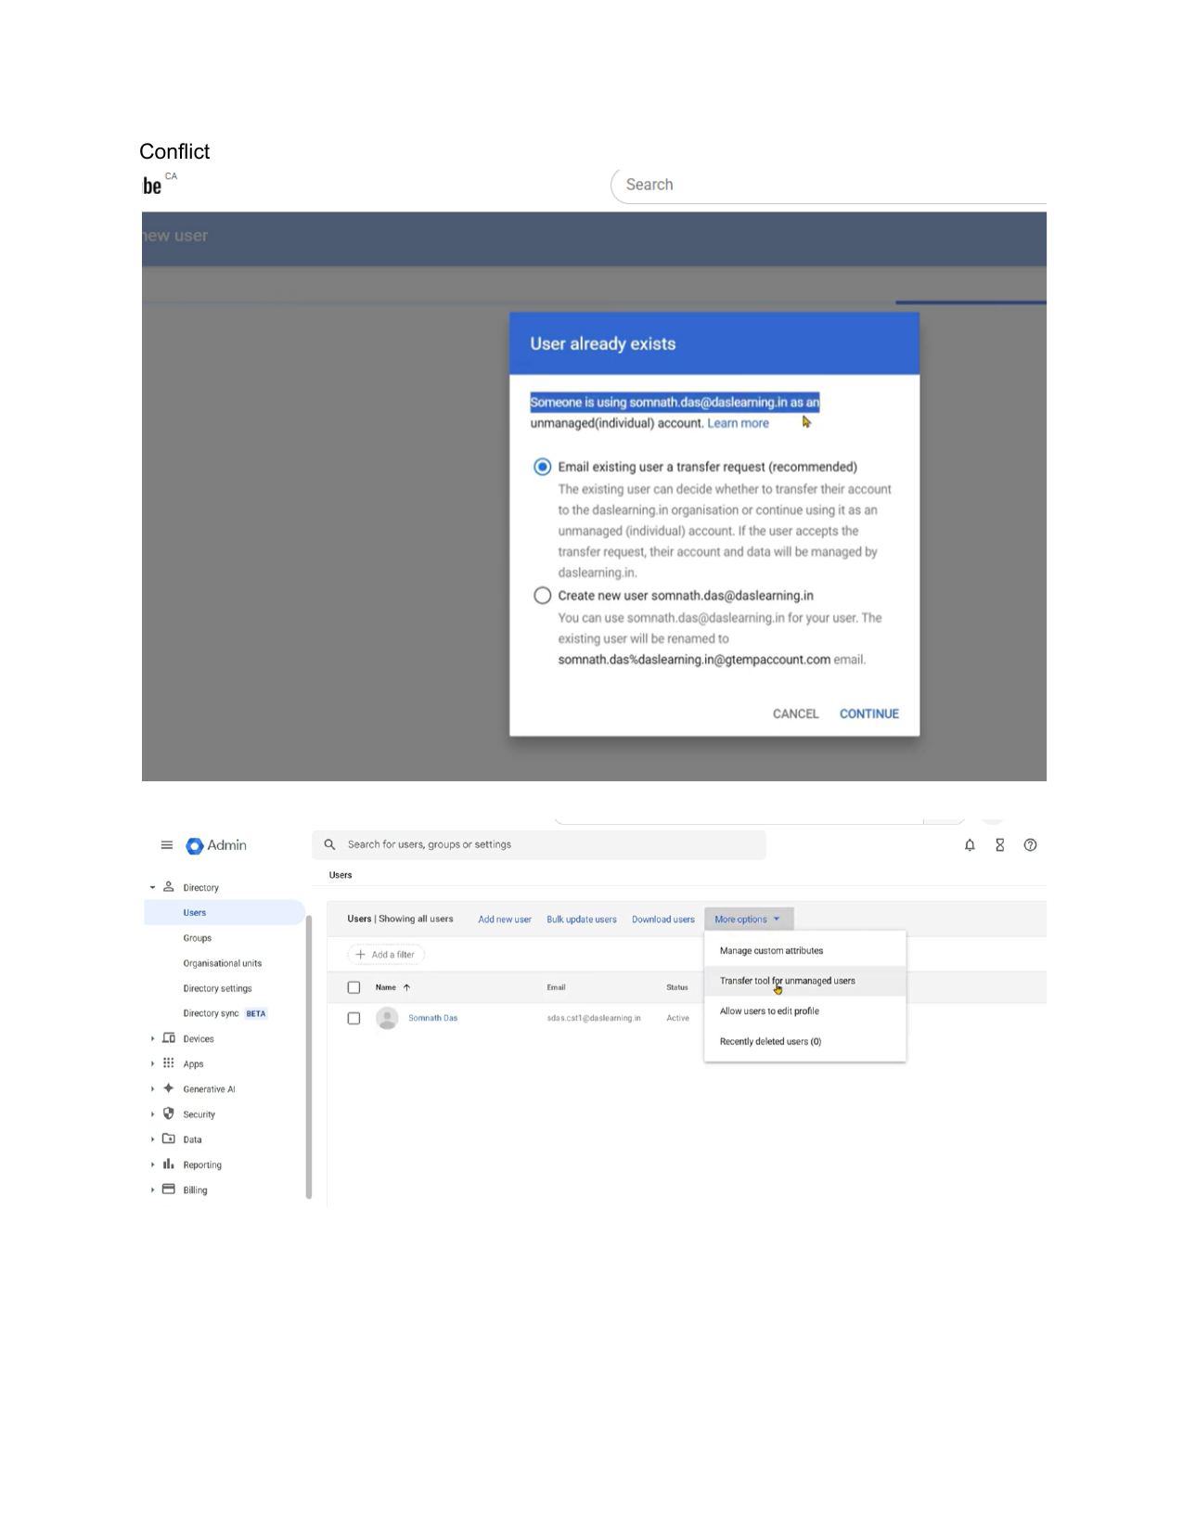

Page 2 - User transfer email received, showing the unmanaged account transfer request.
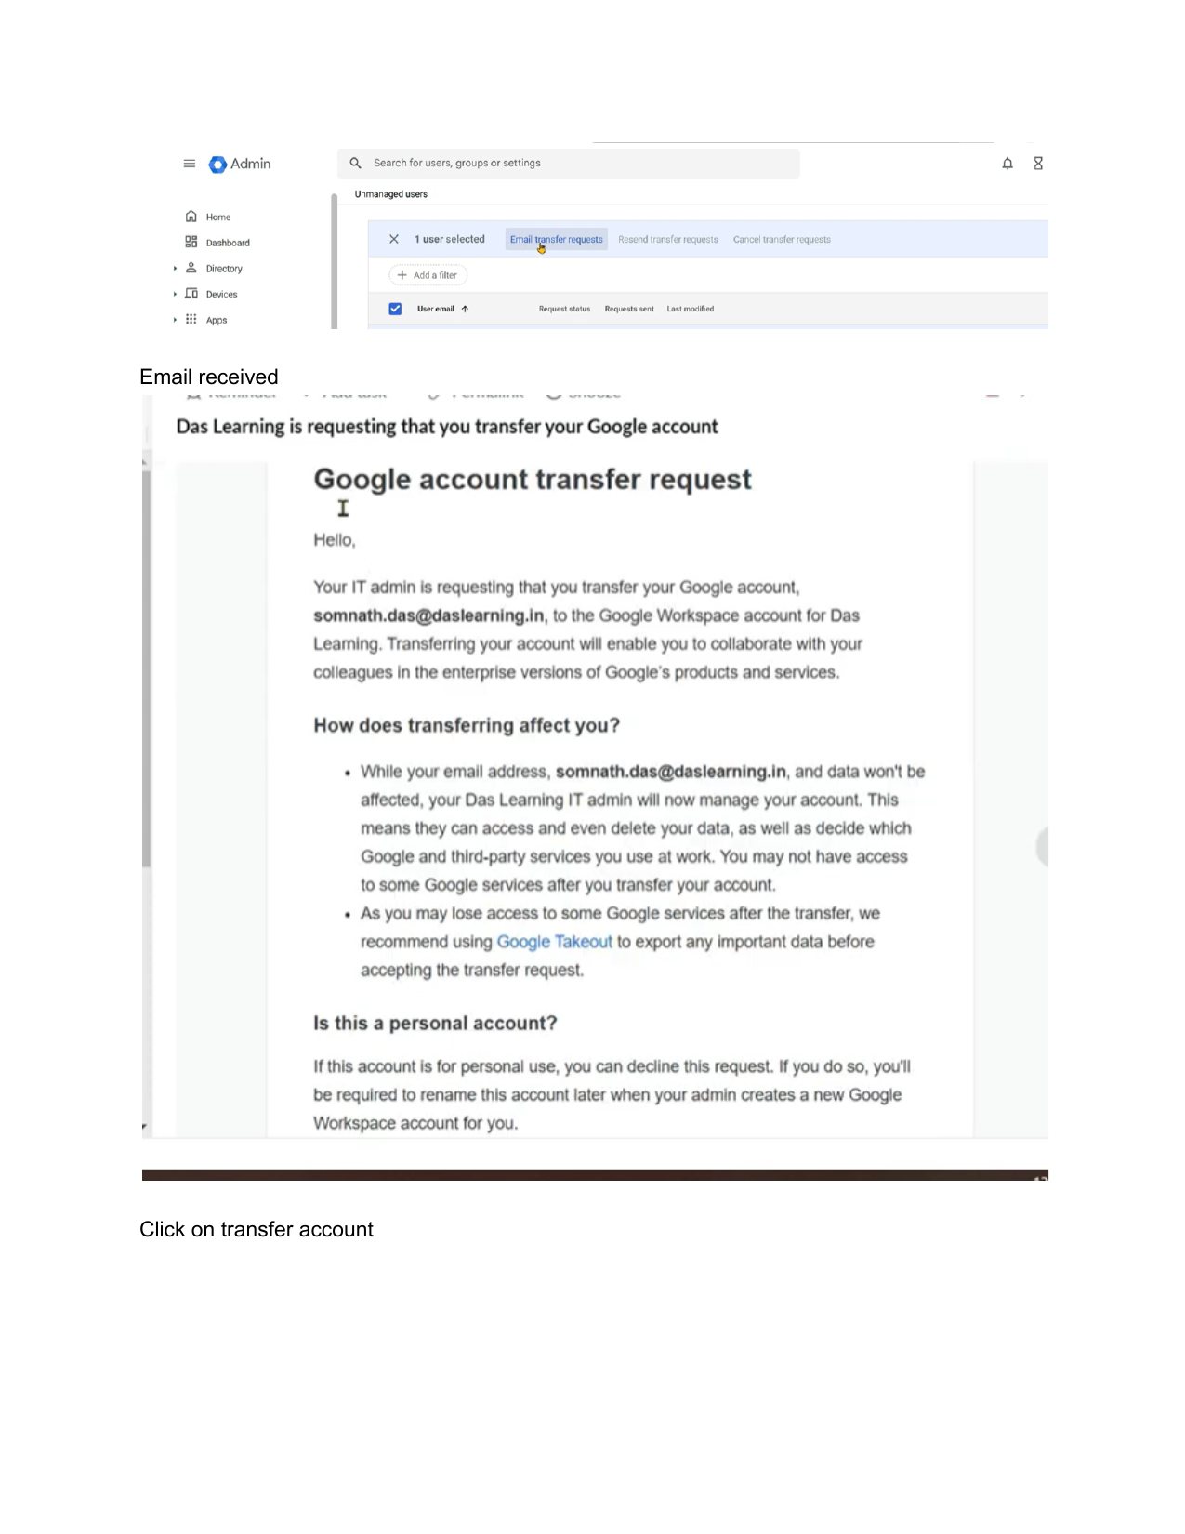

Page 3 - User clicks Transfer account from the email invitation.
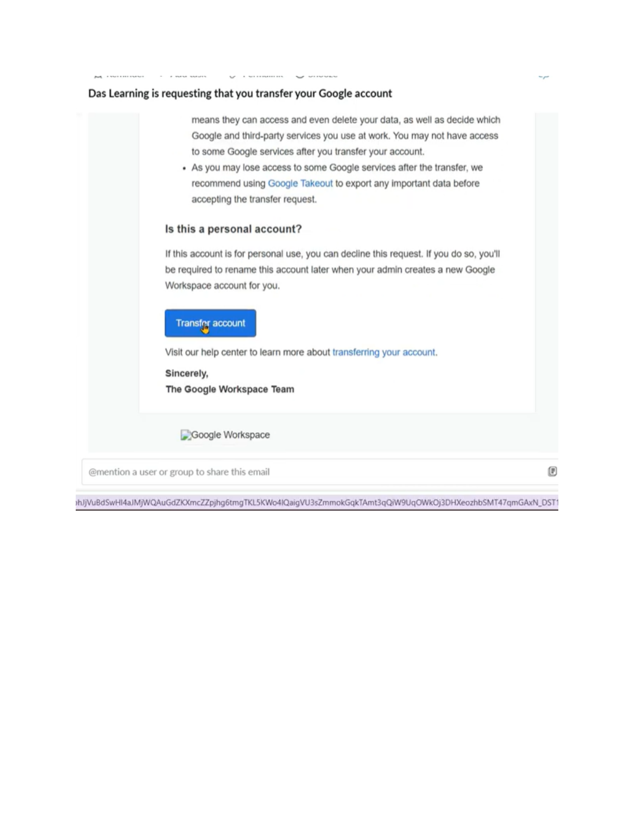

Page 4 - User acceptance screen showing managed account warning and post-transfer app view.
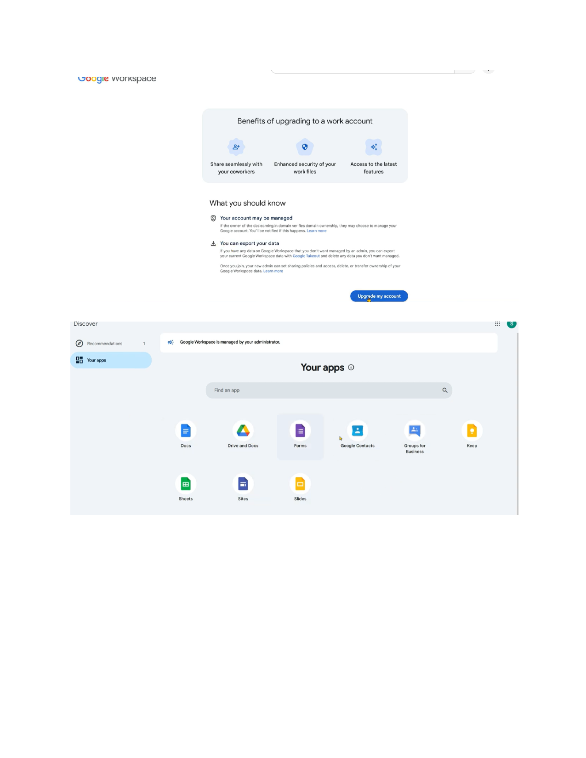

Part 7 - Bringing Transferred Managed Google Users Under Microsoft Entra Provisioning
Purpose. This section provides implementation guidance for bringing transferred or existing managed Google users under Microsoft Entra ID provisioning so that Entra ID becomes the lifecycle source and Google Workspace / Cloud Identity becomes the governed target. This section should be used after unmanaged users have accepted the Google transfer invitation and after the Google account is visible as a managed user in the Google Admin Console.
Target State
Microsoft Entra ID is the identity lifecycle source. Google Workspace / Cloud Identity is the provisioned target. SSO is enforced through Microsoft Entra ID. User creation, update, suspension, group membership, and lifecycle operations are controlled from Entra ID after identity reconciliation is complete.

7.1 Why This Section Belongs in the Transfer and Remediation Guide
The correct document to update is the Unmanaged Google Accounts Transfer and Remediation Guide because the Entra provisioning step happens after a user accepts the unmanaged account transfer invitation. The transfer process brings the Google account under organizational control; Entra provisioning then matches and manages that existing Google account going forward.
- Do not rely on Entra provisioning to resolve unmanaged Google account conflicts automatically.
- Do not delete and recreate transferred Google accounts unless there is no data to preserve and the business has approved that remediation path.
- The purpose of the transfer is to preserve the existing Google identity and data while bringing it under organizational governance.
- The purpose of Entra provisioning is to manage the existing Google account lifecycle going forward, not to create a duplicate account.

7.2 End-to-End Lifecycle Flow
The following lifecycle should be followed for unmanaged users that are moving from personal/unmanaged Google accounts to managed Google accounts and then into Microsoft Entra provisioning scope.
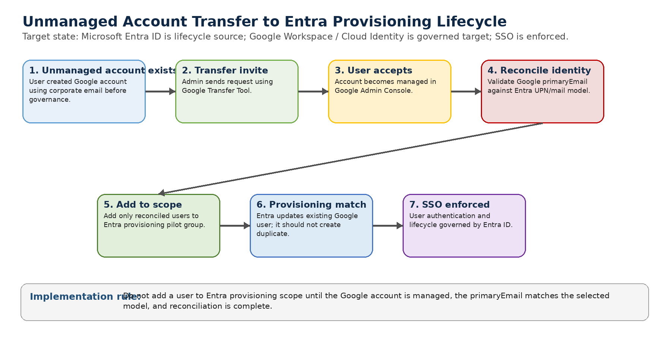

7.3 Required Implementation Rule
Implementation Rule
Do not add a user into Entra provisioning scope until all three conditions are true: (1) the Google account is managed in Google Admin Console, (2) the Google primaryEmail matches the selected Entra mapping model, and (3) the user has been validated in the reconciliation table.

7.4 Why Matching Matters
Microsoft Entra provisioning uses matching rules and mapped attributes to determine whether an Entra user corresponds to an existing target application user. If the value sent by Entra does not match the existing Google account identifier, provisioning can fail to match the existing account and may attempt to create a new account. This creates duplicate-account risk, especially when some Google accounts use UPN-style addresses and other Google accounts use email-style addresses.
User | Entra UPN | Entra Mail | Existing Google Account | Provisioning Risk if primaryEmail = UPN
User A | gsingh35@calgary.ca | gavin.singh@calgary.ca | gsingh35@calgary.ca | Likely match
User B | jsmith35@calgary.ca | john.smith@calgary.ca | john.smith@calgary.ca | May not match; duplicate or error risk

7.5 Mixed Identity Scenario: 50% UPN and 50% Email-Based Google Accounts
If some Google accounts use UPN-based addresses and others use email-based addresses, Entra provisioning should not be enabled broadly until identity reconciliation has been completed. Entra does not automatically know which format to use per user unless the implementation has intentionally designed a validated matching model, scoping model, or migration strategy.
- If primaryEmail is mapped to userPrincipalName, UPN-based Google users may match correctly, but email-based Google users may not match.
- If primaryEmail is mapped to mail, email-based Google users may match correctly, but UPN-based Google users may not match.
- If mismatches are not remediated before broad provisioning, duplicate users, provisioning errors, or lifecycle gaps may occur.
- SSO enforcement should not be applied broadly until the user exists in both Entra ID and Google with the expected matching identifier.

7.6 Identity Reconciliation Decision Flow
The reconciliation process is the control point between Google transfer completion and Entra lifecycle management. This process should be completed before adding users into the Entra provisioning scope.
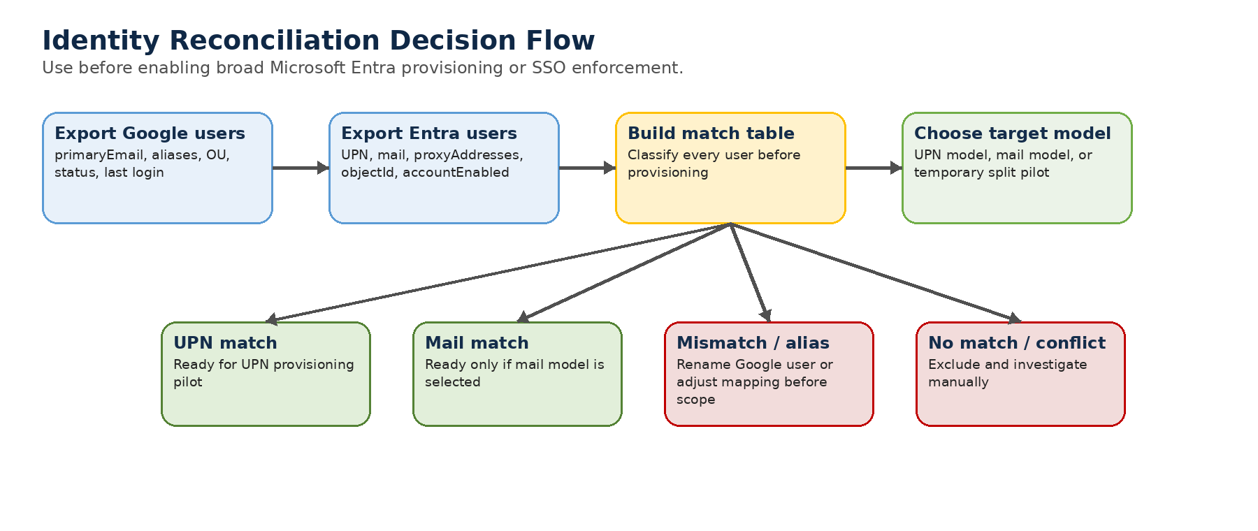

7.7 Reconciliation Workbook
Create a reconciliation workbook before enabling broad provisioning. The workbook should compare exported Google users against exported Entra users and classify every user into a match category.
Column | Description
Google primaryEmail | Current Google login/account identifier
Google aliases | Any alternate addresses on the Google account
Google OU | Current Google organizational unit
Google status | Active, suspended, transferred, or pending remediation
Entra objectId | Stable Entra object identifier
Entra userPrincipalName | UPN used by Entra authentication and provisioning
Entra mail | Business email address attribute in Entra
Entra proxyAddresses | Other email aliases associated with the user
Match type | UPN match, mail match, alias match, mismatch, no match, or conflict
Target Google primaryEmail | Final standardized Google account address
Required action | No change, rename Google user, add alias, investigate, exclude, or manual remediation
Provisioning ready | Yes or No

7.8 Match Classification Model
Match Type | Condition | Action
UPN match | Google primaryEmail equals Entra userPrincipalName | Ready if the target model is UPN
Mail match | Google primaryEmail equals Entra mail | Ready if the target model is mail
Alias match | Google primaryEmail or alias matches UPN/mail/proxyAddresses | Review and standardize before provisioning
Mismatch | Google account belongs to the user but does not match the selected target model | Rename Google primaryEmail or adjust mapping before provisioning
No match | No corresponding Entra user found | Do not provision; investigate ownership and business need
Conflict | Multiple Google accounts or multiple Entra users could match | Manual remediation required before provisioning or SSO enforcement

7.9 Select the Target Identity Model
The project team must select one standard model before production provisioning. The selected model must align with user sign-in experience, support readiness, Google primaryEmail values, Entra attributes, and long-term SSO enforcement.

Option A - Standardize Google primaryEmail to Entra UPN
Use this model if the organization wants the Google identity to match the Microsoft Entra UPN. This is often cleaner where users already sign in to enterprise systems with UPN-style identifiers.
- Target: Google primaryEmail = Entra userPrincipalName.
- Example: Google primaryEmail changes from john.smith@calgary.ca to jsmith35@calgary.ca.
- The old email-style address can remain as a Google alias where required and technically supported.
- Entra provisioning mapping: primaryEmail = userPrincipalName.
- SSO login experience must be communicated clearly because users may enter UPN rather than email address.

Option B - Standardize Google primaryEmail to Entra mail
Use this model if the organization wants Google accounts to use the normal business email address.
- Target: Google primaryEmail = Entra mail.
- Example: Google primaryEmail = gavin.singh@calgary.ca.
- This requires the Entra mail attribute to be populated, unique, and reliable for all users in scope.
- Entra provisioning mapping: primaryEmail = mail.
- This may provide a simpler user-facing identity but requires strong mail attribute quality.

Option C - Temporary Split Model for Migration Only
A temporary split model may be used only for controlled migration waves where one cohort uses UPN mapping and another cohort uses mail mapping. This should not be the long-term operating model because it increases support complexity and duplicate-risk.
Provisioning Scope | Mapping | Use Case
UPN cohort | primaryEmail = userPrincipalName | Users whose existing Google primaryEmail already matches UPN
Email cohort | primaryEmail = mail | Users whose existing Google primaryEmail already matches mail

7.10 Standard Remediation Procedure After Transfer Acceptance
- Confirm the user accepted the transfer request and the account appears as a managed user in Google Admin Console.
- Export or record the Google primaryEmail, aliases, OU, status, and last login date.
- Find the corresponding Entra user by UPN, mail, proxyAddresses, employee ID, or verified authoritative HR record.
- Classify the account as UPN match, mail match, alias match, mismatch, no match, or conflict.
- Validate the selected target identity model for the user.
- Rename the Google primaryEmail where required before adding the user to Entra provisioning scope.
- Add the user to the Entra provisioning pilot group only after reconciliation is complete.
- Run on-demand provisioning and confirm Entra updates the existing Google user rather than creating a duplicate.
- Review provisioning logs and Google Admin Console for expected attribute updates.
- After provisioning is validated, move the user into the correct OU and proceed toward SSO enforcement.

7.11 Microsoft Entra Provisioning Configuration Guidance
Provisioning should be configured in the Google Cloud / G Suite Connector enterprise application in Microsoft Entra ID. The provisioning scope should initially be limited to assigned users and groups so that only reconciled users are provisioned during the pilot stage.
- Use Sync only assigned users and groups for pilot and early production waves.
- Use on-demand provisioning to validate each test user before enabling a larger provisioning cycle.
- Do not use broad all-user provisioning until the reconciliation workbook is complete and exceptions are resolved.
- Configure mappings only after the identity model is confirmed.
- Required core mappings should include primaryEmail, givenName, familyName, and suspended/lifecycle status where supported by the connector.

UPN Model Mapping
If the selected model is UPN, map the Google primary email to Entra userPrincipalName.
Example:
primaryEmail = userPrincipalName
If domain substitution is required, use a validated transformation expression and test it with pilot users before production rollout.

Mail Model Mapping
If the selected model is mail, map the Google primary email to the Entra mail attribute.
primaryEmail = mail

7.12 SSO Enforcement Dependency
SSO enforcement is the end goal, but it should follow provisioning and identity reconciliation. If SSO is enforced before users are properly matched and provisioned, users may be redirected to Entra ID but fail authentication because the expected Entra identity does not match the Google account identifier.
Pre-SSO Check | Expected Result
Google account is managed | User exists in Google Admin Console as a managed user
Google primaryEmail matches target model | Identifier aligns to UPN or mail mapping
User is in Entra provisioning scope | Assigned to pilot or production provisioning group
Provisioning logs are clean | No duplicate creation or unresolved errors
SSO pilot OU configured | Only validated users are moved into SSO-enforced OU
Break-glass admin accounts excluded | Emergency access remains available

7.13 Recommended OU and Group Model for SSO Enforcement
Use OU placement for Google-side policy enforcement and Entra groups for provisioning scope control. This provides a controlled path from transfer acceptance to provisioning validation to SSO enforcement.
Google OU / Entra Group | Purpose
/Unmanaged-Transfer-Staging | Transferred users land here while identity reconciliation is completed
/Provisioning-Pilot | Users validated for Entra provisioning pilot
/SSO-Pilot | Users validated for SSO enforcement pilot
/Employees | Production managed employee OU after validation
/Contractors | Production managed contractor OU after validation
/Exception-Google-Services | Users with approved access to Google services beyond identity
AAD-Google-Provisioning-Pilot | Entra group used to scope pilot provisioning
AAD-Google-SSO-Pilot | Entra group used to scope SSO testing and user communications

7.14 Validation Checklist
Validation Item | Expected Result
Transferred Google account appears in Admin Console | Yes
Google primaryEmail reviewed against target identity model | Yes
Google aliases reviewed | Yes
Entra UPN and mail values reviewed | Yes
Match type documented in reconciliation workbook | Yes
No duplicate Google account exists for same person | Yes
User added to Entra provisioning pilot scope | Only after reconciliation
On-demand provisioning updates existing Google account | Yes
Provisioning logs reviewed | No critical errors
User moved to correct Google OU | Yes
SSO enabled only after provisioning validation | Yes

7.15 Failure Scenarios and Mitigations
Scenario | Risk | Mitigation
Google account uses mail but Entra sends UPN | Duplicate account or failed match | Rename Google account or change mapping before provisioning
Google account uses UPN but Entra sends mail | Duplicate account or failed match | Standardize identity model before adding user to scope
User has no Entra account | SSO lockout after enforcement | Exclude and investigate before SSO
Multiple Google accounts for same person | Ambiguous lifecycle ownership | Manual remediation and business owner decision required
Transferred account contains business data | Data loss if account deleted and recreated | Do not delete; reconcile and manage existing account
Broad provisioning enabled too early | Mass duplicate creation or provisioning errors | Use pilot group and on-demand provisioning first
SSO enforced before provisioning | User cannot sign in | Enforce SSO only after provisioning and login validation
Group email mapping conflicts | Group provisioning failures | Use unique group naming or generated group domain model

7.16 Group Provisioning Guidance
Group provisioning should be handled separately from user reconciliation. Microsoft Entra groups must map to unique Google group email addresses. If groups are not mail-enabled, derive a Google group email address from a controlled naming convention or a generated unique value.
- Avoid duplicate group display names before enabling group provisioning.
- Use a dedicated group domain or subdomain pattern where appropriate, such as groups.calgary.ca.
- Use Entra group assignments or scoping filters to control which groups are provisioned.
- Validate group membership behavior separately from user account matching.

7.17 Recommended Project Wording
Project Guidance Statement
Existing Google accounts must be reconciled before Microsoft Entra provisioning is enabled broadly. If some Google accounts use UPN and others use email address, the project team must first select one target identity model. Each Google account must then be matched to the correct Entra user, standardized to the selected primary email format, and validated before being added to provisioning scope. Provisioning should update existing managed Google users, not create duplicate accounts. SSO enforcement should occur only after provisioning validation is complete.

7.18 Official References
- Google Cloud Architecture Center - Microsoft Entra ID user provisioning and single sign-on: https://docs.cloud.google.com/architecture/identity/federating-gcp-with-azure-ad-configuring-provisioning-and-single-sign-on
- Google Cloud Architecture Center - Federate Google Cloud with Microsoft Entra ID: https://docs.cloud.google.com/architecture/identity/federating-gcp-with-azure-active-directory
- Google Cloud Architecture Center - Reconcile orphaned managed user accounts: https://docs.cloud.google.com/architecture/identity/reconciling-orphaned-managed-user-accounts
- Microsoft Learn - Configure Google Cloud / Google Workspace for automatic user provisioning: https://learn.microsoft.com/en-us/entra/identity/saas-apps/g-suite-provisioning-tutorial
- Microsoft Learn - How application provisioning works in Microsoft Entra ID: https://learn.microsoft.com/en-us/entra/identity/app-provisioning/how-provisioning-works
- Microsoft Learn - Customize application attribute mappings: https://learn.microsoft.com/en-us/entra/identity/app-provisioning/customize-application-attributes
- Microsoft Learn - Expression mappings for application provisioning: https://learn.microsoft.com/en-us/entra/identity/app-provisioning/functions-for-customizing-application-data
- Google Workspace Admin Help - Use the transfer tool to migrate unmanaged users: https://knowledge.workspace.google.com/admin/users/use-the-transfer-tool-to-migrate-unmanaged-users

