Unmanaged Google Accounts
Enterprise Transfer, Remediation, Service Restriction, and SSO Enforcement Guide
Admin Runbook | Google Workspace / Cloud Identity governance

Document purpose
This guide extends the unmanaged user transfer runbook with enterprise licensing scenarios, Google service restriction design, OU/access group structure, SSO enforcement guidance, and edge-case remediation for users accepting Google transfer invitations.

Prepared for: Identity Governance, Google Workspace/Cloud Identity Administration, Security, Privacy, Service Desk
Operating assumption: Microsoft 365 remains the approved email and productivity platform. Google productivity tools are disabled by default unless an exception is approved.
Document status: Draft enterprise guidance for validation, pilot testing, and operational planning

Table of Contents
Table of Contents
1. Executive Summary
2. Evidence from Transfer Testing
3. Target Operating Model
4. Admin Transfer Lifecycle Flow
5. Recommended OU and Access Group Model
6. Licensing and Service Access Model
7. Can the Organization See or Manage User Data Without Workspace Productivity Licenses?
8. Admin Steps: Transfer and Remediation Process
8.1 Locate unmanaged users
8.2 Send transfer invitations
8.3 Monitor invitation status
8.4 Post-acceptance staging
9. Admin Steps: Restrict Google Services by OU and Groups
9.1 Turn Google Workspace services off by default
9.2 Restrict additional Google services
9.3 Use access groups for approved exceptions
9.4 Restrict third-party OAuth access
10. Admin Steps: Prepare for SSO Enforcement
11. Edge Cases and Failure Scenarios
12. Pilot Execution Plan
13. Service Desk and User Communications
14. Checklists
15. Official Google References
Appendix A. Evidence Screenshots from Testing
Page 1 - Admin conflict flow showing transfer request vs create-new-user remediation option.
Page 2 - User transfer email received, showing the unmanaged account transfer request.
Page 3 - User clicks Transfer account from the email invitation.
Page 4 - User acceptance screen showing managed account warning and post-transfer app view.

1. Executive Summary
This guide provides an enterprise operating model for handling unmanaged Google accounts that use an organizational domain. It focuses on the administrator side of the transfer/remediation process, the impact of transferring users when the organization does not license Google productivity tools, and the controls required to support the end goal of SSO enforcement.
The target operating model assumes Microsoft 365 is the authoritative platform for email and productivity. Google Workspace or Cloud Identity is used for identity governance, domain ownership, SSO, and controlled access to approved Google services. Google Drive, Docs, Sheets, Slides, Gmail, Gemini, YouTube, Photos, Pay/Wallet, and third-party OAuth access are disabled by default unless explicitly approved.
Primary design principle
Treat unmanaged account transfer as an identity governance, data protection, and SSO-enforcement project. Do not treat it as only a Google account migration.

Program objective | Required outcome
Control unmanaged identities | Identify unmanaged Google accounts using the corporate domain and resolve them through transfer, rename, or exception review.
Protect user and organizational data | Require users to review and export personal/important data before accepting transfer.
Prevent shadow Google productivity usage | Keep Google productivity services disabled by default where Microsoft 365 is the approved platform.
Prepare for SSO enforcement | Move users through staging/pilot OUs before enforcing Microsoft Entra ID SSO and MFA.
Support exceptions | Enable approved Google services only by documented exception group and business justification.

2. Evidence from Transfer Testing
The attached transfer screenshots show the expected unmanaged account workflow.
Evidence page | What it shows | Enterprise interpretation
Page 1 | Admin conflict prompt: Google detects that a user already exists as an unmanaged individual account. Admin can email the existing user a transfer request or create a new user path that forces rename/remediation. | This proves a conflict exists when a managed account address collides with an unmanaged consumer account.
Pages 2-3 | Transfer email received by the user. The email tells the user that the organization is requesting transfer and warns that the organization can access/delete data and control services after transfer. | User communication must clearly explain privacy, data ownership, and backup expectations.
Page 4 | User acceptance page. It shows benefits of upgrading to a work account and warns that the account may be managed. It also recommends exporting data before accepting. | Backup and service-impact review must happen before broad invitations are sent.

Key finding
The testing confirms that the transfer invitation is not only a login change. It changes the account control model. Once accepted, the account becomes managed by the organization and can be subject to service restrictions, SSO, policies, and lifecycle governance.

3. Target Operating Model
The recommended enterprise operating model is default-deny for Google productivity services and exception-based access for approved use cases.
Service area | Default position | Exception path
Email | Microsoft 365 / Exchange Online remains authoritative. Gmail remains off unless a specific migration decision is made. | Do not change MX records or activate Gmail for the domain unless the organization approves a mail platform change.
Drive, Docs, Sheets, Slides | Off for default transferred users if M365 is the productivity standard. | Enable through an approved access group or OU only where business, security, privacy, and records teams approve.
Gemini / AI services | Off by default. | Enable through AI exception process, with privacy and data handling approval.
YouTube, Photos, Pay/Wallet, Maps history | Off or restricted by default, based on policy. | Approve only if business use is documented. Personal use should be moved to a personal Google account.
Google Cloud Console | Off by default for general users. | Enable for technical users through Cloud exception groups and IAM governance.
Third-party OAuth apps | Restricted by default. | Allow only approved apps through API controls and app access governance.
SSO | Pilot first, then enforce by OU/group. | Maintain break-glass admin accounts with strong MFA and documented emergency process.

4. Admin Transfer Lifecycle Flow
Use the following lifecycle to manage unmanaged account remediation from discovery through SSO enforcement.
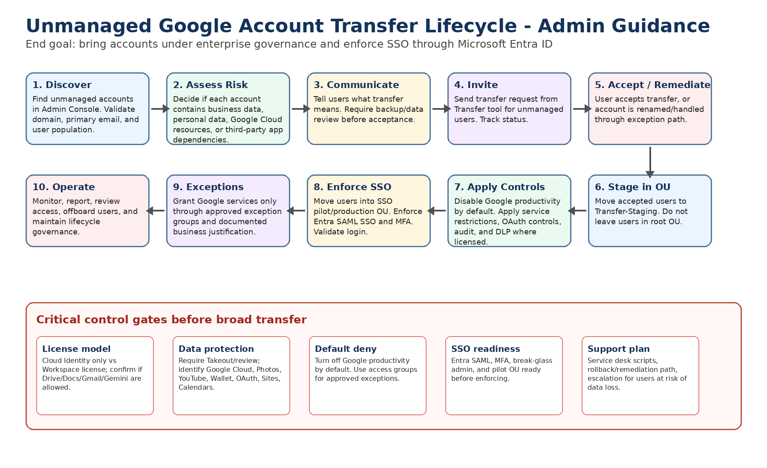
Control point
Do not send transfer invitations broadly until the licensing model, OU structure, Google service restrictions, backup guidance, SSO plan, and support workflow are ready.

5. Recommended OU and Access Group Model
Use OUs to apply inherited baseline policies and access groups to grant approved exceptions across the OU structure.
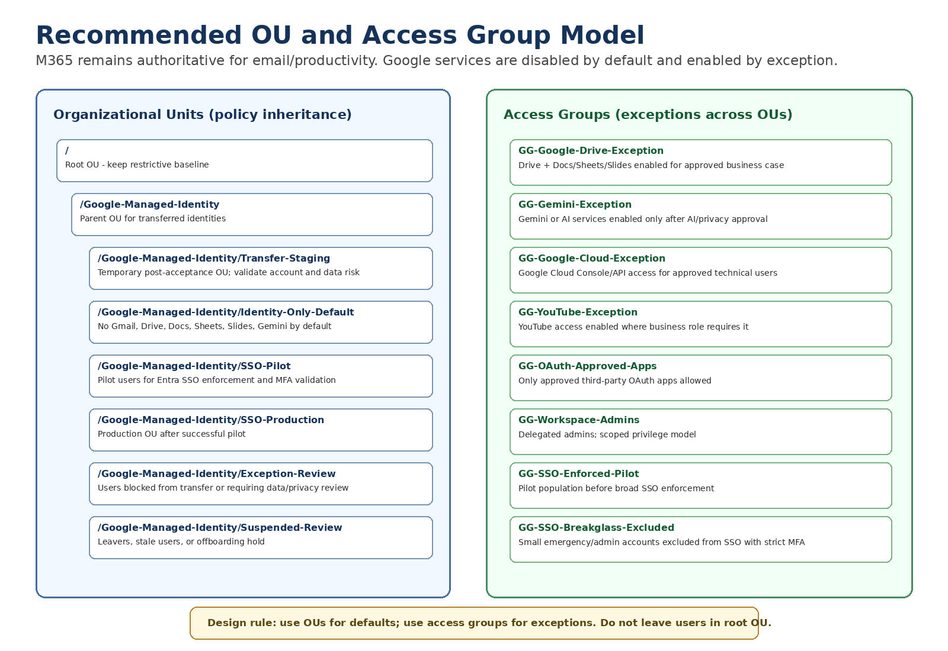

OU / group | Purpose | Key controls
/Google-Managed-Identity/Transfer-Staging | Temporary landing zone immediately after users accept transfer. | Disable productivity services. Validate login, data risk, and service needs before moving forward.
/Google-Managed-Identity/Identity-Only-Default | Long-term default OU for managed accounts that do not require Google productivity. | Gmail, Drive/Docs, Gemini, YouTube, Photos, Wallet/Pay disabled unless approved. SSO ready.
/Google-Managed-Identity/SSO-Pilot | Controlled pilot group for Entra SSO and MFA enforcement. | Apply SSO, MFA, session controls, and help desk monitoring.
/Google-Managed-Identity/SSO-Production | Production OU for users fully onboarded into SSO. | SSO enforced, app access governed, audit reviewed.
/Google-Managed-Identity/Exception-Review | Users with complex data, personal content, Google Cloud, YouTube, Wallet, or OAuth dependency risk. | Pause transfer or restrict access until review complete.
Access group: GG-Google-Drive-Exception | Enable Drive/Docs only for approved users. | Grant service access without changing core OU membership.
Access group: GG-Google-Cloud-Exception | Enable Cloud Console only for approved technical users. | Coordinate with Google Cloud IAM and billing governance.
Access group: GG-Gemini-Exception | Enable AI services only after AI governance approval. | Restrict to approved roles and data handling rules.

6. Licensing and Service Access Model
Accepting a transfer invitation changes the account ownership model; it does not automatically mean the user receives a full Google Workspace productivity experience. Service access depends on license assignment, service status, OU/group policy, and product availability.
Scenario | Likely result | Risk | Admin mitigation
Cloud Identity / identity-only model; no Workspace productivity license | User becomes a managed identity. Gmail and certain Workspace productivity services may not be available unless licensed and enabled. | User expects to continue Drive/Docs access from personal account period but service may be unavailable. | Communicate before transfer; use staging OU; evaluate if temporary license or exception is required for data review.
Workspace license exists but service is disabled | User has a license, but disabled services are hidden or blocked when they sign in. | User believes data is lost because apps no longer appear. | Create temporary data-retrieval exception process where approved.
Gmail not activated because M365 is authoritative | Email continues in Outlook/M365. Gmail should remain off and MX records should not be changed. | Confusion if user tries Gmail and expects corporate mail. | State clearly: email remains Outlook; Google account is for governance/approved services only.
Workspace license assigned accidentally | User may get Drive/Docs/Gmail/Gemini access depending on service settings. | Shadow Google productivity usage starts again. | Disable auto-license where possible; restrict services by OU; use exception groups.
Services enabled at root OU | Transferred users landing in root OU may inherit broad access. | Users get unintended Google services before review. | Set restrictive root baseline before inviting users; immediately move accepted users to staging OU.

Enterprise policy wording
In this operating model, Microsoft 365 remains the approved platform for email and productivity. Transferred Google accounts are managed identities by default. Gmail, Drive, Docs, Sheets, Slides, Gemini, and other Google services are not enabled unless approved through an exception process.

7. Can the Organization See or Manage User Data Without Workspace Productivity Licenses?
After acceptance, Google indicates the organization can manage the account and may access or delete account data. However, the practical ability to view, export, retain, investigate, or recover data depends on licensing, service status, admin privileges, and product-specific tools.
Question | Answer for enterprise planning
Can the organization manage the account after transfer? | Yes. The account becomes managed by the organization. The admin can apply policies, suspend the account, manage identity lifecycle, and restrict services.
Can the organization guarantee users will keep normal access to old Drive/Docs data without licenses? | No. Access can change if Drive/Docs are not licensed or are disabled by policy. This is why backup and staged review are required before acceptance.
Can admins see all user data immediately with Cloud Identity only? | Do not assume full productivity data visibility. Identity controls are available, but data-level admin actions depend on enabled services, licenses, and admin tools.
Can disabling services delete data? | Turning off a service may block access but does not necessarily equal immediate deletion. However, Google warns policies and insufficient licensing/storage can cause data impact. Treat this as a data-loss risk until validated.
What should users do before accepting? | Use Google Takeout and review personal/business data, third-party apps, Photos, YouTube, Wallet, Maps, Sites, secondary calendars, and Google Cloud resources.

Safe guidance to users
If the account contains any important personal or business data, do not accept the invitation until backup is complete and the project team confirms what services will remain available after transfer.

8. Admin Steps: Transfer and Remediation Process

8.1 Locate unmanaged users
Step 1: Go to https://admin.google.com and sign in as a Super Administrator.
Step 2: Go to Menu > Directory > Users.
Step 3: Select More options > Transfer tool for unmanaged users.
Step 4: Wait up to 24 hours after domain verification if users do not appear immediately.

8.2 Send transfer invitations
Step 1: In the Transfer tool, filter for users with Request status = Not sent.
Step 2: Select one pilot user or a small pilot group first. Do not start with broad production population.
Step 3: Click Email transfer request.
Step 4: Confirm the request is sent and record the request date, user, business unit, and pilot wave.

8.3 Monitor invitation status
Step 1: Return to Transfer tool for unmanaged users.
Step 2: Filter by Sent, Accepted, or Cancelled request status.
Step 3: Resend requests only after the user communication/reminder window has passed.
Step 4: If the user does not respond, follow the non-responsive user escalation and rename/remediation path.

8.4 Post-acceptance staging
Step 1: Search for the accepted user under Directory > Users.
Step 2: Move the user immediately into /Google-Managed-Identity/Transfer-Staging.
Step 3: Confirm baseline services are disabled according to policy.
Step 4: Validate login path and decide when the user can move into SSO-Pilot or Identity-Only-Default.

9. Admin Steps: Restrict Google Services by OU and Groups
Google documentation states that admins can turn services on or off for users in the Admin console. Users see only the services that are turned on for them. The recommended model is to disable services by default at root/identity OU and enable only through exception OUs or access groups.

9.1 Turn Google Workspace services off by default
Step 1: Go to Admin console > Apps > Google Workspace.
Step 2: Open Service status.
Step 3: Select the OU that represents default transferred users, such as /Google-Managed-Identity/Identity-Only-Default.
Step 4: For Gmail, Drive and Docs, Calendar, Meet, Chat, Sites, Keep, and other Workspace services, set Service status to Off unless explicitly approved.
Step 5: Save changes and allow time for propagation. Google notes changes can take up to 24 hours, but typically happen faster.

9.2 Restrict additional Google services
Step 1: Go to Admin console > Apps > Additional Google services.
Step 2: Review services such as YouTube, Google Photos, Google Pay, Google Maps, Search and Assistant, Gemini, NotebookLM, Google Cloud, and Web & App Activity.
Step 3: Turn services Off for default OUs where they are not approved.
Step 4: Create exception groups for services that require approved business access.

9.3 Use access groups for approved exceptions
Step 1: Create Google Groups such as GG-Google-Drive-Exception, GG-Gemini-Exception, GG-Google-Cloud-Exception, and GG-OAuth-Approved-Apps.
Step 2: Return to the service configuration page.
Step 3: Use service access customization to enable the service for the specific access group while keeping it off for the default OU.
Step 4: Document the requestor, business justification, approval date, expiry/review date, and data classification conditions.

9.4 Restrict third-party OAuth access
Step 1: Go to Admin console > Security > API controls.
Step 2: Open App access control.
Step 3: Classify approved, limited, and blocked applications.
Step 4: Restrict untrusted third-party apps for default users.
Step 5: Create a review process for business-required OAuth applications before users are transferred at scale.

10. Admin Steps: Prepare for SSO Enforcement
The end goal is to enforce SSO. Do not enforce SSO on newly transferred users until the pilot OU, exception handling, and break-glass strategy are ready.
Phase | Admin action | Exit criteria
Phase 0 - Baseline | Create restrictive OUs, disable services by default, create exception groups, confirm super admin access. | Admin console stable; service matrix approved.
Phase 1 - Transfer pilot | Invite a small group of unmanaged users. Move accepted users into Transfer-Staging. | User acceptance tested; backup/comms validated.
Phase 2 - SSO pilot | Move selected users to SSO-Pilot. Configure Microsoft Entra ID SAML SSO and MFA. | Users can sign in through Entra ID; service desk scripts validated.
Phase 3 - Production enforcement | Move users into SSO-Production. Enforce SSO for target OUs/groups. | Login success rate acceptable; break-glass tested; monitoring active.
Phase 4 - Operations | Run access reviews, service exception reviews, and offboarding controls. | Recurring governance process operational.

Break-glass requirement
Maintain a small number of emergency admin accounts that are excluded from SSO, protected with strong MFA, monitored, and stored in a controlled emergency access process. Without this, an SSO misconfiguration can lock administrators out.

11. Edge Cases and Failure Scenarios
The following scenarios should be included in project risk planning before transfer invitations are sent at scale.
# | Scenario | What can happen | Risk | Mitigation
1 | User accepts but no Google productivity license exists | Drive/Docs/Gmail may not be accessible after transfer. | User believes data is lost. | Require Takeout; consider temporary licensed exception for data review; communicate M365-only model.
2 | Service disabled by OU after acceptance | App disappears or returns access denied. | User cannot retrieve data through normal UI. | Use Transfer-Staging OU and temporary retrieval exception where approved.
3 | Transferred user lands in root OU | User inherits unintended services or settings. | Shadow Google usage or policy gap. | Set restrictive root baseline and move users immediately to staging OU.
4 | Gmail not enabled because M365 is authoritative | User cannot use Gmail for corporate mail. | Confusion and support calls. | State email remains Outlook; do not change MX records.
5 | Workspace license assigned accidentally | Drive/Docs/Gmail/Gemini may become available. | Unapproved productivity usage. | Disable auto-licensing; service off by default; exception groups only.
6 | User has personal data mixed with business data | Personal data becomes subject to organization management. | Privacy complaint or personal data exposure. | Require review and backup; allow rename path for personal accounts.
7 | User ignores transfer request | Unmanaged account remains outside control. | Conflict remains; SSO cannot govern identity. | Resend and escalate; later require rename or create managed account conflict path.
8 | Admin creates managed user instead of transfer | Unmanaged account may be forced to rename/temp account path. | User confusion; access to old content may be disrupted. | Use invite-first for accounts with possible business data.
9 | User is member of Google Family group | Transfer may not be supported. | Acceptance fails. | User leaves family group or organization uses rename/remediation path.
10 | Conflict is on alias/alternate email | Transfer tool may not handle it. | User not visible or not transferable. | Confirm primary email. Use manual account review.
11 | Domain recently verified | Unmanaged users may not appear for up to 24 hours. | False assumption no unmanaged accounts exist. | Wait and re-check before closing discovery.
12 | User has Google Cloud projects or billing | Projects, IAM roles, billing, APIs may be tied to unmanaged account. | Service disruption or billing risk. | Inventory Cloud resources before transfer; coordinate with cloud admins.
13 | User has YouTube channel/Brand Account | Ownership/admin access may behave differently after transfer or service restrictions. | Loss of channel access or business interruption. | Identify YouTube assets and approved owner migration before transfer.
14 | User has Google Photos or personal subscriptions | Photos/Wallet/Pay/subscriptions may be affected by org control or service off policy. | Personal data concerns; payment/subscription disruption. | Move personal services to personal Gmail before acceptance.
15 | User uses Sign in with Google for third-party apps | OAuth restrictions may block apps after transfer. | User loses access to external services. | Review connected apps; approve business apps via API controls.
16 | User has Google Sites or secondary calendars | Some pre-transfer assets may not be manageable after transfer. | Loss of manageability or ownership confusion. | Inventory and migrate ownership before acceptance.
17 | Takeout not completed before acceptance | After transfer, service restrictions may block export. | User cannot easily export personal/important data. | Make Takeout/backup a required pre-acceptance step.
18 | Retention/Vault/DLP policies apply immediately | Data may be retained, deleted, blocked, or investigated based on policy. | Unexpected data impact. | Review policy impact before transfer; stage pilot.
19 | SSO enforced before user is ready | User cannot sign in if Entra mapping/MFA is wrong. | Lockout and support disruption. | Use SSO-Pilot OU and validate UPN/email mapping before enforcement.
20 | Google 2-Step Verification conflicts with Entra MFA | User faces extra prompts or blocked sign-in. | Poor user experience or lockout. | Define MFA source of truth; test with pilot users.
21 | Super admin or break-glass accounts impacted by SSO | Admins can lock themselves out. | High-severity outage. | Exclude controlled break-glass accounts from SSO; test recovery.
22 | Outlook mail flow/quarantine blocks invite | User never receives invitation. | Transfer stalled. | Coordinate with M365 mail/security team; check junk/quarantine.
23 | User leaves organization during migration | Unmanaged account may remain active with corporate identity. | Offboarding gap. | Prioritize leavers; suspend managed accounts once transferred; force rename path if needed.
24 | No documented exception expiry | Temporary exceptions become permanent. | Governance drift. | Every exception group membership requires expiry and review date.

12. Pilot Execution Plan
Wave | Scope | Activities | Go/no-go criteria
Pilot 0 | IT administrators and test accounts only | Validate transfer invitation, backup guidance, root OU restrictions, service off behavior, and SSO pilot. | No lockouts; service matrix works; documentation validated.
Pilot 1 | Small business unit with low Google dependency | Send invitations, move users to staging, validate Outlook email remains unchanged, test SSO. | Support tickets manageable; no unresolved data-loss issues.
Pilot 2 | Users with known Google usage | Pre-review Drive/Cloud/YouTube/OAuth dependencies; use exception handling. | All high-risk accounts have remediation plan.
Production | Phased business units | Transfer waves, SSO enforcement waves, recurring exception review. | Metrics meet threshold and support model is stable.

13. Service Desk and User Communications
Provide the following guidance to users before they accept the invitation.
- Your corporate email remains in Outlook/Microsoft 365. This change does not move your mailbox to Gmail.
- The Google account transfer brings the account under organizational management.
- Some Google services may be turned off after the transfer because Microsoft 365 is the approved productivity platform.
- Back up or move personal content before accepting. Use Google Takeout where appropriate.
- If you use Google Drive, YouTube, Photos, Google Cloud, Maps, Wallet, subscriptions, or Sign in with Google, contact the project team before accepting.
- After transfer, sign-in may be routed through corporate SSO and MFA.
User says | Service desk response
I cannot see Drive after accepting. | Confirm OU, license, and service status. If policy blocks Drive, escalate to data-retrieval/exception process.
I use this account for YouTube or Photos. | Pause transfer if not accepted; after acceptance, escalate for service-specific review.
I never received the invite. | Check Outlook junk/quarantine and verify admin sent request. Resend if needed.
I cannot sign in after transfer. | Check SSO OU placement, Entra account mapping, MFA state, and Google account suspension status.
I do not want personal data managed by the organization. | Use rename/remediation path instead of accepting transfer if policy allows.

14. Checklists
Before broad invitations | Complete?
Domain verified and transfer tool accessible
Restrictive root baseline configured
Transfer-Staging OU created
Identity-Only-Default OU created
SSO-Pilot and SSO-Production OUs created
Gmail, Drive/Docs, Gemini, YouTube, Photos/Pay service status reviewed
OAuth app restrictions configured
Exception groups created and approval workflow defined
User backup/Takeout guide distributed
Service desk scripts and escalation path ready
Entra SSO/MFA tested with pilot accounts
Break-glass admin strategy tested

15. Official Google References
- Find and add unmanaged users: https://knowledge.workspace.google.com/admin/users/find-and-add-unmanaged-users
- Before using the transfer tool: https://knowledge.workspace.google.com/admin/users/before-using-the-transfer-tool
- Use the transfer tool to migrate unmanaged users: https://knowledge.workspace.google.com/admin/users/use-the-transfer-tool-to-migrate-unmanaged-users
- Turn a service on or off for Google Workspace users: https://support.google.com/a/answer/182442?hl=en
- Cloud Identity editions: https://cloud.google.com/identity/docs/editions
- Can't sign in to the Admin console: https://knowledge.workspace.google.com/admin/support/troubleshooting/cant-sign-in-to-the-admin-console
- Domain in use recovery: https://support.google.com/a/contact/domain_in_use

Appendix A. Evidence Screenshots from Testing

Page 1 - Admin conflict flow showing transfer request vs create-new-user remediation option.
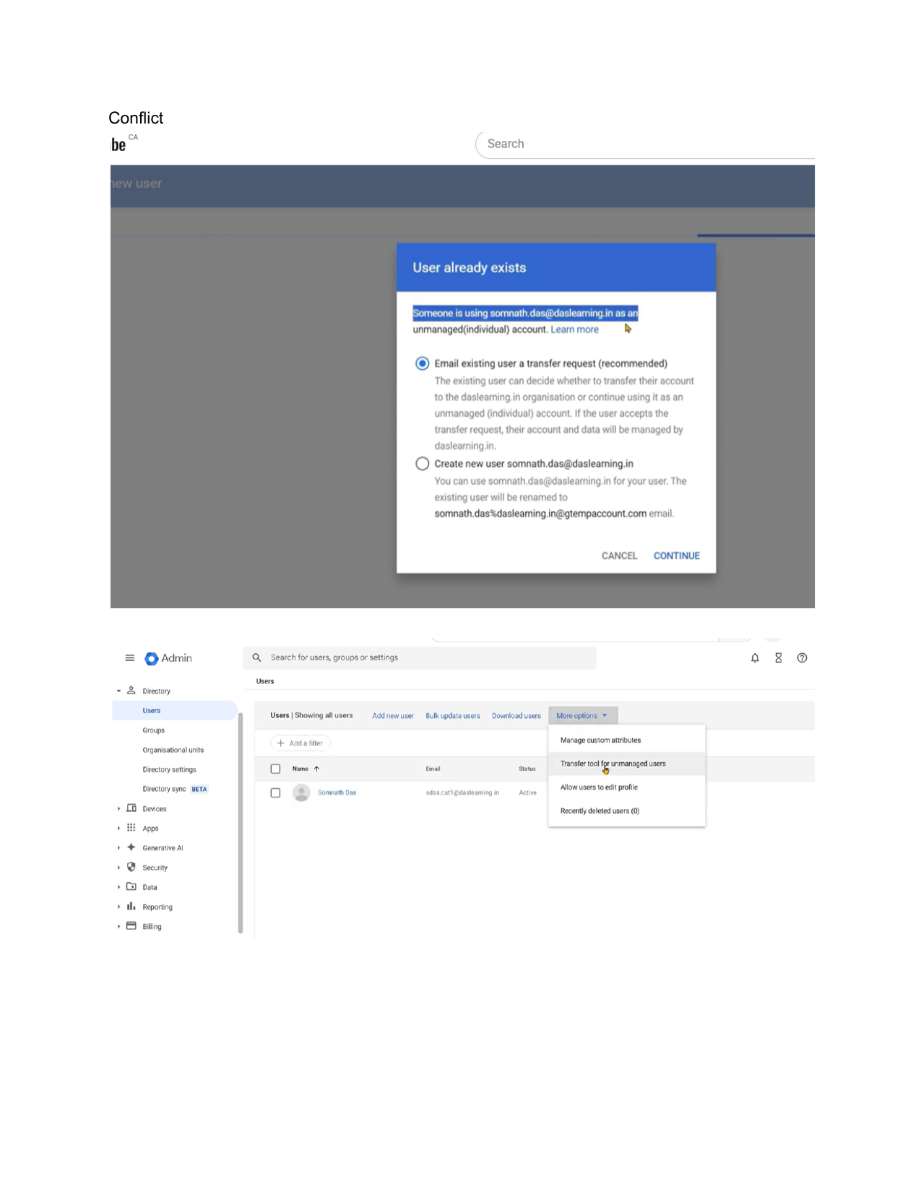

Page 2 - User transfer email received, showing the unmanaged account transfer request.
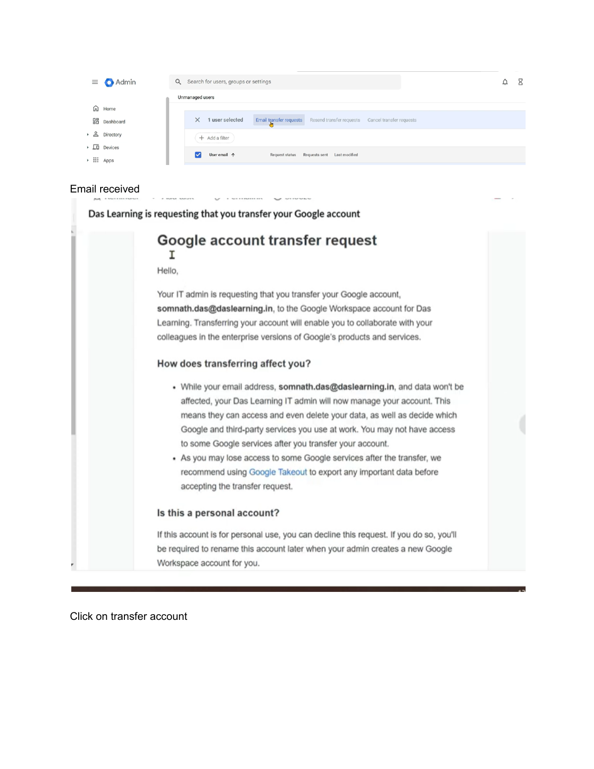

Page 3 - User clicks Transfer account from the email invitation.
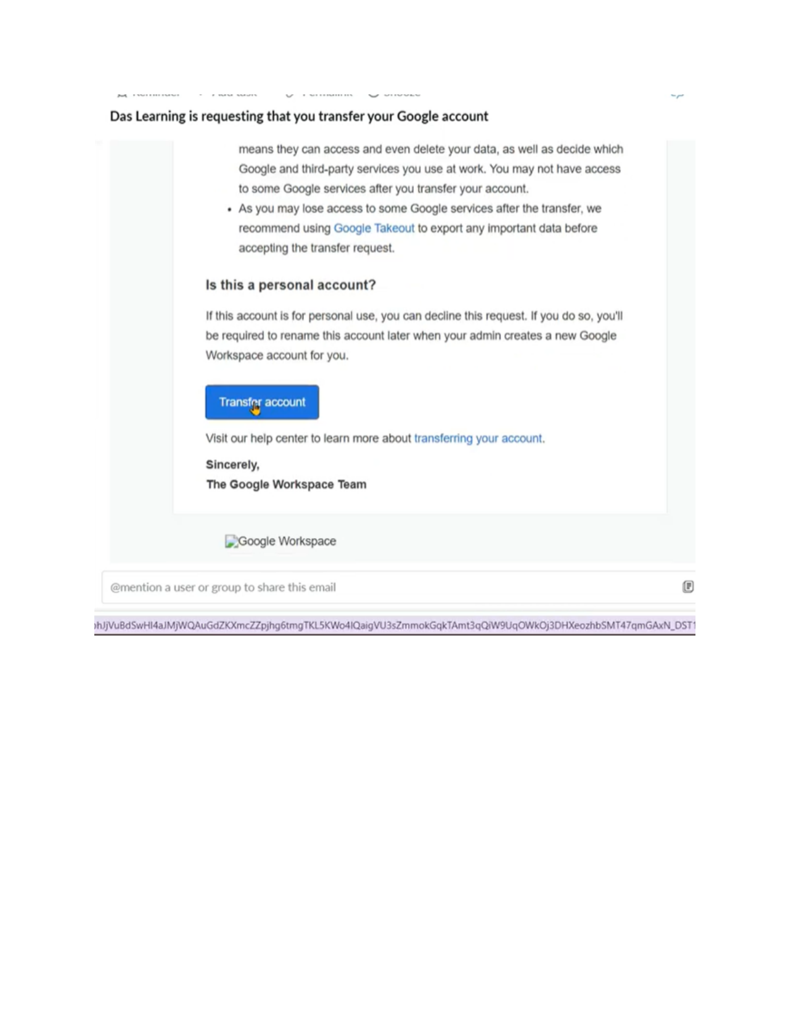

Page 4 - User acceptance screen showing managed account warning and post-transfer app view.
